UNITED STATES

SECURITIES AND EXCHANGE COMMISSION
WASHINGTON, DC 20549

FORM 10-Q

(Mark One)

- QUARTERLY REPORT PURSUANT TO SECTION 13 OR 15(d) OF THE SECURITIES EXCHANGE ACT OF 1934 For the quarterly period ended June 30, 2023

- TRANSITION REPORT PURSUANT TO SECTION 13 OR 15(d) OF THE SECURITIES EXCHANGE ACT OF 1934 For the transition period from ___________ to ___________

Commission File Number: 001-39536

Taysha Gene Therapies, Inc.

(Exact Name of Registrant as Specified in its Charter)

Delaware | 84-3199512
( State or other jurisdiction of | (I.R.S. Employer
incorporation or organization) | Identification No.)
3000 Pegasus Park Drive Ste 1430
Dallas, Texas | 75247
(Address of principal executive offices) | (Zip Code)

Registrant’s telephone number, including area code: (214) 612-0000

Securities registered pursuant to Section 12(b) of the Act:

Title of each class |  | Trading |  | Name of each exchange on which registered
Title of each class |  | Symbol(s) |  | Name of each exchange on which registered
Common stock, par value $0.00001 per share |  | TSHA |  | The Nasdaq Stock Market LLC

Indicate by check mark whether the registrant (1) has filed all reports required to be filed by Section 13 or 15(d) of the Securities Exchange Act of 1934 during the preceding 12 months (or for such shorter period that the registrant was required to file such reports), and (2) has been subject to such filing requirements for the past 90 days. Yes ☒ No ☐

Indicate by check mark whether the registrant has submitted electronically every Interactive Data File required to be submitted pursuant to Rule 405 of Regulation S-T (§232.405 of this chapter) during the preceding 12 months (or for such shorter period that the registrant was required to submit such files). Yes ☒ No ☐

Indicate by check mark whether the registrant is a large accelerated filer, an accelerated filer, a non-accelerated filer, smaller reporting company, or an emerging growth company. See the definitions of “large accelerated filer,” “accelerated filer,” “smaller reporting company,” and “emerging growth company” in Rule 12b-2 of the Exchange Act.

Large accelerated filer | ☐ | Accelerated filer | ☐
Non-accelerated filer | ☒ | Smaller reporting company | ☒
Emerging growth company | ☒

If an emerging growth company, indicate by check mark if the registrant has elected not to use the extended transition period for complying with any new or revised financial accounting standards provided pursuant to Section 13(a) of the Exchange Act. ☐

Indicate by check mark whether the registrant is a shell company (as defined in Rule 12b-2 of the Exchange Act). Yes ☐ No ☒ As of August 14, 2023, the registrant had 64,465,037 shares of common stock, $0.00001 par value per share, outstanding.

Table of Contents

PART I. |  | FINANCIAL INFORMATION |  |  |  |  |  |  |  |  |  |  |  |  |  |  |  |  | Page
Item 1. |  | Condensed Consolidated Financial Statements (Unaudited) |  |  |  |  |  |  |  |  |  |  |  |  |  |  |  |  | 1
 |  | Balance Sheets |  |  |  |  |  |  |  |  |  |  |  |  |  |  |  |  | 1
 |  | Statements of Operations |  |  |  |  |  |  |  |  |  |  |  |  |  |  |  |  | 2
 |  | Statements of Stockholders’ (Deficit) Equity |  |  |  |  |  |  |  |  |  |  |  |  |  |  |  |  | 3
 |  | Statements of Cash Flows |  |  |  |  |  |  |  |  |  |  |  |  |  |  |  |  | 5
 |  | Notes to Financial Statements |  |  |  |  |  |  |  |  |  |  |  |  |  |  |  |  | 6
Item 2. |  | Management’s Discussion and Analysis of Financial Condition and Results of Operations |  |  |  |  |  |  |  |  |  |  |  |  |  |  |  |  | 24
Item 3. |  | Quantitative and Qualitative Disclosures About Market Risk |  |  |  |  |  |  |  |  |  |  |  |  |  |  |  |  | 62
Item 4. |  | Controls and Procedures |  |  |  |  |  |  |  |  |  |  |  |  |  |  |  |  | 62
PART II. |  | OTHER INFORMATION
Item 1. |  | Legal Proceedings |  |  |  |  |  |  |  |  |  |  |  |  |  |  |  |  | 63
Item 1A. |  | Risk Factors |  |  |  |  |  |  |  |  |  |  |  |  |  |  |  |  | 63
Item 2. |  | Unregistered Sales of Equity Securities and Use of Proceeds |  |  |  |  |  |  |  |  |  |  |  |  |  |  |  |  | 64
Item 3. |  | Defaults Upon Senior Securities |  |  |  |  |  |  |  |  |  |  |  |  |  |  |  |  | 65
Item 4. |  | Mine Safety Disclosures |  |  |  |  |  |  |  |  |  |  |  |  |  |  |  |  | 65
Item 5. |  | Other Information |  |  |  |  |  |  |  |  |  |  |  |  |  |  |  |  | 65
Item 6. |  | Exhibits |  |  |  |  |  |  |  |  |  |  |  |  |  |  |  |  | 66
Signatures |  |  |  |  |  |  |  |  |  |  |  |  |  |  |  |  |  |  | 67

i

PART I—FINANCIAL INFORMATION

Item 1. Financial Statements.

Taysha Gene Therapies, Inc.

Condensed Consolidated Balance Sheets

(in thousands, except share and per share data)

(Unaudited)

 |  | June 30, |  |  | December 31,
 |  | 2023 |  |  | 2022
ASSETS
Current assets:
Cash and cash equivalents | $ | 45,083 |  | $ | 87,880
Prepaid expenses and other current assets |  | 9,032 |  |  | 8,537
Total current assets |  | 54,115 |  |  | 96,417
Restricted cash |  | 2,637 |  |  | 2,637
Property, plant and equipment, net |  | 14,139 |  |  | 14,963
Operating lease right-of-use assets |  | 10,348 |  |  | 10,943
Other non-current assets |  | 304 |  |  | 1,316
Total assets | $ | 81,543 |  | $ | 126,276
LIABILITIES AND STOCKHOLDERS' (DEFICIT) EQUITY
Current liabilities
Accounts payable | $ | 10,766 |  | $ | 10,946
Accrued expenses and other current liabilities |  | 19,632 |  |  | 18,287
Deferred revenue |  | 20,243 |  |  | 33,557
Total current liabilities |  | 50,641 |  |  | 62,790
Deferred revenue, net of current portion |  | 6,212 |  |  | —
Term loan, net |  | 38,354 |  |  | 37,967
Operating lease liability, net of current portion |  | 19,528 |  |  | 20,440
Other non-current liabilities |  | 3,922 |  |  | 4,130
Total liabilities |  | 118,657 |  |  | 125,327
Commitments and contingencies - Note 12
Stockholders' (deficit) equity
Preferred stock, $0.00001 par value per share; 10,000,000 shares authorized and no shares issued and
outstanding as of June 30, 2023 and December 31, 2022 |  | — |  |  | —
Common stock, $0.00001 par value per share; 200,000,000 shares authorized and 64,432,637 and
63,207,507 issued and outstanding as of June 30, 2023 and December 31, 2022, respectively |  | 1 |  |  | 1
Additional paid-in capital |  | 406,546 |  |  | 402,389
Accumulated deficit |  | (443,661 ) |  |  | (401,441 )
Total stockholders’ (deficit) equity |  | (37,114 ) |  |  | 949
Total liabilities and stockholders' (deficit) equity | $ | 81,543 |  | $ | 126,276

The accompanying notes are an integral part of these unaudited condensed consolidated financial statements.

1

Taysha Gene Therapies, Inc.

Condensed Consolidated Statements of Operations

(in thousands, except share and per share data)

(Unaudited)

 |  | For the Three Months |  |  |  |  |  | For the Six Months
 |  | Ended June 30, |  |  |  |  |  | Ended June 30,
 |  | 2023 |  |  | 2022 |  |  | 2023 |  |  | 2022
Revenue | $ | 2,395 |  | $ | — |  | $ | 7,101 |  | $ | —
Operating expenses:
Research and development |  | 19,791 |  |  | 23,506 |  |  | 32,305 |  |  | 61,688
General and administrative |  | 5,988 |  |  | 9,867 |  |  | 14,739 |  |  | 21,336
Total operating expenses |  | 25,779 |  |  | 33,373 |  |  | 47,044 |  |  | 83,024
Loss from operations |  | (23,384 ) |  |  | (33,373 ) |  |  | (39,943 ) |  |  | (83,024 )
Other income (expense):
Interest income |  | 223 |  |  | 27 |  |  | 542 |  |  | 41
Interest expense |  | (1,440 ) |  |  | (743 ) |  |  | (2,814 ) |  |  | (1,415 )
Other income (expense) |  | 3 |  |  | (3 ) |  |  | (5 ) |  |  | (11 )
Total other income (expense), net |  | (1,214 | ) |  | (719 | ) |  | (2,277 | ) |  | (1,385 | )
Net loss | $ | (24,598 ) |  | $ | (34,092 ) |  | $ | (42,220 ) |  | $ | (84,409 )
Net loss per common share, basic and diluted | $ | (0.38 | ) | $ | (0.85 | ) | $ | (0.66 | ) | $ | (2.16 | )
Weighted average common shares outstanding, basic and diluted |  | 64,244,531 |  |  | 40,142,403 |  |  | 63,755,435 |  |  | 39,163,996

The accompanying notes are an integral part of these unaudited condensed consolidated financial statements.

2

Taysha Gene Therapies, Inc.

Condensed Consolidated Statements of Stockholders’ (Deficit) Equity

(in thousands, except share data)

(Unaudited)

For the Three Months Ended June 30, 2023

 |  |  |  |  |  |  | Additional |  |  |  |  |  | Total
 | Common Stock |  |  |  |  |  | Paid-in |  |  | Accumulated |  |  | Stockholders'
 | Shares |  | Amount |  |  |  | Capital |  |  | Deficit |  |  | Deficit
Balance as of March 31, 2023 | 63,473,349 |  | $ | 1 |  | $ | 404,114 |  | $ | (419,063 | ) | $ | (14,948 | )
Stock-based compensation | — |  |  | — |  |  | 2,222 |  |  | — |  |  | 2,222
Issuance of common stock in private placement, net of offering costs of $40 | 705,218 |  |  | — |  |  | 210 |  |  | — |  |  | 210
Issuance of common stock upon vesting and settlement of restricted stock units | 254,070 |  |  | — |  |  | — |  |  | — |  |  | —
Net loss | — |  |  | — |  |  | — |  |  | (24,598 ) |  |  | (24,598 )
Balance as of June 30, 2023 | 64,432,637 |  | $ | 1 |  | $ | 406,546 |  | $ | (443,661 ) |  | $ | (37,114 )

For the Three Months Ended June 30, 2022

 |  |  |  |  |  |  | Additional |  |  |  |  |  | Total
 | Common Stock |  |  |  |  |  | Paid-in |  |  | Accumulated |  |  | Stockholders'
 | Shares |  | Amount |  |  |  | Capital |  |  | Deficit |  |  | Equity
Balance as of March 31, 2022 | 38,473,945 |  | $ | — |  | $ | 336,485 |  | $ | (285,744 | ) | $ | 50,741
Stock-based compensation | — |  |  | — |  |  | 4,249 |  |  | — |  |  | 4,249
Issuance of common stock, net of sales commissions and other offering costs of $392 | 2,000,000 |  |  | 1 |  |  | 11,608 |  |  | — |  |  | 11,609
Issuance of common stock upon vesting and settlement of restricted stock units | 546,141 |  |  | — |  |  | — |  |  | — |  |  | —
Net loss | — |  |  | — |  |  | — |  |  | (34,092 ) |  |  | (34,092 )
Balance as of June 30, 2022 | 41,020,086 |  | $ | 1 |  | $ | 352,342 |  | $ | (319,836 ) |  | $ | 32,507

The accompanying notes are an integral part of these unaudited condensed consolidated financial statements.

3

Taysha Gene Therapies, Inc.

Condensed Consolidated Statements of Stockholders’ (Deficit) Equity

(in thousands, except share data)

(Unaudited)

For the Six Months Ended June 30, 2023

 |  |  |  |  |  |  | Additional |  |  |  |  |  | Total
 | Common Stock |  |  |  |  |  | Paid-in |  |  | Accumulated |  |  | Stockholders'
 | Shares |  | Amount |  |  |  | Capital |  |  | Deficit |  | Equity (Deficit)
Balance as of December 31, 2022 | 63,207,507 |  | $ | 1 |  | $ | 402,389 |  | $ | (401,441 | ) | $ | 949
Stock-based compensation | — |  |  | — |  |  | 3,897 |  |  | — |  |  | 3,897
Issuance of common stock in private placement, net of offering costs of $40 | 705,218 |  |  | — |  |  | 210 |  |  | — |  |  | 210
Issuance of common stock upon vesting and settlement of restricted stock units, net | 483,992 |  |  | — |  |  | — |  |  | — |  |  | —
Issuance of common stock under ESPP | 35,920 |  |  | — |  |  | 50 |  |  | — |  |  | 50
Net loss | — |  |  | — |  |  | — |  |  | (42,220 ) |  |  | (42,220 )
Balance as of June 30, 2023 | 64,432,637 |  | $ | 1 |  | $ | 406,546 |  | $ | (443,661 | ) | $ | (37,114 | )

For the Six Months Ended June 30, 2022

 |  |  |  |  |  |  | Additional |  |  |  |  |  | Total
 | Common Stock |  |  |  |  |  | Paid-in |  |  | Accumulated |  |  | Stockholders'
 | Shares |  | Amount |  |  |  | Capital |  |  | Deficit |  | Equity (Deficit)
Balance as of December 31, 2021 | 38,473,945 |  | $ | — |  | $ | 331,032 |  | $ | (235,649 | ) | $ | 95,383
Adjustment to beginning accumulated deficit from the adoption of ASC 842 | — |  |  | — |  |  | — |  |  | 222 |  |  | 222
Stock-based compensation | — |  |  | — |  |  | 9,702 |  |  | — |  |  | 9,702
Issuance of common stock upon vesting and settlement of restricted stock units | 546,141 |  |  | — |  |  | — |  |  | — |  |  | —
Issuance of common stock, net of sales commissions and other offering costs of $392 | 2,000,000 |  |  | 1 |  |  | 11,608 |  |  | — |  |  | 11,609
Net loss | — |  |  | — |  |  | — |  |  | (84,409 ) |  |  | (84,409 )
Balance as of June 30, 2022 | 41,020,086 |  | $ | 1 |  | $ | 352,342 |  | $ | (319,836 | ) | $ | 32,507

The accompanying notes are an integral part of these unaudited condensed consolidated financial statements.

4

Taysha Gene Therapies, Inc.

Condensed Consolidated Statements of Cash Flows

(in thousands)

(Unaudited)

 |  | For the Six Months
 | 2023 | Ended June 30, |  |  | 2022
Cash flows from operating activities
Net loss | $ | (42,220 ) |  | $ | (84,409 )
Adjustments to reconcile net loss to net cash used in operating activities:
Depreciation expense |  | 674 |  |  | 533
Research and development license expense |  | 3,500 |  |  | 1,250
Stock-based compensation |  | 3,897 |  |  | 9,470
Non-cash lease expense |  | 603 |  |  | 646
Other |  | 387 |  |  | 387
Changes in operating assets and liabilities:
Prepaid expenses and other assets |  | 509 |  |  | 80
Accounts payable |  | 2,123 |  |  | 6,212
Accrued expenses and other liabilities |  | (1,324 ) |  |  | (8,461 )
Deferred revenue |  | (7,101 ) |  |  | —
Net cash used in operating activities |  | (38,952 ) |  |  | (74,292 )
Cash flows from investing activities
Purchase of research and development license |  | — |  |  | (3,250 )
Purchase of property, plant and equipment |  | (3,852 ) |  |  | (16,290 )
Net cash used in investing activities |  | (3,852 ) |  |  | (19,540 )
Cash flows from financing activities
Proceeds from issuance of common stock, net of sales commissions |  | — |  |  | 11,640
Proceeds from issuance of common stock from private placement |  | 500 |  |  | —
Payment of shelf registration costs |  | (387 ) |  |  | (227 )
Proceeds from common stock issuances under ESPP |  | 50 |  |  | 321
Other |  | (156 ) |  |  | (766 )
Net cash provided by financing activities |  | 7 |  |  | 10,968
Net decrease in cash, cash equivalents and restricted cash |  | (42,797 ) |  |  | (82,864 )
Cash, cash equivalents and restricted cash at the beginning of the period |  | 90,517 |  |  | 151,740
Cash, cash equivalents and restricted cash at the end of the period | $ | 47,720 |  | $ | 68,876
Cash and cash equivalents |  | 45,083 |  |  | 66,239
Restricted cash |  | 2,637 |  |  | 2,637
Cash, cash equivalents and restricted cash at the end of the period | $ | 47,720 |  | $ | 68,876
Supplemental disclosure of cash flow information:
Cash paid for interest | $ | 2,399 |  | $ | 935
Supplemental disclosure of noncash investing and financing activities:
Property, plant and equipment in accounts payable and accrued expenses |  | — |  |  | 2,722
Right-of-use assets obtained in exchange for lease liabilities |  | — |  |  | 18,925
Offering costs not yet paid |  | — |  |  | 109
Issuance of warrants in connection with private placement |  | 252 |  |  | —
Purchase of research and development license not yet paid |  | 3,500 |  |  | 1,000


The accompanying notes are an integral part of these unaudited condensed consolidated financial statements.

5

Note 1—Organization and Description of Business Operations

Taysha Gene Therapies, Inc. (the “Company” or “Taysha”) was originally formed under the laws of the State of Texas on September 20, 2019 (“Inception”). Taysha converted to a Delaware corporation on February 13, 2020, which had no impact to the Company’s par value or issued and authorized capital structure.

Taysha is a patient-centric gene therapy company focused on developing and commercializing AAV-based gene therapies for the treatment of monogenic diseases of the central nervous system in both rare and large patient populations.

Sales Agreement

On October 5, 2021, the Company entered into a Sales Agreement (the “Sales Agreement”) with SVB Securities LLC (f/k/a SVB Leerink LLC) and Wells Fargo Securities, LLC (collectively, the “Sales Agents”), pursuant to which the Company may issue and sell, from time to time in its sole discretion, shares of its common stock having an aggregate offering price of up to $150.0 million through the Sales Agents. In March 2022, the Company amended the Sales Agreement to, among other things, include Goldman Sachs & Co. LLC as an additional Sales Agent. The Sales Agents may sell common stock by any method permitted by law deemed to be an “at-the-market offering” as defined in Rule 415(a)(4) of the Securities Act, including sales made directly on or through the Nasdaq Global Select Market or any other existing trade market for the common stock, in negotiated transactions at market prices prevailing at the time of sale or at prices related to prevailing market prices, or any other method permitted by law. Any shares of the Company’s common stock will be issued pursuant to the Company’s shelf registration statement on Form S-3 (File No. 333-260069) (the “Shelf Registration Statement”), which the Securities and Exchange Commission ("SEC") declared effective on October 14, 2021; however the Company’s use of the Shelf Registration Statement will be limited for so long as the Company is subject to General Instruction I.B.6 of Form S-3, which limits the amounts that the Company may sell under the Shelf Registration Statement and in accordance with the Sales Agreement. The Sales Agents are entitled to receive 3.0% of the gross sales price per share of common stock sold under the Sales Agreement. In April 2022, the Company sold 2,000,000 shares of common stock under the Sales Agreement and received $11.6 million in net proceeds. No other shares of common stock have been issued and sold pursuant to the Sales Agreement as of June 30, 2023.

Liquidity and Going Concern

The accompanying condensed consolidated financial statements are prepared in accordance with generally accepted accounting principles applicable to a going concern, which contemplates the realization of assets and the satisfaction of liabilities in the normal course of business.

Pursuant to ASC 205, Presentation of Financial Statements, the Company is required to and does evaluate at each annual and interim period whether there are conditions or events, considered in the aggregate, that raise substantial doubt about its ability to continue as a going concern within one year after the date that the condensed consolidated financial statements are issued.

The assessment of the Company’s ability to meet its future obligations is inherently judgmental, subjective and susceptible to change. Based on the Company’s current forecast, management believes that it will have sufficient cash, including the anticipated net proceeds from the private placement expected to close in August 2023 (See Note 15), to maintain the Company’s planned operations for the next twelve months following the issuance of these condensed consolidated financial statements. However given the inherent uncertainties in the forecast, the Company has considered both quantitative and qualitative factors that are known or reasonably knowable as of the date that these condensed consolidated financial statements are issued and concluded that there are conditions present in the aggregate that raise substantial doubt about the Company’s ability to continue as a going concern.

The Company has incurred operating losses since inception and expects to continue to incur significant operating losses for the foreseeable future and may never become profitable. As of June 30, 2023, the Company had an accumulated deficit of $443.7 million. Losses are expected to continue as the Company continues to invest in its research and development activities. Future capital requirements will depend on many factors, including the timing and extent of spending on research and development and the market acceptance of the Company’s products. The Company will need to obtain additional financing in order to complete clinical studies and launch and commercialize any product candidates for which it receives regulatory approval. There can be no assurance that such financing will be available or will be on terms acceptable to the Company.

6

Note 2—Summary of Significant Accounting Policies

Basis of Presentation

The unaudited condensed consolidated financial statements have been prepared in conformity with accounting principles generally accepted in the United States ("GAAP") as determined by the Financial Accounting Standards Board (“FASB”) Accounting Standards Codification (“ASC”) for interim financial information and the instructions to Form 10-Q and Article 10 of Regulation S-X and are consistent in all material respects with those included in the Company’s Annual Report on Form 10-K for the year ended December 31, 2022, filed with the SEC on March 28, 2023 (the “2022 Annual Report”). In the opinion of management, the unaudited condensed consolidated financial statements reflect all adjustments, which include only normal recurring adjustments necessary for the fair statement of the balances and results for the periods presented. The consolidated balance sheet as of December 31, 2022, is derived from audited financial statements, however, it does not include all of the information and footnotes required by GAAP for complete financial statements. These unaudited condensed consolidated financial statements should be read in conjunction with the consolidated financial statements and related notes in the Company’s 2022 Annual Report.

Principles of Consolidation

The accompanying interim condensed consolidated financial statements include the accounts of Taysha and its wholly owned subsidiaries. All intercompany transactions and balances have been eliminated in consolidation.

Use of Estimates

The preparation of financial statements in conformity with GAAP requires management to make estimates and assumptions that affect the reported amounts of assets and liabilities and disclosure of contingent assets and liabilities at the date of the financial statements and the reported amounts of expenses during the reporting period. The most significant estimates and assumptions in the Company’s financial statements relate to the determination of the fair value of the common stock prior to the initial public offering ("IPO") (as an input into stock-based compensation), estimating manufacturing accruals and accrued or prepaid research and development expenses, the measurement of impairment of long-lived assets, and the allocation of consideration received in connection with the Astellas Transactions. These estimates and assumptions are based on current facts, historical experience and various other factors believed to be reasonable under the circumstances, the results of which form the basis for making judgments about the carrying values of assets and liabilities and the recording of expenses that are not readily apparent from other sources. Actual results may differ materially from these estimates. To the extent there are material differences between the estimates and actual results, the Company’s future results of operations will be affected.

Significant Accounting Policies

There have been no changes in the Company’s significant accounting policies as disclosed in Note 2 to the audited consolidated financial statements included in the 2022 Annual Report, except as described below.

Warrants

The Company accounts for warrants as either equity-classified or liability-classified instruments based on an assessment of the warrant’s specific terms and applicable authoritative guidance in FASB ASC 480, Distinguishing Liabilities from Equity (“ASC 480”) and ASC 815, Derivatives and Hedging (“ASC 815”). The assessment considers whether the warrants are freestanding financial instruments pursuant to ASC 480, meet the definition of a liability pursuant to ASC 480, and whether the warrants meet all of the requirements for equity classification under ASC 815, including whether the warrants are indexed to the Company’s own common shares and whether the warrant holders could potentially require “net cash settlement” in a circumstance outside of the Company’s control, among other conditions for equity classification. This assessment, which requires the use of professional judgment, is conducted at the time of warrant issuance and as of each subsequent reporting period while the warrants are outstanding.

For issued or modified warrants that meet all of the criteria for equity classification, the warrants are required to be recorded as a component of additional paid-in capital at the time of issuance. For issued or modified warrants that do not meet all the criteria for equity classification, the warrants are required to be recorded at their initial fair value on the date of issuance, and each balance sheet date thereafter. The Company classifies the warrants as liabilities at their fair value and adjusts the warrants to fair value at each reporting period. This liability is subject to remeasurement at each balance sheet date until the warrants are exercised or expire, and any change in fair value is recognized in the Company’s condensed consolidated statement of operations.

Comprehensive Loss

Comprehensive loss is equal to net loss as presented in the accompanying condensed consolidated statements of operations.

7

Recently Adopted Accounting Pronouncements

In February 2016, the FASB issued ASU No. 2016-02, Leases (Topic 842), as amended, with guidance regarding the accounting for and disclosure of leases. This update requires lessees to recognize the liabilities related to all leases, including operating leases, with a term greater than 12 months on the balance sheets. This update also requires lessees and lessors to disclose key information about their leasing transactions.

On December 31, 2022, the Company adopted ASU 2016-02 using the modified retrospective approach and utilizing the effective date as its date of initial application. The Company has retrospectively changed its previously issued condensed consolidated financial statements as of June 30, 2022 as presented within the Company's June 30, 2022 Quarterly Report on Form 10-Q to reflect the adoption of ASC 842 on January 1, 2022. The condensed consolidated financial statements for the three and six months ended June 30, 2022 presented herein differ from the Company's condensed consolidated financial statements included in the Company's June 30, 2022 Quarterly Report on Form 10-Q as those condensed consolidated financial statements were prepared using the former accounting standard referred to as ASC Topic 840, Leases.

The Company elected the following practical expedients, which must be elected as a package and applied consistently to all of its leases at the transition date (including those for which the entity is a lessee or a lessor): i) the Company did not reassess whether any expired or existing contracts are or contain leases; ii) the Company did not reassess the lease classification for any expired or existing leases (that is, all existing leases that were classified as operating leases in accordance with ASC 840 are classified as operating leases, and all existing leases that were classified as capital leases in accordance with ASC 840 are classified as finance leases); and iii) the Company did not reassess initial direct costs for any existing leases. For leases that existed prior to the date of initial application of ASC 842 (which were previously classified as operating leases), a lessee may elect to use either the total lease term measured at lease inception under ASC 840 or the remaining lease term as of the date of initial application of ASC 842 in determining the period for which to measure its incremental borrowing rate. In transition to ASC 842, the Company utilized the remaining lease term of its leases in determining the appropriate incremental borrowing rates.

The adoption of this standard resulted in the recognition of operating lease right-of-use assets and operating lease liabilities of $18.4 million and $19.1 million, respectively, on the Company’s condensed consolidated balance sheet at adoption relating to its operating leases. The lease liabilities were determined based on the present value of the remaining minimum lease payments. Upon adoption of ASC 842, the Company also (i) derecognized the build-to-suit lease asset of $26.3 million previously presented in property, plant and equipment, (ii) derecognized the build-to-suit lease liability of $26.5 million, and (iii) eliminated $0.7 million of deferred rent liabilities and tenant improvement allowances as of January 1, 2022, as these liabilities are reflected in the operating lease right-of-use assets. In adopting ASU 2016-02, the Company recorded a total one-time adjustment of $0.2 million to the opening balance of accumulated deficit as of January 1, 2022, related to the de-recognition of the build-to-suit lease asset and related build-to-suit lease obligation. The adoption did not have a material impact on accumulated deficit and on the condensed consolidated statements of operations and cash flows.

8

The following table summarizes the effect of the adoption of ASC 842 on the condensed consolidated statement of operations and statement of cash flows for the six months ended June 30, 2022 (in thousands):

 |  |  |  |  |  |  |  | After ASC 842
 | Pre ASC 842 Six |  |  |  |  |  |  | Six Months
 |  | Months Ended |  |  | ASC 842 |  |  | Ended
 |  | June 30, 2022 |  |  | Adjustments |  |  | June 30, 2022
Condensed Consolidated Statement of Operations
Operating expenses:
Research and development | $ | 60,917 |  | $ | 771 |  | $ | 61,688
Other income (expense):
Interest expense |  | (1,761 ) |  |  | 346 |  |  | (1,415 )
Net loss |  | (83,984 ) |  |  | (425 ) |  |  | (84,409 )
Condensed Consolidated Statement of Cash Flows
Adjustments to reconcile net loss to net cash used in operating activities:
Depreciation expense | $ | 531 |  | $ | 2 |  | $ | 533
Non-cash lease expense |  | — |  |  | 646 |  |  | 646
Changes in operating assets and liabilities:
Accrued expenses and other current liabilities |  | (7,958 ) |  |  | (503 ) |  |  | (8,461 )
Cash flows from financing activities
Other |  | (1,046 ) |  |  | 280 |  |  | (766 )
Supplemental disclosure of noncash investing and financing activities:
Right-of-use assets obtained in exchange for lease liabilities |  | — |  |  | 18,925 |  |  | 18,925

The following table summarizes the effect of the adoption of ASC 842 on the condensed consolidated statement of operations for the three months ended June 30, 2022 (in thousands):

 |  | Pre ASC 842 |  |  |  |  |  | After ASC 842
 |  | Three Months |  |  |  |  |  | Three Months
 |  | Ended |  |  | ASC 842 |  |  | Ended
 |  | June 30, 2022 |  |  | Adjustments |  |  | June 30, 2022
Condensed Consolidated Statement of Operations
Operating expenses:
Research and development | $ | 23,118 |  | $ | 388 |  | $ | 23,506
Other income (expense):
Interest expense |  | (912 ) |  |  | 169 |  |  | (743 )
Net loss |  | (33,873 ) |  |  | (219 ) |  |  | (34,092 )

Note 3—Balance Sheet Components

Prepaid expenses and other current assets consisted of the following (in thousands):

 |  | June 30, |  |  |  | December 31,
 | 2023 |  |  |  |  | 2022
Prepaid research and development |  | $ | 4,470 |  | $ | 4,840
Prepaid clinical trial |  |  | 2,972 |  |  | 2,119
Deferred offering costs |  |  | 724 |  |  | 724
Prepaid insurance |  |  | 333 |  |  | 388
Prepaid bonus |  |  | 23 |  |  | 18
Other |  |  | 510 |  |  | 448
Total prepaid expenses and other current assets |  | $ | 9,032 |  | $ | 8,537
 | 9

Property, plant and equipment, net consisted of the following (in thousands):
 |  | June 30, |  |  | December 31,
 |  | 2023 |  |  | 2022
Leasehold improvements | $ | 2,091 |  | $ | 2,091
Laboratory equipment |  | 2,868 |  |  | 2,868
Computer equipment |  | 1,115 |  |  | 1,115
Furniture and fixtures |  | 878 |  |  | 898
Construction in progress |  | 9,498 |  |  | 9,633
 |  | 16,450 |  |  | 16,605
Accumulated depreciation |  | (2,311 ) |  |  | (1,642 )
Property, plant and equipment, net | $ | 14,139 |  | $ | 14,963

In November 2022, the Company recognized a non-cash impairment charge of $36.4 million for the manufacturing facility asset group, of which $26.3 million relates to construction in progress and finance lease right-of-use assets. The impairment charge was estimated using a discounted cash flow model and recorded in the consolidated statements of operations for the year ended December 31, 2022. Property, plant and equipment, net includes $1.1 million and $1.3 million of assets capitalized as finance leases as of June 30, 2023 and December 31, 2022, respectively.

Depreciation expense was $0.4 million and $0.3 million for the three months ended June 30, 2023 and 2022, respectively. Depreciation expense was $0.7 million and $0.5 million for the six months ended June 30, 2023 and 2022, respectively.

Accrued expenses and other current liabilities consisted of the following (in thousands):
 |  | June 30, |  |  | December 31,
 |  | 2023 |  |  | 2022
Accrued research and development | $ | 7,016 |  | $ | 8,190
Accrued license fees |  | 3,500 |  |  | —
Accrued clinical trial |  | 2,159 |  |  | 1,473
Accrued compensation |  | 2,049 |  |  | 2,519
Accrued severance |  | 1,754 |  |  | 1,463
Lease liabilities, current portion |  | 1,638 |  |  | 1,521
Accrued professional and consulting fees |  | 580 |  |  | 390
Warrant liability |  | 252 |  |  | —
Accrued property, plant and equipment |  | — |  |  | 2,081
Other |  | 684 |  |  | 650
Total accrued expenses and other current liabilities | $ | 19,632 |  | $ | 18,287

Note 4— Leases

The Company leases certain office, laboratory, and manufacturing space.

Dallas Lease

On January 11, 2021, the Company entered into a lease agreement (the “Dallas Lease”) with Pegasus Park, LLC, a Delaware limited liability company (the “Dallas Landlord”), pursuant to which the Company will lease approximately 15,000 square feet of office space at 3000 Pegasus Park Drive, Dallas, Texas 75247 (the “Office Space”).

The Dallas Lease commenced on May 27, 2021, and has a term of approximately ten years. The Company has an option to extend the term of the Dallas Lease for one additional period of five years.

The Dallas Landlord has the right to terminate the Dallas Lease, or the Company’s right to possess the Office Space without terminating the Dallas Lease, upon specified events of default, including the Company’s failure to pay rent in a timely manner and upon the occurrence of certain events of insolvency with respect to the Company.

10

Dallas Lease Expansion

On December 14, 2021, the Company amended the Dallas Lease (the “Dallas Lease Amendment”) with the Dallas Landlord, pursuant to which the Company will lease approximately 18,000 square feet of office space adjacent to the Office Space at 3000 Pegasus Park Drive, Dallas, Texas 75247 (the “Expansion Premises”).

The Dallas Lease Amendment commenced on July 1, 2022, and has a term of approximately ten years.

The Company is obligated to pay operating costs and utilities applicable to the Expansion Premises. Total future minimum lease payments under the Dallas Lease Amendment over the initial 10-year term are approximately $6.0 million. The Company will be responsible for costs of constructing interior improvements within the Expansion Premises that exceed a $40.00 per rentable square foot construction allowance provided by the Dallas Landlord.

The Company has a right of first refusal with respect to certain additional office space on the 15th floor at 3000 Pegasus Park Drive, Dallas, Texas 75247 before the Dallas Landlord accepts any offer for such space.

Durham Lease

On December 17, 2020, the Company entered into a lease agreement (the “Durham Lease”) with Patriot Park Partners II, LLC, a Delaware limited liability company (the “Durham Landlord”), pursuant to which the Company agreed to lease approximately 187,500 square feet of a manufacturing facility located at 5 National Way, Durham, North Carolina (the “Facility”). The Durham Lease commenced on April 1, 2021 and is expected to have a term of approximately fifteen years and six months. The Company has two options to extend the term of the Durham Lease, each for a period of an additional five years.

The Company was not required to provide a security deposit in connection with its entry into the Durham Lease. The Company will be responsible for constructing interior improvements within the Facility. The Company was required to place $2.6 million in an escrow account which will be released when the improvements are substantially complete. The escrow funds are recorded as restricted cash on the condensed consolidated balance sheet as of June 30, 2023. The Durham Landlord has the right to terminate the Durham Lease upon specified events of default, including the Company’s failure to pay rent in a timely manner and upon the occurrence of certain events of insolvency with respect to the Company.

Summary of all lease costs recognized under ASC 842

The following table summarizes the lease costs recognized under ASC 842 and other information pertaining to the Company's operating leases for the three and six months ended June 30, 2023 and 2022 (in thousands):

 | Three Months Ended June 30, |  |  |  |  |  |  |  | For the Six Months Ended June 30,
 | 2023 |  | 2022 |  |  |  |  |  | 2023 |  |  | 2022
Operating lease cost | $ | 708 |  | $ | 535 |  |  | $ | 1,360 |  | $ | 1,108
Variable lease cost |  | 243 |  |  | 194 |  |  |  | 486 |  |  | 387
Total lease cost | $ | 951 | $ |  | 729 | $ |  |  | 1,846 | $ |  | 1,495

Supplemental information related to the remaining lease term and discount rate are as follows:
 | June 30, 2023 |  |  |  | December 31, 2022
Weighted average remaining lease term (in years) - Finance leases |  | 3.38 |  |  | 3.88
Weighted average remaining lease term (in years) - Operating leases |  | 11.07 |  |  | 11.45
Weighted average discount rate - Finance leases |  | 10.52 % |  |  | 10.51 %
Weighted average discount rate - Operating leases |  | 7.75 % |  |  | 7.72 %
11

Supplemental cash flow information related to the Company's operating leases are as follows (in thousands):

 |  | For the Six Months Ended June 30,
 |  | 2023 |  |  | 2022
Operating cash flows for operating leases | $ | 1,631 |  | $ | 726

As of June 30, 2023, future minimum commitments under ASC 842 under the Company's operating and finance leases were as follows (in thousands):

Year Ending December 31, |  | Operating |  |  | Finance
2023 | $ | 1,425 |  | $ | 227
2024 |  | 2,918 |  |  | 454
2025 |  | 3,021 |  |  | 454
2026 |  | 2,485 |  |  | 399
2027 |  | 2,577 |  |  | —
Thereafter |  | 19,721 |  |  | —
Total lease payments |  | 32,147 |  |  | 1,534
Less: imputed interest |  | (11,318 ) |  |  | (273 )
Total lease liabilities | $ | 20,829 |  | $ | 1,261
Lease liabilities, current |  | 1,301 |  |  | 337
Lease liabilities, non-current |  | 19,528 |  |  | 924
Total lease liabilities | $ | 20,829 |  | $ | 1,261


Note 5—Astellas Agreements

On October 21, 2022 (the “Effective Date”), the Company entered into the Option Agreement with Astellas, pursuant to which the Company granted to Astellas an exclusive option to obtain an exclusive, worldwide, royalty and milestone-bearing right and license (A) to research, develop, make, have made, use, sell, offer for sale, have sold, import, export and otherwise exploit, or, collectively, exploit, the product known, as of the Effective Date, as TSHA-120 (the “120 GAN Product”), and any backup products with respect thereto for use in the treatment of GAN or any other gene therapy product for use in the treatment of GAN that is controlled by Taysha or any of its affiliates or with respect to which the Company or any of its affiliates controls intellectual property rights covering the exploitation thereof, or a GAN Product, and (B) under any intellectual property rights controlled by Taysha or any of its affiliates with respect to such exploitation (the “GAN Option”). Subject to certain extensions, the GAN Option is exercisable from the Effective Date through a specified period of time following Astellas’ receipt of (i) the formal minutes from the Type B end-of-Phase 2 meeting between Taysha and the FDA in response to the Company’s meeting request sent to the FDA on September 19, 2022 for the 120 GAN Product (the “Type B end-of-Phase 2 Meeting”), (ii) all written feedback from the FDA with respect to the Type B end-of-Phase 2 Meeting, and (iii) all briefing documents sent by Taysha to the FDA with respect to the Type B end-of-Phase 2 Meeting.

Under the Option Agreement, the Company also granted to Astellas an exclusive option to obtain an exclusive, worldwide, royalty and milestone-bearing right and license (A) to exploit any Rett Product (as defined below), and (B) under any intellectual property rights controlled by Taysha or any of its affiliates with respect to such exploitation (the “Rett Option,” and together with the GAN Option, each, an “Option”). Subject to certain extensions, the Rett Option is exercisable from the Effective Date through a specified period of time following Astellas’ receipt of (i) certain clinical data from the female pediatric trial and (ii) certain specified data with respect to TSHA-102, such period, the Rett Option Period, related to (i) the product known, as of the Effective Date, as TSHA-102 and any backup products with respect thereto for use in the treatment of Rett syndrome, and (ii) any other gene therapy product for use in the treatment of Rett syndrome that is controlled by Taysha or any of its affiliates or with respect to which the Company or any of its affiliates controls intellectual property rights covering the exploitation thereof (a “Rett Product”).

The parties have agreed that, if Astellas exercises an Option, the parties will, for a specified period, negotiate a license agreement in good faith on the terms and conditions outlined in the Option Agreement, including payments by Astellas of a to be determined upfront payment, certain to be determined milestone payments, and certain to be determined royalties on net sales of GAN Products and/or Rett Products, as applicable.

12

During the Rett Option Period, the Company has agreed to (A) not solicit or encourage any inquiries, offers or proposals for, or that could reasonably be expected to lead to, a Change of Control (as defined in the Option Agreement), or (B) otherwise initiate a process for a potential Change of Control, in each case, without first notifying Astellas and offering Astellas the opportunity to submit an offer or proposal to the Company for a transaction that would result in a Change of Control. If Astellas fails or declines to submit any such offer within a specified period after the receipt of such notice, the Company will have the ability to solicit third party bids for a Change of Control transaction. If Astellas delivers an offer to the Company for a transaction that would result in a Change of Control, the Company and Astellas will attempt to negotiate in good faith the potential terms and conditions for such potential transaction that would result in a Change of Control for a specified period, which period may be shortened or extended by mutual agreement.

As partial consideration for the rights granted to Astellas under the Option Agreement, Astellas paid the Company the Upfront Payment, which is $20.0 million. Astellas or any of its affiliates shall have the right, in its or their discretion and upon written notice to the Company, to offset the amount of the Upfront Payment (in whole or in part, until the full amount of the Upfront Payment has been offset) against (a) any payment(s) owed to Taysha or any of its affiliates (or to any third party on behalf of the Company) under or in connection with any license agreement entered into with respect to any GAN Product or Rett Product, including, any upfront payment, milestone payment or royalties owed to Taysha or any of its affiliates (or to any third party on behalf of the Company) under or in connection with any such license agreement or (b) any amount owed to Taysha or any of its affiliates in connection with a Change of Control transaction with Astellas or any of its affiliates. As further consideration for the rights granted to Astellas under the Option Agreement, the Company and Astellas also entered into the Securities Purchase Agreement.

Securities Purchase Agreement

On October 21, 2022, the Company entered into the Securities Purchase Agreement with Astellas, pursuant to which the Company agreed to issue and sell to Astellas in a private placement (the “Private Placement”), an aggregate of 7,266,342 shares (the “Private Placement Shares”), of its common stock, for aggregate gross proceeds of $30.0 million. The Private Placement closed on October 24, 2022. Pursuant to the Securities Purchase Agreement, in connection with the Private Placement, Astellas has the right to designate one individual to attend all meetings of the Board in a non-voting observer capacity. The Company also granted Astellas certain registration rights with respect to the Private Placement Shares.

Accounting Treatment

In October 2022, upon closing of the Private Placement and transferring the 7,266,342 shares to Astellas, the Company recorded the issuance of shares at fair value. Fair value of the shares transferred to Astellas was calculated in accordance with ASC 820, Fair Value Measurement by analyzing the Company's stock price for a short period of time prior to and after the transaction date as traded on the NASDAQ. The NASDAQ trading data is considered an active market and a Level 1 measurement under ASC 820. The fair value was determined to be approximately $13.95 million or $1.92 per share. The $16.1 million difference between the $30.0 million paid by Astellas and the fair market value of shares issued was allocated to the transaction price of the Option Agreement.

The Company determined that the Option Agreement falls within the scope of ASC 606, Revenue from Contracts with Customers as the development of TSHA-102 for the treatment of Rett Syndrome and TSHA-120 for the treatment of GAN are considered ordinary activities for the Company. In accordance with ASC 606, the Company evaluated the Option Agreement and identified three separate performance obligations: (1) option to obtain licensing right to GAN, (2) option to obtain licensing right to Rett and (3) performance of research and development activities in the Rett development plan. The transaction price is determined to be $36.1 million which is comprised of the $20.0 million Upfront Payment and the $16.1 million allocated from the Private Placement.

To determine the standalone selling price ("SSP") of the Rett and GAN options, which the Company concluded to be material rights, the Company utilized the probability-weighted expected return (PWERM) method. The PWERM method contemplates the probability and timing of an option exercise. At contract inception, the Company estimated that the probability of exercise was 50% for each of the GAN and Rett options. The SSP of the Rett research and development activities was estimated using an expected cost plus margin approach. The standalone selling prices of the material rights and Rett research and development activities were then used to proportionately allocate the $36.1 million transaction price to the three performance obligations. The $36.1 million transaction price was recorded as deferred revenue on the condensed consolidated balance sheet at the inception of the Astellas Transactions.

13

The following table summarizes the allocation of the transaction price to the three performance obligations at contract inception (in thousands):

 |  | Transaction Price Allocation
Option to obtain license for Rett | $ | 5,485
Option to obtain license for GAN |  | 2,317
Rett research and development activities |  | 28,257
Total | $ | 36,059

Revenue allocated to the material rights will be recognized at a point in time when each option period expires or when a decision is made by Astellas to exercise or not exercise each option. Revenue from the Rett research and development activities will be recognized as activities are performed using an input method, according to the costs incurred as related to the total costs expected to be incurred to satisfy the performance obligation. The transfer of control occurs over this time period and is a reliable measure of progress towards satisfying the performance obligation.

During the six months ended June 30, 2023, the Company determined that the total estimated costs to be incurred to satisfy the performance obligation associated with Rett research and development activities had increased from the cost estimate used for the year ended December 31, 2022, and the three months ended March 31, 2023. The cumulative impact of this change would have resulted in a $3.1 million decrease related to revenue previously recognized based on prior cost estimates.

The Company recognized revenue of $2.4 million and $7.1 million from Rett research and development activities for the three and six months ended June 30, 2023, respectively. As of June 30, 2023, the Company recorded deferred revenue of $20.2 million within current liabilities and $6.2 million within long-term liabilities in the accompanying consolidated balance sheet. The Company will recognize revenues for these performance obligations as they are satisfied.

Note 6—Loan with Silicon Valley Bank

On August 12, 2021 (the “Closing Date”), the Company entered into a Loan and Security Agreement (the “Term Loan Agreement”), by and among the Company, the lenders party thereto from time to time (the “Lenders”) and Silicon Valley Bank, as administrative agent and collateral agent for the Lenders (“Agent”). The Term Loan Agreement provides for (i) on the Closing Date, $40.0 million aggregate principal amount of term loans available through December 31, 2021, (ii) from January 1, 2022 until September 30, 2022, an additional $20.0 million term loan facility available at the Company’s option upon having three distinct and active clinical stage programs, determined at the discretion of the Agent, at the time of draw, (iii) from October 1, 2022 until March 31, 2023, an additional $20.0 million term loan facility available at the Company’s option upon having three distinct and active clinical stage programs, determined at the discretion of the Agent, at the time of draw and (iv) from April 1, 2023 until December 31, 2023, an additional $20.0 million term loan facility available upon approval by the Agent and the Lenders (collectively, the “Term Loans”). The Company drew $30.0 million in term loans on the Closing Date and $10.0 million in term loans in December 2021. The Company did not draw on the two additional $20.0 million tranches prior to expiration on September 30, 2022 and March 31, 2023.

The interest rate applicable to the Term Loans is the greater of (a) the WSJ Prime Rate plus 3.75% or (b) 7.00% per annum. The Term Loans are interest only from the Closing Date through August 31, 2024, after which the Company is required to pay equal monthly installments of principal through August 1, 2026, the maturity date.

The Term Loans may be prepaid in full through August 12, 2023, with payment of a 1.00% prepayment premium, after which they may be prepaid in full with no prepayment premium. An additional final payment of 7.5% of the amount of Terms Loans advanced by the Lenders (“Exit Fee”) will be due upon prepayment or repayment of the Term Loans in full. The Exit Fee of $3.0 million was recorded as debt discount and has also been fully accrued within non-current liabilities as of June 30, 2023. The debt discount is being accreted using the effective interest method over the term of the Term Loans within interest expense in the condensed consolidated statements of operations.

The obligations under the Term Loan Agreement are secured by a perfected security interest in all of the Company’s assets except for intellectual property and certain other customarily excluded property pursuant to the terms of the Term Loan Agreement. There are no financial covenants and no warrants associated with the Term Loan Agreement. The Term Loan Agreement contains various covenants that limit the Company’s ability to engage in specified types of transactions without the consent of the Lenders which include, among others, incurring or assuming certain debt; merging, consolidating or acquiring all or substantially all of the capital stock or property of another entity; changing the nature of the Company’s business; changing the Company’s organizational structure or type; licensing, transferring or disposing of certain assets; granting certain types of liens on the Company’s assets; making certain investments; and paying cash dividends.

14

The Term Loan Agreement also contains customary representations and warranties, and also includes customary events of default, including payment default, breach of covenants, change of control, and material adverse effects. The Company was in compliance with all covenants under the Term Loan Agreement as of June 30, 2023. Upon the occurrence of an event of default, a default interest rate of an additional 5% per annum may be applied to the outstanding loan balances, and the Lenders may declare all outstanding obligations immediately due and payable and exercise all of its rights and remedies as set forth in the Term Loan Agreement and under applicable law.

During the three and six months ended June 30, 2023, the Company recognized interest expense related to the Term Loan of $1.4 million and $2.7 million, respectively.

Future principal debt payments on the loan payable as of June 30, 2023 are as follows (in thousands):
Year Ending December 31,
2023 | $ | —
2024 |  | 6,667
2025 |  | 20,000
2026 |  | 13,333
Total principal payments |  | 40,000
Unamortized debt discount |  | (1,646 )
Term Loan, net | $ | 38,354

On March 10, 2023, Silicon Valley Bank, based in Santa Clara, California, was closed by the California Department of Financial Protection and Innovation, which appointed the Federal Deposit Insurance Corporation (“FDIC”) as receiver. On March 27, 2023, First Citizens Bank purchased the remaining assets, deposits and loans of Silicon Valley Bank. As a result, the portion of the Company's term loans previously held by Silicon Valley Bank is now held by Silicon Valley Bank as a division of First-Citizen’s Bank & Trust Company. The remaining portion of the Company's term loans are still held by SVB Capital, which is currently in bankruptcy proceedings.

Note 7—Research, Collaboration and License Agreements

UT Southwestern Agreement

On November 19, 2019, the Company entered into a research, collaboration and license agreement (“UT Southwestern Agreement”) with the Board of Regents of the University of Texas System on behalf of The University of Texas Southwestern Medical Center (“UT Southwestern”). Under the UT Southwestern Agreement, UT Southwestern is primarily responsible for preclinical development activities with respect to licensed products for use in certain specified indications (up to investigational new drug application-enabling studies), and the Company is responsible for all subsequent clinical development and commercialization activities with respect to the licensed products. UT Southwestern will conduct such preclinical activities for a two-year period under mutually agreed upon sponsored research agreements that were entered into beginning in April 2020. During the initial research phase, the Company has the right to expand the scope of specified indications under the UT Southwestern Agreement.

In connection with the UT Southwestern Agreement, the Company obtained an exclusive, worldwide, royalty-free license under certain patent rights of UT Southwestern and a non-exclusive, worldwide, royalty-free license under certain know-how of UT Southwestern, in each case to make, have made, use, sell, offer for sale and import licensed products for use in certain specified indications. Additionally, the Company obtained a non-exclusive, worldwide, royalty-free license under certain patents and know-how of UT Southwestern for use in all human uses, with a right of first refusal to obtain an exclusive license under certain of such patent rights and an option to negotiate an exclusive license under other of such patent rights. The Company is required to use commercially reasonable efforts to develop, obtain regulatory approval for, and commercialize at least one licensed product.

On April 2, 2020, the Company amended the UT Southwestern Agreement to include the addition of another licensed product and certain indications, and a right of first refusal to the Company over certain patient dosing patents. No additional consideration was transferred in connection with this amendment. In March 2022, the Company and UT Southwestern mutually agreed to revise the payment schedules and current performance expectations of the current sponsored research agreements under the UT Southwestern Agreement and defer payments by fifteen months.

The UT Southwestern Agreement expires on a country-by-country and licensed product-by-licensed product basis upon the expiration of the last valid claim of a licensed patent in such country for such licensed product. After the initial research term, the Company may terminate the agreement, on an indication-by-indication and licensed product-by-licensed product basis, at any time

15

upon specified written notice to UT Southwestern. Either party may terminate the agreement upon an uncured material breach of the agreement or insolvency of the other party.

In November 2019, as partial consideration for the license rights granted under the UT Southwestern Agreement, the Company issued 2,179,000 shares of its common stock, or 20% of its then outstanding fully-diluted common stock, to UT Southwestern. The Company does not have any future milestone or royalty obligations to UT Southwestern under the UT Southwestern Agreement other than costs related to maintenance of patents.

Abeona CLN1 Agreements

In August 2020, the Company entered into license and inventory purchase agreements (collectively, the “Abeona Agreements”) with Abeona Therapeutics Inc. (“Abeona”) for worldwide exclusive rights to certain intellectual property rights and know-how relating to the research, development and manufacture of ABO-202, an AAV-based gene therapy for CLN1 disease (also known as infantile Batten disease). Under the terms of the Abeona Agreements, the Company made initial cash payments to Abeona of $3.0 million for the license fee and $4.0 million for purchase of clinical materials and reimbursement for previously incurred development costs in October 2020. In exchange for the license rights, the Company recorded an aggregate of $7.0 million within research and development expenses in the consolidated statements of operations for the year ended December 31, 2020, since the acquired license or acquired inventory do not have an alternative future use. The Company is obligated to make up to $26.0 million in regulatory-related milestones and up to $30.0 million in sales-related milestones per licensed CLN1 product. The Company will also pay an annual earned royalty in the high single digits on net sales of any licensed CLN1 products. The license agreement with Abeona (the “Abeona License Agreement”) expires on a country-by-country and licensed product-by-licensed product basis upon the expiration of the last royalty term of a licensed product. Either party may terminate the Abeona License Agreement upon an uncured material breach of the agreement or insolvency of the other party. The Company may terminate the Abeona License Agreement for convenience upon specified prior written notice to Abeona.

In December 2021, a regulatory milestone was triggered in connection with this agreement and therefore the Company recorded $3.0 million within research and development expenses in the consolidated statements of operations for the year ended December 31, 2021. The milestone fee was paid in January 2022 and classified as an investing cash outflow in the condensed consolidated statements of cash flows for the six months ended June 30, 2022. No additional milestone payments were made or triggered in connection with this agreement during the six months ended June 30, 2023.

Abeona Rett Agreement

On October 29, 2020, the Company entered into a license agreement (the “Abeona Rett Agreement”) with Abeona pursuant to which the Company obtained an exclusive, worldwide, royalty-bearing license, with the right to grant sublicenses under certain patents, know-how and materials originally developed by the University of North Carolina at Chapel Hill, the University of Edinburgh and Abeona to research, develop, manufacture, have manufactured, use, and commercialize licensed products for gene therapy and the use of related transgenes for Rett syndrome.

Subject to certain obligations of Abeona, the Company is required to use commercially reasonable efforts to develop at least one licensed product and commercialize at least one licensed product in the United States.

In connection with the Abeona Rett Agreement, the Company paid Abeona a one-time upfront license fee of $3.0 million which was recorded in research and development expenses in the consolidated statements of operations for the year ended December 31, 2020, since the acquired license does not have an alternative future use. The Company is obligated to pay Abeona up to $26.5 million in regulatory-related milestones and up to $30.0 million in sales-related milestones per licensed Rett product and high single-digit royalties on net sales of licensed Rett products. Royalties are payable on a licensed product-by-licensed product and country-by-country basis until the latest of the expiration or revocation or complete rejection of the last licensed patent covering such licensed product in the country where the licensed product is sold, the loss of market exclusivity in such country where the product is sold, or, if no licensed product exists in such country and no market exclusivity exists in such country, ten years from first commercial sale of such licensed product in such country.

The Abeona Rett Agreement expires on a country-by-country and licensed product-by-licensed product basis upon the expiration of the last royalty term of a licensed product. Either party may terminate the agreement upon an uncured material breach of the agreement or insolvency of the other party. The Company may terminate the agreement for convenience upon specified prior written notice to Abeona.

In March 2022, the Company’s clinical trial application ("CTA") filing for TSHA-102 for the treatment of Rett Syndrome was approved by Health Canada and therefore triggered a regulatory milestone payment in connection with the Abeona Rett Agreement. The Company recorded $1.0 million within research and development expenses in the condensed consolidated statements

16

of operations for the six months ended June 30, 2022. The $1.0 million regulatory milestone fee was paid in July 2022. In May 2023, the Company dosed the first patient with TSHA-102 in the Phase 1/2 REVEAL trial evaluating the safety and preliminary efficacy of TSHA-102 in adult patients with Rett syndrome and therefore triggered a milestone payment in connection with the Abeona Rett Agreement. The Company recorded $3.5 million within research and development expenses in the condensed consolidated statements of operations for the six months ended June 30, 2023. This milestone fee was not paid as of June 30, 2023 and has been recorded in accrued expenses and other current liabilities in the condensed consolidated balance sheet as of June 30, 2023. No additional milestone payments were made or triggered in connection with the Abeona Rett Agreement during the six months ended June 30, 2023.

Acquisition of Worldwide Rights for TSHA-120 for the treatment of GAN

In March 2021, the Company acquired the exclusive worldwide rights to a clinical-stage AAV9 gene therapy program, now known as TSHA-120, for the treatment of Giant Axonal Neuropathy (“GAN”). TSHA-120 is an intrathecally dosed AAV9 gene therapy currently being evaluated in a clinical trial for the treatment of GAN. The trial is being conducted by the National Institutes of Health (“NIH”) in close collaboration with a leading patient advocacy group focused on finding treatments and cures for GAN. TSHA-120 has received rare pediatric disease and orphan drug designations from the U.S. Food and Drug Administration for the treatment of GAN. The worldwide rights were acquired through a license agreement, effective March 29, 2021, between Hannah’s Hope Fund for Giant Axonal Neuropathy, Inc. (“HHF”) and the Company (the “GAN Agreement”).

Under the terms of the GAN Agreement, in exchange for granting the Company the exclusive worldwide rights to TSHA-120, HHF received an upfront payment of $5.5 million and will be eligible to receive clinical, regulatory and commercial milestones totaling up to $19.3 million, as well as a low, single-digit royalty on net sales upon commercialization of the product. No additional milestone payments were made or triggered in connection with the GAN Agreement during the six months ended June 30, 2023.

License Agreement for CLN7

In March 2022, the Company entered into a license agreement with UT Southwestern (the “CLN7 Agreement”) pursuant to which the Company obtained an exclusive worldwide, royalty-bearing license with right to grant sublicenses to develop, manufacture, use, and commercialize licensed products for gene therapy for CLN7, a form of Batten Disease. In connection with the CLN7 Agreement, the Company paid a one-time upfront license fee of $0.3 million. The Company recorded the upfront license fee in research and development expense in the condensed consolidated statements of operations since the acquired license does not have an alternative future use. The Company is obligated to pay UT Southwestern up to $7.7 million in regulatory-related milestones and up to $7.5 million in sales-related milestones, as well as a low, single-digit royalty on net sales upon commercialization of the product. No additional milestone payments were made or triggered in connection with the CLN7 Agreement during the six months ended June 30, 2023.

Note 8—Stock-Based Compensation

On July 1, 2020, the Company’s board of directors approved the 2020 Equity Incentive Plan (“Existing Plan”) which permits the granting of incentive stock options, non-statutory stock options, stock appreciation rights, restricted stock awards (“RSAs”), restricted stock units (“RSUs”) and other stock-based awards to employees, directors, officers and consultants. As of September 16, 2020, the approval date of the New Plan (as defined below), no additional awards will be granted under the Existing Plan. The terms of the Existing Plan will continue to govern the terms of outstanding equity awards that were granted prior to approval of the New Plan.

On September 16, 2020, the Company’s stockholders approved the 2020 Stock Incentive Plan (“New Plan”), which became effective upon the execution of the underwriting agreement in connection with the IPO. The number of shares of common stock reserved for issuance under the New Plan automatically increases on January 1 of each year, for a period of ten years, from January 1, 2021, continuing through January 1, 2030, by 5% of the total number of shares of common stock outstanding on December 31 of the preceding calendar year, or a lesser number of shares as may be determined by the Company’s board of directors. On January 1, 2023, the Company’s board of directors increased the number of shares of common stock reserved for issuance under the New Plan by 3,160,375 shares.

Furthermore, on September 16, 2020, the Company’s stockholders approved the Employee Stock Purchase Plan (“ESPP”), which became effective upon the execution of the underwriting agreement in connection with the IPO. The maximum number of shares of common stock that may be issued under the ESPP will not exceed 362,000 shares of common stock, plus the number of shares of common stock that are automatically added on January 1st of each year for a period of up to ten years, commencing on the first January 1 following the IPO and ending on (and including) January 1, 2030, in an amount equal to the lesser of (i) one percent (1.0%) of the total number of shares of capital stock outstanding on December 31st of the preceding calendar year, and (ii) 724,000 shares of common stock. No shares were added to the ESPP in 2021. On January 1, 2022 and 2023, the Company’s board of directors

17

increased the number of shares of common stock reserved for issuance under the ESPP by 384,739 and 632,075 respectively. The Company has issued 108,993 shares of common stock under the ESPP as of June 30, 2023.

The number of shares available for grant under the Company's incentive plans were as follows:

 | Existing |  |  | New
 | Plan |  |  | Plan |  |  | Total
Available for grant - December 31, 2022 | — |  |  | 1,067,682 |  |  | 1,067,682
Plan adjustments and amendments | (667,828 ) |  |  | 3,828,203 |  |  | 3,160,375
Grants | — |  |  | (5,191,357 ) |  |  | (5,191,357 )
Forfeitures | 667,828 |  |  | 2,707,496 |  |  | 3,375,324
Available for grant - June 30, 2023 | — |  |  | 2,412,024 |  |  | 2,412,024

Stock Options

For the three months ended June 30, 2023, 1,427,100 shares of common stock under the New Plan were awarded with a weighted-average grant date fair value per share of $0.50. For the six months ended June 30, 2023, 2,470,471 shares of common stock under the New Plan were awarded with a weighted-average grant date fair value per share of $0.65. The stock options vest over one to four years and have a ten-year contractual term.

The following weighted-average assumptions were used to estimate the fair value of time-based vesting stock options that were granted during the three and six months ended June 30, 2023 and 2022:

 | Three Months Ended June 30, |  |  |  |  | Six Months Ended June 30,
2023 |  |  |  | 2022 |  | 2023 |  | 2022
Risk-free interest rate |  | 3.72 | % | 2.77 | % | 3.61 | % | 2.16 | %
Expected dividend yield |  | — |  | — |  | — |  | —
Expected term (in years) |  | 5.8 |  | 6.0 |  | 5.9 |  | 6.1
Expected volatility |  | 81 % |  | 76 % |  | 81 % |  | 76 %

The following table summarizes time-based vesting stock option activity, during the six months ended June 30, 2023:

 |  |  |  |  |  | Weighted
 |  |  |  | Weighted |  | Average |  |  | Aggregate
 |  |  |  | Average |  | Remaining |  |  | Intrinsic
 | Stock |  |  | Exercise |  | Contractual |  |  | Value
 | Options |  |  | Price |  | Life (in years) |  |  | (in thousands)
Outstanding at December 31, 2022 | 6,158,078 |  | $ | 11.84 |  | 8.9 |  | $ | 62
Options granted | 2,470,471 |  |  | 0.91 |  | — |  |  | —
Options cancelled or forfeited | (1,927,564 ) |  |  | 11.19 |  | — |  |  | —
Options expired | (732,376 ) |  |  | 23.28 |  | — |  |  | —
Outstanding at June 30, 2023 | 5,968,609 |  | $ | 6.12 |  | 9.1 |  | $ | —
Options exercisable at June 30, 2023 | 1,049,702 |  | $ | 18.55 | 7.5 |  | $ |  | —

The aggregate intrinsic value in the above table is calculated as the difference between the fair value of the Company’s common stock at the respective reporting date and the exercise price of the stock options. As of June 30, 2023, the total unrecognized compensation related to unvested time-based vesting stock option awards granted was $10.9 million, which the Company expects to recognize over a weighted-average period of approximately 2.4 years. No stock options were exercised during the period.

Performance Stock Options

In February 2023, the Company issued options to purchase 70,235 shares of common stock to employees under the New Plan that contain performance-based vesting conditions, subject to continued employment through each anniversary and achievement of the performance conditions. The grant date fair value of these awards was not material. As of June 30, 2023, 58,346 of the shares subject to the performance-based options were outstanding, all of which vested during the period. No stock options were exercised during the period.

18

In May 2023, the Company issued options to purchase 2,166,653 shares of common stock to employees under the New Plan that contain both service and performance-based vesting conditions with a weighted average grant date fair value per share of $0.50. The stock options have a 10-year contractual term and vest over 3.6 years if a combination of clinical, regulatory and financing performance conditions are achieved. As of June 30, 2023, no compensation expense was recorded related to the awards as achievement of the performance conditions was not considered probable. The following assumptions were used to estimate the fair value of performance and service-based stock options that were granted during the six months ended June 30, 2023:

 | For the three months | For the six months
 | ended | ended
 | June 30, 2023
Risk-free interest rate | 4.04 % | 4.02 | %
Expected dividend yield | — | —
Expected term (in years) | 6.0 | 6.0
Expected volatility | 81 % | 81 %

Market-based Stock Options

In February 2023, the Company issued options to purchase 70,233 shares of common stock to employees under the New Plan that contain a market-based vesting condition, subject to continued employment through each anniversary and achievement of the market condition. The grant date fair value of the stock options that contain market-based vesting conditions was not material. As of June 30, 2023, 58,344 of the shares subject to the stock options that contain a market-based vesting condition were outstanding, and no options vested during the period.

Restricted Stock Units

In February 2023, the Company issued 81,236 RSUs to employees under the New Plan. The RSUs are subject to a service-based vesting condition. The service-based RSUs vest in equal annual installments over a four-year period. The Company at any time may accelerate the vesting of the RSUs. Such shares are not accounted for as outstanding until they vest.

The Company's default tax withholding method for RSUs granted prior to 2023 is the sell-to-cover method, in which shares with a market value equivalent to the tax withholding obligation are sold on behalf of the holder of the RSUs upon vesting and settlement to cover the tax withholding liability and the cash proceeds from such sales are remitted by the Company to taxing authorities. For RSUs granted in 2023, the Company's tax withholding policy allows the RSU holder to choose to either pay cash to the Company for the tax withholding obligation or elect the net withholding method, in which shares with a market equivalent to the tax withholding obligation are withheld and the net shares are issued to the RSU holder.

In March 2023, the Company issued 251,296 RSUs to the former President and Chief Executive officer of the Company in connection with his resignation from the Company and Board of Directors. The RSUs vested immediately.

The Company’s RSU activity for the six months ended June 30, 2023 was as follows:

 |  |  |  | Weighted
 |  |  |  | Average
 |  |  |  | Grant Date
 | Number |  |  | Fair Value
 | of Shares |  |  | per Share
Nonvested at December 31, 2022 | 1,257,844 |  | $ | 6.52
Restricted units granted | 332,532 |  |  | 1.06
Vested | (474,209 ) |  |  | 3.01
Cancelled or forfeited | (658,343 ) |  |  | 5.18
Nonvested at June 30, 2023 | 457,824 |  | $ | 8.12

As of June 30, 2023, the total unrecognized compensation related to unvested RSUs granted was $2.6 million which is expected to be amortized on a straight-line basis over a weighted-average period of approximately 1.1 years.

19

Performance and Market-based Restricted Stock Units

In February 2023, the Company issued 81,233 RSUs to employees under the New Plan that contain a combination of performance and market-based vesting conditions, subject to continued employment through each anniversary and achievement of market and performance conditions. The grant date fair value of the RSUs that contain performance and market-based vesting conditions was not material. As of June 30, 2023, 34,673 of the RSUs were unvested and still outstanding and 34,671 RSUs vested and were settled during the period.

Restricted Stock Awards

The Company’s former President and Chief Executive Officer, was awarded 769,058 RSAs under the Existing Plan on July 1, 2020, which vested over a three-year term, subject to continuous employment. The fair value of these RSAs at the grant date of July 1, 2020, was $5.28 per share. On March 2, 2023, the Company’s former President and Chief Executive Officer resigned from the Board of Directors, therefore cancelling any remaining unvested tranches.

The Company’s RSA activity for the six months ended June 30, 2023 was as follows:

 |  |  |  | Weighted
 |  |  |  | Average
 |  |  |  | Grant Date
 | Number |  |  | Fair Value
 | of Shares |  |  | per Share
Nonvested at December 31, 2022 | 85,494 |  | $ | 5.28
Restricted stock granted | — |  |  | —
Vested | (64,120 ) |  |  | 5.28
Cancelled or forfeited | (21,374 ) |  |  | 5.28
Nonvested at June 30, 2023 | — |  | $ | —

Employee Stock Purchase Plan

In February 2022, the Company’s board of directors authorized the first offering under the ESPP. Under the ESPP, eligible employees may purchase shares of Taysha common stock through payroll deductions at a price equal to 85% of the lower of the fair market values of the stock as of the beginning or the end of six-month offering periods. An employee’s payroll deductions under the ESPP are limited to 15% of the employee’s compensation and employees may not purchase more than 1,800 of shares of Taysha common stock during any offering period. During the six months ended June 30, 2023 and 2022, stock-based compensation expense related to the ESPP was not material.

Stock-based Compensation Expense

The following table summarizes the total stock-based compensation expense for the stock options, ESPP, RSAs and RSUs recorded in the condensed consolidated statements of operations for the three and six months ended June 30, 2023 and 2022 (in thousands):

 | For the Three Months Ended June 30, |  |  |  |  |  |  | For the Six Months Ended June 30,
 | 2023 |  | 2022 |  |  |  |  | 2023 |  |  | 2022
Research and development expense | $ | 1,082 |  | $ | 1,316 |  | $ | 819 |  | $ | 3,893
General and administrative expense |  | 1,140 |  |  | 2,825 |  |  | 3,078 |  |  | 5,577
Total | $ | 2,222 |  | $ | 4,141 |  | $ | 3,897 |  | $ | 9,470

Note 9—Warrants

In April 2023, the Company entered into a securities purchase agreement (the “SSI Securities Purchase Agreement”), with two affiliates of SSI Strategy Holdings LLC (“SSI”), named therein (the “SSI Investors”) pursuant to which the Company agreed to issue and sell to the SSI Investors in a private placement (the “SSI Private Placement”), 705,218 shares of its common stock (the “SSI Shares”) and warrants (the “SSI Warrants”) to purchase an aggregate of 525,000 shares of the Company's common stock (the “Warrant Shares”). SSI provides certain consulting services to the Company. Each SSI Warrant has an exercise price of $0.7090 per Warrant Share, which was the closing price of the Company's common stock on the Nasdaq Global Market on April 4, 2023. The SSI Warrants issued in the SSI Private Placement provide that the holder of the SSI Warrants will not have the right to exercise any portion of its SSI Warrants until the achievement of certain clinical and regulatory milestones related to the Company's clinical programs. The SSI Private Placement closed on April 5, 2023. Gross proceeds of the SSI Private Placement were $0.5 million.

20

The Company concluded that the SSI Warrants do not meet the criteria for equity classification under the guidance of ASC 815 due to settlement provisions that permit the holder to receive a variable number of shares in the event of a specified fundamental transaction as well as provisions that permit the holder to participate in dividends. As the SSI Warrants do not meet the criteria for equity classification, the Company recorded the warrants as liabilities at their fair value. This liability is subject to remeasurement at each balance sheet date until the warrants are exercised or expire, and any change in fair value is recognized in the Company’s condensed consolidated statement of operations.

The Company determined the fair value of the SSI Warrants at issuance was $0.3 million using the Black-Scholes-Merton option pricing model.

The following assumptions were used to estimate the fair value of the warrants:

Risk-free interest rate | 3.46 %
Expected dividend yield | —
Expected term (in years) | 5.2
Expected volatility | 81 %

The fair value adjustment as of June 30, 2023 was immaterial. As of June 30, 2023, 150,000 of the SSI Warrants have vested and are exercisable.

No warrants were exercised during the period.

Note 10—Net Loss Per Common Share

Basic net loss per common share is computed by dividing net loss attributable to common stockholders by the weighted-average number of shares of common stock outstanding for the period. Since the Company had a net loss in all periods presented, basic and diluted net loss per common share are the same.

The following table represents the calculation of basic and diluted net loss per common share (in thousands, except share and per share data):

 |  | For the Three Months Ended June 30, |  |  |  |  |  | For the Six Months Ended June 30,
 |  | 2023 |  |  | 2022 |  |  | 2023 |  |  | 2022
Net loss | $ | (24,598 | ) | $ | (34,092 | ) | $ | (42,220 | ) | $ | (84,409 | )
Weighted-average shares of common stock outstanding used to compute net |  | 64,244,531 |  |  | 40,142,403 |  |  | 63,755,435 |  |  | 39,163,996
loss per common share, basic and diluted |  | 64,244,531 |  |  | 40,142,403 |  |  | 63,755,435 |  |  | 39,163,996
Net loss per common share, basic and diluted | $ | (0.38 | ) | $ | (0.85 | ) | $ | (0.66 | ) | $ | (2.16 | )


The following common stock equivalents outstanding as of June 30, 2023 and 2022 were excluded from the computation of diluted net loss per share attributable to common stockholders for the periods presented because including them would have been anti‑dilutive:

 | June 30, |  | June 30,
 | 2023 | 2022
Unvested RSUs | 492,497 |  | 1,340,624
Unvested RSAs | — | 213,735
Stock options | 8,251,952 | 5,148,695
Warrants | 525,000 |  | —
Total | 9,269,449 |  | 6,703,054

Note 11—Income Taxes

Deferred tax assets and liabilities are determined based on the difference between the financial statement and tax bases of assets and liabilities using enacted tax rates in effect for the year in which the differences are expected to reverse. Valuation allowances are provided if based upon the weight of available evidence, it is more likely than not that some or all of the deferred tax assets will not be realized. The Company has evaluated the positive and negative evidence bearing upon the realizability of its deferred tax assets. There is no provision for income taxes because the Company has incurred operating losses and capitalized certain items for income tax purposes since its inception and maintains a full valuation allowance against its net deferred tax assets. The reported amount of income tax expense for the period differs from the amount that would result from applying the federal statutory tax rate to net loss before taxes primarily because of the change in valuation allowance.

As of June 30, 2023, there were no material changes to either the nature or the amounts of the uncertain tax positions previously determined for the year ended December 31, 2022.

21

Note 12—Commitments and Contingencies

Litigation

The Company is not a party to any material legal proceedings and is not aware of any pending or threatened claims. From time to time, the Company may be subject to various legal proceedings and claims that arise in the ordinary course of its business activities.

Commitments

In the normal course of business, the Company enters into contracts that contain a variety of indemnifications with its employees, licensors, suppliers and service providers. The Company’s maximum exposure under these arrangements is unknown at June 30, 2023. The Company does not anticipate recognizing any significant losses relating to these arrangements.

Note 13 – Strategic Reprioritization

In March 2022, the Company implemented changes to the Company’s organizational structure as well as a broader operational cost reduction plan to enable the Company to focus on specific clinical-stage programs for GAN and Rett syndrome. Substantially all other research and development activities have been paused to increase operational efficiency.

In connection with prioritization of programs, the Company reduced headcount by approximately 35% across all functions in March 2022. In accordance with ASC 420, Exit and Disposal Activities, the Company recorded one-time severance and termination-related costs of $2.6 million in the condensed consolidated statements of operations for the six months ended June 30, 2022, primarily within research and development expenses. Throughout the first quarter of 2023, the Company further reduced headcount and recorded additional one-time severance and termination related costs of $2.7 million within research and development and general and administrative expenses.

The Company expects payment of these costs to be complete by March 31, 2024. The amount of accrued severance recorded as of June 30, 2023 is as follows (in thousands):

 |  | As of June 30, 2023
Accrued severance balance as of December 31, 2022 | $ | 1,463
Severance recorded |  | 2,691
Severance paid |  | (2,400 )
Accrued severance balance as of June 30, 2023 | $ | 1,754

Note 14 – Retirement Plan

In July 2021, the Company adopted a 401(k) retirement savings plan that provides retirement benefits to all full-time employees. Eligible employees may contribute a percentage of their annual compensation, subject to Internal Revenue Service limitations. The Company contributed $0.1 million and $0.1 million to the 401(k) retirement savings plan for the three months ended June 30, 2023 and 2022, respectively. The Company contributed $0.2 million and $0.6 million to the 401(k) retirement savings plan for the six months ended June 30, 2023 and 2022, respectively.

Note 15– Subsequent Events

Private Placement

On August 14, 2023, the Company entered into a Securities Purchase Agreement (the “Purchase Agreement”) with certain institutional and other accredited investors (the “Purchasers”), pursuant to which the Company agreed to sell and issue to the Purchasers in a private placement transaction (the “Private Placement”) (i) 122,412,376 shares (the “Shares”) of the Company’s common stock, par value $0.00001 (“Common Stock”), and (ii) with respect to certain Purchasers, pre-funded warrants to purchase 44,250,978 shares of Common Stock (the “Pre-Funded Warrants”) in lieu of Shares. The purchase price per share of Common Stock is $0.90 per share (the “Purchase Price”), and the purchase price for the Pre-Funded Warrants is the Purchase Price minus $0.001 per Pre-Funded Warrant.

The Pre-Funded Warrants have a per share exercise price of $0.001, subject to proportional adjustments in the event of stock splits or combinations or similar events. The Pre-Funded Warrants will not expire until exercised in full. The Pre-Funded Warrants

22

may not be exercised if the aggregate number of shares of Common Stock beneficially owned by the holder thereof immediately following such exercise would exceed a specified beneficial ownership limitation; provided, however, that a holder may increase or decrease the beneficial ownership limitation by giving 61 days’ notice to the Company, but not to any percentage in excess of 19.99%. The Pre-Funded Warrants will only be exercisable upon receipt of stockholder approval of an increase in the authorized shares of the Company's common stock (the “Stockholder Approval”), which the Company will first seek to obtain at a special meeting of stockholders to be held by December 31, 2023. If the Company does not obtain Stockholder Approval by December 31, 2023, it is required to pay liquidated damages of 2.0% of the aggregate purchase price paid by each holder of Pre-Funded Warrants. For any subsequent failure to obtain Stockholder Approval, the Company is required to pay an additional 2.0% as liquidated damages.

The closing of the Private Placement is expected to occur on or before August 16, 2023 (the “Closing”), subject to customary closing conditions. The total gross proceeds to the Company at the Closing are expected to be approximately $150 million, before deducting placement agent commissions and offering expenses payable by the Company.

Under the terms of the Purchase Agreement, the Company has agreed to prepare and file, within 15 days after the Closing (the “Filing Deadline”), one or more registration statements with the Securities and Exchange Commission (the “SEC”) to register for resale the Common Stock issued under the Purchase Agreement and the shares of Common Stock issuable upon conversion of the Pre-Funded Warrants (the “Warrant Shares”) issued pursuant to the Purchase Agreement (together, the “Registrable Securities”), and to cause the applicable registration statements to become effective within a specified period after the Filing Deadline (the “Effectiveness Deadline”). The Company also agreed to use its best efforts to keep such registration statement effective until the earlier of (i) the third anniversary of the Effectiveness Date, as defined in the Purchase Agreement, or (ii) the date all Shares and Warrant Shares (assuming cashless exercise) held by or issuable to a Holder may be sold under Rule 144 without being subject to any volume, manner of sale or publicly available information requirements.

The Company has also agreed, among other things, to pay all Registration Expenses, as defined in the Purchase Agreement, which excludes the fees of legal counsel for any Holder, as defined in the Purchase Agreement. All selling commissions applicable to the sale of Registrable Securities and all fees and expenses of legal counsel for any Holder, as defined in the Purchase Agreement, shall be borne by such Holder.

In the event the registration statement has not been filed by the Filing Deadline or has not been declared effective by the SEC by the Effectiveness Deadline, each as defined in the Purchase Agreement, subject to certain limited exceptions, the Company has agreed to make pro rata payments to each Purchaser as liquidated damages in an amount equal to 1.0% of the Purchaser’s Subscription Amount, as defined in the Purchase Agreement, per 20-day period or pro rata for any portion thereof for each such 20-day period during which such event continues, subject to certain caps set forth in the Purchase Agreement.

The Purchase Agreement contains customary representations, warranties and covenants that were made solely for the benefit of the parties to the Purchase Agreement. Such representations, warranties and covenants (i) are intended as a way of allocating risk between the parties to the Purchase Agreement and not as statements of fact, and (ii) may apply standards of materiality in a way that is different from what may be viewed as material by stockholders of, or other investors in, the Company. Accordingly, the Purchase Agreement is included with this filing only to provide investors with information regarding the terms of transaction and not to provide investors with any other factual information regarding the Company. Investors should not rely on the representations, warranties and covenants or any descriptions thereof as characterizations of the actual state of facts or condition of the Company or any of its subsidiaries or affiliates. Moreover, information concerning the subject matter of the representations and warranties may change after the date of the Purchase Agreement, which subsequent information may or may not be fully reflected in public disclosures.

The Company has granted the Purchasers customary indemnification rights in connection with the registration statement. The Purchasers have also granted the Company customary indemnification rights in connection with the registration statement.

23

Item 2. Management’s Discussion and Analysis of Financial Condition and Results of Operations.

The following discussion and analysis of our financial condition and results of operations should be read in conjunction with our unaudited condensed consolidated financial statements and related notes included in this Quarterly Report on Form 10-Q and the audited financial statements and notes thereto as of and for the year ended December 31, 2022 and the related Management’s Discussion and Analysis of Financial Condition and Results of Operations, included in our Annual Report on Form 10-K for the year ended December 31, 2022, or Annual Report, filed with the Securities and Exchange Commission, or the SEC, on March 28, 2023. Unless the context requires otherwise, references in this Quarterly Report on Form 10-Q to “we,” “us,” and “our” refer to Taysha Gene Therapies, Inc. together with its consolidated subsidiaries.

Forward-Looking Statements

The information in this discussion contains forward-looking statements and information within the meaning of Section 27A of the Securities Act of 1933, as amended, or the Securities Act, and Section 21E of the Securities Exchange Act of 1934, as amended, or the Exchange Act, which are subject to the “safe harbor” created by those sections. These forward-looking statements include, but are not limited to, statements concerning our strategy, future operations, future financial position, future revenues, projected costs, prospects and plans and objectives of management. The words “anticipates,” “believes,” “estimates,” “expects,” “intends,” “may,” “plans,” “projects,” “will,” “would” and similar expressions are intended to identify forward-looking statements, although not all forward-looking statements contain these identifying words. We may not actually achieve the plans, intentions, or expectations disclosed in our forward-looking statements and you should not place undue reliance on our forward-looking statements. Actual results or events could differ materially from the plans, intentions and expectations disclosed in the forward-looking statements that we make. These forward-looking statements involve risks and uncertainties that could cause our actual results to differ materially from those in the forward-looking statements, including, without limitation, the risks set forth in Part II, Item 1A, “Risk Factors” in this Quarterly Report on Form 10-Q and Part II, Item 1A, “Risk Factors” in our Annual Report. The forward-looking statements are applicable only as of the date on which they are made, and we do not assume any obligation to update any forward-looking statements.

Note Regarding Trademarks

All brand names or trademarks appearing in this report are the property of their respective holders. Unless the context requires otherwise, references in this report to the “Company,” “we,” “us,” and “our” refer to Taysha Gene Therapies, Inc.

Overview

We are a patient-centric gene therapy company focused on developing and commercializing AAV-based gene therapies for the treatment of monogenic diseases of the central nervous system, or CNS. We were founded in partnership with The University of Texas Southwestern Medical Center, or UT Southwestern, to develop and commercialize transformative gene therapy treatments. Together with UT Southwestern, we possess a portfolio of gene therapy product candidates, with exclusive options to acquire several additional development programs at no cost. By combining our management team’s proven experience in gene therapy drug development and commercialization with UT Southwestern’s world-class gene therapy research capabilities, we believe we have created a powerful engine to develop transformative therapies to dramatically improve patients’ lives. In March 2022, we announced strategic pipeline prioritization initiatives focused on giant axonal neuropathy, or GAN, and Rett syndrome, and we have subsequently further paused substantially all other research and development activities to increase operational efficiency.

In April 2021, we acquired exclusive worldwide rights to TSHA-120, a clinical-stage, intrathecally dosed AAV9 gene therapy program for the treatment of GAN. A Phase 1/2 clinical trial of TSHA-120 is being conducted by the National Institutes of Health, or NIH, under an accepted investigational new drug application, or IND. We reported clinical safety and functional MFM32, a validated 32-item scale for motor function measurement developed for neuromuscular diseases, data from this trial for the highest dose cohort of 3.5x10¹⁴ total vector genomes, or vg, (by dot blot) and 1.0x10¹⁴ total vg (by ddPCR) in January 2022, where we saw continued clinically meaningful slowing of disease progression similar to that achieved with the lower dose cohorts, which we considered confirmatory of disease modification. We recently completed a commercially representative Good Manufacturing Practices, or GMP, batch of TSHA-120, which demonstrated that the pivotal lots from the commercial grade material were generally analytically comparable to the original clinical trial material. Release testing for this batch was completed in the fourth quarter of 2022. In September 2022, we submitted a meeting request to the U.S. Food and Drug Administration, or the FDA, and were granted a Type B end-of-Phase 2 meeting via teleconference on December 13, 2022. In January 2023, we reported feedback from the Type B end-of-Phase 2 meeting with the FDA following receipt of the formal meeting minutes. The FDA provided additional clarity for TSHA-120 where MFM32 was acknowledged as an acceptable endpoint with a recommendation to dose additional patients in a double-blind, placebo-controlled design to support a Biologics License Application, or BLA. The FDA acknowledged that our overall approach to manufacturing of commercial material was appropriate pending review of a planned Chemistry, Manufacturing and

24

Controls, or CMC, data package for TSHA-120. Subsequently, we submitted follow up questions in response to the formal meeting minutes. The FDA clarified MFM32 as a relevant primary endpoint in the setting of a randomized, double-blind, placebo-controlled trial and acknowledged Taysha's challenge in designing such study due to the ultra-rare nature of GAN. The FDA was open to acceptance of more uncertainty due to difficulty in enrolling a sufficient number of patients and regulatory flexibility in a controlled trial setting. In addition, the FDA indicated it was willing to consider alternative study designs utilizing objective measurements to demonstrate a relatively large treatment effect that is self-evident and clinically meaningful. The FDA acknowledged that the size of the safety database will be a review issue and acceptance of the existing safety data from treated patients will depend on demonstration of product comparability. We have completed the CMC module 3 amendment submission detailing drug comparability data and received feedback in July 2023. The FDA concluded that analytical data is sufficient to support the comparability study (comparing early clinical and pivotal lots) and pivotal lot release for use in planned clinical studies.

We are evaluating TSHA-102 in the REVEAL Phase 1/2 clinical trial, which is an open-label, dose escalation, randomized, multicenter study that is examining the safety and efficacy of TSHA-102 in adult female patients with Rett syndrome. We dosed the first adult patient with Rett syndrome in the first half of 2023. The independent data monitoring committee, or IDMC, meeting to review the initial safety data from the first patient took place in the early third quarter of 2023 at which time the IDMC provided clearance to dose the next patient. There have been no treatment-emergent serious adverse events as of the six-week assessment post-treatment. We will continue to report quarterly updates on available clinical data from the adult study. We submitted a clinical trial application, or CTA, to the United Kingdom’s Medicines and Healthcare Products Regulatory Agency, or MHRA, for pediatric patients with Rett syndrome and submitted an IND application for pediatric patients with Rett syndrome to the FDA for TSHA-102 early in the third quarter of 2023. In August 2023, we received clearance from the FDA on our IND for TSHA-102 in pediatric patients with Rett syndrome.

We have a limited operating history. Since our inception, our operations have focused on organizing and staffing our company, business planning, raising capital and entering into collaboration agreements for conducting preclinical research and development activities for our product candidates. Both of our lead product candidates are still in the clinical stage. We do not have any product candidates approved for sale and have not generated any revenue from product sales. We have funded our operations primarily through: (i) the sale of equity, raising an aggregate of $439.0 million of gross proceeds from our initial public offering, or the IPO, sales of common stock pursuant to our Sales Agreement (as defined below) and our October 2022 follow-on offering; (ii) pre-IPO private placements of our convertible preferred stock and other private placements of our common stock; (iii) our Term Loan Agreement (as defined below); and (iv) the Astellas Transactions.

On August 12, 2021, or the Closing Date, we entered into a Loan and Security Agreement, or the Term Loan Agreement, with the lenders party thereto from time to time, or the Lenders and Silicon Valley Bank, as administrative agent and collateral agent for the Lenders, or the Agent. The Term Loan Agreement provides for (i) on the Closing Date, $40.0 million aggregate principal amount of term loans available through December 31, 2021, (ii) from January 1, 2022 until September 30, 2022, an additional $20.0 million term loan facility available at the Company’s option upon having three distinct and active clinical stage programs, determined at the discretion of the Agent, at the time of draw, (iii) from October 1, 2022 until March 31, 2023, an additional $20.0 million term loan facility available at our option upon having three distinct and active clinical stage programs, determined at the discretion of the Agent, at the time of draw and (iv) from April 1, 2023 until December 31, 2023, an additional $20.0 million term loan facility available upon approval by the Agent and the Lenders, or, collectively, the Term Loans. We drew $30.0 million in term loans on the Closing Date and drew an additional $10.0 million term loan on December 29, 2021. We did not draw any of the additional $20.0 million tranches prior to their expiration on September 30, 2022 and March 31, 2023. The loan repayment schedule provides for interest only payments until August 31, 2024, followed by consecutive monthly payments of principal and interest. All unpaid principal and accrued and unpaid interest with respect to each term loan is due and payable in full on August 1, 2026.

Since our inception, we have incurred significant operating losses. Our net losses were $42.2 million for the six months ended June 30, 2023 and $84.4 million for the six months ended June 30, 2022. As of June 30, 2023, we had an accumulated deficit of $443.7 million. We expect to continue to incur significant expenses and operating losses for the foreseeable future. We anticipate that our expenses will increase significantly in connection with our ongoing activities, as we:

- continue to advance the clinical development of our product candidates and, if we determine to do so in the future, reprioritize the advancement of our preclinical and discovery programs;

- conduct our ongoing clinical trials of TSHA-102, TSHA-120 and any other future product candidates that we advance;

- seek regulatory approval for any product candidates that successfully complete clinical trials;

- continue to develop our gene therapy product candidate pipeline;

- scale up our clinical and regulatory capabilities;

25

- work with CMOs for the manufacture current GMP material for clinical trials or potential commercial sales;

- establish a commercialization infrastructure and scale up internal and external manufacturing and distribution capabilities to commercialize any product candidates for which we may obtain regulatory approval;

- adapt our regulatory compliance efforts to incorporate requirements applicable to marketed products;

- maintain, expand and protect our intellectual property portfolio;

- hire additional clinical, manufacturing quality control, regulatory, manufacturing and scientific and administrative personnel;

- add operational, financial and management information systems and personnel, including personnel to support our product development and planned future commercialization efforts; and

- incur additional legal, accounting and other expenses in operating as a public company.

Our Pipeline

We possess a portfolio of gene therapy product candidates for monogenic diseases of the CNS in both rare and large patient populations, with exclusive options to acquire several additional development programs at no cost. Our portfolio of gene therapy candidates targets broad neurological indications across three distinct therapeutic categories: neurodegenerative diseases, neurodevelopmental disorders and genetic epilepsies. Our current pipeline, including the stage of development of each of our product candidates, is represented in the table below:
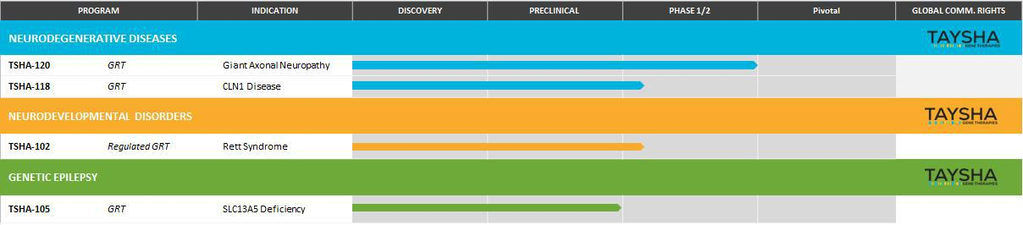

TSHA-102 for Rett Syndrome

TSHA-102 is a self-complementary intrathecally delivered AAV9 gene transfer therapy product candidate in clinical evaluation for Rett syndrome, a neurodevelopmental disorder and one of the most common genetic causes of severe intellectual disability, characterized by rapid developmental regression and in many cases caused by heterozygous loss of function mutations in MECP2, a gene essential for neuronal and synaptic function in the brain. TSHA-102 has been designed to prevent gene overexpression-related toxicity by inserting microRNA, or miRNA target binding sites into the 3’ untranslated region of viral genomes. This overexpression of MECP2 is seen clinically in patients with a condition known as MECP2 duplication syndrome, where elevated levels of MECP2 result in a clinical phenotype similar to Rett syndrome both in terms of symptoms and severity. TSHA-102 is constructed from a neuronal specific promoter, MeP426, coupled with the miniMECP2 transgene, a truncated version of MECP2, and miRNA-Responsive Auto-Regulatory Element, or miRARE, our novel miRNA target panel, packaged in self-complementary AAV9, which enables cellular regulation of both endogenous and exogenous MECP2 expression. According to the Rett Syndrome Research Trust, Rett syndrome affects more than 350,000 patients worldwide. The estimated addressable patient population with typical Rett syndrome caused by a pathogenic/likely pathogenic MECP2 mutation is between 15,000 and 20,000 patients in the United States, European Union and United Kingdom.

In May 2021, preclinical data for TSHA-102 were published online in Brain, a highly esteemed neurological science peer-reviewed journal. The preclinical study was conducted by the UT Southwestern Medical Center laboratory of Sarah Sinnett, Ph.D., and evaluated the safety and efficacy of regulated miniMECP2 gene transfer, TSHA-102 (AAV9/miniMECP2-miRARE), via IT administration in adolescent mice between four and five weeks of age. TSHA-102 was compared to unregulated full length MECP2 (AAV9/MECP2) and unregulated miniMECP2 (AAV9/miniMECP2).

26

TSHA-102 extended survival of KO (MECP2 -/y) mice by 56% via IT delivery. In contrast, the unregulated miniMECP2 gene transfer failed to significantly extend KO survival at all doses tested. Additionally, the unregulated full-length MECP2 construct did not demonstrate a significant extension in survival and was associated with an unacceptable toxicity profile in wild type mice.

In addition to survival, behavioral side effects were explored. Mice were subjected to phenotypic scoring and a battery of tests including gait, hindlimb clasping, tremor and others to comprise an aggregate behavioral score. miRARE attenuated miniMECP2-mediated aggravation in wild type aggregate phenotype severity scores. Mice were scored on an aggregate severity scale using an established protocol. AAV9/MECP2- and AAV9/miniMECP2-treated wild type mice had a significantly higher mean (worse) aggregate behavioral severity score versus that observed for saline-treated mice (p <0.05; at 6–30 and 7–27 weeks of age, respectively). TSHA-102-treated wild type mice had a significantly lower (better) mean aggregate severity score versus those of AAV9/MECP2- and AAV9/miniMECP2-treated mice at most timepoints from 11–19 and 9–20 weeks of age, respectively. No significant difference was observed between saline- and TSHA-102-treated wild type mice.

miRARE-mediated genotype-dependent gene regulation was demonstrated by analyzing tissue sections from wild type and KO mice treated with AAV9 vectors given intrathecally. When KO mice were injected with a vector expressing the mini-MECP2 transgene with and without the miRARE element, miRARE reduced overall miniMECP2 transgene expression compared to unregulated miniMECP2 in wild type mice as shown below.

The graph on the left depicts KO mice treated with regulated and unregulated vectors showed equivalent vector DNA biodistribution, confirming matched titers and injection accuracy (n = 3-8 mice per bar).

The graph on the right depicts miRARE significantly decreased transgene expression versus that conferred by the unregulated vector construct (n = 6-8 mice per bar; P < 0.05 for brain, cervical cord, or CC, thoracic cord, or TC, and lumbar cord, or LC).
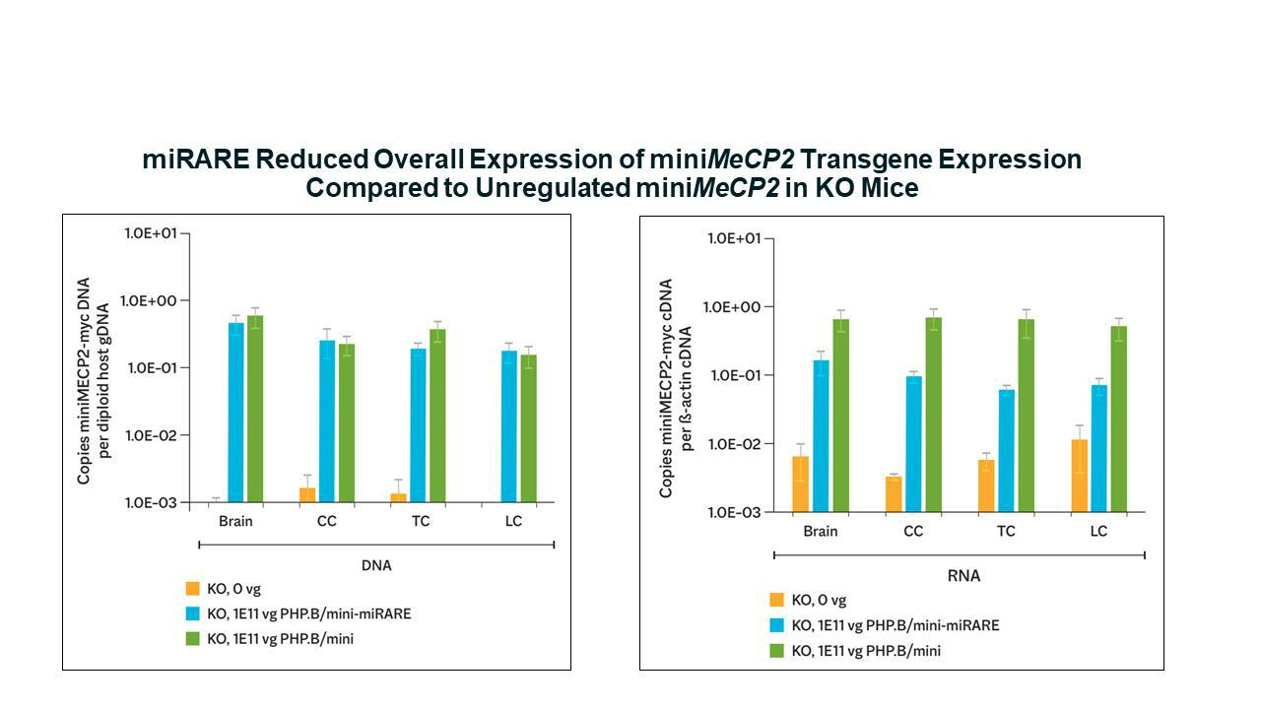

Source: Variant of Supplemental Fig 6B and C from Sinnett et al 2021

27

TSHA-102 demonstrated regulated expression in different regions of the brain. As shown in the graph and photos below, in the pons and midbrain, miRARE inhibited mean MECP2 gene expression in a genotype-dependent manner as indicated by significantly fewer myc(+) cells observed in wild type mice compared to KO mice (p<0.05), thereby demonstrating that TSHA-102 achieved MECP2 expression levels similar to normal physiological parameters.
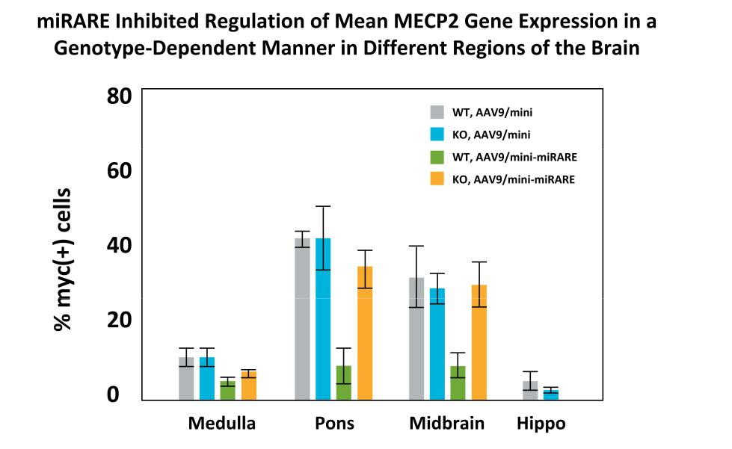

Source: Variant of Fig 6B from Sinnett SE, Boyle E, Lyons C, Gray SJ. Engineered microRNA-based regulatory element permits safe high-
dose miniMECP2 gene therapy in Rett mice. Brain. 2021; 144(10): 3005-3019
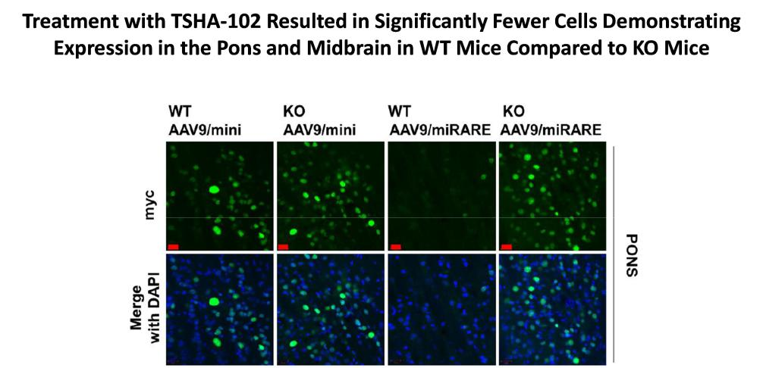

Source: Figure 6C from Sinnett SE, Boyle E, Lyons C, Gray SJ. Engineered microRNA-based regulatory element
permits safe high-dose miniMECP2 gene therapy in Rett mice. Brain. 2021; 144(10): 3005-3019.

In preclinical animal models, intrathecal myc-tagged TSHA-102 was not associated with early death and did not cause adverse behavioral side effects in wild type mice demonstrating appropriate downregulation of miniMECP2 protein expression as compared to unregulated MECP2 gene therapy constructs. In addition, preclinical data demonstrated that miRARE reduced overall

28

expression of miniMECP2 transgene expression and regulated genotype-dependent myc-tagged miniMECP2 expression across different brain regions on a cell-by-cell basis and improved the safety of TSHA-102 without compromising efficacy in juvenile mice. Pharmacologic activity of TSHA-102 following IT administration was assessed in the MECP2 KO mouse model of Rett syndrome across three dose levels and three age groups (n=252). A one-time IT injection of TSHA-102 significantly increased survival at all dose levels, with the mid to high doses improving survival across all age groups compared to vehicle-treated controls. Treatment with TSHA-102 significantly improved body weight, motor function and respiratory assessments in MECP2 KO mice. An additional study in neonatal mice (n=45) was completed and data showed prolonged survival. Finally, IND/CTA-enabling 6-month GLP toxicology studies examined the biodistribution, toxicological effects and mechanism of action of TSHA-102 when intrathecally administered to NHP and rats in three dose levels, up to 2.0x10¹⁵ vg/animal, which was well tolerated in both WT species. Biodistribution, as reflected by DNA copy number, was observed in multiple areas of the brain, sections of spinal cord and the DRG as shown below.

NHP Toxicology Study - Broad biodistribution to brain and spinal cord
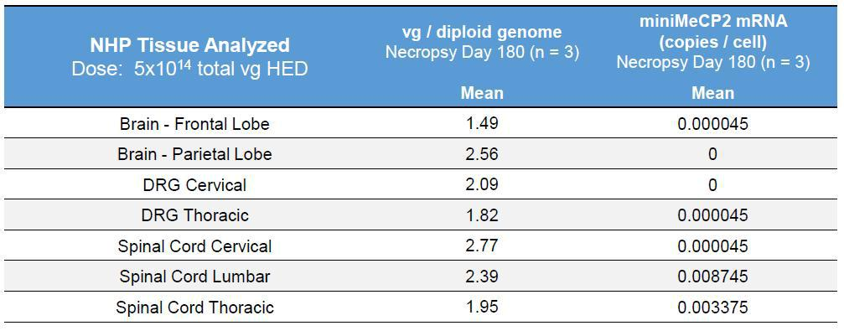

Source: Company data

Importantly, mRNA levels across multiple tissues were low, indicating miRARE regulation is minimizing transgene expression from the construct in the presence of endogenous MECP2 as expected, despite the high levels of DNA that were delivered. No toxicity from transgene overexpression was observed, confirmed by functional and histopathologic evaluations demonstrating no detrimental change in neurobehavioral assessments and no adverse tissue findings on necropsy.

In a neonatal KO Rett mouse efficacy study, treatment with TSHA-102 resulted in near normalization of survival as shown below. TSHA-102 at the dose of 8.8x10¹⁰ vg/mouse, which translates to the Human Equivalent Dose of 2.86x10¹⁴ vg/participant significantly improved survival when administered in Postnatal day mice by intracerebroventricular, or ICV, injection. While the longest-lived vehicle‐treated Mecp2^{‐/Y} male survived to 13.3 weeks only, 47% of the treated Mecp2^{‐/Y} males survived to 36 weeks of age, which was the conclusion of the study and all subjects were then sacrificed. The Bird Score, a composite measure of six different phenotypes, was significantly improved in TSHA‐102‐treated KO mice. TSHA‐102 significantly delayed the average age of onset for severe clasping from approximately 7 to 21 weeks and severely abnormal gait from approximately 8 to 20 weeks. TSHA‐102 treatment at 8.8x10¹⁰ vg/mouse extended survival significantly in neonatal Mecp2^{‐/Y} males, improved weight, improved their overall phenotypic score, and delayed the age of onset for severely abnormal limb clasping and gait.

29

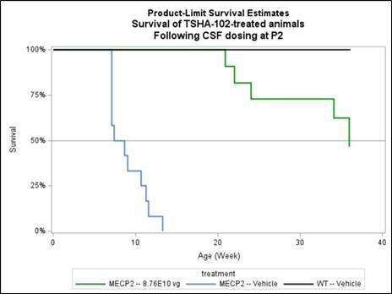

Source: Company data

In addition, neonatal KO Rett mice demonstrated normalization of behavior following treatment with TSHA-102 as assessed by the Bird Score, a composite measure of six different phenotypic abilities. KO animals were initially assessed at four weeks of age with a mean Bird Score of four. Over the course of the study, TSHA-102 improved the behaviors (as assessed by the Bird aggregate score) of TSHA-102 treated mice as shown below.
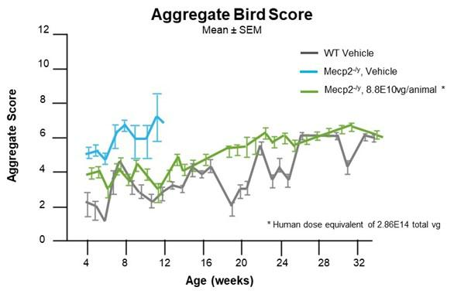

Source: Lyst MJ, Bird A. Rett syndrome: a complex disorder with simple roots. Nat Rev

Genet. 2015 May;16(5):261-75. doi: 10.1038/nrg3897. Epub 2015 Mar 3. PMID: 25732612

As shown in the table below, TSHA-102 demonstrated broad biodistribution to the brain and spinal cord with low mRNA in the tissue of NHPs. Vector genome copy numbers detected in the brain, spinal cord and DRG were appropriately above 1.0 vg/diploid genome. miniMECP2 mRNA measured in the brain, spinal cord and DRG were zero, indicating downregulation of miRNA copies.

30

In summary, we believe the totality of preclinical data generated to date, which includes the mouse pharmacology study to ascertain the minimally effective dose, two toxicology studies (wild type rat and wild type NHP), a mouse distribution and gene expression study, and the recent neonatal mouse data, represents the most robust package supporting clinical advancement of TSHA-102 in Rett syndrome as shown below.
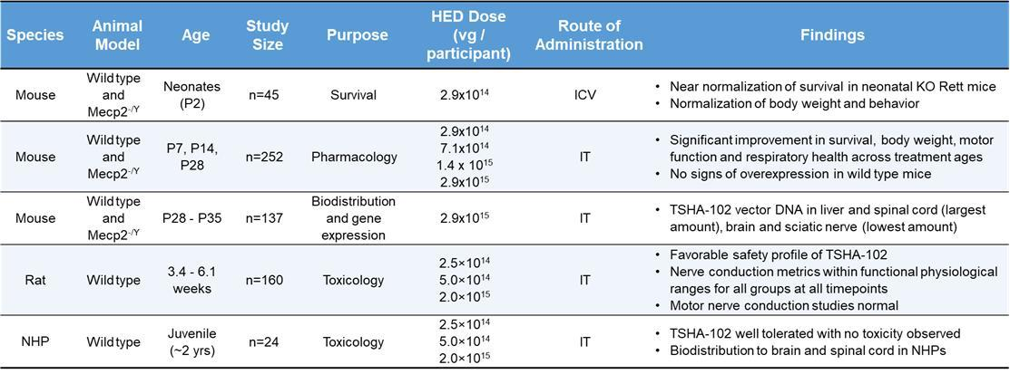

Safety and biodistribution assessments in NHPs were presented in May 2022 at the International Rett Syndrome Foundation (IRSF) meeting along with the caregiver perspective on Rett syndrome in adulthood. At the ASCEND National Summit, there was an oral presentation on “Putting Patients at the Center.” Finally, mouse pharmacology, rat and NHP toxicology data were presented at the 25th Annual Meeting of the American Society of Gene & Cell Therapy (ASGCT) and the European Society for Gene and Cell Therapy Congress (ESGCT).

To illustrate the full therapeutic potential of TSHA-102, additional data was generated, evaluating the efficacy in neonatal mice. TSHA-102 was assessed in a pharmacology study in neonatal KO (Mecp2^{-/Y}) mice. TSHA-102 was administered to postnatal Day 2 (P2) old mouse pups via intracerebroventricular (ICV) route. Efficacy parameters evaluated included body weight (BW), survival, and phenotypic scores (Bird score). TSHA-102 in P2 KO mice at a dose of 8.8x10¹⁰ vg/mouse [Human Equivalent Dose, (HED) 2.86x10¹⁴ vg/participant] significantly improved survival, BW, and behavior. The median survival for vehicle-treated KO mice was 8.1 weeks. While the longest-lived vehicle‐treated KO mouse survived to only 13.3 weeks, half (47%) of the TSHA-120 treated KO mice survived to 36 weeks of age, the age at which monitoring was ended. TSHA‐102 significantly improved BW in KO mice compared to vehicle treated KO mice. Bird score, a composite measure of six different phenotypes, was significantly improved in TSHA‐102‐ treated KO mice. TSHA‐102 significantly delayed the average age of onset for severe clasping from approximately 7 to 21 weeks and severely abnormal gait from approximately 8 to 20 weeks. Overall, TSHA‐102 treatment at 8.8x10¹⁰ vg/mouse significantly extended survival in neonatal KO (Mecp2^{‐/Y}) males, improved weight, improved their overall phenotypic score, and delayed the age of onset for severely abnormal limb clasping and gait.

Phase 1/2 REVEAL Clinical Trial

We submitted a CTA for TSHA-102 in November 2021 and announced initiation of clinical development under a CTA approved by Health Canada in March 2022. We are advancing TSHA-102 in the REVEAL Phase 1/2 clinical trial, which is an open-label, dose escalation and dose-expansion, randomized, multicenter study that will examine the safety and efficacy of TSHA-102 in up to 18 adult female patients with Rett syndrome. Participants will receive a single lumbar intrathecal injection of TSHA-102. Dose escalation will evaluate two dose levels of TSHA-102 sequentially. In cohort 1, the first patient was dosed with a dose of 5.7x10¹⁴ total vg, and the remaining patients in cohort 1 will receive the same dose, and the second cohort will be given a dose of 1x10¹⁵ total vg. The maximum tolerated dose or maximum administered dose established will then be administered during dose expansion. Key

31

assessments will include Rett-specific and global assessments, quality of life, biomarkers, and neurophysiology and imaging assessments as seen below.
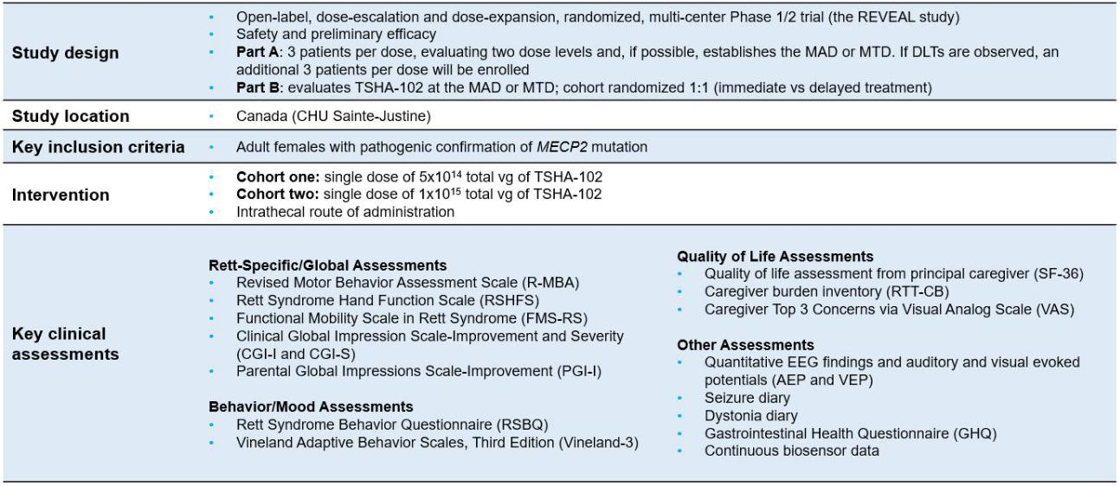

Sainte-Justine Mother and Child University Hospital Center in Montreal, Quebec, Canada has been selected as the initial clinical trial site under the direction of Dr. Elsa Rossignol, Assistant Professor Neuroscience and Pediatrics, and Principal Investigator. We dosed the first adult patient with Rett syndrome in the first half of 2023. The IDMC meeting to review the initial clinical data from the first patient took place in the early third quarter of 2023 at which time the IDMC provided clearance to dose the next patient. We plan on dosing the next patient in the third quarter of 2023, with continued dosing of adult patients in the second half of 2023. TSHA-102 demonstrated a well-tolerated safety profile with no treatment-emergent serious adverse events as of six weeks assessment post treatment. We submitted a CTA to the MHRA in pediatric patients with Rett syndrome and submitted an IND application in pediatric patients with Rett syndrome to the FDA for TSHA-102 early in the third quarter of 2023. In August 2023, we received clearance from the FDA on our IND for TSHA-102 in pediatric patients with Rett syndrome.

We have received orphan drug designation and rare pediatric disease designation from the FDA and orphan drug designation from the European Commission for TSHA-102 for the treatment of Rett syndrome.

TSHA-102 REVEAL Clinical Trial Safety and Efficacy Endpoints

Primary efficacy endpoints are patient assessments by clinicians using the Clinical Global Impressions Scale – Improvement, or CGI-I, Rett Syndrome Hand Function Scale, and Revised Motor Behavior Assessment, or R-MBA. Secondary endpoints include patient assessments by clinicians and caregivers using the Clinical Global Impressions Scale – Severity, or CGI-S, the Rett Syndrome Behavior Questionnaire, or RSBQ and other clinical assessment scales.

In the first adult patient dosed, TSHA-102 demonstrated a well-tolerated safety profile with no treatment-emergent serious adverse events as of the six-week assessment post-treatment. In addition, the Principal Investigator (PI) observed significant clinical improvement in multiple domains, including autonomic function (sleep and breathing), vocalization, as well as gross motor skills (gained ability to sit unassisted for three minutes for the first time in over a decade) and fine motor skills (gained ability to hold objects), supported by initial clinical data and video evidence.

32

In August 2023, we reported initial clinical observations from the first patient dosed in the REVEAL trial. The first patient dosed in the REVEAL trial demonstrated an improvement in key efficacy endpoints four weeks post-TSHA-102 administration as depicted in the graph below.
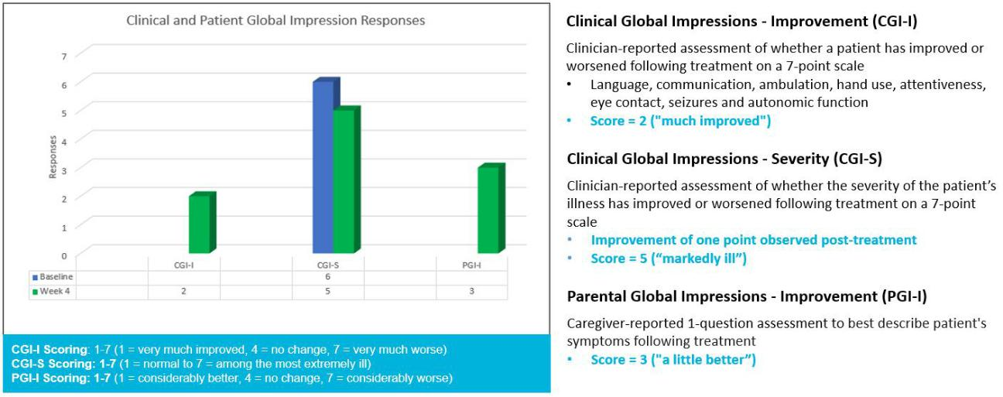

The patient demonstrated a significant clinical improvement in RSBQ Total Score four weeks post-TSHA-102 administration as depicted in the chart below.
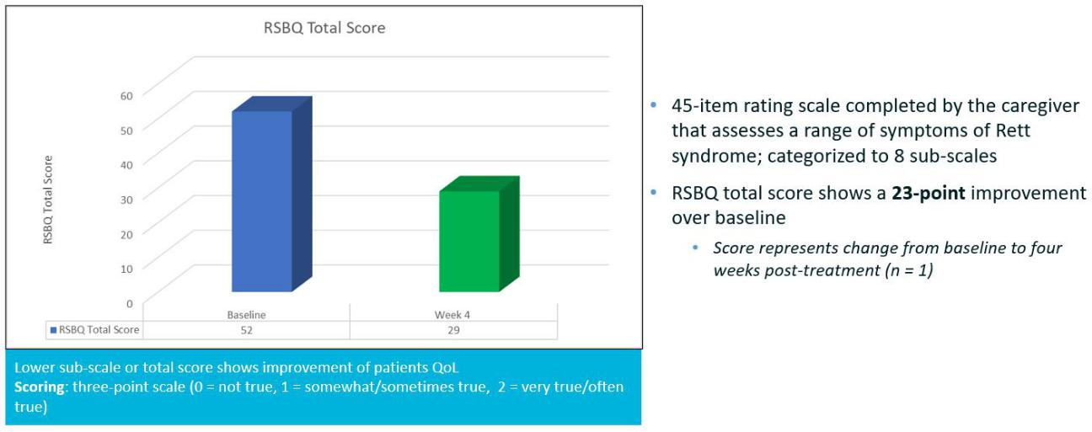

33

The patient demonstrated a significant clinical improvement in most of the RSBQ sub-scale domains assessed four weeks post-TSHA-102 administration as depicted in the graph below.
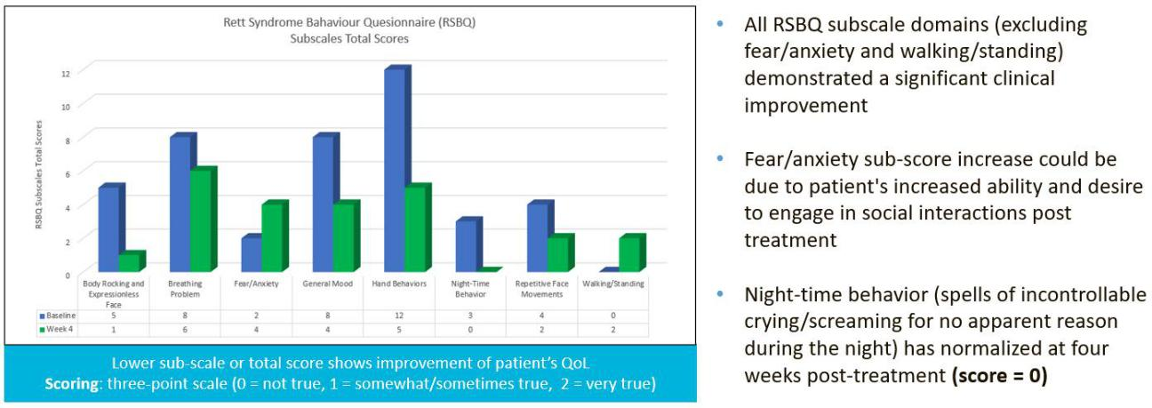

No marked changes were seen in the R-MBA data at four weeks post-TSHA-102 administration as depicted in the graph below.
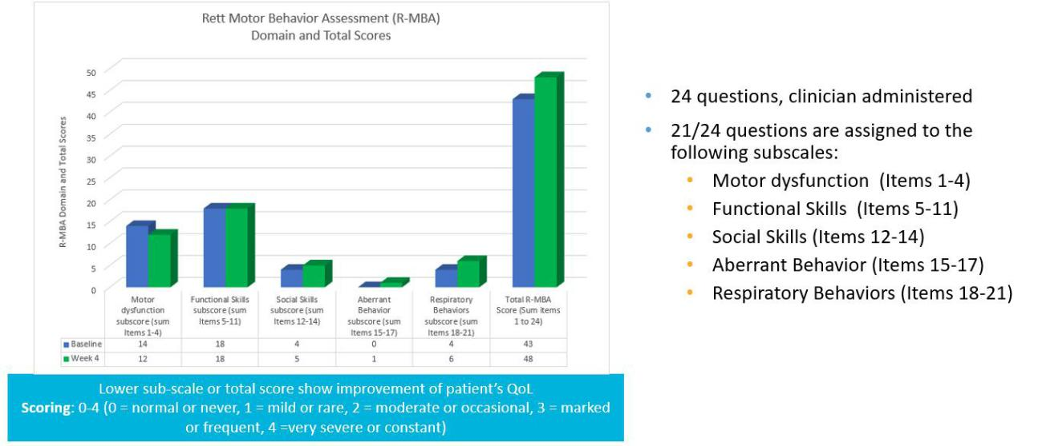

34

There were no quantifiable seizure events post-TSHA-102 administration through day 35 as depicted in the graph below.
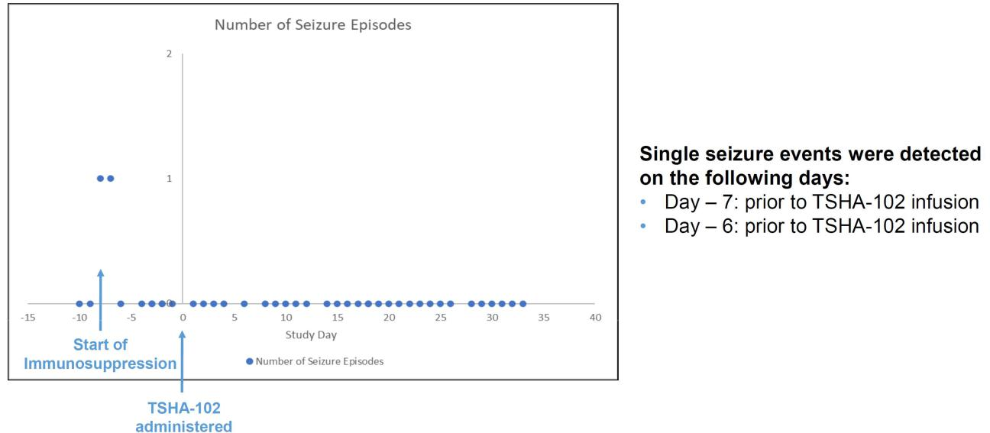

Seizure events on days 6 and 7 prior to TSHA-102 infusion are likely a result of the immunosuppression, impacting background anti-seizure medication levels. We plan to dose the next patient in the REVEAL trial in the third quarter. We will provide quarterly clinical updates on Rett patients.

TSHA-120 for Giant Axonal Neuropathy (GAN)

In March 2021, we acquired the exclusive worldwide rights to a clinical-stage, intrathecally dosed AAV9 gene therapy program, now known as TSHA-120, for the treatment of GAN, pursuant to a license agreement with Hannah’s Hope Fund for Giant Axonal Neuropathy, Inc., or HHF. Under the terms of the agreement, HHF received an upfront payment of $5.5 million and will be eligible to receive clinical, regulatory and commercial milestones totaling up to $19.3 million, as well as a low, single-digit royalty on net sales upon commercialization of TSHA-120.

GAN is an ultra-rare autosomal recessive, progressive neurodegenerative disease of the central, peripheral and autonomic nervous systems caused by deficiency or complete loss-of-function of gigaxonin and the accumulation of intermediate filaments. Epidemiology studies indicate there are between 1,000 and 1,500 treatable GAN patients in the United States, European Union and United Kingdom.

There is an early (classical) and late-onset (non-classical) phenotype associated with the disease, with shared pathophysiology due to accumulation of intermediate filaments. Symptoms and features of children with classical GAN usually develop before the age of five years with distal muscle weakness and sensory loss due to axonal sensory motor neuropathy, manifesting as bilateral foot drop and difficulties with fine motor coordination. An abnormal, wide based, unsteady gait due to CNS and cerebellar involvement is also a common initial clinical manifestation. Children with the classical phenotype typically have dull, tightly curled, coarse hair (“kinky” hair), “giant” axons pathognomonic on a nerve biopsy due to accumulation of intermediate filaments, and progressive spinal cord atrophy and white matter abnormalities, initially around the cerebellar dentate nucleus, on MRI images. Symptoms progress and, as the children grow older, they develop progressive proximal muscle weakness, resulting in difficulties raising their arms and standing from the floor or a chair, scoliosis, distal contractures, progressive gait and limb ataxia, leading to loss of ambulation by the second decade. Progressive optic nerve atrophy, seen early in the disease, results in increasing deterioration of visual acuity in later stages and has been more recently described. Indeed, decreased visual acuity was seen at baseline in approximately half of GAN patients aged 3-21 years, enrolled in a natural history study [Brain. 2021 Nov 29;144(10):3239-3250]. Due to increased respiratory muscle weakness and restrictive respiratory failure as a result of severe scoliosis, assisted ventilation is required in adolescents. GAN patients often die during their late teens or early twenties, typically due to respiratory failure.

35

The late-onset, or non-classical, phenotype is often categorized as Charcot-Marie-Tooth Type 2, or CMT2, as it presents as a typical early onset axonal sensory motor neuropathy without the typical kinky hair and CNS involvement of the classical phenotype and has a relatively slow progression. This phenotype might represent up to 6% of all CMT2 diagnosis. In the late-onset population, patients have poor quality of life and significantly compromised activities of daily living. The disease is life limiting but not as severely as classic GAN. In classic GAN, symptomatic treatments attempt to maximize physical development and minimize the rate of deterioration. Currently, there are no approved disease-modifying therapies available, only palliative treatments.

TSHA-120 is an AAV9 self-complementary viral vector with an engineered transgene encoding the full length human gigaxonin protein. The construct was invented by Dr. Steven Gray and is the first AAV9 gene therapy candidate to deliver a codon optimized, functional copy of the GAN gene with optimal tropism and rapid expression under the control of a JeT promoter that drives ubiquitous expression.
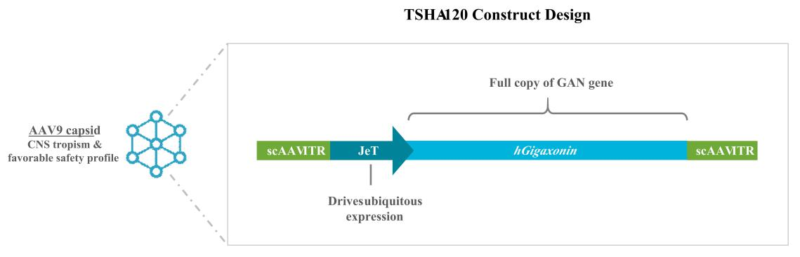

We have received orphan drug designation and rare pediatric disease designation from the FDA for TSHA-120 for the treatment of GAN. In April 2022, we received orphan drug designation from the European Commission for TSHA-120 for the treatment of GAN.

36

There is an ongoing longitudinal prospective natural history study being led by the NIH, that has already identified and followed a number of patients with GAN for over five years with disease progression characterized by a number of clinical assessments. This is a basket natural history study, where GAN was one of the rare diseases to be included. The baseline characteristics of the first 45 GAN patients, aged 3 to 21 years have been published. Imaging data from this study have demonstrated that there are distinctive increased T2 signal abnormalities within the cerebellar white matter surrounding the dentate nucleus of the cerebellum, which represent one of the earliest brain imaging findings in individuals with GAN. These findings precede the more widespread periventricular and deep white matter signal abnormalities associated with advanced disease. In addition, cortical and spinal cord atrophy appeared to correspond to more advanced disease severity and older age. Impaired pulmonary function in patients with GAN also was observed, with forced vital capacity correlating well with several functional outcomes such as the MFM32. Nocturnal hypoventilation and sleep apnea progressed over time, with sleep apnea worsening as ambulatory function deteriorated. Total MFM32 score also correlated with ambulatory status, where independently ambulant individuals performed better and had higher MFM32 scores than the non-ambulant group, as shown in the graph below.
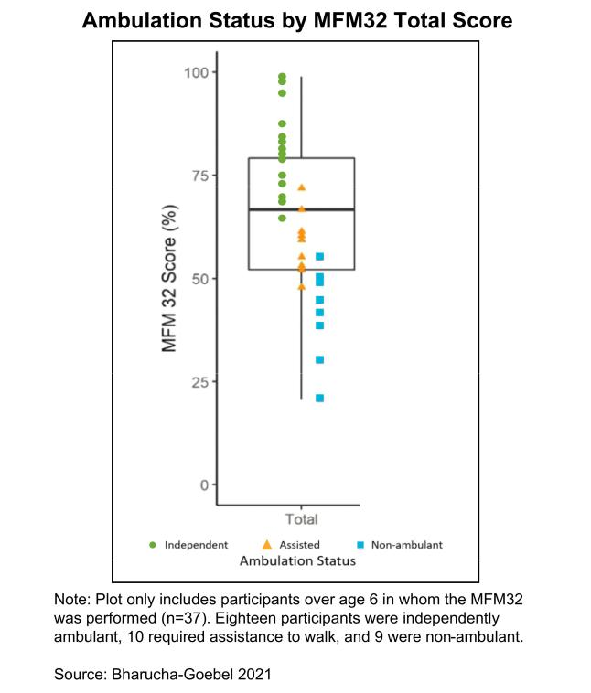

37

Patients also reported significant autonomic dysfunction based on the COMPASS 31 self-assessment questionnaire. In addition, nerve conduction function demonstrated progressive sensorimotor polyneuropathy with age. As would be expected for a neurodegenerative disease, younger patients have higher baseline MFM32 scores. Other composite scores evaluating neuropathy severity, Neuropathy Impairment Score, or NIS, and ataxia, Friedreich’s Ataxia Rating Scale, or FARS, showed a highly significant correlation with age in the classic GAN patients, as well as MFM32, with all three composite scores tracking well with ambulatory status. These three clinically relevant composite scores are therefore relevant markers of function for the classic GAN phenotype.

In preliminary data and analysis from longitudinal follow up, ten patients have had at least a second timepoint at different time intervals. The rate of decline in the MFM32 scores demonstrated some consistency across patients of all ages, with most demonstrating a calculated annualized average 8-point decline regardless of age and/or baseline MFM32 score, as shown in the natural history plot below.
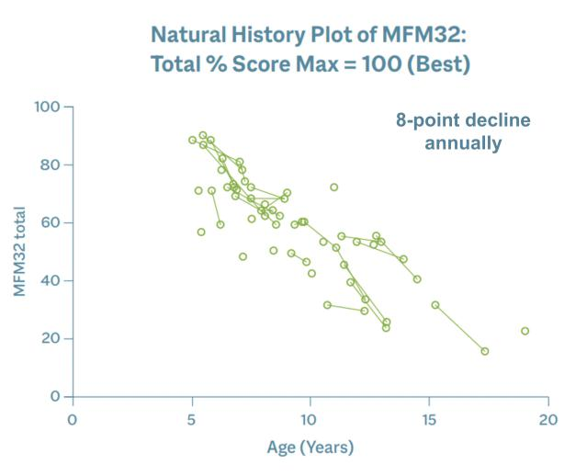

A 4-point score change in the MFM32 is considered clinically meaningful in other pediatric neuromuscular disorders, such as Spinal Muscular Atrophy, suggesting that patients with GAN lose significant function annually. To date, we have up to eight years of robust data from this study.

Preclinical Data

TSHA-120 performed well across in vitro and in vivo studies, and demonstrated improved motor function and nerve pathology, and long-term safety across several animal models. Of note, improved dorsal root ganglia, or DRG, pathology was demonstrated in TSHA-120-treated GAN knockout, or KO, mice. These preclinical results have been published in a number of peer-reviewed journals.

38

Additional preclinical data from a GAN KO rodent model that had received AAV9-mediated GAN gene therapy demonstrated that GAN rodents treated at 16 months performed significantly better than 18-month old untreated GAN rodents and equivalently to controls. These rodents were evaluated using a rotarod performance test which is designed to evaluate endurance, balance, grip strength and motor coordination in rodents. The time to fall off the rotarod, known as latency, was also evaluated and the data below demonstrated the clear difference in latency in treated versus untreated GAN rodents.
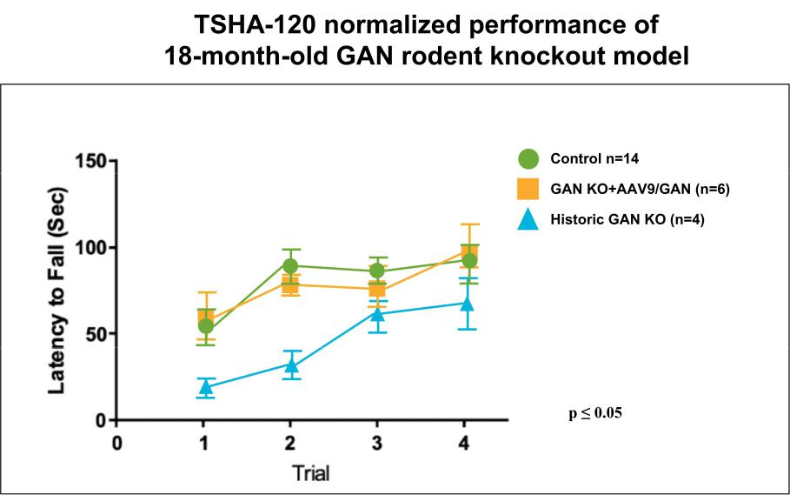

Source: Unpublished rotarod performance data of a rat model of GAN (homozygous A49E variant) from Dr Steven Gray

A result is considered statistically significant when the probability of the result occurring by random chance, rather than from the efficacy of the treatment, is sufficiently low. The conventional method for determining the statistical significance of a result is known as the “p-value,” which represents the probability that random chance caused the result (e.g., a p-value = 0.01 means that there is a 1% probability that the difference between the control group and the treatment group is purely due to random chance). Generally, a p-value less than 0.05 is considered statistically significant.

With respect to DRG inflammation, a topic of considerable interest within the gene therapy arena, the DRG have a significantly abnormal histological appearance and function as a consequence of underlying disease pathophysiology. Treatment with TSHA-120 resulted in considerable improvements in the pathological appearance of the DRG in the GAN KO mice. Shown below is tissue from a GAN KO mouse model with numerous abnormal neuronal inclusions containing aggregates of damaged neurofilament in the DRG as indicated by the yellow arrows. On image C, tissue from the GAN KO mice treated with an intrathecal, or IT, injection of TSHA-120 had a notable improvement in the reduction of these neuronal inclusions in the DRG.
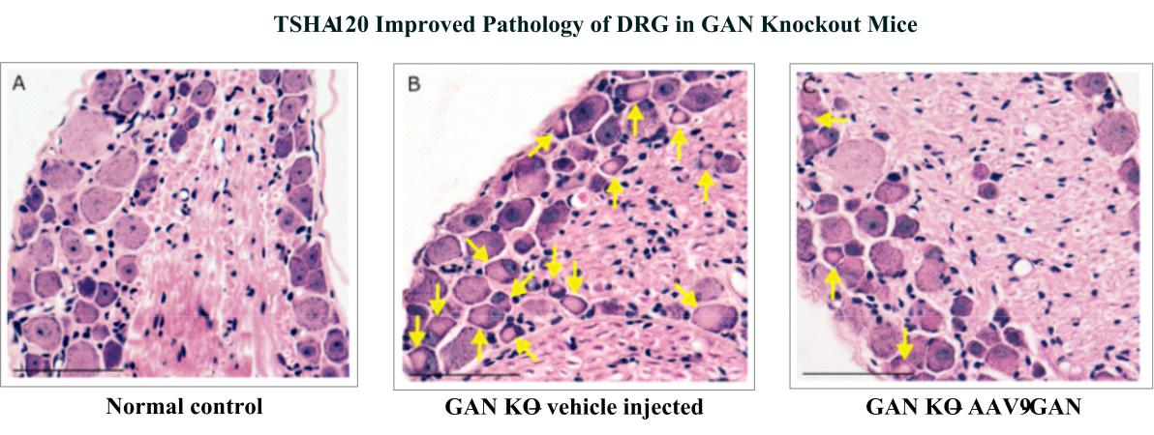

Source: Variant of Fig 6 A-C from Bailey RM, Armao D, Kalburgi SN, Gray SJ (2018) Development of Intrathecal Aav9 Gene Therapy for Giant Axonal Neuropathy. Molecular Therapy-Methods & Clinical Development 9160-171.

39

When a quantitative approach to reduce inclusions in the DRG was applied, it was observed that TSHA-120 treated mice experienced a statistically significant reduction in the average number of neuronal inclusions versus the GAN KO mice that received vehicle as illustrated below.
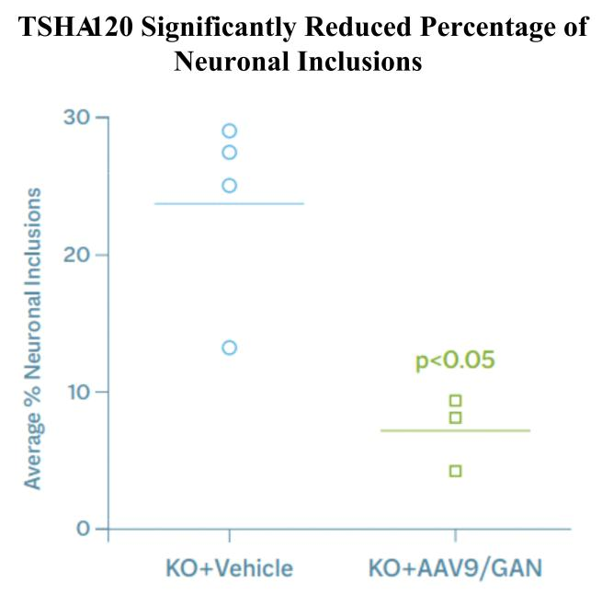

Source: Variant of Fig 6 D from Bailey RM, Armao D, Kalburgi SN, Gray SJ (2018) Development of Intrathecal Aav9 Gene Therapy for Giant Axonal Neuropathy. Molecular Therapy-Methods & Clinical Development 9160-171.

40

Additionally, TSHA-120 demonstrated improved pathology of the sciatic nerve in the GAN KO mice as shown below.
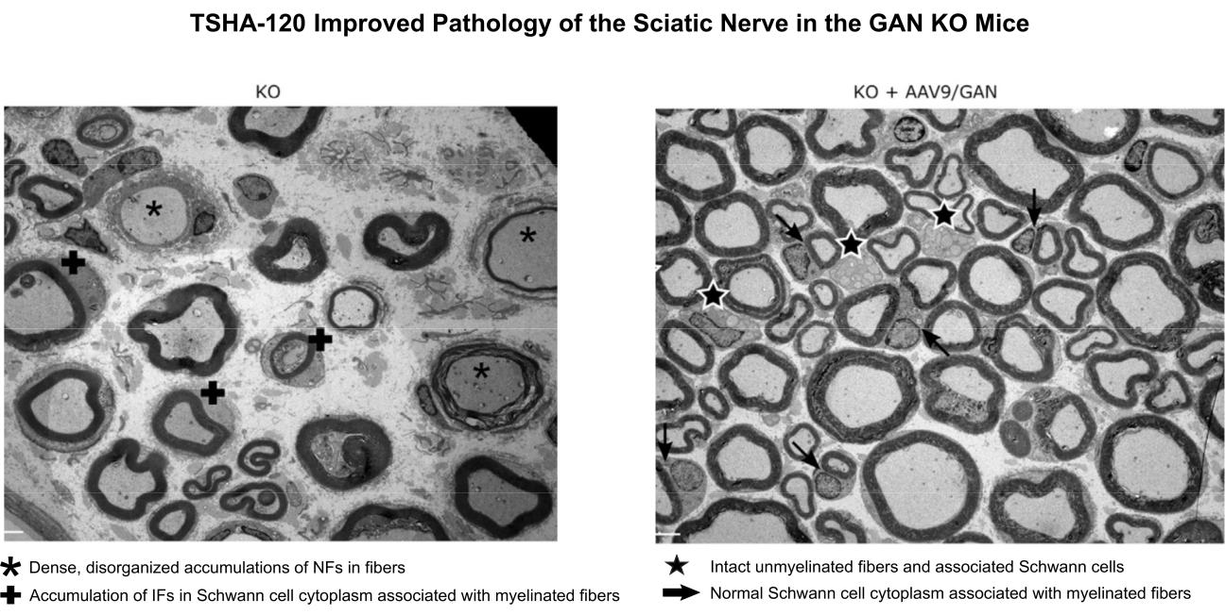

Source: variant of Fig 7 A and B from Bailey RM, Armao D, Kalburgi SN, Gray SJ (2018) Development of Intrathecal Aav9 Gene Therapy for Giant Axonal Neuropathy. Molecular Therapy-Methods & Clinical Development 9160-171.

Results of Ongoing Phase 1/2 Clinical Trial

A Phase 1/2 clinical trial of TSHA-120 is being conducted by the NIH under an accepted IND. The ongoing trial is a single-site, open-label, non-randomized, dose-escalation trial, in which patients are intrathecally dosed with one of four dose levels of TSHA-120 – 3.5x10¹³ total vg, 1.2x10¹⁴ total vg, 1.8x10¹⁴ total vg or 3.5x10¹⁴ total vg (by dot blot). The primary endpoint is to assess safety, with secondary endpoints measuring efficacy using pathologic, physiologic, functional, and clinical markers. To date, 14 patients have been intrathecally dosed and 12 patients have up to three years’ worth of long-term follow up data. The pre-treatment period interval between visits in these patients ranged from 3.7 to 31.5 months, with patients having at least two visits before being treated. A calculated yearly natural history decline was based on this data and served as a comparison for all post-treatment analysis.

At 1-year post-gene transfer, a clinically meaningful and statistically significant slowing or halting of disease progression was seen with TSHA-120 at the highest dose of 3.5x10¹⁴ total vg (n=3). The change in the rate of decline in the MFM32 score improved by 5 points in the 3.5x10¹⁴ total vg cohort compared to an 8-point decline in natural history.

The primary Bayesian efficacy analysis for MFM32 was conducted in the per protocol population, by dose group, at Year 1 post-dosing interval. Hierarchical models for repeated measures were used to estimate posterior distributions for change in slope of the total MFM32 percent score compared to pre-treatment decline in trial participants. Frequentist analysis of change from baseline in total MFM32 percent score was also performed, by dose group, using linear mixed models.

41

The change in the rate of decline in the MFM32 score of all therapeutic doses combined (n=12) showed the change in the rate of decline in the MFM32 score slowed by 5.20% points (p=0.0022), compared with the annualized pre-gene transfer rate of decline of 7.73% points.
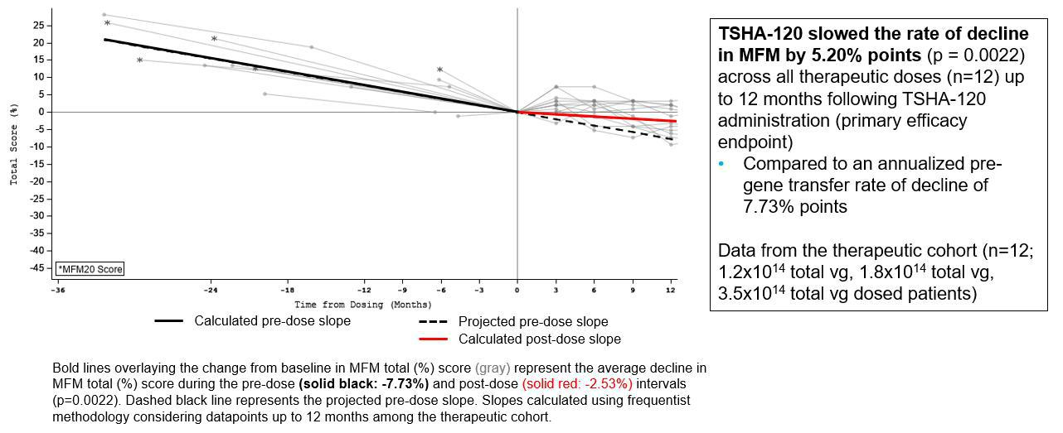

Source: Preliminary analysis with a data cut as of July 2022

A Bayesian analysis was conducted on the 1.2x10¹⁴ total vg, 1.8x10¹⁴ total vg and 3.5x10¹⁴ total vg dose cohorts at Year 1 to assess the probability of clinically meaningful slowing of disease progression as compared to natural history. This type of statistical analysis enables direct probability statements to be made and is both useful and accepted by regulatory agencies in interventional studies of rare diseases and small patient populations. As shown in the table below, for all therapeutic dose cohorts, there was nearly 100% probability of any slowing of disease and a 79.4% probability of clinically meaningful slowing of 50% or more following treatment with TSHA-120 compared to natural history data.
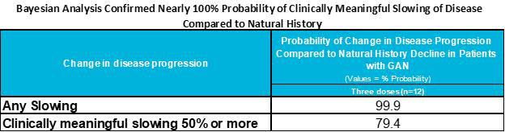

Source: Variant of Table 12 from Appendix 3 of the Type B End-of-Phase 2 Meeting package submitted to the FDA in Oct-2022 and held Dec2022.

42

There remained consistent improvement in TSHA-120’s effect over time on the mean change from baseline in the MFM32 score for patients in the therapeutic dose cohorts compared to their estimated decline over the years in the pre-treatment period. Analysis of long-term MFM total (%) scores showed slowing of disease progression by 2.49% (p=0.0065) points on the MFM% total score, as seen in the chart below.
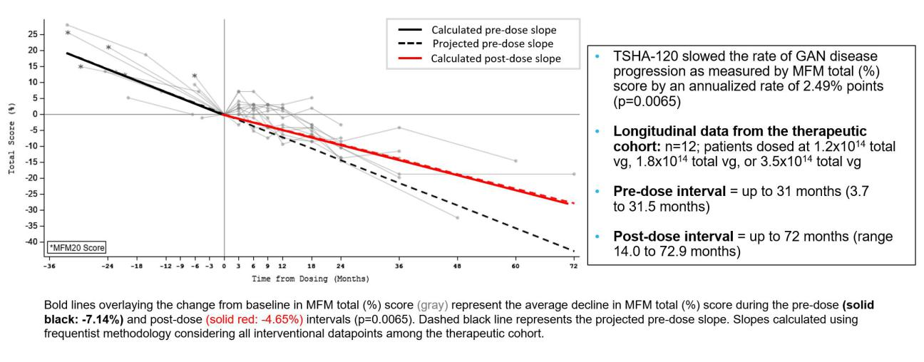

Source: Preliminary analysis with a data cut as of July 2022

New Comprehensive Data Analysis

Data transfer from NIH has been completed. Since the Type B end-of-Phase 2 meeting with the FDA, we have performed an extensive analysis of the totality of data available from both the natural history and interventional study data to address the FDA’s feedback on the heterogeneity of disease progression in GAN and the effort-dependent nature of MFM32 as a primary endpoint, considering the unblinded study design.

The analysis of the natural history study data showed that GAN is characterized by rapidly progressive, severe CNS and peripheral nervous system, or PNS, degeneration, leading to weakness and early ataxia in all patients. This rapid and predictable progression significantly impacts GAN patients and their caregivers' quality of life (Bharucha-Goebel, Norato et al., 2021), as confirmed by the primary analysis of MFM32. We have developed a disease progression model, or DPM, and applied to cross-sectional and longitudinal data from all natural history classic GAN patients to quantitatively characterize disease progression, similar to other disease models in ultra-rare diseases (Garbade, Zielonka et al. 2021, Barrett, Nicholas et al. 2022). The DPM established classic GAN as a homogenous disease that follows a progressive, monotonic decline across a range of relevant CNS and PNS endpoints. As such, we believe this DPM provides a suitable methodology to utilize the natural history study patients as an external control for comparison to treated patients to evaluate the treatment effect of TSHA-120, consistent with the FDA draft guidance on externally controlled trials (Considerations for the Design and Conduct of Externally Controlled Trials for Drug and Biologic Products, 2023; (Food and Drug Administration, 2023)).

This flexible model does not assume linearity and accounts for changes in rate of decline as patients age, which provides greater utility in a progressive disease like GAN that has observed floor and ceiling effects in many endpoints. Use of the DPM also begins to address the FDA’s feedback regarding the possible effort-dependence of some clinical endpoints in the setting of an open-label, non-randomized, interventional study. When compared to the DPM’s predicted disease progression in untreated patients, the positive treatment response observed across multiple clinical performance and objective biological endpoints in GAN patients treated with TSHA-120, is highly unlikely to occur by chance.

Additional Endpoints

Many additional endpoints have been collected in this clinical trial pre-and post-treatment, and long-term follow up data is being collected. We have identified functional endpoints including MFM32, mFARS (ataxia scale) and LogMAR (visual acuity), electrophysiological endpoints including sensory nerve action potential, or SNAP, and compound muscle action potential, or CMAP, and biological endpoints including nerve fiber density in skin biopsies. When TSHA-120 treated individuals were compared against the expected rate of disease progression from the DPM, a favorable deviation in the trajectory of the disease course was observed across multiple endpoints. These analyses are supportive of the pre-specified Program Advisory and Oversight Committee analysis of

43

the primary and secondary endpoints. At the group level, when reviewed as aggregate data, the majority of measured efficacy endpoints show a drug effect with high probability of slowing disease progression.

With analysis against the DPM, the total estimated annualized rate of decline for MFM32 showed a treatment effect size of 7% with an 81% probability of disease slowing. The treatment effect was primarily observed in Domain 2, which captured axial and proximal motor function (13%; 95% CI
- -5% to 30%) and Domain 3, which captured distal motor function (28%; 95% CI = 7% to 47%) with 99% probability of positive treatment effect on slowing disease progression with an estimated treatment effect of 28%. As anticipated for a patient population with impaired baseline ambulatory, the estimated treatment effect among Domain 1 items assessing standing, transfers, and mobility independence, was minimal (-27%; 95% CI = -54% to -3%) and did not predict disease slowing with confidence (1%). Based on the duration of the disease, GAN patients are susceptible to irreversible muscle fibrosis of the lower-limbs and reinnervation would not be expected to restore motor function.

DPM Estimates of MFM32 Total and Domain Scores
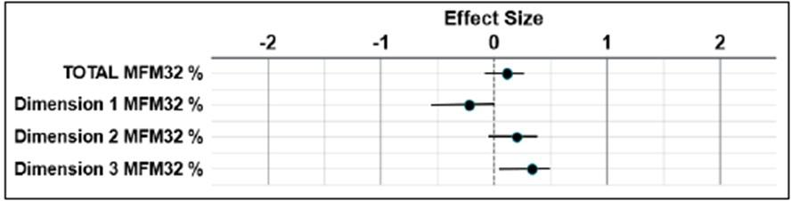

Source: Preliminary analysis with a data cut as of May 2023

Additional analyses utilizing FARS and mFARS demonstrated a meaningful treatment effect of TSHA-120, slowing the expected annualized worsening of ataxia. The mFARS scoring range runs from 0 to 93, with a higher score indicating greater impairment. The DPM estimated treatment effect sizes of 31% (mFARS; 95% CI = 7% to 52%) and 29% (FARS; 95% CI = 8% to 47%) with 99% probability of slowing the expected deterioration in ataxic motor function. These results translate approximately to an annualized relative -1.28 change in mFARS and -2.25 FARS scores.

Clinically, these data need to be interpreted in the context of important functions for patients. In particular, hand and arm function are crucial for activities of daily living for patients; thus, any slowing of decline in hand and arm function is directly and clinically relevant and is expected to improve GAN patients’ daily functioning (Johnson-Kerner, Roth et al. 2014, Bailey, Armao et al. 2018). We assessed the relationship between clinical outcome scores and real-world activities of daily living, or (ADL), utilizing the methodology described by Duong and colleagues in 2021 (Duong, Staunton et al. 2021). ADLs span 9 functional categories (speech, swallowing, cutting food and handling utensils, dressing, personal hygiene, falling, walking, quality of sitting position, and bladder function) and are scored on a 5-point Linkert scale, with higher scores indicating greater caregiver dependency. Most participants having already suffered substantial decline or complete loss of mobility by the time they were treated during the interventional study. The smallest functional impact was observed on activities related to ambulation (e.g., walking). Moderate to robust treatment effects were observed in ADL categories related to personal independence and self-care, including self-feeding, completing personal hygiene tasks (i.e., brushing hair and teeth), visual and physical interaction with technology, interpersonal communication, and engagement with the environment in many other ways. These activities are vital to patients’ independence and to reducing caregiver burden and are particularly dependent upon maintaining use of the upper limbs.

44

DPM Estimates of Activities of Daily Living
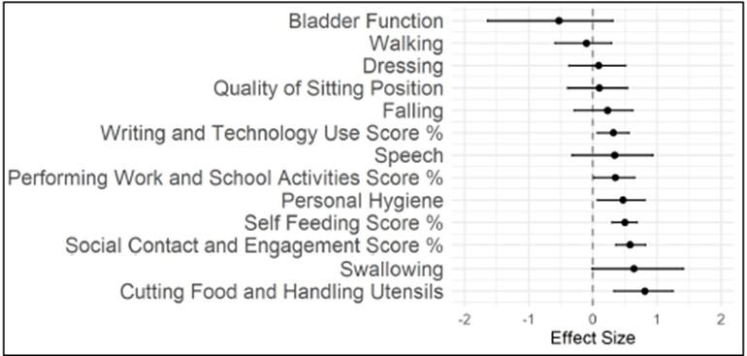

Source: Preliminary analysis with a data cut as of May 2023. ADLs reported or determined from MFM32 and FARS assessments. Treatment effect

size: 0 = natural history course of disease, 1 = arrest of disease, >1 = absolute improvement of disease. Negative values indicate acceleration vs predicted natural history disease course.

GAN patients experience a progressive decrease in visual acuity and a corresponding increase in the visual acuity of participants, measured by the LogMAR score, during the course of disease. In the GAN natural history study, the LogMAR ranged from 0.0 to 1.2 (mean ± SD: 0.4 ± 0.3) (Zein, Bharucha-Goebel et al. 2016). In the interventional study, patients experienced a decline in visual acuity during the pre-treatment interval of up to 36 months, consistent with an expected natural history decline. With treatment, the DPM estimated treatment effect sizes of 51% (left eye; 95% CI = 33% to 68%) and 70% (right eye; 95% CI = 54% to 84%) and approximate 100% probability of positive treatment effect on slowing disease progression. These results translate to an approximate relative annualized change of -0.06 in the left eye and -0.09 in the right eye.

In addition to the extended analysis of clinical functional endpoints from both the natural history study and the interventional study, we further reviewed objective electrophysiological and biological endpoints. Analysis against the DPM estimated a 100% probability of seeing measurable improvement in nerve response with ulnar SNAP and median SNAP amplitude with an estimated treatment effect of 189% and 152%, respectively. Similarly, aberrant CMAP responses were recorded at baseline, indicating widespread motor unit junction dysfunction among GAN patients, with analysis against the DPM estimating a 94% probability of seeing measurable improvement in the ulnar nerve CMAP amplitude with an estimated treatment effect of 29%.

Four out of the five patients that had stabilization or recovery in SNAPs had increased regenerative clusters on nerve biopsy. An increase in regenerative clusters score is associated with both new nerve fiber injury or a regenerative process, and typical evaluation of regenerative clusters relies on three consecutive measurements (electrophysiology and biopsy). Considering the restoration of SNAP activity that is dependent of axonal integrity in multiple treated patients, reasonable confidence in favor of the interpretation of an active axonal regenerative response to nerve fiber injury can be made. Skin biopsy specimens from the proximal thigh and distal leg collected from interventional study participants at baseline and the contralateral site one-year post-gene transfer were subject to histological examination. Five patients saw stabilization or increases in nerve fiber density of the skin in at least one location of the proximal or distal leg at month 12, including three out of the three high-dose patients and one medium-high dose patient. The examination of epidermal nerve fibers revealed objective evidence that rescue following gene transfer occurred in a dose dependent manner, and these results therefore suggested a specific relationship with TSHA-120 administration.

Results indicated that treatment with TSHA-120 lead to improvements in electrophysiological responses and regeneration of nervous tissue – findings that do not occur in the natural history of GAN. The combination of peripheral nerve improvement allows for preserved hand strength and function, as seen in mFARS, MFM32 Domain 3, and ADL scores. The findings for arm function are crucial to preserving daily functioning for GAN patients, especially since lower limb function is often lost early in the course of disease (Bharucha-Goebel, Norato et al. 2021). We believe the evidence from these non-effort dependent functional and biological data supported the improvements observed in clinician reported outcomes, including the mFARS and MFM32.

45

Treatment effects observed in categories related to personal independence and self-care, particularly activities involving the use of the upper limbs.
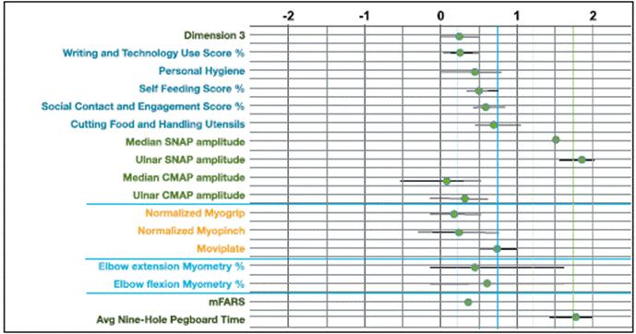

Source: Preliminary analysis with a data cut as of May 2023

Following treatment of TSHA-120, broad drug-effects have been observed in GAN patients, with notable stabilizations apparent across ADLs, functional clinician-reported and performance outcomes, electrophysiological outcomes and in objective biological data. Individually and collectively, TSHA-120 has shown a trend towards efficacy across multiple functional domains and is able to slow the rate of disease progression in ways that are very meaningful for GAN patients. Taken together, we believe these data provide a robust data set from which we can reasonably ascertain the broad efficacy of TSHA-120 in GAN patients. We have submitted a request for a formal meeting with the FDA and anticipate a meeting in the third quarter of 2023 to discuss this new data analysis and inform us on the next steps in the regulatory pathway on GAN.

Safety and Tolerability

TSHA-120 has been well-tolerated at multiple doses with no signs of significant acute or subacute inflammation, no sudden sensory changes and no drug-related or persisting transaminitis. Adverse events related to immunosuppression or study procedures were similar to what has been seen with other gene therapies and transient in nature. There was no increase in incidence of adverse events with increased dose. Importantly, TSHA-120 was safely dosed in the presence of neutralizing antibodies as a result of the combination of route of administration, dosing and immunosuppression regimen.

46

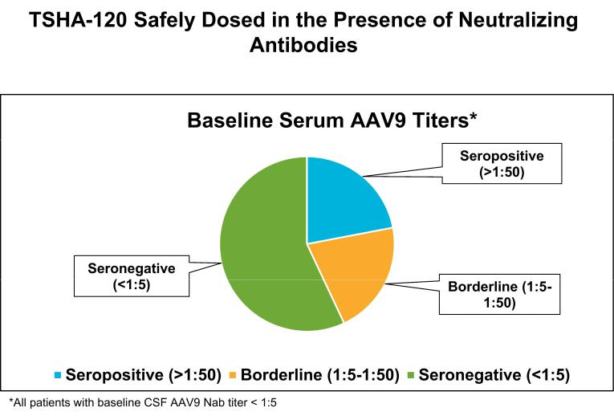

Source: NIH

We currently have over seven years of longitudinal data in individual patients with GAN from our ongoing clinical study. Treatment with TSHA-120 was well-tolerated with no significant safety issues. There was no apparent increase in incidence of adverse events with increased dose, no dose-limiting toxicity, no signs of acute or subacute inflammation, no sudden sensory changes and no drug-related or persistent elevation of transaminases. Adverse events related to immunosuppression or study procedures were similar to what was seen with other gene therapies and transient in nature. The most common non-serious adverse events considered possibly or probably related to TSHA-120 included cerebrospinal fluid, or CSF, pleocytosis, leukocytosis, CSF Ig increased, thrombocytosis, headache, and cardiac disorders (electrocardiogram abnormalities). All serious adverse events were assessed as unlikely or unrelated to TSHA-120 except for one serious adverse event of pyrexia considered possibly related to TSHA-120 occurring in a participant treated at the high-dose.

While safety surveillance is ongoing, most events reported to date began within three months of dosing and based on the pattern of occurrence of overall number and percentage of Treatment-Emergent Adverse Events, or TEAEs, assessed as at least possibly related to TSHA-120, there did not appear to be an increase of events with increasing dose of TSHA-120.

Related Treatment-Emergent Adverse Events Reporting Rate Per Patient, Per Interval by Dose – Up to Year 3
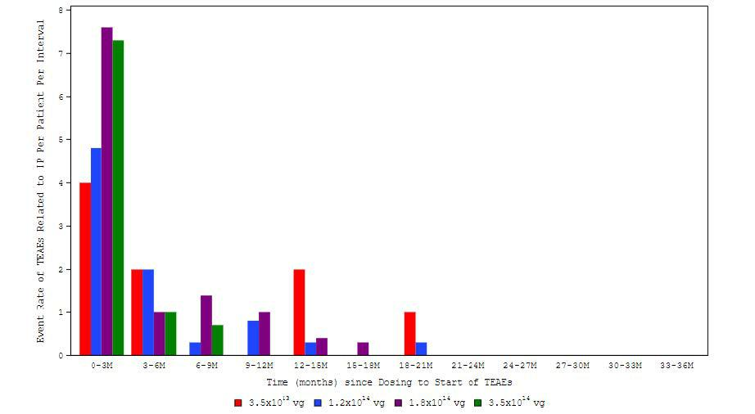

M = Month; TEAE = treatment emergent adverse event
Source: Preliminary analysis with a data cut as of May 2023.

47

In order to deliver a robust CMC data package to support licensure discussions, we have successfully completed six development and GMP lots of TSHA-120 with our contract development and manufacturing organization, or CDMO, partner. We have also completed a comprehensive side-by-side biochemical and biophysical analysis of current and previous clinical lots. Our CDMO utilizes the same Pro10TM manufacturing platform used to produce the original GAN lots, which is intended to reduce comparability risk. Five development lots ranging from 2L to 250L scale and one full-scale 500L GMP lot were analyzed side-by-side with the current TSHA-120 clinical lot using a comprehensive analytical panel that is expected to meet current regulatory requirements including assays for critical attributes such as product and process residuals, empty/full ratio, genetic integrity, potency and strength.

The TSHA-120 pivotal lot, which yielded over 50 patient doses of TSHA-120 at the highest dose cohort of 1.0x1014 vg by ddPCR, was released in November 2022. This material positions us for future BLA-enabling activities and commercial production. These lots were also placed on stability to provide critical shelf-life data.

In September 2021, we submitted a request for a Scientific Advice meeting for TSHA-120 to the MHRA and were granted a meeting in January 2022. The MHRA agreed on our commercial manufacturing and release assay testing strategy including potency assays. Finally, the MHRA was supportive of our proposal to perform validation work on MFM32 for GAN as a key clinical endpoint and for us to explore the MFM32 items with patients and families as part of this process. In September 2022, we submitted a meeting request to the FDA and were granted a Type B end-of-Phase 2 meeting via teleconference on December 13, 2022. In January 2023, we reported feedback from the Type B end-of-Phase 2 meeting with the FDA following receipt of the formal meeting minutes. The FDA provided additional clarity for TSHA-120 where MFM32 was acknowledged as an acceptable endpoint with a recommendation to dose additional patients in a double-blind, placebo-controlled design to support a BLA. The FDA acknowledged our overall approach to manufacturing of commercial material was deemed appropriate pending review of a planned CMC data package for TSHA-120. Subsequently, we submitted follow-up questions in response to the formal meeting minutes. The FDA clarified MFM32 as a relevant primary endpoint in the setting of a controlled trial and acknowledged our challenge in designing such study due to the ultra-rare nature of GAN. The FDA was open to acceptance of more uncertainty due to difficulty in enrolling a sufficient number of patients and regulatory flexibility in a controlled trial setting. In addition, the FDA indicated it was willing to consider alternative study designs utilizing objective measurements to demonstrate a relatively large treatment effect that is self-evident and clinically meaningful. The FDA acknowledged that the size of the safety database will be a review issue and acceptance of the existing safety data from treated patients will depend on demonstration of product comparability. We have completed the CMC module 3 amendment submission detailing drug comparability data and received feedback in the third quarter of 2023. The FDA concluded that analytical data is sufficient to support the comparability study (comparing early clinical and pivotal lots) and pivotal lot release for use in planned clinical studies.

Other Programs

We have at this time deprioritized the evaluation of our preclinical product candidates TSHA-105 for SLC13A5, TSHA-118 for CLN1 and TSHA-121 for CLN7. Although we are not currently evaluating the potential of TSHA-105, TSHA-118 and TSHA-121, we may again evaluate any of these in the future as a product candidate as a component of our pipeline expansion plans, or pursue partnerships to advance these programs.

TSHA-118 for CLN1 Disease

CLN1 disease (one of the forms of Batten disease), a lysosomal storage disorder, is a progressive, fatal neurodegenerative disease with early childhood onset that has an estimated incidence of approximately 1 in 138,000 live births worldwide. The estimated prevalence of CLN1 disease is 1,000 patients in the United States and European Union. CLN1 disease is caused by loss-of-function mutations in the CLN1 gene that encodes the enzyme palmitoyl-protein thioesterase-1, a small glycoprotein involved in the degradation of certain lipid-modified proteins. Loss of function mutations in the CLN1 gene causes accumulation of these lipid-modified proteins in cells, eventually leading to aggregation, neuronal cellular dysfunction and ultimately neuronal cell death.

In the infantile-onset form of CLN1 disease, clinical symptoms appear between six to 24 months and include rapid deterioration of speech and motor function, refractory epilepsy, ataxia and visual failure. Infantile-onset CLN1 patients are typically poorly responsive by five years of age and remain noncommunicative until their death, which usually occurs by seven years of age. Late-infantile-onset CLN1 disease begins between two to four years of age with initial visual and cognitive decline followed by the development of ataxia and myoclonus, or quick, involuntary muscle jerks. Juvenile-onset CLN1 disease patients present between the ages of five to ten years old, with vision loss as a first symptom followed by cognitive decline, seizures and motor decline. Approximately 60% of the children diagnosed with CLN1 disease in the United States present with early-onset infantile forms, with the remaining 40% experiencing later-onset childhood forms.

48

All currently available therapeutic approaches for patients with CLN1 disease are targeted towards the treatment of symptoms, and no disease-modifying therapies have been approved. Gene therapy has shown promise in correcting forms of neuronal ceroid lipofuscinoses diseases that involve mutations in soluble enzymes, in part, due to cross-correction of neighboring non-transduced cells.

We believe that the introduction of a functional CLN1 gene using an AAV9 vector delivered intrathecally to the CNS offers the potential of a disease-modifying therapeutic approach for this disease. TSHA-118 is a self-complementary AAV9 viral vector that expresses human codon-optimized CLN1 complementary deoxyribonucleic acid under control of the chicken ß-actin hybrid promoter. We acquired exclusive worldwide rights to certain intellectual property rights and know-how relating to the research, development and manufacture of TSHA-118 (formerly ABO-202) in August 2020 pursuant to a license agreement with Abeona Therapeutics Inc., or Abeona.

TSHA-118 has been granted orphan drug designation, rare pediatric disease designation and fast track designation from the FDA and orphan drug designation from the European Medicines Agency for the treatment of CLN1 disease.

There is currently an open IND for the CLN1 program. We submitted a CTA filing for TSHA-118 which was approved by Health Canada in 2021. Clinical trial material has been manufactured and released and is now ready for use in a clinical trial setting.

TSHA-105 for SLC13A5 Deficiency

We are developing TSHA-105 for the treatment of SLC13A5 deficiency, a rare autosomal recessive epileptic encephalopathy characterized by the onset of seizures within the first few days of life. SLC13A5 deficiency is caused by bi-allelic loss-of function mutations in the SLC13A5 gene, which codes for a sodium dependent citrate transporter, or NaCT, that is largely expressed in the brain and liver. To date, all tested mutations result in no or a greatly reduced amount of the citrate in the cells. Diminished NaCT function leads to loss of neuronal uptake of citrate and other metabolites such as succinate that are critical to brain energy metabolism and function. Affected children have impairments in gross motor function and speech production with relative preservation of fine motor skills and receptive speech. Currently, there are no approved therapies for SLC13A5 deficiency, and treatment is largely to address symptoms. The estimated prevalence of SLC13A5 deficiency is 1,900 patients in the United States and European Union.

We are developing TSHA-105 as a gene replacement therapy for SLC13A5 deficiency. TSHA-105 is constructed from a codon-optimized human SLC13A5 gene packaged in a self-complementary AAV9 capsid.

We have received orphan drug designation and rare pediatric disease designation from the FDA and orphan drug designation from the European Commission for TSHA-105 for the treatment of epilepsy caused by SLC13A5 deficiency. Clinical trial material has been manufactured and released and is now ready for use in a clinical trial setting.

TSHA-113 for Tauopathies

We are developing TSHA-113 for the treatment of tauopathies. Tauopathies comprise a large subset of neurodegenerative diseases involving the aggregation of microtubule associated protein tau, or MAPT, protein into neurofibrillary or gliofibrillary tangles in the human brain. These include MAPT-associated frontotemporal dementia, or FTD, progressive supranuclear palsy, or PSP, corticobasal degeneration, or CD, and Alzheimer’s disease. There are an estimated 11,000 patients in United States and Europe affected by MAPT mediated FTD and 2,000 to 2,500 are affected with MAPT-mediated PSP. and CD, and Alzheimer’s disease affects an estimated 6.2 million Americans and 7.8 million Europeans.

Intrathecal delivery of an antisense oligonucleotide, or ASO, targeting Tau mRNA by Biogen/Ionis in a Phase 1 study demonstrated durable, robust, time and dose dependent lowering of tau protein and phospho-tau in cerebrospinal fluid of Alzheimer’s disease patients. Buoyed by these results, in August 2022, Biogen started a Phase 2 trial in people with mild cognitive impairment or mild dementia due to Alzheimer’s disease. This ASO target validation paved the way for other approaches targeting intercellular tau mRNA (reduce tau protein production), for treating Tauopathies.

Unlike an ASO treatment, which would require repeat lifelong administration, we are developing a one-time treatment for Tauopathies. TSHA-113 is an AAV9 capsid that packages a tau-specific miRNA and is delivered in the cerebrospinal fluid for the treatment of tauopathies. This miRNA targets all six isoforms of tau mRNA.

We tested the efficacy of TSHA-113 in PS19 mice, a validated mouse model for tauopathies. These mice express human MAPT, and they exhibit significant tau pathology, neurodegeneration, loss of body weight and progressive hind-limb paralysis around nine to 12 months of age. We tested efficacy of our treatment by delivering TSHA-113 to PS19 mice at three months, six months and nine months of age via intracisterna magna injection. We found that the tau mRNA and protein levels were significantly reduced by

49

TSHA-113 treatment. Consistently, the tau seeding assay showed reduced levels of pathological tau in brains from PS19 mice treated with TSHA-113. In addition, TSHA-113 treatment was able to rescue the survival rate, loss in body weight, and the hind limb clasping phenotype in the PS19 mice when treated at three months, six months and nine months of age. Taken together, these results demonstrate that a one-time, vectorized delivery of a tau-specific miRNA is a promising approach for treatment for tauopathies. Ongoing and future work is focused on optimal dose determination for IND-enabling studies.

TSHA-106 for Angelman syndrome

We are developing TSHA-106 for the treatment of Angelman syndrome, a neurodevelopmental disorder caused by a maternal deficiency of the UBE3A gene. Angelman syndrome is characterized by profound developmental delay, ataxia and gait disturbance, sleep disorder, seizures, heightened anxiety, aggression and severe speech impairments. Angelman syndrome affects approximately one per 12,000 to 20,000 patients worldwide.

Angelman syndrome is an imprinting disorder in which the maternal gene is deficient and the paternal copy of UBE3A is intact but silenced by a long non-coding RNA, UBE3A antisense transcript, or UBE3A-ATS. Delivery of an ASO targeting UBE3A-ATS showed promising results in ameliorating Angelman syndrome symptoms in a transgenic mouse model.

We have in-licensed a novel gene replacement therapy from University of North Carolina. This novel construct is designed to express two isoforms of UBE3A mRNA from the same codon optimized transgene cassette and could potentially be a one-time treatment for the disease. The unique design feature allows short and long hUBE3A isoforms expression at a near-endogenous 3:1 (short/long) ratio, a feature that could help to support optimal therapeutic outcomes. Additionally, this construct uses human Synapsin 1 promoter, to limit UBE3A expression primarily in neurons, the primary therapeutic target for treating Angelman syndrome.

In a published study, this dual isoform expressing cassette was packaged into PHP.B capsids and administered by intracerebroventricular injections in neonatal mice models. This treatment significantly improved motor learning and innate behaviors in Angelman syndrome mice (PMID: 34676830). It rendered Angelman syndrome mice resilient to epileptogenesis and associated hippocampal neuropathologies induced by seizure kindling. These results demonstrated the feasibility, tolerability, and therapeutic potential for dual-isoform hUBE3A gene transfer in the treatment of AS.

To advance these findings into translatable interventions, our collaborators packaged the dual isoform expressing cassette into AAV9 capsids and undertook animal proof of concept studies. Overall, these results are highly consistent with the published data describing neonatal ICV delivery of a similar dose of the PHP.B/hUBE3Aopt vector (PMID: 34676830) and support continued development. Ongoing and future work is focused on optimal dose and route of administration determination for IND enabling studies.

There are an estimated 55,000 patients with Angelman syndrome in the United States and Europe.

TSHA-114 for Fragile X Syndrome

We are developing TSHA-114 for the treatment of Fragile X syndrome, the most common single gene cause of autism and cognitive impairment, affecting about one in 6,000 individuals worldwide. Fragile X syndrome is diagnosed around three years of age and characterized by anxiety, aggression, hyperactivity, attention deficits and sleep and communication disruption.

Fragile X syndrome is caused by a pathological expansion of a CGG triplet repeat in the 5’ untranslated region of the FMR1 gene. Expansion of the triplet above the normal 5–55 repeats to 200 or more causes hypermethylation of the gene promoter, and shutdown of transcription and translation of the encoded protein, fragile X mental retardation protein, or FMRP. The expanded repeat also induces formation of RNA: DNA heteroduplexes that induces epigenetic gene silencing. Although most patients with Fragile X syndrome do not express FMRP, some individuals with the full mutation produce low amounts of the protein (less than 10% of normal levels). FMRP expression in unaffected persons varies greatly from person to person. Current pharmacotherapeutic treatments for Fragile X syndrome are solely directed towards symptom relief.

We conducted proof of concept studies in animal models of Fragile X (Fmr1 KO) with TSHA-114. No significant adverse effects were observed in behavioral, serological or pathohistological markers up to 12 months after intrathecal administration of TSHA-114 in wild-type mice. TSHA-114 treated FMRKO showed widespread FMRP expression was observed throughout brain post administration. TSHA-114 treated FMRKO mice showed robust suppression of audiogenic seizures and normalization of fear conditioning behavior. In addition, assessment of circadian locomotor activity revealed restoration of hyperactivity and sleep. Assessment of transgene expression and behavioral responses in individual mice demonstrated correlations between the level of FMRP expression and drug efficacy.

50

The results from the study strongly support continued development. Ongoing and future work is focused on optimal dose and route of administration determination for IND enabling studies.

There are an estimated 75,000 patients with Fragile X syndrome in the United States and Europe.

License Agreements

Research, Collaboration and License Agreement with The University of Texas Southwestern Medical Center

In November 2019, we entered into a research, collaboration and license agreement, or the UT Southwestern Agreement, with The Board of Regents of the University of Texas System on behalf of UT Southwestern, as amended in April 2020.

In connection with the UT Southwestern Agreement, we obtained an exclusive, worldwide, royalty-free license under certain patent rights of UT Southwestern and a non-exclusive, worldwide, royalty-free license under certain know-how of UT Southwestern, in each case to make, have made, use, sell, offer for sale and import licensed products for use in certain specified indications. Additionally, we obtained a non-exclusive, worldwide, royalty-free license under certain patents and know-how of UT Southwestern for use in all human uses, with a right of first refusal to obtain an exclusive license under certain of such patent rights and an option to negotiate an exclusive license under other of such patent rights. We are required to use commercially reasonable efforts to develop, obtain regulatory approval for, and commercialize at least one licensed product.

In connection with the UT Southwestern Agreement, we issued to UT Southwestern 2,179,000 shares of our common stock. We do not have any future milestone or royalty obligations to UT Southwestern under the UT Southwestern Agreement, other than costs related to the maintenance of patents.

The UT Southwestern Agreement expires on a country-by-country and licensed product-by-licensed product basis upon the expiration of the last valid claim of a licensed patent in such country for such licensed product. After the initial research term, we may terminate the agreement, on an indication-by-indication and licensed product-by-licensed product basis, at any time upon specified written notice to UT Southwestern. Either party may terminate the agreement upon an uncured material breach of the agreement or insolvency of the other party.

License Agreement with Abeona (CLN1 Disease)

In August 2020, we entered into a license agreement, or the Abeona CLN1 Agreement, with Abeona Therapeutics Inc., or Abeona. In connection with the Abeona CLN1 Agreement, we obtained an exclusive, worldwide, royalty-bearing license, with the right to grant sublicenses under certain patents, know-how and materials originally developed by the University of North Carolina at Chapel Hill and Abeona to research, develop, manufacture, have manufactured, use, and commercialize licensed products for gene therapy for the prevention, treatment, or diagnosis of CLN1 Disease (one of the forms of Batten disease) in humans.

In connection with the license grant, we paid Abeona a one-time upfront license fee of $3.0 million during fiscal year 2020. We are obligated to pay Abeona up to $26.0 million in regulatory-related milestones and up to $30.0 million in sales-related milestones per licensed product and high single-digit royalties on net sales of licensed products. Royalties are payable on a licensed product-by-licensed product and country-by-country basis until the latest of the expiration or revocation or complete rejection of the last licensed patent covering such licensed product in the country where the licensed product is sold, the loss of market exclusivity in such country where the product is sold, or, if no licensed product exists in such country and no market exclusivity exists in such country, ten years from first commercial sale of such licensed product in such country. In addition, concurrent with the Abeona CLN1 Agreement, we entered into a purchase and reimbursement agreement with Abeona, pursuant to which we purchased specified inventory from Abeona and reimbursed Abeona for certain research and development costs previously incurred for total consideration of $4.0 million paid in fiscal year 2020.

In December 2021 the Company’s CTA filing for TSHA-118 for the treatment of CLN1 disease was approved by Health Canada and therefore triggered a regulatory milestone payment in connection with the Abeona CLN1 Agreement. We recorded $3.0 million within research and development expenses in the consolidated statements of operations for the year ended December 31, 2021. The milestone fee was paid in January 2022 and has been classified as an investing outflow in the condensed consolidated statements of cash flows for the six months ended June 30, 2022. No additional milestone payments were made or triggered during the six months ended June 30, 2023.

51

The Abeona CLN1 Agreement expires on a country-by-country and licensed product-by-licensed product basis upon the expiration of the last royalty term of a licensed product. Either party may terminate the agreement upon an uncured material breach of the agreement or insolvency of the other party. We may terminate the agreement for convenience upon specified prior written notice to Abeona.

License Agreement with Abeona (Rett Syndrome)

In October 2020, we entered into a license agreement, or the Abeona Rett Agreement, with Abeona pursuant to which we obtained an exclusive, worldwide, royalty-bearing license, with the right to grant sublicenses under certain patents, know-how and materials originally developed by the University of North Carolina at Chapel Hill, the University of Edinburgh and Abeona to research, develop, manufacture, have manufactured, use, and commercialize licensed products for gene therapy and the use of related transgenes for Rett syndrome.

Subject to certain obligations of Abeona, we are required to use commercially reasonable efforts to develop at least one licensed product and commercialize at least one licensed product in the United States.

In connection with the Abeona Rett Agreement, we paid Abeona a one-time upfront license fee of $3.0 million during fiscal year 2020. We are obligated to pay Abeona up to $26.5 million in regulatory-related milestones and up to $30.0 million in sales-related milestones per licensed product and high single-digit royalties on net sales of licensed products. Royalties are payable on a licensed product-by-licensed product and country-by-country basis until the latest of the expiration or revocation or complete rejection of the last licensed patent covering such licensed product in the country where the licensed product is sold, the loss of market exclusivity in such country where the product is sold, or, if no licensed product exists in such country and no market exclusivity exists in such country, ten years from first commercial sale of such licensed product in such country.

In March 2022, our CTA filing for TSHA-102 for the treatment of Rett Syndrome was approved by Health Canada and therefore triggered a regulatory milestone payment in connection with the Rett Agreement. We recorded $1.0 million within research and development expenses in the condensed consolidated statements of operations for the six months ended June 30, 2022. This milestone fee was paid in July 2022. In May 2023, we dosed the first patient with TSHA-102 in the Phase 1/2 REVEAL trial evaluating the safety and preliminary efficacy of TSHA-102 in adult patients with Rett syndrome and therefore triggered a milestone payment in connection with this agreement. We recorded $3.5 million within research and development expenses in the condensed consolidated statements of operations for the six months ended June 30, 2023. This milestone fee was not paid as of June 30, 2023 and has been recorded in accrued expenses and other current liabilities in the condensed consolidated balance sheet as of June 30, 2023. No additional milestone payments were made or triggered in connection with this agreement during the six months ended June 30, 2023.

The Abeona Rett Agreement expires on a country-by-country and licensed product-by-licensed product basis upon the expiration of the last royalty term of a licensed product. Either party may terminate the agreement upon an uncured material breach of the agreement or insolvency of the other party. We may terminate the agreement for convenience.

Option Agreement with Astellas

On October 21, 2022, or the Effective Date, we entered into an Option Agreement, or the Option Agreement, with Audentes Therapeutics, Inc.

(d/b/a Astellas Gene Therapy), or Astellas.

TSHA-120 Giant Axonal Neuropathy

Under the Option Agreement, we granted to Astellas an exclusive option to obtain an exclusive, worldwide, royalty and milestone-bearing right and license (A) to research, develop, make, have made, use, sell, offer for sale, have sold, import, export and otherwise exploit, or, collectively, Exploit or the Exploitation, the product known, as of the Effective Date, as TSHA-120, or the 120 GAN Product, and any backup products with respect thereto for use in the treatment of GAN or any other gene therapy product for use in the treatment of GAN that is controlled by us or any of our affiliates or with respect to which we or any of our affiliates controls intellectual property rights covering the Exploitation thereof, or a GAN Product, and (B) under any intellectual property rights controlled by us or any of our affiliates with respect to such Exploitation, or the GAN Option. Subject to certain extensions, the GAN Option is exercisable from the Effective Date through a specified period of time following Astellas’ receipt of (i) the formal minutes from the Type B end-of-Phase 2 meeting between us and the FDA in response to our meeting request sent to the FDA on September 19, 2022 for the 120 GAN Product, (ii) all written feedback from the FDA with respect to the Type B end-of-Phase 2 Meeting, and (iii) all briefing documents sent by us to the FDA with respect to the Type B end-of-Phase 2 Meeting.

52

TSHA-102 Rett Syndrome

Under the Option Agreement, we also granted to Astellas an exclusive option to obtain an exclusive, worldwide, royalty and milestone- bearing right and license (A) to Exploit any Rett Product (as defined below), and (B) under any intellectual property rights controlled by us or any of our affiliates with respect to such Exploitation, or the Rett Option, and together with the GAN Option, each, an Option. Subject to certain extensions, the Rett Option is exercisable from the Effective Date through a specified period of time following Astellas’ receipt of (1) certain clinical data from the female pediatric trial and (2) certain specified data with respect to TSHA-102, or the Rett Option Period related to (i) the product known, as of the Effective Date, as TSHA-102 and any backup products with respect thereto for use in the treatment of Rett syndrome, and (ii) any other gene therapy product for use in the treatment of Rett syndrome that is controlled by us or any of our affiliates or with respect to which we or any of our affiliates controls intellectual property rights covering the Exploitation thereof, or a Rett Product.

The parties have agreed that, if Astellas exercises an Option, the parties will, for a specified period, negotiate a license agreement in good faith on the terms and conditions outlined in the Option Agreement, including payments by Astellas of a to-be-determined upfront payment, certain to-be-determined milestone payments, and certain to-be-determined royalties on net sales of GAN Products and/or Rett Products, as applicable.

Going Concern

Since inception, we have incurred operating losses and expect to continue to incur significant operating losses for the foreseeable future and may never become profitable. Losses are expected to continue as we continue to invest in our research and development activities. The assessment of our ability to meet our future obligations is inherently judgmental, subjective and susceptible to change. Based on our current forecast, we believe that we will have sufficient cash, including the anticipated net proceeds from the private placement expected to close in August 2023 (See Note 15 of the financial statements included in this Quarterly Report on Form 10-Q and “—Liquidity and Capital Resources” below), to maintain our planned operations for the next twelve months following the issuance of these condensed consolidated financial statements. However given the inherent uncertainties in the forecast, we have considered both quantitative and qualitative factors that are known or reasonably knowable as of the date that these condensed consolidated financial statements are issued and concluded that there are conditions present in the aggregate that raise substantial doubt about our ability to continue as a going concern.

Recent Developments

NASDAQ Notices

On April 25, 2023, we received a letter from The Nasdaq Stock Market, or Nasdaq, notifying us that, for the previous 30 consecutive business day periods prior to the date of the letter, the closing bid price for our common stock was below $1.00. In accordance with Nasdaq Listing Rule 5810(c)(3)
- we were provided an initial period of 180 calendar days, or until October 23, 2023, to regain compliance with Nasdaq’s bid price requirement. If, at any time before October 23, 2023, the bid price for our common stock closed at $1.00 or more for a minimum of 10 consecutive business days, we would regain compliance with the bid price requirement, unless Nasdaq staff exercised its discretion to extend this 10-day period pursuant to Nasdaq rules. In the event we do not regain compliance with the minimum bid price requirement by October 23, 2023, we may be eligible for an additional 180-calendar day compliance period if we elect to transfer to The Nasdaq Capital Market to take advantage of the additional compliance period offered on that market. To qualify, we would be required to meet the continued listing requirement for market value of publicly held shares and all other initial listing standards for The Nasdaq Capital Market, with the exception of the bid price requirement, and would need to provide written notice of our intention to cure the bid price deficiency during the second compliance period. Our failure to regain compliance during this period could result in delisting. During the six months ended June 30, 2023, our board of directors and stockholders approved a series of alternate amendments to our Amended and Restated Certificate of Incorporation to effect a reverse stock split of our common stock, where the board of directors will have the discretion to select the reverse stock split ratio from within a range between and including one-for-five and one-for-twenty. Such reverse stock split, and the reverse stock split ratio, will be at the sole discretion of the board of directors at any time prior to our 2024 Annual Meeting of Stockholders.

On August 3, 2023, we received a further written notice, or the MVLS Notice, from Nasdaq indicating that we are no longer in compliance with the minimum Market Value of Listed Securities, or MVLS, of $50,000,000 required for continued listing on The Nasdaq Global Select Market, as set forth in Nasdaq Listing Rule 5450(b)(2)(A), or the MVLS Requirement. In accordance with Nasdaq Listing Rule 5810(c)(3)(C), we have a period of 180 calendar days, or until January 30, 2024, or the MVLS Compliance Date, to regain compliance with the MVLS Requirement. To regain compliance, our MVLS must close at $50,000,000 or more for a minimum of 10 consecutive business days prior to the MVLS Compliance Date. In the event we do not regain compliance with the MVLS Requirement prior to the Compliance Date, Nasdaq will notify us that our securities are subject to delisting, at which we may appeal the delisting determination to a Nasdaq hearings panel.

53

Components of Results of Operations

Revenue

Revenue for the six months ended June 30, 2023 was derived from the Astellas Transactions. We recognize revenue as research and development activities related to our Rett program are performed and will recognize revenue related to the Rett and GAN Options at a point in time when the options are exercised or the option period expires.

To date, we have not recognized any revenue from product sales, and we do not expect to generate any revenue from the sale of products, if approved, in the foreseeable future. If our development efforts for our product candidates are successful and result in regulatory approval, or license agreements with third parties, we may generate revenue in the future from product sales. However, there can be no assurance as to when we will generate such revenue, if at all.

Operating Expenses

Research and Development Expenses

Research and development expenses primarily consist of preclinical development of our product candidates and discovery efforts, including conducting preclinical studies, manufacturing development efforts, preparing for clinical trials and activities related to regulatory filings for our product candidates. Research and development expenses are recognized as incurred and payments made prior to the receipt of goods or services to be used in research and development are capitalized until the goods or services are received. Costs incurred in obtaining technology licenses through asset acquisitions are charged to research and development expense if the licensed technology has not reached technological feasibility and has no alternative future use. Research and development expenses include or could include:

- employee-related expenses, including salaries, bonuses, benefits, stock-based compensation, severance costs and other related costs for those employees involved in research and development efforts;

- license maintenance fees and milestone fees incurred in connection with various license agreements;

- external research and development expenses incurred under agreements with consultants, contract research organizations, or CROs, investigative sites and consultants to conduct our preclinical studies;

- costs related to manufacturing material for our preclinical studies and clinical trials, including fees paid to contract manufacturing organizations, or CMOs;

- laboratory supplies and research materials;

- costs related to compliance with regulatory requirements; and

- facilities, depreciation and other allocated expenses, which include direct and allocated expenses for rent, maintenance of facilities, insurance and equipment.

Research and development activities are central to our business model. Product candidates in later stages of clinical development generally have higher development costs than those in earlier stages of clinical development, primarily due to the increased size and duration of later-stage clinical trials. We reduced our research and development and general and administrative spend from 2021 to 2022 but plan to increase our research and development expenses, particularly with respect to the Rett clinical trials, for the foreseeable future as we continue the development of our product candidates and manufacturing processes and conduct discovery and research activities for our preclinical programs. We cannot determine with certainty the timing of initiation, the duration or the completion costs of current or future preclinical studies and clinical trials of our product candidates due to the inherently unpredictable nature of preclinical and clinical development. Clinical and preclinical development timelines, the probability of success and development costs can differ materially from expectations. We anticipate that we will make determinations as to which product candidates to pursue and how much funding to direct to each product candidate on an ongoing basis in response to the results of ongoing and future preclinical studies and clinical trials, regulatory developments and our ongoing assessments as to each product candidate’s commercial potential. We will need to raise substantial additional capital in the future. Our clinical development costs are expected to increase significantly as we commence clinical trials. Our future expenses may vary significantly each period based on factors such as:

- expenses incurred to conduct preclinical studies required to advance our product candidates into clinical development;

- per patient trial costs, including based on the number of doses that patients received;

- the number of patients who enroll in each trial;

- the number of trials required for approval;

54

- the number of sites included in the trials;

- the countries in which the trials are conducted;

- the length of time required to enroll eligible patients;

- the drop-out or discontinuation rates of patients;

- potential additional safety monitoring requested by regulatory agencies;

- the duration of patient participation in the trials and follow-up;

- the phase of development of the product candidate;

- third-party contractors failing to comply with regulatory requirements or meet their contractual obligations to us in a timely manner, or at all;

- the ability to manufacture of our product candidates;

- regulators or institutional review boards requiring that we or our investigators suspend or terminate clinical development for various reasons, including noncompliance with regulatory requirements or a finding that the participants are being exposed to unacceptable health risks; and

- the efficacy and safety profile of our product candidates.

General and Administrative Expenses

General and administrative expenses consist principally of salaries and related costs for personnel in executive and administrative functions, including stock-based compensation, severance costs, travel expenses and recruiting expenses. Other general and administrative expenses include professional fees for legal, consulting, accounting and audit and tax-related services and insurance costs.

We anticipate that certain of our general and administrative expenses will decrease in the future as a result of the reductions in our headcount in 2022 and 2023 to support our infrastructure and focus on a more prioritized set of programs in Rett and GAN. We also anticipate that our general and administrative expenses as a result of payments for accounting, audit, legal, consulting services, as well as costs associated with maintaining compliance with Nasdaq listing rules and SEC requirements, director and officer liability insurance, investor and public relations activities and other expenses associated with operating as a public company will stay constant for the near future but may increase over time.

Impairment of Long-lived Assets

Impairment of long-lived assets are the result of an asset group's carrying value exceeding the fair value. In November 2022, we decided not to continue building out our manufacturing facility in North Carolina. We recorded a non-cash, non-recurring impairment charge related to the construction in progress and right-of-use lease assets at the manufacturing facility.

55

Results of Operations

Results of Operations for the Three Months ended June 30, 2023 and 2022

The following table summarizes our results of operations for the three months ended June 30, 2023 and 2022 (in thousands):

 | For the Three Months Ended June 30,
 | 2023 |  |  |  | 2022
Revenue | $ | 2,395 |  | $ | —
Operating expenses:
Research and development |  | 19,791 |  |  | 23,506
General and administrative |  | 5,988 |  |  | 9,867
Total operating expenses |  | 25,779 |  |  | 33,373
Loss from operations |  | (23,384 ) |  |  | (33,373 )
Other income (expense):
Interest income |  | 223 |  |  | 27
Interest expense |  | (1,440 ) |  |  | (743 )
Other income (expense) |  | 3 |  |  | (3 )
Total other income (expense), net |  | (1,214 | ) |  | (719 | )
Net loss | $ | (24,598 ) |  | $ | (34,092 )

Revenue

Revenue related to the Astellas Transactions was $2.4 million for the three months ended June 30, 2023, which was executed in November 2022.

The revenue recorded is the result of Rett research and development activities performed during the second quarter of 2023.

Research and Development Expenses

Research and development expenses were $19.8 million for the three months ended June 30, 2023, compared to $23.5 million for the three months ended June 30, 2022. The $3.7 million decrease was due to lower compensation expense as a result of reduced headcount and fewer manufacturing batches and other raw material purchases.

General and Administrative Expenses

General and administrative expenses were $6.0 million for the three months ended June 30, 2023, compared to $9.9 million for the three months ended June 30, 2022. The decrease of $3.9 million was due to reduced compensation from lower headcount, consulting and professional fees.

Other Income (Expense)

Interest Expense

Interest expense was $1.4 million for the three months ended June 30, 2023, compared to $0.7 million for the three months ended June 30, 2022. The increase of approximately $0.7 million was primarily attributable to higher interest expense incurred under the Term Loan Agreement due to higher interest rates on our Term Loan during the three months ended June 30, 2023 compared to the comparative period in the prior year.

56

Results of Operations for the Six Months ended June 30, 2023 and 2022

The following table summarizes our results of operations for the six months ended June 30, 2023 and 2022 (in thousands):

For the Six Months

Ended June 30,

 | 2023 |  |  |  | 2022
Revenue | $ | 7,101 |  | $ | —
Operating expenses:
Research and development |  | 32,305 |  |  | 61,688
General and administrative |  | 14,739 |  |  | 21,336
Total operating expenses |  | 47,044 |  |  | 83,024
Loss from operations |  | (39,943 ) |  |  | (83,024 )
Other income (expense):
Interest income |  | 542 |  |  | 41
Interest expense |  | (2,814 ) |  |  | (1,415 )
Other income (expense) |  | (5 ) |  |  | (11 )
Total other income (expense), net |  | (2,277 | ) |  | (1,385 | )
Net loss | $ | (42,220 ) |  | $ | (84,409 )

Revenue

Revenue related to the Astellas Transactions was $7.1 million for the six months ended June 30, 2023, which was executed in November 2022.

The revenue recorded is the result of Rett research and development activities performed during the first half of 2023.

Research and Development Expenses

Research and development expenses were $32.3 million for the six months ended June 30, 2023, compared to $61.7 million for the six months ended June 30, 2022. The $29.4 million decrease was driven by the effects of the strategic reprioritization efforts taken in March 2022, which resulted in a reduction of $9.2 million in research and development manufacturing and other raw material purchases and $9.0 million in lower compensation expense as a result of headcount reductions. We also incurred $8.7 million in lower expenses in third-party research and development consulting fees, mainly related to pre-clinical studies, and IND-enabling toxicology studies. This was partially offset by an increase in activity surrounding ongoing clinical trial efforts in the Rett REVEAL study.

General and Administrative Expenses

General and administrative expenses were $14.7 million for the six months ended June 30, 2023, compared to $21.3 million for the six months ended June 30, 2022. The decrease of approximately $6.6 million was primarily due to a reduction in consulting expense and lower general and administrative compensation costs.

Other Income (Expense)

Interest Expense

Interest expense was $2.8 million for the six months ended June 30, 2023, compared to $1.4 million for the six months ended June 30, 2022. The increase of approximately $1.4 million was primarily attributable to higher interest expense incurred under the Term Loan Agreement due to higher interest rates on our Term Loan during the six months ended June 30, 2023 compared to the comparative period in the prior year.

Liquidity and Capital Resources

Overview

Since our inception, we have not generated any revenue from product sales and have incurred significant operating losses. As of June 30, 2023, we had cash and cash equivalents of $45.1 million. We have funded our operations primarily through equity financings, raising an aggregate of $439.0 million in gross proceeds from equity financings, including from our IPO, the sale of common stock pursuant to the Sales Agreement, our October 2022 Follow-on Offering, private placements of common stock and convertible preferred stock, from our loan agreement with Silicon Valley Bank and from the Astellas Transactions. Specifically, between March and July 2020, we closed on the sale of an aggregate of 10,000,000 shares of Series A convertible preferred stock for gross proceeds of $30.0 million. In July and August 2020, we closed on the sale of an aggregate of 5,647,048 shares of Series B

57

convertible preferred stock for gross proceeds of $96.0 million. In September 2020, we raised gross proceeds of $181.0 million in our initial public offering.

On August 12, 2021, or the Closing Date, we entered into a Loan and Security Agreement, or the Term Loan Agreement, with the lenders party thereto from time to time, or the Lenders and Silicon Valley Bank, as administrative agent and collateral agent for the Lenders, or the Agent. The Term Loan Agreement provides for (i) on the Closing Date, $40.0 million aggregate principal amount of term loans available through December 31, 2021, (ii) from January 1, 2022 until September 30, 2022, an additional $20.0 million term loan facility available at the Company’s option upon having three distinct and active clinical stage programs, determined at the discretion of the Agent, at the time of draw, (iii) from October 1, 2022 until March 31, 2023, an additional $20.0 million term loan facility available at our option upon having three distinct and active clinical stage programs, determined at the discretion of the Agent, at the time of draw and (iv) from April 1, 2023 until December 31, 2023, an additional $20.0 million term loan facility available upon approval by the Agent and the Lenders, or, collectively, the Term Loans. We drew $30.0 million in term loans on the Closing Date and an additional $10.0 million in term loans on December 29, 2021. We did not draw on any of the additional $20.0 million tranches prior to their expiration on September 30, 2022 and March 31, 2023. The loan repayment schedule provides for interest only payments until August 31, 2024, followed by consecutive monthly payments of principal and interest. All unpaid principal and accrued and unpaid interest with respect to each term loan is due and payable in full on August 1, 2026.

On October 5, 2021, we filed a shelf registration statement on Form S-3 with the SEC in relation to the registration of common stock, preferred stock, debt securities, warrants and units or any combination thereof up to a total aggregate offering price of $350.0 million. We also simultaneously entered into a Sales Agreement, or the Sales Agreement with SVB Leerink LLC and Wells Fargo Securities, LLC, or the Sales Agents, pursuant to which we may issue and sell, from time to time at our discretion, shares of our common stock having an aggregate offering price of up to $150.0 million through the Sales Agents. In March 2022, we amended the Sales Agreement to, among other things, include Goldman Sachs & Co. LLC as an additional Sales Agent. Any shares of our common stock will be issued pursuant to our shelf registration statement on Form S-3 (File No. 333-260069), or the Shelf Registration Statement, which the SEC declared effective on October 14, 2021; however our use of the Shelf Registration Statement will be limited for so long as we are subject to General Instruction I.B.6 of Form S-3, which limits the amounts that the Company may sell under the Shelf Registration Statement and in accordance with the Sales Agreement. In April 2022, we sold 2,000,000 shares of common stock pursuant to the Sales Agreement and received net proceeds of $11.6 million. No other shares of common stock have been issued and sold pursuant to the Sales Agreement as of June 30, 2023.

On October 21, 2022, we entered into the Option Agreement with Astellas granting Astellas an exclusive option to obtain exclusive, worldwide, royalty and milestone-bearing rights and licenses related to TSHA-120 and TSHA-102. As partial consideration for the rights granted to Astellas under the Option Agreement, Astellas paid us a one-time payment in the amount of $20.0 million, or the Upfront Payment, in November 2022.

Also on October 21, 2022, we entered into the Securities Purchase Agreement with Astellas, pursuant to which we agreed to issue and sell to Astellas in a private placement, or the Private Placement, an aggregate of 7,266,342 shares of our common stock, or the Private Placement Shares, for aggregate proceeds of approximately $30.0 million. The Private Placement closed on October 24, 2022. Pursuant to the Securities Purchase Agreement, in connection with the Private Placement, Astellas has the right to designate one individual to attend all meetings of the Board in a non-voting observer capacity. We also granted Astellas certain registration rights with respect to the Private Placement Shares.

On October 26, 2022, we entered into the Underwriting Agreement, to issue and sell 14,000,000 shares of our common stock, par value $0.00001 per share, in an underwritten public offering pursuant to an effective registration statement on Form S-3 and a related prospectus and prospectus supplement. The offering price to the public was $2.00 per share and the Underwriter purchased the shares from us pursuant to the Underwriting Agreement at a price of $1.88 per share. In addition, we granted the Underwriter an option to purchase, for a period of 30 days, up to an additional 2,100,000 shares of our common stock. The Follow-on Offering closed on October 31, 2022 and we received net proceeds of $26.0 million after deducting underwriting discounts, commissions and offering expenses. On November 10, 2022, the Underwriter exercised their option to purchase an additional 765,226 shares of our common stock and we received net proceeds of $1.4 million after deducting underwriting discounts and commissions.

In April 2023, we entered into a securities purchase agreement, or the SSI Securities Purchase Agreement, with two affiliates of SSI Strategy Holdings LLC, or SSI, named therein, or the SSI Investors, pursuant to which we agreed to issue and sell to the SSI Investors in a private placement, or the SSI Private Placement, 705,218 shares of our common stock, or the SSI Shares, and warrants, or the SSI Warrants, to purchase an aggregate of 525,000 shares of our common stock, or the Warrant Shares. SSI provides certain consulting services to the Company. Each SSI Warrant has an exercise price of $0.7090 per Warrant Share, which was the closing price of our common stock on the Nasdaq Global Market on April 4, 2023. The SSI Warrants issued in the SSI Private Placement provide that the holder of the SSI Warrants will not have the right to exercise any portion of its SSI Warrants until the achievement of

58

certain clinical and regulatory milestones related to our clinical programs. The SSI Private Placement closed on April 5, 2023. Gross proceeds of the SSI Private Placement were $0.5 million.

In August 2023, we entered into a securities purchase agreement, or the August 2023 Securities Purchase Agreement, with certain institutional and other accredited investors, or the Purchasers, pursuant to which we agreed to sell and issue to the Purchasers in a private placement transaction, or the August 2023 Private Placement, (i) 122,412,376 shares, or the Shares, of common stock and (ii) with respect to certain Purchasers, pre-funded warrants to purchase 44,250,978 shares of common stock, or the Pre-Funded Warrants, in lieu of Shares. The purchase price is $0.90 per share, or the Purchase Price and the purchase price for the Pre-Funded Warrants is the Purchase Price minus $0.001 per Pre-Funded Warrant. The closing of the Private Placement is expected to occur on or before August 16, 2023, subject to customary closing conditions. The total gross proceeds are expected to be approximately $150 million, before deducting placement agent commissions and offering expenses payable by us.

Funding Requirements

To date, we have not generated any revenues from the commercial sale of approved drug products, and we do not expect to generate substantial revenue for at least the next few years. If we fail to complete the development of our product candidates in a timely manner or fail to obtain their regulatory approval, our ability to generate future revenue will be compromised. We do not know when, or if, we will generate any revenue from our product candidates, and we do not expect to generate significant revenue unless and until we obtain regulatory approval of, and commercialize, our product candidates. Our expenses decreased from 2021 to 2022 as a result of our program prioritization efforts and reduced headcount. We anticipate further reductions in spending in 2023 compared to 2022 levels due to the strategic pipeline prioritization initiatives focused on developing Rett and GAN. If we obtain approval for any of our product candidates, we expect to incur significant commercialization expenses related to sales, marketing, manufacturing and distribution. We anticipate that we will need substantial additional funding in connection with our continuing operations. If we are unable to raise capital when needed or on attractive terms, we could be forced to delay, reduce or eliminate our research and development programs or future commercialization efforts.

As of June 30, 2023, our material cash requirements consisted of $33.7 million in total lease payments under our noncancelable leases for equipment, laboratory space and office space. These leases are described in further detail in Note 4 to our unaudited condensed consolidated financial statements located in “Part I – Financial Information, Item 1. Financial Statements” in this Quarterly Report on Form 10-Q. Our most significant purchase commitments consist of approximately $15.6 million in cancellable purchase obligations to our CROs and other clinical trial vendors.

We believe that our existing cash and cash equivalents, including the anticipated net proceeds from the August 2023 Private Placement, will enable us to fund our operating expenses and capital requirements into the third quarter of 2025. We will require additional capital to fund the research and development of our product candidates, to fund our manufacturing activities, to fund precommercial activities of our programs and for working capital and general corporate purposes. The assessment of our ability to meet our future obligations is inherently judgmental, subjective and susceptible to change. Based on our current forecast, we believe that we will have sufficient cash to maintain our planned operations for the next twelve months following the issuance of these condensed consolidated financial statements. However, given the inherent uncertainties in the forecast, we have considered both quantitative and qualitative factors that are known or reasonably knowable as of the date that these condensed consolidated financial statements are issued and concluded that there are conditions present in the aggregate that raise substantial doubt about our ability to continue as a going concern.

Because of the numerous risks and uncertainties associated with research, development and commercialization of biological products, we are unable to estimate the exact amount of our operating capital requirements. Our future funding requirements will depend on many factors, including, but not limited to:

- the scope, progress, costs and results of discovery, preclinical development, laboratory testing and clinical trials for TSHA-102, TSHA-120 and any current and future product candidates that we advance;

- our ability to access sufficient additional capital on a timely basis and on favorable terms;

- the extent to which we develop, in-license or acquire other product candidates and technologies in our gene therapy product candidate pipeline;

- the costs and timing of process development and manufacturing scale-up activities associated with our product candidates and other programs as we advance them through preclinical and clinical development;

- the number and development requirements of product candidates that we may pursue;

- the costs, timing and outcome of regulatory review of our product candidates;

59

- our headcount growth and associated costs as we expand our research and development capabilities and establish a commercial infrastructure;

- the costs and timing of future commercialization activities, including product manufacturing, marketing, sales, and distribution, for any of our product candidates for which we receive marketing approval;

- the costs and timing of preparing, filing and prosecuting patent applications, maintaining and enforcing our intellectual property rights and defending any intellectual property-related claims;

- the revenue, if any, received from commercial sales of our product candidates for which we receive marketing approval;

- the costs of operating as a public company.

Identifying potential product candidates and conducting preclinical studies and clinical trials is a time-consuming, expensive and uncertain process that takes many years to complete, and we may never generate the necessary data or results required to obtain marketing approval and achieve product sales. In addition, our product candidates, if approved, may not achieve commercial success. Our commercial revenues, if any, will be derived from sales of product candidates that we do not expect to be commercially available in the near term, if at all. Accordingly, we will need to continue to rely on additional financing to achieve our business objectives. Adequate additional financing may not be available to us on acceptable terms, or at all. To the extent that we raise additional capital through the sale of equity or convertible debt securities, the terms of these equity securities or this debt may restrict our ability to operate. The Term Loan Agreement contains negative covenants, including, among other things, restrictions on indebtedness, liens investments, mergers, dispositions, prepayment of other indebtedness and dividends and other distributions. Any future additional debt financing and equity financing, if available, may involve agreements that include covenants limiting and restricting our ability to take specific actions, such as incurring additional debt, making capital expenditures, entering into profit-sharing or other arrangements or declaring dividends. If we raise additional funds through collaborations, strategic alliances or marketing, distribution or licensing arrangements with third parties, we may be required to relinquish valuable rights to our technologies, future revenue streams, research programs or product candidates or to grant licenses on terms that may not be favorable to us.

Cash Flows

The following table shows a summary of our cash flows for the six months ended June 30, 2023 and 2022 (in thousands):

For the Six Months

Ended June 30,

 | 2023 |  |  |  | 2022
Net cash used in operating activities | $ | (38,952 | ) | $ | (74,292 | )
Net cash used in investing activities |  | (3,852 ) |  |  | (19,540 )
Net cash provided by financing activities |  | 7 |  |  | 10,968
Net change in cash, cash equivalents and restricted cash | $ | (42,797 ) |  | $ | (82,864 )

Operating Activities

For the six months ended June 30, 2023, our net cash used in operating activities of $39.0 million primarily consisted of a net loss of $42.2 million, primarily attributable to our spending on research and development expenses. The net loss of $42.2 million was offset by $9.0 million of adjustments for non-cash items, primarily stock-based compensation expense of $3.9 million and the $3.5 million milestone license fee to Abeona related to the dosing of the first adult patient in the TSHA-102 Phase 1/2 REVEAL trial. Additional cash used in operating activities of $7.1 million was due to a decrease in deferred revenue.

For the six months ended June 30, 2022, our net cash used in operating activities of $74.3 million primarily consisted of a net loss of $84.4 million, primarily attributable to our spending on research and development expenses. The net loss of $84.4 million was partially offset by adjustments for non-cash items, primarily stock-based compensation and depreciation expense of $10.0 million.

Investing Activities

During the six months ended June 30, 2023, investing activities used $3.9 million of cash primarily attributable to capital expenditures related to the close out of our in-house manufacturing facility project. During the six months ended June 30, 2022, investing activities used $19.5 million of cash primarily attributable to the regulatory milestone payment of $3.0 million paid to Abeona pursuant to the CLN1 Agreement, and $16.3 million in capital expenditures related to our in-house manufacturing facility.

60

Financing Activities

During the six months ended June 30, 2023, financing activities provided less than $0.1 million of cash, which is primarily attributable to the proceeds from the SSI Strategy Private Placement, partially offset by the payment of shelf registration costs and other financing transactions. During the six months ended June 30, 2022, financing activities provided $11.0 million of cash, which is primarily attributable to $11.6 million net proceeds from the sale of 2,000,000 shares of common stock pursuant to the Sales Agreement and $0.3 million of ESPP contributions. The proceeds were partially offset by the payment of shelf registration costs, and other financing transactions.

Off-Balance Sheet Arrangements

We did not have during the periods presented, and we do not currently have, any off-balance sheet arrangements, as defined in the rules and regulations of the SEC.

Critical Accounting Policies and Significant Judgments and Estimates

There were no material changes to our critical accounting policies that are disclosed in our audited consolidated financial statements for the year ended December 31, 2022 filed with the SEC on March 28, 2023.

Recent Accounting Pronouncements

See Note 2 to our unaudited condensed consolidated financial statements located in “Part I – Financial Information, Item 1. Financial Statements” in this Quarterly Report on Form 10-Q for a description of recent accounting pronouncements applicable to our condensed consolidated financial statements.

Emerging Growth Company and Smaller Reporting Company Status

In April 2012, the Jumpstart Our Business Startups Act of 2012, or JOBS Act, was enacted. Section 107 of the JOBS Act provides that an “emerging growth company” can take advantage of the extended transition period provided in Section 7(a)(2)(B) of the Securities Act of 1933, as amended, for complying with new or revised accounting standards. Thus, an emerging growth company can delay the adoption of certain accounting standards until those standards would otherwise apply to private companies. We elected the extended transition period for complying with new or revised accounting standards, which delays the adoption of these accounting standards until they would apply to private companies.

In addition, as an emerging growth company, we may take advantage of specified reduced disclosure and other requirements that are otherwise applicable generally to public companies. These provisions include:

- an exception from compliance with the auditor attestation requirements of Section 404 of the Sarbanes-Oxley Act of 2002, as amended;

- reduced disclosure about our executive compensation arrangements in our periodic reports, proxy statements and registration statements;

- exemptions from the requirements of holding non-binding advisory votes on executive compensation or golden parachute arrangements; and

- an exemption from compliance with the requirements of the Public Company Accounting Oversight Board regarding the communication of critical audit matters in the auditor’s report on financial statements.

We may take advantage of these provisions until we no longer qualify as an emerging growth company. We will cease to qualify as an emerging growth company on the date that is the earliest of: (i) December 31, 2025, (ii) the last day of the fiscal year in which we have more than $1.235 billion in total annual gross revenues, (iii) the date on which we are deemed to be a “large accelerated filer” under the rules of the SEC, which means the market value of our common stock that is held by non-affiliates exceeds $700 million as of the prior June 30th, or (iv) the date on which we have issued more than $1.0 billion of non-convertible debt over the prior three-year period. We may choose to take advantage of some but not all of these reduced reporting burdens. We have taken advantage of certain reduced reporting requirements in this Quarterly Report on Form 10-Q and our other filings with the SEC. Accordingly, the information contained herein may be different than you might obtain from other public companies in which you hold equity interests.

61

We are also a “smaller reporting company,” meaning that the market value of our shares held by non-affiliates is less than $700 million and our annual revenue was less than $100 million during the most recently completed fiscal year. We may continue to be a smaller reporting company if either (i) the market value of our shares held by non-affiliates is less than $250 million or (ii) our annual revenue was less than $100 million during the most recently completed fiscal year and the market value of our shares held by non-affiliates is less than $700 million. If we are a smaller reporting company at the time we cease to be an emerging growth company, we may continue to rely on exemptions from certain disclosure requirements that are available to smaller reporting companies. Specifically, as a smaller reporting company, we may choose to present only the two most recent fiscal years of audited financial statements in our Annual Report on Form 10-K and, similar to emerging growth companies, smaller reporting companies have reduced disclosure obligations regarding executive compensation.

Item 3. Quantitative and Qualitative Disclosures About Market Risk.

We are a smaller reporting company as defined by Rule 12b-2 of the Exchange Act and are not required to provide the information required under this Item.

Item 4. Controls and Procedures.

Evaluation of Disclosure Controls and Procedures

Our management, with the participation of our Chief Executive Officer and Chief Financial Officer, has evaluated the effectiveness of our disclosure controls and procedures (as defined in Rules 13a-15(e) and 15d-15(e) under the Exchange Act ), as of the end of the period covered by this Form 10-Q. Based on such evaluation, our Chief Executive Officer and Chief Financial Officer have concluded that as of June 30, 2023, our disclosure controls and procedures were effective to provide reasonable assurance that the information required to be disclosed by us in this Form 10-Q was (a) reported within the time periods specified by SEC rules and regulations, and (b) communicated to our management, including our Chief Executive Officer and Chief Financial Officer, to allow timely decisions regarding any required disclosure.

Changes in Internal Control Over Financial Reporting

There were no changes in our internal control over financial reporting identified in management’s evaluation pursuant to Rules 13a-15(d) or 15d-15(d) of the Exchange Act during the period covered by this Quarterly Report on Form 10-Q that materially affected, or are reasonably likely to materially affect, our internal control over financial reporting.

Inherent Limitations on Effectiveness of Internal Controls

In designing and evaluating the disclosure controls and procedures, management recognizes that any controls and procedures, no matter how well designed and operated, can provide only reasonable, not absolute, assurance of achieving the desired control objectives. In addition, the design of disclosure controls and procedures must reflect the fact that there are resource constraints and that management is required to apply judgment in evaluating the benefits of possible controls and procedures relative to their costs. Our management, including our Chief Executive Officer and Chief Financial Officer, believes that our disclosure controls and procedures and internal control over financial reporting are designed to provide reasonable assurance of achieving their objectives and are effective at the reasonable assurance level. However, our management does not expect that our disclosure controls and procedures or our internal control over financial reporting will prevent all errors and all fraud.

62

PART II—OTHER INFORMATION

Item 1. Legal Proceedings.

We are not subject to any material legal proceedings. From time to time, we may be involved in various claims and legal proceedings relating to claims arising out of our operations. We are not currently a party to any legal proceedings that, in the opinion of our management, are likely to have a material adverse effect on our business. Regardless of outcome, litigation can have an adverse impact on us because of defense and settlement costs, diversion of management resources and other factors.

Item 1A. Risk Factors.

Our business is subject to risks and events that, if they occur, could adversely affect our financial condition and results of operations and the trading price of our securities. In addition to the other information set forth in this quarterly report on Form 10-Q, you should carefully consider the factors described in Part I, Item 1A. “Risk Factors” of our Annual Report on Form 10-K for the fiscal year ended December 31, 2022, filed with the Securities and Exchange Commission on March 28, 2023. Other than as described below, there have been no material changes to the risk factors described in that report.

Risks Related to the Development of our Product Candidates

Interim “top-line” and preliminary results from our clinical trials that we announce or publish from time to time may change as more patient data become available and are subject to audit and verification procedures that could result in material changes in the final data.

From time to time, we may publish interim top-line or preliminary results from our clinical trials. Interim results from clinical trials that we may complete are subject to the risk that one or more of the clinical outcomes may materially change as patient enrollment continues and more patient data become available. Preliminary or top-line results also remain subject to audit and verification procedures that may result in the final data being materially different from the preliminary data we previously published. As a result, interim and preliminary data should be viewed with caution until the final data are available. For example, in August 2023 we announced initial clinical observations from the first adult patient treated in the Phase 1/2 REVEAL trial of TSHA-102. However, those observations may not endure or be repeated in subsequently dosed patients or any age or disease severity, including patients receiving higher doses of TSHA-102. Initial clinical observations also may not translate into success on primary endpoints of the REVEAL trial through week 52. Differences between preliminary or interim data and final data could significantly harm our business prospects and may cause the trading price of our common stock to fluctuate significantly.

Risks Related to Ownership of our Common Stock

If we fail to comply with our obligations in our current and future intellectual property licenses with third parties, we could lose rights that are important to our business.

We are heavily reliant upon licenses to certain patent rights and proprietary technology for the development of our product candidates, in particular the UT Southwestern Agreement and our license agreements with Abeona. These license agreements impose diligence, development and commercialization timelines and milestone payment, royalty, insurance and other obligations on us. If we fail to comply with our obligations, our licensors may have the right to terminate our licenses, in which event we might not be able to develop, manufacture or market any product that is covered by the intellectual property we in-license from such licensor and may face other penalties. Such an occurrence would materially adversely affect our business prospects. For example, in July 2023 we received a notice from Hannah's Hope Foundation that alleges we are in breach of our license agreement relating to TSHA-120 for the treatment of GAN. We believe we are not in breach of such agreement and intend to pursue all avenues with Hannah's Hope Foundation to resolve this dispute; however, there is no guarantee that we will be successful in such effort.

Licenses to additional third-party technology and materials that may be required for our development programs may not be available in the future or may not be available on commercially reasonable terms, or at all, which could have a material adverse effect on our business and financial condition. Although we control the prosecution, maintenance and enforcement of the licensed and sublicensed intellectual property relating to our product candidates, we may require the cooperation of our licensors and any upstream licensor, which may not be forthcoming. Therefore, we cannot be certain that the prosecution, maintenance and enforcement of these patent rights will be in a manner consistent with the best interests of our business. If we or our licensor fail to maintain such patents, or if we or our licensor lose rights to those patents or patent applications, the rights we have licensed may be reduced or eliminated and our right to develop and commercialize any of our product candidates that are the subject of such licensed rights could be adversely affected. In addition to the foregoing, the risks associated with patent rights that we license from third parties will also apply to patent rights we may own in the future. Further, if we fail to comply with our development obligations under our license agreements, we may lose our patent rights with respect to such agreement on a territory-by-territory basis, which would affect our patent rights worldwide.

63

Termination of our current or any future license agreements would reduce or eliminate our rights under these agreements and may result in our having to negotiate new or reinstated agreements with less favorable terms or cause us to lose our rights under these agreements, including our rights to important intellectual property or technology. Any of the foregoing could prevent us from commercializing our other product candidates, which could have a material adverse effect on our operating results and overall financial condition.

In addition, intellectual property rights that we in-license in the future may be sublicenses under intellectual property owned by third parties, in some cases through multiple tiers. The actions of our licensors may therefore affect our rights to use our sublicensed intellectual property, even if we are in compliance with all of the obligations under our license agreements. Should our licensors or any of the upstream licensors fail to comply with their obligations under the agreements pursuant to which they obtain the rights that are sublicensed to us, or should such agreements be terminated or amended, our ability to develop and commercialize our product candidates may be materially harmed.

If we fail to meet all applicable requirements of Nasdaq and Nasdaq determines to delist our common stock, the delisting could adversely affect the market liquidity of our common stock and the market price of our common stock could decrease.

On April 25, 2023, we received a letter from Nasdaq, notifying us that, for the previous 30 consecutive business day periods prior to the date of the letter, the closing bid price for our common stock was below $1.00. In accordance with Nasdaq Listing Rule 5810(c)(3)(A) we have been provided an initial period of 180 calendar days, or until October 23, 2023, to regain compliance with Nasdaq’s bid price requirement. If, at any time before October 23, 2023, the bid price for our common stock closes at $1.00 or more for a minimum of 10 consecutive business days, we will regain compliance with the bid price requirement, unless Nasdaq staff exercised its discretion to extend this 10-day period pursuant to Nasdaq rules. During the six months ended June 30, 2023, our board of directors and stockholders approved a series of alternate amendments to our Amended and Restated Certificate of Incorporation to effect a reverse stock split of our common stock, where the board of directors will have the discretion to select the reverse stock split ratio from within a range between and including one-for-five and one-for-twenty. Such reverse stock split, and the reverse stock split ratio, will be at the sole discretion of the board of directors at any time prior to our 2024 Annual Meeting of Stockholders. The continuing effect of a reverse stock split, if effected, cannot be predicted with any certainty. It is possible that the per share price of our common stock after the reverse stock split will not rise in proportion to the reduction in the number of shares outstanding resulting from the reverse stock split, effectively reducing our market capitalization, and there can be no assurance that the market price per post-reverse split share will either exceed or remain in excess of the $1.00 minimum bid price for a sustained period of time.

On August 3, 2023, we received a further written notice, or the MVLS Notice, from Nasdaq indicating that we are no longer in compliance with the minimum Market Value of Listed Securities, or MVLS, of $50,000,000 required for continued listing on The Nasdaq Global Select Market, as set forth in Nasdaq Listing Rule 5450(b)(2)(A), or the MVLS Requirement. In accordance with Nasdaq Listing Rule 5810(c)(3)(C), we have a period of 180 calendar days, or until January 30, 2024, or the MVLS Compliance Date, to regain compliance with the MVLS Requirement. To regain compliance, our MVLS must close at $50,000,000 or more for a minimum of 10 consecutive business days prior to the MVLS Compliance Date. In the event we do not regain compliance with the MVLS Requirement prior to the Compliance Date, Nasdaq will notify us that our securities are subject to delisting, at which we may appeal the delisting determination to a Nasdaq hearings panel.

If we are unable to satisfy the Nasdaq criteria for continued listing, our common stock would be subject to delisting. A delisting of our common stock could negatively impact us by, among other things, reducing the liquidity and market price of our common stock; reducing the number of investors willing to hold or acquire our common stock, which could negatively impact our ability to raise equity financing; decreasing the amount of news and analyst coverage of us; and limiting our ability to issue additional securities or obtain additional financing in the future. In addition, delisting from Nasdaq may negatively impact our reputation and, consequently, our business.

Item 2. Unregistered Sales of Equity Securities and Use of Proceeds.

(a) Recent Sales of Unregistered Equity Securities

On April 5, 2023, we entered into the SSI Securities Purchase Agreement with the SSI Investors, pursuant to which we agreed to issue and sell to the SSI Investors in the SSI Private Placement 705,218 shares of our common stock, or the SSI Shares, and warrants, or the SSI Warrants, to purchase an aggregate of 525,000 shares of our common stock, or the Warrant Shares. SSI provides certain consulting services to us. Each SSI Warrant has an exercise price of $0.7090 per Warrant Share, which was the closing price of our common stock on the Nasdaq Global Market on April 4, 2023. The SSI Warrants issued in the SSI Private Placement provide that the holder of the SSI Warrants will not have the right to exercise any portion of its SSI Warrants until the achievement of certain clinical and regulatory milestones related to the Company’s clinical programs. The SSI Private Placement closed on April 5, 2023. Gross proceeds of the SSI Private Placement were $0.5 million. The shares of common stock issued by us pursuant to the Securities

64

Purchase Agreement were not initially registered under the Securities Act. We relied on the exemption from the registration requirements of the Securities Act under Section 4(a)(2) thereof.

(b) Use of Proceeds

None.

(c) Issuer Purchases of Equity Securities

None.

Item 3. Defaults Upon Senior Securities.

Not applicable.

Item 4. Mine Safety Disclosures.

Not applicable.

Item 5. Other Information.

None.

65

Item 6. Exhibits.

The exhibits listed on the Exhibit Index are either filed or furnished with this report or incorporated herein by reference.

Exhibit
Number |  |  |  |  | Description
3.1 |  |  | Amended and Restated Certificate of Incorporation (incorporated by reference to Exhibit 3.1 to the Company’s Current Report on Form 8-K
 |  |  | (File No. 001-39536), filed with the Securities and Exchange Commission on September 29, 2020).
3.2 |  |  | Amended and Restated Bylaws (incorporated by reference to Exhibit 3.4 to the Company’s Current Report on Form 8-K (File No. 001-
 |  |  | 39536), filed with the Securities and Exchange Commission on September 29, 2020).
10.1*+ |  |  | Amended and Restated Non-employee director compensation policy.
31.1* |  |  | Certification of Principal Executive Officer Pursuant to Rules 13a-14(a) and 15d-14(a) under the Securities Exchange Act of 1934, as
 |  |  | Adopted Pursuant to Section 302 of the Sarbanes-Oxley Act of 2002.
31.2* |  |  | Certification of Principal Financial Officer Pursuant to Rules 13a-14(a) and 15d-14(a) under the Securities Exchange Act of 1934, as
 |  |  | Adopted Pursuant to Section 302 of the Sarbanes-Oxley Act of 2002.
32.1# |  |  | Certification of Principal Executive Officer Pursuant to 18 U.S.C. Section 1350, as Adopted Pursuant to Section 906 of the Sarbanes-Oxley
 |  |  | Act of 2002.
32.2# |  |  | Certification of Principal Financial Officer Pursuant to 18 U.S.C. Section 1350, as Adopted Pursuant to Section 906 of the Sarbanes-Oxley
 |  |  | Act of 2002.
101.INS |  |  | XBRL Instance Document - the instance document does not appear in the Interactive Data File because its XBRL tags are embedded within
 |  |  | the Inline XBRL document
101.SCH |  |  | Inline XBRL Taxonomy Extension Schema Document
101.CAL |  |  | Inline XBRL Taxonomy Extension Calculation Linkbase Document
101.DEF |  |  | Inline XBRL Taxonomy Extension Definition Linkbase Document
101.LAB |  |  | Inline XBRL Taxonomy Extension Label Linkbase Document
101.PRE |  |  | Inline XBRL Taxonomy Extension Presentation Linkbase Document
  - Cover Page Interactive Data File (formatted as inline XBRL and contained in Exhibit 101). * Filed herewith.
- These certifications are being furnished solely to accompany this quarterly report pursuant to 18 U.S.C. Section 1350, and are not being filed for purposes of Section 18 of the Securities Exchange Act of 1934, as amended, and are not to be incorporated by reference into any filing of the registrant, whether made before or after the date hereof, regardless of any general incorporation language in such filing.

+ Indicates management contract or compensatory plan.

66

SIGNATURES

Pursuant to the requirements of the Securities Exchange Act of 1934, the registrant has duly caused this report to be signed on its behalf by the undersigned thereunto duly authorized.

Taysha Gene Therapies, Inc.

Date: August 14, 2023 By: /s/ Sean Nolan

Sean Nolan

Chief Executive Officer

(Principal Executive Officer)

Date: August 14, 2023 By: /s/ Kamran Alam

Kamran Alam

Chief Financial Officer

(Principal Financial and Accounting Officer)

67

Exhibit 10.1

Taysha Gene Therapies, Inc.

Non-Employee Director Compensation Policy

Each member of the Board of Directors (the “Board”) who is not also serving as an employee of or consultant to Taysha Gene Therapies, Inc. (the “Company”) or any of its subsidiaries (each such member, an “Eligible Director”) will receive the compensation described in this Non-Employee Director Compensation Policy for his or her Board service upon and following the date of the underwriting agreement between the Company and the underwriters managing the initial public offering of the Company’s common stock (the “Common Stock”), pursuant to which the Common Stock is priced in such initial public offering (the “Effective Date”). An Eligible Director may decline all or any portion of his or her compensation by giving notice to the Company prior to the date cash may be paid or equity awards are to be granted, as the case may be. This policy is effective as of the Effective Date and may be amended at any time in the sole discretion of the Board or the Compensation Committee of the Board.

Annual Cash Compensation

The annual cash compensation amount set forth below is payable to Eligible Directors in equal quarterly installments, payable in arrears on the last day of each fiscal quarter in which the service occurred. If an Eligible Director joins the Board or a committee of the Board at a time other than effective as of the first day of a fiscal quarter, each annual retainer set forth below will be pro-rated based on days served in the applicable fiscal quarter, with the pro-rated amount paid on the last day of the first fiscal quarter in which the Eligible Director provides the service and regular full quarterly payments thereafter. All annual cash fees are vested upon payment.

- Annual Board Service Retainer:

  - All Eligible Directors: $35,000
b. Independent Chair of the Board Service Retainer (in addition to Eligible Director Service Retainer): $30,000

- Annual Committee Chair Service Retainer:

  - Chair of the Audit Committee: $15,000
  - Chair of the Clinical and Science Committee: $15,000
  - Chair of the Compensation Committee: $10,000
  - Chair of the Nominating and Corporate Governance Committee: $8,000

- Annual Committee Member Service Retainer (not applicable to Committee Chairs):

  - Member of the Audit Committee: $7,500
  - Member of the Clinical and Science Committee: $7,500
  - Member of the Compensation Committee: $5,000
  - Member of the Nominating and Corporate Governance Committee: $4,000

Equity Compensation

The equity compensation set forth below will be granted under the Company’s 2020 Stock Incentive Plan (the “Plan”), subject to the approval of the Plan by the Company’s stockholders. All stock options granted under this policy will be nonstatutory stock options, with an exercise price per share equal to 100% of the Fair Market Value (as defined in the Plan) of the underlying Common Stock on the date of grant, and a term of ten years from the date of grant (subject to earlier termination in connection with a termination of service as provided in the Plan).

1

- Initial Grant: For each Eligible Director who is first elected or appointed to the Board following the Effective Date, on the date of such Eligible Director’s initial election or appointment to the Board (or, if such date is not a market trading day, the first market trading day thereafter), the Eligible Director will be automatically, and without further action by the Board or the Compensation Committee of the Board, granted a stock option to purchase 43,800 shares of Common Stock (the “Initial Grant”). The shares subject to each Initial Grant will vest in equal monthly installments over a three year period such that the option is fully vested on the third anniversary of the date of grant, subject to the Eligible Director’s Continuous Service (as defined in the Plan) through each such vesting date and will vest in full upon a Change in Control (as defined in the Plan).

- Annual Grant: On the date of each annual stockholder meeting of the Company held after the Effective Date, each Eligible Director who continues to serve as a non-employee member of the Board following such stockholder meeting will be automatically, and without further action by the Board or the Compensation Committee of the Board, granted a stock option to purchase 36,200 shares of Common Stock (the “Annual Grant”). The shares subject to the Annual Grant will vest in full on the first anniversary of the date of grant; provided, that the Annual Grant will in any case be fully vested on the date of Company’s next annual stockholder meeting, subject to the Eligible Director’s Continuous Service (as defined in the Plan) through such vesting date; provided, further, that the Annual Grant will vest in full upon a Change in Control (as defined in the Plan).

Non-Employee Director Compensation Limit

As provided in the Plan and notwithstanding the foregoing, the aggregate value of all compensation granted or paid, as applicable, to any individual for service as a Non-Employee Director (as defined in the Plan) with respect to any period commencing on the date of the Company’s annual meeting of stockholders for a particular year and ending on the day immediately prior to the date of the Company’s annual meeting of stockholders for the next subsequent year (the “Annual Period”), including awards granted under the Plan and cash fees paid by the Company to such Non-Employee Director, will not exceed (1) $750,000 in total value or (2) in the event such Non-Employee Director is first appointed or elected to the Board during such Annual Period, $1,000,000 in total value, in each case calculating the value of any equity awards based on the grant date fair value of such equity awards for financial reporting purposes. As provided in the Plan, this limitation will apply commencing with the Annual Period that begins on the Company’s first Annual Meeting of Stockholders following the effective date of the Plan.

2

Exhibit 31.1

CERTIFICATION PURSUANT TO

RULES 13a-14(a) AND 15d-14(a) UNDER THE SECURITIES EXCHANGE ACT OF 1934,

AS ADOPTED PURSUANT TO SECTION 302 OF THE SARBANES-OXLEY ACT OF 2002

I, Sean Nolan, certify that:

- I have reviewed this Quarterly Report on Form 10-Q of Taysha Gene Therapies, Inc.;

- Based on my knowledge, this report does not contain any untrue statement of a material fact or omit to state a material fact necessary to make the statements made, in light of the circumstances under which such statements were made, not misleading with respect to the period covered by this report;

- Based on my knowledge, the financial statements, and other financial information included in this report, fairly present in all material respects the financial condition, results of operations and cash flows of the registrant as of, and for, the periods presented in this report;

- The registrant's other certifying officer(s) and I are responsible for establishing and maintaining disclosure controls and procedures (as defined in Exchange Act Rules 13a-15(e) and 15d-15(e)) and internal control over financial reporting (as defined in exchange act rules 13a-15(f) and 15d-15(f)) for the registrant and have:

  - Designed such disclosure controls and procedures, or caused such disclosure controls and procedures to be designed under our supervision, to ensure that material information relating to the registrant, including its consolidated subsidiaries, is made known to us by others within those entities, particularly during the period in which this report is being prepared;

  - Designed such internal control over financial reporting, or caused such internal control over financial reporting to be designed under our supervision, to provide reasonable assurance regarding the reliability of financial reporting and the preparation of financial statements for external purposes in accordance with generally accepted accounting principles;

  - Evaluated the effectiveness of the registrant's disclosure controls and procedures and presented in this report our conclusions about the effectiveness of the disclosure controls and procedures, as of the end of the period covered by this report based on such evaluation; and

  - Disclosed in this report any change in the registrant's internal control over financial reporting that occurred during the registrant's most recent fiscal quarter (the registrant's fourth fiscal quarter in the case of an annual report) that has materially affected, or is reasonably likely to materially affect, the registrant's internal control over financial reporting; and

- The registrant's other certifying officer(s) and I have disclosed, based on our most recent evaluation of internal control over financial reporting, to the registrant's auditors and the audit committee of the registrant's board of directors (or persons performing the equivalent functions):

  - All significant deficiencies and material weaknesses in the design or operation of internal control over financial reporting which are reasonably likely to adversely affect the registrant's ability to record, process, summarize and report financial information; and

  - Any fraud, whether or not material, that involves management or other employees who have a significant role in the registrant's internal control over financial reporting.

Date: August 14, 2023 By: /s/ Sean Nolan

Sean Nolan

Chief Executive Officer

(Principal Executive Officer)

Exhibit 31.2

CERTIFICATION PURSUANT TO

RULES 13a-14(a) AND 15d-14(a) UNDER THE SECURITIES EXCHANGE ACT OF 1934,

AS ADOPTED PURSUANT TO SECTION 302 OF THE SARBANES-OXLEY ACT OF 2002

I, Kamran Alam, certify that:

- I have reviewed this Quarterly Report on Form 10-Q of Taysha Gene Therapies, Inc.;

- Based on my knowledge, this report does not contain any untrue statement of a material fact or omit to state a material fact necessary to make the statements made, in light of the circumstances under which such statements were made, not misleading with respect to the period covered by this report;

- Based on my knowledge, the financial statements, and other financial information included in this report, fairly present in all material respects the financial condition, results of operations and cash flows of the registrant as of, and for, the periods presented in this report;

- The registrant's other certifying officer(s) and I are responsible for establishing and maintaining disclosure controls and procedures (as defined in Exchange Act Rules 13a-15(e) and 15d-15(e)) and internal control over financial reporting (as defined in exchange act rules 13a-15(f) and 15d-15(f)) for the registrant and have:

  - Designed such disclosure controls and procedures, or caused such disclosure controls and procedures to be designed under our supervision, to ensure that material information relating to the registrant, including its consolidated subsidiaries, is made known to us by others within those entities, particularly during the period in which this report is being prepared;

  - Designed such internal control over financial reporting, or caused such internal control over financial reporting to be designed under our supervision, to provide reasonable assurance regarding the reliability of financial reporting and the preparation of financial statements for external purposes in accordance with generally accepted accounting principles;

  - Evaluated the effectiveness of the registrant's disclosure controls and procedures and presented in this report our conclusions about the effectiveness of the disclosure controls and procedures, as of the end of the period covered by this report based on such evaluation; and

  - Disclosed in this report any change in the registrant's internal control over financial reporting that occurred during the registrant's most recent fiscal quarter (the registrant's fourth fiscal quarter in the case of an annual report) that has materially affected, or is reasonably likely to materially affect, the registrant's internal control over financial reporting; and

- The registrant's other certifying officer(s) and I have disclosed, based on our most recent evaluation of internal control over financial reporting, to the registrant's auditors and the audit committee of the registrant's board of directors (or persons performing the equivalent functions):

  - All significant deficiencies and material weaknesses in the design or operation of internal control over financial reporting which are reasonably likely to adversely affect the registrant's ability to record, process, summarize and report financial information; and

  - Any fraud, whether or not material, that involves management or other employees who have a significant role in the registrant's internal control over financial reporting.

Date: August 14, 2023 By: /s/ Kamran Alam

Kamran Alam

Chief Financial Officer

(Principal Financial Officer and Principal Accounting Officer)

Exhibit 32.1

CERTIFICATION PURSUANT TO

18 U.S.C. SECTION 1350, AS ADOPTED PURSUANT TO

SECTION 906 OF THE SARBANES-OXLEY ACT OF 2002

Pursuant to the requirement set forth in Rule 13a-14(b) of the Securities Exchange Act of 1934, as amended (the “Exchange Act”) and Section 1350 of Chapter 63 of Title 18 of the United States Code (18 U.S.C. §1350), Sean Nolan, Chief Executive Officer of Taysha Gene Therapies, Inc. (the “Company”) hereby certifies that, to the best of his knowledge:

- The Company’s Quarterly Report on Form 10-Q for the period ended June 30, 2023, to which this Certification is attached as Exhibit 32.1 (the “Periodic Report”) fully complies with the requirements of Section 13(a) or Section 15(d) of the Exchange Act; and

- The information contained in the Periodic Report fairly presents, in all material respects, the financial condition and results of operations of the Company.

Date: August 14, 2023 By: /s/ Sean Nolan

Sean Nolan

Chief Executive Officer

(Principal Executive Officer)

Exhibit 32.2

CERTIFICATION PURSUANT TO

18 U.S.C. SECTION 1350, AS ADOPTED PURSUANT TO

SECTION 906 OF THE SARBANES-OXLEY ACT OF 2002

Pursuant to the requirement set forth in Rule 13a-14(b) of the Securities Exchange Act of 1934, as amended (the “Exchange Act”) and Section 1350 of Chapter 63 of Title 18 of the United States Code (18 U.S.C. §1350), Kamran Alam, Chief Financial Officer of Taysha Gene Therapies, Inc. (the “Company”) hereby certifies that, to the best of his knowledge:

- The Company’s Quarterly Report on Form 10-Q for the period ended June 30, 2023, to which this Certification is attached as Exhibit 32.2 (the “Periodic Report”) fully complies with the requirements of Section 13(a) or Section 15(d) of the Exchange Act; and

- The information contained in the Periodic Report fairly presents, in all material respects, the financial condition and results of operations of the Company.

Date: August 14, 2023 By: /s/ Kamran Alam

Kamran Alam

Chief Financial Officer

(Principal Financial Officer and Principal Accounting Officer)

