UNITED STATES

SECURITIES AND EXCHANGE COMMISSION
WASHINGTON, DC 20549

FORM 10-Q

(Mark One)

- QUARTERLY REPORT PURSUANT TO SECTION 13 OR 15(d) OF THE SECURITIES EXCHANGE ACT OF 1934 For the quarterly period ended June 30, 2022

- TRANSITION REPORT PURSUANT TO SECTION 13 OR 15(d) OF THE SECURITIES EXCHANGE ACT OF 1934 For the transition period from ___________ to ___________

Commission File Number: 001-39536

Taysha Gene Therapies, Inc.

(Exact Name of Registrant as Specified in its Charter)

Delaware | 84-3199512
( State or other jurisdiction of | (I.R.S. Employer
incorporation or organization) | Identification No.)
3000 Pegasus Park Drive Ste 1430
Dallas, Texas | 75247
(Address of principal executive offices) | (Zip Code)

Registrant’s telephone number, including area code: (214) 612-0000

Securities registered pursuant to Section 12(b) of the Act:

Title of each class |  | Trading |  | Name of each exchange on which registered
 |  | Symbol(s) |  | Name of each exchange on which registered
Common stock, par value $0.00001 per share |  | TSHA |  | The Nasdaq Stock Market LLC

Indicate by check mark whether the registrant (1) has filed all reports required to be filed by Section 13 or 15(d) of the Securities Exchange Act of 1934 during the preceding 12 months (or for such shorter period that the registrant was required to file such reports), and (2) has been subject to such filing requirements for the past 90 days.
Yes ☒ No ☐

Indicate by check mark whether the registrant has submitted electronically every Interactive Data File required to be submitted pursuant to Rule 405 of Regulation S-T (§232.405 of this chapter) during the preceding 12 months (or for such shorter period that the registrant was required to submit such files). Yes ☒ No ☐

Indicate by check mark whether the registrant is a large accelerated filer, an accelerated filer, a non-accelerated filer, smaller reporting company, or an emerging growth company. See the definitions of “large accelerated filer,” “accelerated filer,” “smaller reporting company,” and “emerging growth company” in Rule 12b-2 of the Exchange Act.

Large accelerated filer | ☐ | Accelerated filer | ☐
Non-accelerated filer | ☒ | Smaller reporting company | ☒
Emerging growth company | ☒

If an emerging growth company, indicate by check mark if the registrant has elected not to use the extended transition period for complying with any new or revised financial accounting standards provided pursuant to Section 13(a) of the Exchange Act. ☐

Indicate by check mark whether the registrant is a shell company (as defined in Rule 12b-2 of the Exchange Act). Yes ☐ No ☒ As of August 11, 2022, the registrant had 41,093,159 shares of common stock, $0.00001 par value per share, outstanding.

Table of Contents

PART I. |  | FINANCIAL INFORMATION |  |  |  |  |  |  |  |  |  |  |  |  |  |  |  |  |  | Page
Item 1. |  | Condensed Consolidated Financial Statements (Unaudited) |  |  |  |  |  |  |  |  |  |  |  |  |  |  |  |  |  | 1
 |  | Balance Sheets |  |  |  |  |  |  |  |  |  |  |  |  |  |  |  |  |  | 1
 |  | Statements of Operations |  |  |  |  |  |  |  |  |  |  |  |  |  |  |  |  |  | 2
 |  | Statements of Stockholders’ Equity |  |  |  |  |  |  |  |  |  |  |  |  |  |  |  |  |  | 3
 |  | Statements of Cash Flows |  |  |  |  |  |  |  |  |  |  |  |  |  |  |  |  |  | 5
 |  | Notes to Financial Statements |  |  |  |  |  |  |  |  |  |  |  |  |  |  |  |  |  | 6
Item 2. |  | Management’s Discussion and Analysis of Financial Condition and Results of Operations |  |  |  |  |  |  |  |  |  |  |  |  |  |  |  |  |  | 18
Item 3. |  | Quantitative and Qualitative Disclosures About Market Risk |  |  |  |  |  |  |  |  |  |  |  |  |  |  |  |  |  | 51
Item 4. |  | Controls and Procedures |  |  |  |  |  |  |  |  |  |  |  |  |  |  |  |  |  | 51
PART II.
 |  | OTHER INFORMATION
Item 1. |  | Legal Proceedings |  |  |  |  |  |  |  |  |  |  |  |  |  |  |  |  |  | 53
Item 1A. |  | Risk Factors |  |  |  |  |  |  |  |  |  |  |  |  |  |  |  |  |  | 53
Item 2. |  | Unregistered Sales of Equity Securities and Use of Proceeds |  |  |  |  |  |  |  |  |  |  |  |  |  |  |  |  |  | 54
Item 3. |  | Defaults Upon Senior Securities |  |  |  |  |  |  |  |  |  |  |  |  |  |  |  |  |  | 54
Item 4. |  | Mine Safety Disclosures |  |  |  |  |  |  |  |  |  |  |  |  |  |  |  |  |  | 54
Item 5. |  | Other Information |  |  |  |  |  |  |  |  |  |  |  |  |  |  |  |  |  | 54
Item 6. |  | Exhibits |  |  |  |  |  |  |  |  |  |  |  |  |  |  |  |  |  | 55
Signatures |  |  |  |  |  |  |  |  |  |  |  |  |  |  |  |  |  |  |  | 56

i

PART I—FINANCIAL INFORMATION

Item 1. Financial Statements.

Taysha Gene Therapies, Inc.

Condensed Consolidated Balance Sheets

(in thousands, except share and per share data)

(Unaudited)

 |  | June 30, |  |  | December 31,
 |  | 2022 |  |  | 2021
ASSETS
Current assets:
Cash and cash equivalents | $ | 66,239 |  | $ | 149,103
Prepaid expenses and other current assets |  | 10,596 |  |  | 10,499
Total current assets |  | 76,835 |  |  | 159,602
Restricted cash |  | 2,637 |  |  | 2,637
Deferred lease asset |  | 643 |  |  | 667
Property, plant and equipment, net |  | 61,011 |  |  | 50,610
Other non-current assets |  | 1,206 |  |  | 440
Total assets | $ | 142,332 |  | $ | 213,956
LIABILITIES AND STOCKHOLDERS' EQUITY
Current liabilities
Accounts payable | $ | 23,967 |  | $ | 21,763
Accrued expenses and other current liabilities |  | 18,986 |  |  | 29,983
Total current liabilities |  | 42,953 |  |  | 51,746
Build-to-suit lease liability |  | 25,609 |  |  | 25,900
Term loan, net |  | 37,580 |  |  | 37,192
Other non-current liabilities |  | 3,480 |  |  | 3,735
Total liabilities |  | 109,622 |  |  | 118,573
Commitments and contingencies - Note 9
Stockholders' equity
Preferred stock, $0.00001 par value per share; 10,000,000 shares authorized and no shares issued and
outstanding as of June 30, 2022 and December 31, 2021 |  | — |  |  | —
Common stock, $0.00001 par value per share; 200,000,000 shares authorized and 41,020,086 and
38,473,945 issued and outstanding as of June 30, 2022 and December 31, 2021, respectively |  | 1 |  |  | —
Additional paid-in capital |  | 352,342 |  |  | 331,032
Accumulated deficit |  | (319,633) |  |  | (235,649)
Total stockholders’ equity |  | 32,710 |  |  | 95,383
Total liabilities and stockholders' equity | $ | 142,332 |  | $ | 213,956

The accompanying notes are an integral part of these unaudited condensed consolidated financial statements.

1

Taysha Gene Therapies, Inc.

Condensed Consolidated Statements of Operations

(in thousands, except share and per share data)

(Unaudited)

 |  | For the Three Months |  |  |  |  |  |  | For the Six Months
 |  | Ended June 30, |  |  |  |  |  |  | Ended June 30,
 |  | 2022 |  |  | 2021 |  |  |  | 2022 |  |  | 2021
Operating expenses:
Research and development | $ | 23,118 |  | $ | 30,643 |  | $ |  | 60,917 |  | $ | 54,497
General and administrative |  | 9,867 |  |  | 10,129 |  |  |  | 21,336 |  |  | 18,365
Total operating expenses |  | 32,985 |  |  | 40,772 |  |  |  | 82,253 |  |  | 72,862
Loss from operations |  | (32,985) |  |  | (40,772) |  |  |  | (82,253) |  |  | (72,862)
Other income (expense):
Interest income |  | 27 |  |  | 40 |  |  |  | 41 |  |  | 106
Interest expense |  | (912) |  |  | (194) |  |  |  | (1,761) |  |  | (194)
Other expense |  | (3) |  |  | — |  |  |  | (11) |  |  | —
Total other expense, net |  | (888) |  |  | (154) |  |  |  | (1,731) |  |  | (88)
Net loss | $ | (33,873) |  | $ | (40,926) |  |  | $ | (83,984) |  | $ | (72,950)
Net loss per common share, basic and diluted | $ | (0.84) |  | $ | (1.09) |  |  | $ | (2.14) |  | $ | (1.96)
Weighted average common shares outstanding, basic and diluted |  | 40,142,403 |  |  | 37,479,164 |  |  |  | 39,163,996 |  |  | 37,237,115

The accompanying notes are an integral part of these unaudited condensed consolidated financial statements.

2

Taysha Gene Therapies, Inc.

Condensed Consolidated Statements of Stockholders’ Equity

(in thousands, except share data)

(Unaudited)

For the Three Months Ended June 30, 2022

 |  |  |  |  |  |  | Additional |  |  |  |  |  | Total
 | Common Stock |  |  |  |  |  | Paid-in |  |  | Accumulated |  |  | Stockholders'
 | Shares |  | Amount |  |  |  | Capital |  |  | Deficit |  |  | Equity
Balance as of March 31, 2022 | 38,473,945 |  | $ | — |  | $ | 336,485 |  | $ | (285,760) |  | $ | 50,725
Stock-based compensation | — |  |  | — |  |  | 4,249 |  |  | — |  |  | 4,249
Issuance of common stock, net of sales commissions and other offering costs of $392 | 2,000,000 |  |  | 1 |  |  | 11,608 |  |  | — |  |  | 11,609
Issuance of common stock upon vesting and settlement of restricted stock units | 546,141 |  |  | — |  |  | — |  |  | — |  |  | —
Net loss | — |  |  | — |  |  | — |  |  | (33,873) |  |  | (33,873)
Balance as of June 30, 2022 | 41,020,086 |  | $ | 1 |  | $ | 352,342 |  | $ | (319,633) |  | $ | 32,710

For the Three Months Ended June 30, 2021

 |  |  |  |  |  |  | Additional |  |  |  |  |  | Total
 | Common Stock |  |  |  |  |  | Paid-in |  |  | Accumulated |  |  | Stockholders'
 | Shares |  | Amount |  |  |  | Capital |  |  | Deficit |  |  | Equity
Balance as of March 31, 2021 | 37,761,435 |  | $ | — |  | $ | 316,022 |  | $ | (93,150) |  | $ | 222,872
Stock-based compensation | — |  |  | — |  |  | 4,549 |  |  | — |  |  | 4,549
Issuance of common stock upon vesting and settlement of restricted stock units | 629,730 |  |  | — |  |  | — |  |  | — |  |  | —
Net loss | — |  |  | — |  |  | — |  |  | (40,926) |  |  | (40,926)
Balance as of June 30, 2021 | 38,391,165 |  | $ | — |  | $ | 320,571 |  | $ | (134,076) |  | $ | 186,495

The accompanying notes are an integral part of these unaudited condensed consolidated financial statements

3

Taysha Gene Therapies, Inc.

Condensed Consolidated Statements of Stockholders’ Equity

(in thousands, except share data)

(Unaudited)

For the Six Months Ended June 30, 2022

 |  |  |  |  |  |  |  |  |  |  |  | Additional |  |  |  |  |  |  |  |  |  |  | Total
 |  |  | Common Stock |  |  |  |  |  |  |  |  | Paid-in |  |  |  |  | Accumulated |  |  |  |  |  | Stockholders'
 |  |  | Shares |  |  | Amount |  |  |  |  |  | Capital |  |  |  |  | Deficit |  |  |  |  |  | Equity
Balance as of December 31, 2021 |  |  | 38,473,945 |  |  | $ | — |  |  |  | $ | 331,032 |  |  |  | $ | (235,649) |  |  |  |  | $ | 95,383
Stock-based compensation |  |  | — |  |  |  | — |  |  |  |  | 9,702 |  |  |  |  | — |  |  |  |  |  | 9,702
Issuance of common stock, net of sales commissions and other offering costs of $392 |  |  | 2,000,000 |  |  |  | 1 |  |  |  |  | 11,608 |  |  |  |  | — |  |  |  |  |  | 11,609
Issuance of common stock upon vesting and settlement of restricted stock units |  |  | 546,141 |  |  |  | — |  |  |  |  | — |  |  |  |  | — |  |  |  |  |  | —
Net loss |  |  | — |  |  |  | — |  |  |  |  | — |  |  |  |  | (83,984) |  |  |  |  |  | (83,984)
Balance as of June 30, 2022 | $ |  | 41,020,086 |  |  | $ | 1 |  |  |  | $ | 352,342 |  |  |  | $ | (319,633) |  |  |  |  | $ | 32,710
For the Six Months Ended June 30, 2021
 |  |  |  |  |  |  |  |  |  |  |  | Additional |  |  |  |  |  |  |  |  |  |  | Total
 |  |  | Common Stock |  |  |  |  |  |  |  |  | Paid-in |  |  |  | Accumulated |  |  |  |  |  | Stockholders'
 |  |  | Shares |  |  | Amount |  |  |  |  |  | Capital |  |  |  |  | Deficit |  |  |  |  |  | Equity
Balance as of December 31, 2020 |  |  | 37,761,435 |  | $ |  | — |  |  | $ |  | 312,428 |  |  | $ |  | (61,126) |  |  |  | $ |  | 251,302
Stock-based compensation |  |  | — |  |  |  | — |  |  |  |  | 8,143 |  |  |  |  | — |  |  |  |  |  | 8,143
Issuance of common stock upon vesting and settlement of restricted stock units |  |  | 629,730 |  |  |  | — |  |  |  |  | — |  |  |  |  | — |  |  |  |  |  | —
Net loss |  |  | — |  |  |  | — |  |  |  |  | — |  |  |  |  | (72,950) |  |  |  |  |  | (72,950)
Balance as of June 30, 2021 |  |  | 38,391,165 |  | $ |  | — |  |  | $ |  | 320,571 |  |  | $ |  | (134,076) |  |  |  | $ |  | 186,495

The accompanying notes are an integral part of these unaudited condensed consolidated financial statements

4

Taysha Gene Therapies, Inc.

Condensed Consolidated Statements of Cash Flows

(in thousands)

(Unaudited)

 |  | For the Six Months Ended June 30,
 | 2022 |  |  |  |  |  | 2021
Cash flows from operating activities
Net loss | $ |  | (83,984) |  | $ |  | (72,950)
Adjustments to reconcile net loss to net cash used in operating activities:
Depreciation expense |  |  | 531 |  |  |  | 117
Research and development license expense |  |  | 1,250 |  |  |  | 5,500
Stock-based compensation |  |  | 9,470 |  |  |  | 8,143
Other |  |  | 387 |  |  |  | 194
Changes in operating assets and liabilities:
Prepaid expenses and other assets |  |  | 80 |  |  |  | (3,282)
Accounts payable |  |  | 6,212 |  |  |  | 2,382
Accrued expenses and other liabilities |  |  | (7,958) |  |  |  | 15,053
Due to related party |  |  | — |  |  |  | (8)
Net cash used in operating activities |  |  | (74,012) |  |  |  | (44,851)
Cash flows from investing activities
Purchase of research and development license |  |  | (3,250) |  |  |  | (5,500)
Purchase of property, plant and equipment |  |  | (16,290) |  |  |  | (3,532)
Net cash used in investing activities |  |  | (19,540) |  |  |  | (9,032)
Cash flows from financing activities
Payment of shelf registration costs |  |  | (227) |  |  |  | —
ESPP contributions |  |  | 321 |  |  |  | —
Proceeds from issuance of common stock, net of sales commissions |  |  | 11,640 |  |  |  | —
Other |  |  | (1,046) |  |  |  | —
Net cash provided by financing activities |  |  | 10,688 |  |  |  | —
Net decrease in cash, cash equivalents and restricted cash |  |  | (82,864) |  |  |  | (53,883)
Cash, cash equivalents and restricted cash at the beginning of the period |  |  | 151,740 |  |  |  | 251,253
Cash, cash equivalents and restricted cash at the end of the period |  | $ | 68,876 |  |  | $ | 197,370
Cash and cash equivalents |  |  | 66,239 |  |  |  | 197,370
Restricted cash |  |  | 2,637 |  |  |  | —
Cash, cash equivalents and restricted cash at the end of the period |  | $ | 68,876 |  |  | $ | 197,370
Supplemental disclosure of cash flow information:
Cash paid for interest | $ |  | 935 |  | $ |  | —
Supplemental disclosure of noncash investing and financing activities:
Property, plant and equipment in accounts payable and accrued expenses |  |  | 2,722 |  |  |  | 3,308
Acquisition of property, plant and equipment funded by landlord |  |  | — |  |  |  | 606
Deferred offering costs not yet paid |  |  | 109 |  |  |  | —
Purchase of research and development license not yet paid |  |  | 1,000 |  |  |  | —
Build-to-suit lease liability |  |  | — |  |  |  | 26,250

The accompanying notes are an integral part of these unaudited condensed consolidated financial statements

5

Note 1—Organization and Description of Business Operations

Taysha Gene Therapies, Inc. (the “Company” or “Taysha”) was originally formed under the laws of the State of Texas on September 20, 2019 (“Inception”). Taysha converted to a Delaware corporation on February 13, 2020, which had no impact to the Company’s par value or issued and authorized capital structure.

Taysha is a patient-centric gene therapy company focused on developing and commercializing AAV-based gene therapies for the treatment of monogenic diseases of the central nervous system in both rare and large patient populations.

Sales Agreement

On October 5, 2021, the Company entered into a Sales Agreement (the “Sales Agreement”) with SVB Securities LLC (f/k/a SVB Leerink LLC) and Wells Fargo Securities, LLC (collectively, the “Sales Agents”), pursuant to which the Company may issue and sell, from time to time in its sole discretion, shares of its common stock having an aggregate offering price of up to $150.0 million through the Sales Agents. In March 2022, the Company amended the Sales Agreement to, among other things, include Goldman Sachs & Co. LLC as an additional Sales Agent. The Sales Agents may sell common stock by any method permitted by law deemed to be an “at-the-market offering” as defined in Rule 415(a)(4) of the Securities Act, including sales made directly on or through the Nasdaq Global Select Market or any other existing trade market for the common stock, in negotiated transactions at market prices prevailing at the time of sale or at prices related to prevailing market prices, or any other method permitted by law. The Sales Agents are entitled to receive 3.0% of the gross sales price per share of common stock sold under the Sales Agreement. In April 2022, the Company sold 2,000,000 shares of common stock under the Sales Agreement and received $11.6 million in net proceeds. No other shares of common stock have been issued and sold pursuant to the Sales Agreement as of June 30, 2022.

Going Concern

The accompanying condensed consolidated financial statements are prepared in accordance with generally accepted accounting principles applicable to a going concern, which contemplates the realization of assets and the satisfaction of liabilities in the normal course of business.

The Company has incurred operating losses since inception and expects to continue to incur significant operating losses for the foreseeable future and may never become profitable. As of June 30, 2022, the Company had an accumulated deficit of $319.6 million and cash and cash equivalents of $66.2 million. Losses are expected to continue as the Company continues to invest in its research and development activities. Management believes that there is presently insufficient funding available to allow the Company to fund its currently planned research and discovery programs and the build-out of its GMP manufacturing facility for a period exceeding one year from the date of this filing with the Securities and Exchange Commission. These conditions and events raise substantial doubt about the Company’s ability to continue as a going concern.

In response to these conditions and to meet the Company’s capital requirements, management plans to use its current cash on hand, along with access to the term loan facility (see Note 4), and some combination of the following: (i) dilutive and/or non-dilutive financings, (ii) out-licensing or strategic alliances/collaborations, and (iii) out-licensing or sale of its non-core assets. If the Company raises additional funds through collaborations, strategic alliances, business development or licensing arrangements with third parties, the Company might have to relinquish valuable rights to its technologies, future revenue streams, research programs or product candidates. However, these plans have not yet been finalized and are not within the Company’s control, and therefore cannot be deemed probable. As a result, the Company has concluded that management’s plans do not alleviate substantial doubt about the Company’s ability to continue as a going concern.

The condensed consolidated financial statements do not include any adjustments relating to the recoverability and classification of recorded asset amounts or the amounts and classification of liabilities that might result from the outcome of this uncertainty.

6

Note 2—Summary of Significant Accounting Policies

Basis of Presentation

The unaudited condensed consolidated financial statements have been prepared in conformity with accounting principles generally accepted in the United States ("GAAP") as determined by the Financial Accounting Standards Board (“FASB”) Accounting Standards Codification (“ASC”) for interim financial information and the instructions to Form 10-Q and Article 10 of Regulation S-X and are consistent in all material respects with those included in the Company’s Annual Report on Form 10-K for the year ended December 31, 2021, filed with the Securities and Exchange Commission ("SEC") on March 31, 2022 (the “2021 Annual Report”). In the opinion of management, the unaudited condensed consolidated financial statements reflect all adjustments, which include only normal recurring adjustments necessary for the fair statement of the balances and results for the periods presented. The consolidated balance sheet as of December 31, 2021 is derived from audited financial statements, however, it does not include all of the information and footnotes required by GAAP for complete financial statements. These unaudited condensed consolidated financial statements should be read in conjunction with the consolidated financial statements and related notes in the Company’s 2021 Annual Report.

Principles of Consolidation

The accompanying interim condensed consolidated financial statements include the accounts of Taysha and its inactive wholly owned U.S. subsidiaries as well as two foreign subsidiaries incorporated during 2021. All intercompany transactions and balances have been eliminated in consolidation.

Use of Estimates

The preparation of financial statements in conformity with GAAP requires management to make estimates and assumptions that affect the reported amounts of assets and liabilities and disclosure of contingent assets and liabilities at the date of the financial statements and the reported amounts of expenses during the reporting period. The most significant estimates and assumptions in the Company’s financial statements relate to the determination of the fair value of the common stock prior to the Company’s initial public offering (“IPO”) in September 2020 (as an input into stock-based compensation), and estimating preclinical manufacturing accruals and accrued or prepaid research and development expenses. These estimates and assumptions are based on current facts, historical experience and various other factors believed to be reasonable under the circumstances, the results of which form the basis for making judgments about the carrying values of assets and liabilities and the recording of expenses that are not readily apparent from other sources. Actual results may differ materially from these estimates. To the extent there are material differences between the estimates and actual results, the Company’s future results of operations will be affected. In response to the ongoing and rapidly evolving COVID-19 pandemic, management considered the impact of the estimated economic implications on the Company’s critical and significant accounting estimates, including assessment of impairment of long-lived assets.

Significant Accounting Policies

There have been no changes in the Company’s significant accounting policies as disclosed in Note 2 to the audited consolidated financial statements included in the 2021 Annual Report.

Comprehensive Loss

Comprehensive loss is equal to net loss as presented in the accompanying condensed consolidated statements of operations.

Recently Issued Accounting Pronouncements

In February 2016, the FASB issued ASU No. 2016-02, Leases (Topic 842), as amended, with guidance regarding the accounting for and disclosure of leases. This update requires lessees to recognize the liabilities related to all leases, including operating leases, with a term greater than 12 months on the balance sheets. This update also requires lessees and lessors to disclose key information about their leasing transactions. This guidance will become effective for the Company for annual reporting periods beginning after December 15, 2021 and interim periods within fiscal years beginning after December 15, 2022. The new standard requires the use of one of the following two approaches, either (1) retrospectively to each prior reporting period presented in the financial statements with the cumulative effect recognized at the beginning of the earliest comparative period presented, or (2) retrospectively at the beginning of the period of adoption through a cumulative-effect adjustment. The Company has not yet concluded which approach will be utilized to adopt the new standard and is currently evaluating the impact of this standard on its condensed consolidated financial statements.

7

Note 3—Balance Sheet Components

Prepaid expenses and other current assets consisted of the following (in thousands):
 |  |  |  | June 30, |  |  |  |  |  | December 31,
 |  |  |  | 2022 |  |  |  |  |  | 2021
Prepaid research and development |  |  | $ | 6,128 |  |  |  |  | $ | 5,218
Prepaid clinical trial |  |  |  | 2,934 |  |  |  |  |  | 3,298
Deferred offering costs |  |  |  | 698 |  |  |  |  |  | 545
Prepaid insurance |  |  |  | 108 |  |  |  |  |  | 148
Prepaid bonus |  |  |  | 51 |  |  |  |  |  | 427
Other |  |  |  | 677 |  |  |  |  |  | 863
Total prepaid expenses and other current assets |  |  | $ | 10,596 |  |  |  |  | $ | 10,499
Property, plant and equipment consisted of the following (in thousands):
 |  |  |  | June 30, |  |  |  |  |  | December 31,
 |  |  |  | 2022 |  |  |  |  |  | 2021
Leasehold improvements |  | $ |  | 2,090 |  |  |  | $ |  | 2,067
Laboratory equipment |  |  |  | 1,438 |  |  |  |  |  | 1,095
Computer equipment |  |  |  | 1,129 |  |  |  |  |  | 1,098
Furniture and fixtures |  |  |  | 896 |  |  |  |  |  | 845
Construction in progress |  |  |  | 56,474 |  |  |  |  |  | 46,004
 |  |  |  | 62,027 |  |  |  |  |  | 51,109
Accumulated depreciation |  |  |  | (1,016) |  |  |  |  |  | (499)
Property, plant and equipment, net |  | $ |  | 61,011 |  |  |  | $ |  | 50,610

Included in construction in progress at June 30, 2022 was $56.3 million of costs associated with the Build-to-Suit lease (see Note 9), which includes $3.1 million of capitalized payroll and payroll-related costs.

Depreciation expense was $0.3 million and $0.5 million for the three and six months ended June 30, 2022, respectively. Depreciation expense was less than $0.1 million and $0.1 million for the three and six months ended June 30, 2021, respectively.

Accrued expenses and other current liabilities consisted of the following (in thousands):
 |  | June 30, |  |  |  | December 31,
 |  | 2022 |  |  |  | 2021
Accrued research and development | $ | 8,918 |  |  | $ | 11,895
Accrued compensation |  | 4,620 |  |  |  | 7,703
Accrued license fees |  | 1,500 |  |  |  | 3,500
Accrued property, plant and equipment |  | 1,224 |  |  |  | 2,644
Accrued clinical trial |  | 807 |  |  |  | 1,659
Accrued professional and consulting fees |  | 439 |  |  |  | 1,091
Other |  | 1,478 |  |  |  | 1,491
Total accrued expenses and other current liabilities | $ | 18,986 |  |  | $ | 29,983

Note 4—Loan with Silicon Valley Bank

On August 12, 2021 (the “Closing Date”), the Company entered into a Loan and Security Agreement (the “Term Loan Agreement”), by and among the Company, the lenders party thereto from time to time (the “Lenders”) and Silicon Valley Bank, as administrative agent and collateral agent for the Lenders (“Agent”). The Term Loan Agreement provides for (i) on the Closing Date, $40.0 million aggregate principal amount of term loans available through December 31, 2021, (ii) from January 1, 2022 until September 30, 2022, an additional $20.0 million term loan facility available at the Company’s option upon having three distinct and active clinical stage programs, determined at the discretion of the Agent, at the time of draw, (iii) from October 1, 2022 until March 31, 2023, an additional $20.0 million term loan facility available at the Company’s option upon having three distinct and active clinical stage programs, determined at the discretion of the Agent, at the time of draw and (iv) from April 1, 2023 until December 31, 2023, an additional $20.0 million term loan facility available upon approval by the Agent and the Lenders (collectively, the “Term Loans”). The Company drew $30.0 million in term loans on the Closing Date and $10.0 million in term loans in December 2021.

8

The interest rate applicable to the Term Loans is the greater of (a) the WSJ Prime Rate plus 3.75% or (b) 7.00% per annum. The Term Loans are interest only from the Closing Date through August 31, 2024, after which the Company is required to pay equal monthly installments of principal through August 1, 2026, the maturity date.

The Term Loans may be prepaid in full through August 12, 2022 with payment of a 2.00% prepayment premium, after which they may be prepaid in full through August 12, 2023 with payment of a 1.00% prepayment premium, after which they may be prepaid in full with no prepayment premium. An additional final payment of 7.5% of the amount of Terms Loans advanced by the Lenders (“Exit Fee”) will be due upon prepayment or repayment of the Term Loans in full. The Exit Fee of $3.0 million was recorded as debt discount and has also been fully accrued within non-current liabilities as of June 30, 2022. The debt discount is being accreted using the effective interest method over the term of the Term Loans within interest expense in the condensed consolidated statements of operations.

The obligations under the Term Loan Agreement are secured by a perfected security interest in all of the Company’s assets except for intellectual property and certain other customarily excluded property pursuant to the terms of the Term Loan Agreement. There are no financial covenants and no warrants associated with the Term Loan Agreement. The Term Loan Agreement contains various covenants that limit the Company’s ability to engage in specified types of transactions without the consent of the Lenders which include, among others, incurring or assuming certain debt; merging, consolidating or acquiring all or substantially all of the capital stock or property of another entity; changing the nature of the Company’s business; changing the Company’s organizational structure or type; licensing, transferring or disposing of certain assets; granting certain types of liens on the Company’s assets; making certain investments; and paying cash dividends.

The Term Loan Agreement also contains customary representations and warranties, and also includes customary events of default, including payment default, breach of covenants, change of control, and material adverse effects. The Company was in compliance with all covenants under the Term Loan Agreement as of June 30, 2022. Upon the occurrence of an event of default, a default interest rate of an additional 5% per annum may be applied to the outstanding loan balances, and the Lenders may declare all outstanding obligations immediately due and payable and exercise all of its rights and remedies as set forth in the Term Loan Agreement and under applicable law.

During the six months ended June 30, 2022, the Company recognized interest expense related to the Term Loan of $1.4 million.

Future principal debt payments on the loan payable as of June 30, 2022 are as follows (in thousands):
Year Ending December 31,
2022 |  |  | —
2023 |  |  | —
2024 |  |  | 6,667
2025 |  |  | 20,000
2026 |  |  | 13,333
Total principal payments |  |  | 40,000
Unamortized debt discount |  |  | (2,420)
Term Loan, net |  | $ | 37,580

Note 5—Research, Collaboration and License Agreements

UT Southwestern Agreement

On November 19, 2019, the Company entered into a research, collaboration and license agreement (“UT Southwestern Agreement”) with the Board of Regents of the University of Texas System on behalf of The University of Texas Southwestern Medical Center (“UT Southwestern”). Under the UT Southwestern Agreement, UT Southwestern is primarily responsible for preclinical development activities with respect to licensed products for use in certain specified indications (up to investigational new

9

drug application-enabling studies), and the Company is responsible for all subsequent clinical development and commercialization activities with respect to the licensed products. UT Southwestern will conduct such preclinical activities for a two-year period under mutually agreed upon sponsored research agreements that were entered into beginning in April 2020. During the initial research phase, the Company has the right to expand the scope of specified indications under the UT Southwestern Agreement.

In connection with the UT Southwestern Agreement, the Company obtained an exclusive, worldwide, royalty-free license under certain patent rights of UT Southwestern and a non-exclusive, worldwide, royalty-free license under certain know-how of UT Southwestern, in each case to make, have made, use, sell, offer for sale and import licensed products for use in certain specified indications. Additionally, the Company obtained a non-exclusive, worldwide, royalty-free license under certain patents and know-how of UT Southwestern for use in all human uses, with a right of first refusal to obtain an exclusive license under certain of such patent rights and an option to negotiate an exclusive license under other of such patent rights. The Company is required to use commercially reasonable efforts to develop, obtain regulatory approval for, and commercialize at least one licensed product.

On April 2, 2020, the Company amended the UT Southwestern Agreement to include the addition of another licensed product and certain indications, and a right of first refusal to the Company over certain patient dosing patents. No additional consideration was transferred in connection with this amendment. In March 2022, the Company and UT Southwestern mutually agreed to revise the payment schedules and current performance expectations of the current sponsored research agreements under the UT Southwestern Agreement and defer payments by fifteen months.

The UT Southwestern Agreement expires on a country-by-country and licensed product-by-licensed product basis upon the expiration of the last valid claim of a licensed patent in such country for such licensed product. After the initial research term, the Company may terminate the agreement, on an indication-by-indication and licensed product-by-licensed product basis, at any time upon specified written notice to UT Southwestern. Either party may terminate the agreement upon an uncured material breach of the agreement or insolvency of the other party.

In November 2019, as partial consideration for the license rights granted under the UT Southwestern Agreement, the Company

issued 2,179,000 shares of its common stock, or 20% of its then outstanding fully-diluted common stock, to UT Southwestern. As additional consideration, UT Southwestern was entitled to receive additional shares if their holdings fell below 10% on a fully-diluted basis before or as a result of the completion of a qualified financing. In March 2020, following the initial closing of the Series A convertible preferred stock agreement, which met the definition of such qualified financing, the anti-dilution feature expired and no additional shares were issued. UT Southwestern no longer owns such shares of common stock as of January 2022. The Company does not have any future milestone or royalty obligations to UT Southwestern under the UT Southwestern Agreement other than costs related to maintenance of patents.

Queen’s Agreement

On February 21, 2020, the Company entered into a license agreement with Queen’s (the “Queen’s Agreement”) to obtain the exclusive perpetual, royalty-bearing license, with the right to sublicense through multiple tiers, under certain patent rights and know-how of Queen’s, including certain improvements to such patent rights and know-how, to develop products in any field which use one or more valid claims of the patents licensed under the Queen’s Agreement (the “Licensed Patents”), or the technology, information and intellectual property related to the patents licensed under the Queen’s Agreement (together with the Licensed Patents, the “Licensed Products”), and to make, have made, use, sell, offer for sale, import and export Licensed Products and otherwise exploit such patents and know-how for use in certain specified indications. In exchange for the rights granted to the Company, the Company made a cash payment of $3.0 million in April 2020 which was recorded within research and development expenses in the consolidated statements of operations for the year ended December 31, 2020 since the acquired license does not have an alternative future use. The Company is obligated to make aggregate cash payments of up to $10.0 million upon the completion of a combination of regulatory milestones and up to $10.0 million upon the completion of a combination of commercial milestones. In further consideration of the rights granted, beginning with the Company’s first commercial sale of the Licensed Products, the Company will also pay an annual earned royalty in the low single digits on net sales of Licensed Products, subject to certain customary reductions, and a percentage of non-royalty sublicensing revenue ranging in the low double digits. Royalties are payable, on a Licensed Products-by-Licensed Products and a country-by-country basis, until expiration of the last valid claim of a Licensed Patent covering such Licensed Products in such country and the expiration of any regulatory exclusivity for such Licensed Products in such country.

No additional milestone payments were made in connection with the Queen’s Agreement during the six months ended June 30, 2022.

10

Abeona CLN1 Agreements

In August 2020, the Company entered into license and inventory purchase agreements (collectively, the “Abeona Agreements”) with Abeona Therapeutics Inc. (“Abeona”) for worldwide exclusive rights to certain intellectual property rights and know-how relating to the research, development and manufacture of ABO-202, an AAV-based gene therapy for CLN1 disease (also known as infantile Batten disease). Under the terms of the Abeona Agreements, the Company made initial cash payments to Abeona of $3.0 million for the license fee and $4.0 million for purchase of clinical materials and reimbursement for previously incurred development costs in October 2020. In exchange for the license rights, the Company recorded an aggregate of $7.0 million within research and development expenses in the consolidated statements of operations for the year ended December 31, 2020 since the acquired license or acquired inventory do not have an alternative future use. The Company is obligated to make up to $26.0 million in regulatory-related milestones and up to $30.0 million in sales-related milestones per licensed CLN1 product. The Company will also pay an annual earned royalty in the high single digits on net sales of any licensed CLN1 products. The license agreement with Abeona (the “Abeona License Agreement”) expires on a country-by-country and licensed product-by-licensed product basis upon the expiration of the last royalty term of a licensed product. Either party may terminate the Abeona License Agreement upon an uncured material breach of the agreement or insolvency of the other party. The Company may terminate the Abeona License Agreement for convenience upon specified prior written notice to Abeona.

In December 2021, the Company’s Clinical Trial Application (“CTA”) filing for TSHA-118 for the treatment of CLN1 disease was approved by Health Canada and therefore triggered a regulatory milestone payment in connection with this agreement. The Company recorded $3.0 million within research and development expenses in the consolidated statements of operations for the year ended December 31, 2021. The milestone fee was paid in January 2022 and classified as an investing cash outflow in the condensed consolidated statements of cash flows for the six months ended June 30, 2022.

Abeona Rett Agreement

On October 29, 2020, the Company entered into a license agreement (the “Abeona Rett Agreement”) with Abeona pursuant to which the Company obtained an exclusive, worldwide, royalty-bearing license, with the right to grant sublicenses under certain patents, know-how and materials originally developed by the University of North Carolina at Chapel Hill, the University of Edinburgh and Abeona to research, develop, manufacture, have manufactured, use, and commercialize licensed products for gene therapy and the use of related transgenes for Rett syndrome.

Subject to certain obligations of Abeona, the Company is required to use commercially reasonable efforts to develop at least one licensed product and commercialize at least one licensed product in the United States.

In connection with the Abeona Rett Agreement, the Company paid Abeona a one-time upfront license fee of $3.0 million which was recorded in research and development expenses in the consolidated statements of operations for the year ended December 31, 2020 since the acquired license does not have an alternative future use. The Company is obligated to pay Abeona up to $26.5 million in regulatory-related milestones and up to $30.0 million in sales-related milestones per licensed Rett product and high single-digit royalties on net sales of licensed Rett products. Royalties are payable on a licensed product-by-licensed product and country-by-country basis until the latest of the expiration or revocation or complete rejection of the last licensed patent covering such licensed product in the country where the licensed product is sold, the loss of market exclusivity in such country where the product is sold, or, if no licensed product exists in such country and no market exclusivity exists in such country, ten years from first commercial sale of such licensed product in such country.

The Abeona Rett Agreement expires on a country-by-country and licensed product-by-licensed product basis upon the expiration of the last royalty term of a licensed product. Either party may terminate the agreement upon an uncured material breach of the agreement or insolvency of the other party. The Company may terminate the agreement for convenience upon specified prior written notice to Abeona.

In March 2022, the Company’s CTA filing for TSHA-102 for the treatment of Rett Syndrome was approved by Health Canada and therefore triggered a regulatory milestone payment in connection with this agreement. The Company recorded $1.0 million within research and development expenses in the condensed consolidated statements of operations for the six months ended June 30, 2022. The $1.0 million regulatory milestone fee was paid in July 2022.

11

Acquisition of Worldwide Rights for TSHA-120 for the treatment of GAN

In March 2021, the Company acquired the exclusive worldwide rights to a clinical-stage AAV9 gene therapy program, now known as TSHA-120, for the treatment of Giant Axonal Neuropathy (“GAN”). TSHA-120 is an intrathecally dosed AAV9 gene therapy currently being evaluated in a clinical trial for the treatment of GAN. The trial is being conducted by the National Institutes of Health (“NIH”) in close collaboration with a leading patient advocacy group focused on finding treatments and cures for GAN. TSHA-120 has received rare pediatric disease and orphan drug designations from the U.S. Food and Drug Administration for the treatment of GAN. The worldwide rights were acquired through a license agreement, effective March 29, 2021, between Hannah’s Hope Fund for Giant Axonal Neuropathy, Inc. (“HHF”) and the Company (the “GAN Agreement”).

Under the terms of the GAN Agreement, in exchange for granting the Company the exclusive worldwide rights to TSHA-120, HHF received an upfront payment of $5.5 million and will be eligible to receive clinical, regulatory and commercial milestones totaling up to $19.3 million, as well as a low, single-digit royalty on net sales upon commercialization of the product.

In exchange for the license rights, the Company recorded an aggregate of $5.5 million within research and development expenses in the condensed consolidated statements of operations for the six months ended June 30, 2021, since the acquired license does not have an alternative future use. This license fee was paid in April 2021 and has been classified as an investing outflow in the condensed consolidated statements of cash flows for the six months ended June 30, 2021. No additional milestone payments were made in connection with the GAN Agreement during the six months ended June 30, 2022.

License Agreement for CLN7

In March 2022, the Company entered into a license agreement with UT Southwestern (the “CLN7 Agreement”) pursuant to which the Company obtained an exclusive worldwide, royalty-bearing license with right to grant sublicenses to develop, manufacture, use, and commercialize licensed products for gene therapy for CLN7, a form of Batten Disease In connection with the CLN7 Agreement, the Company paid one-time up-front license fee of $0.3 million. The Company recorded the up-front license fee in research and development expense in the condensed consolidated statements of operations since the acquired license does not have an alternative future use. The up-front license fee was classified as an investing cash outflow in the condensed consolidated statements of cash flows for the six months ended June 30, 2022. The Company is obligated to pay UT Southwestern up to $7.7 million in regulatory-related milestones and up to $7.5 million in sales-related milestones, as well as a low, single-digit royalty on net sales upon commercialization of the product.

Note 6—Stock-Based Compensation

On July 1, 2020, the Company’s board of directors approved the 2020 Equity Incentive Plan (“Existing Plan”) which permits the granting of incentive stock options, non-statutory stock options, stock appreciation rights, RSAs, RSUs and other stock-based awards to employees, directors, officers and consultants. On July 1, 2020, 3,529,412 shares of common stock were authorized for issuance under the Existing Plan. On September 16, 2020, the Company increased the number of shares of common stock authorized for issuance under the Existing Plan to 3,845,294. As of September 16, 2020, the approval date of the New Plan (as defined below), no additional awards will be granted under the Existing Plan. The terms of the Existing Plan will continue to govern the terms of outstanding equity awards that were granted prior to approval of the New Plan.

On September 16, 2020, the Company’s stockholders approved the 2020 Stock Incentive Plan (“New Plan”), which became effective upon the execution of the underwriting agreement in connection with the IPO. Initially, the number of shares available for future issuance under the New Plan was the sum of (1) 3,390,168 new shares of common stock, (2) 209,841 remaining shares of common stock reserved under the Existing Plan that became available for issuance upon the effectiveness of the New Plan and (3) the number of shares of common stock subject to outstanding awards under the Existing Plan when the New Plan became effective that thereafter expire or are forfeited, canceled, withheld to satisfy tax withholding or to purchase or exercise an award, repurchased by the Company or are otherwise terminated. The number of shares of common stock reserved for issuance under the New Plan automatically increases on January 1 of each year, for a period of ten years, from January 1, 2021 continuing through January 1, 2030, by 5% of the total number of shares of common stock outstanding on December 31 of the preceding calendar year, or a lesser number of shares as may be determined by the Company’s board of directors. On January 1, 2021 the Company’s board of directors increased the number of shares of common stock reserved for issuance under the New Plan by 1,434,934 shares. On January 1, 2022 the Company’s board of directors increased the number of shares of common stock reserved for issuance under the New Plan by 1,923,697 shares.

12

Furthermore, on September 16, 2020, the Company’s stockholders approved the Employee Stock Purchase Plan (“ESPP”), which became effective upon the execution of the underwriting agreement in connection with the IPO. The maximum number of shares of common stock that may be issued under the ESPP will not exceed 362,000 shares of common stock, plus the number of shares of common stock that are automatically added on January 1st of each year for a period of up to ten years, commencing on the first January 1 following the IPO and ending on (and including) January 1, 2030, in an amount equal to the lesser of (i) one percent (1.0%) of the total number of shares of capital stock outstanding on December 31st of the preceding calendar year, and (ii) 724,000 shares of common stock. No shares were added to the ESPP in 2021. On January 1, 2022, the Company’s board of directors increased the number of shares of common stock reserved for issuance under the ESPP by 384,739. No issuances have been made under the ESPP as of June 30, 2022.

Stock Options

On July 1, 2020, options to purchase 2,896,782 shares of common stock under the Existing Plan were awarded to certain employees and consultants of the Company with an exercise price per share of $0.80, which were expected to vest over a four-year period, all of which were subsequently cancelled (the “Cancelled Options”). The grant date fair value of the Cancelled Options was $13.8 million at the original grant date. In exchange, the Company awarded 2,518,932 RSUs on September 2, 2020, which are expected to vest over a four-year term. The Company accounted for the changes in award terms as a modification in accordance with ASC 718 Compensation – Stock Compensation. The modification was accounted for as an exchange of the original award for a new award with total compensation cost equal to the grant-date fair value of the original award plus any incremental value measured on the modification date. The Company determined that there was no incremental value as the fair value of the original award immediately before the modification was greater than the fair value of the new award immediately after the modification. Accordingly, the Company continues to recognize the remaining compensation cost of the Cancelled Options over the vesting period of the RSUs.

For the three months ended June 30, 2022, 777,852 shares of common stock under the New Plan were awarded with a weighted-average grant date fair value per share of $4.13. For the six months ended June 30, 2022 2,679,952 shares of common stock under the New Plan were awarded with a weighted-average grant date fair value per share of $4.21. The stock options vest over one to four years and have a ten-year contractual term.

The following weighted-average assumptions were used to estimate the fair value of stock options that were granted during the three and six months ended June 30, 2022 and 2021:

 | Three Months Ended June 30, |  |  |  |  | Six Months Ended June 30,
 | 2022 |  |  | 2021 |  | 2022 |  | 2021
Risk-free interest rate |  | 2.77% |  | 1.07% |  | 2.16% |  | 0.80%
Expected dividend yield |  | — |  | — |  | — |  | —
Expected term in years |  | 6.0 |  | 6.0 |  | 6.1 |  | 6.0
Expected volatility |  | 76% |  | 76% |  | 76% |  | 75%

The following table summarizes stock option activity, during the six months ended June 30, 2022:

 |  |  |  |  |  | Weighted
 |  |  |  | Weighted |  | Average |  |  | Aggregate
 |  |  |  | Average |  | Remaining |  |  | Intrinsic
 | Stock |  |  | Exercise |  | Contractual |  |  | Value
 | Options |  |  | Price |  | Life (in years) |  |  | (in thousands)
Outstanding at December 31, 2021 | 3,649,962 |  | $ | 24.13 |  | 9.2 |  | $ | —
Options granted | 2,679,952 |  |  | 6.24
Options cancelled or forfeited | (1,170,879) |  |  | 15.53
Options expired | (10,340) |  |  | 21.71
Outstanding at June 30, 2022 | 5,148,695 |  | $ | 16.78 |  | 8.9 |  | $ | 85
Vested and expected to vest at June 30, 2022 | 5,148,695 |  | $ | 16.78 |  | 8.9 |  | $ | 85
Options exercisable at June 30, 2022 | 1,094,502 |  | $ | 25.03 |  | 7.9 |  | $ | —

The aggregate intrinsic value in the above table is calculated as the difference between the fair value of the Company’s common stock as of

June 30, 2022 and the exercise price of the stock options. As of June 30, 2022, the total unrecognized compensation related to unvested stock option awards

granted was $37.3 million, which the Company expects to recognize over a weighted-average period of approximately 3.1 years. No stock options were

exercised during the period.

13

In March 2022, the Company announced a strategic reprioritization. As part of the reprioritization, the Company reduced its workforce by approximately 35% (see Note 10). All outstanding unvested awards were forfeited upon each employee’s termination date, resulting in a forfeit of 713,540 awards in April 2022 and reversal of $0.8 million in stock-based compensation expense in April 2022.

Restricted Stock Units

On September 2, 2020, the Company issued 331,121 RSUs to an employee under the Existing Plan; 25% of the shares of common stock underlying the RSUs vest at each anniversary over a four-year period. The RSUs are subject to a service-based vesting condition. The Company at any time may accelerate the vesting of the RSUs. Such shares are not accounted for as outstanding until they vest. As of June 30, 2022, the total unrecognized compensation related to unvested RSUs granted, including the remaining compensation cost associated with the RSUs granted on September 2, 2020 in exchange for the Cancelled Options, was $8.6 million which is expected to be amortized on a straight-line basis over a weighted-average period of approximately 2.0 years.

The Company's default tax withholding method for RSUs is the sell-to-cover method, in which shares with a market value equivalent to the tax withholding obligation are sold on behalf of the holder of the RSUs upon vesting and settlement to cover the tax withholding liability and the cash proceeds from such sales are remitted by the Company to taxing authorities.

The Company’s RSU activity for the six months ended June 30, 2022 was as follows:

 |  |  |  | Weighted
 |  |  |  | Average
 |  |  |  | Grant Date
 | Number |  |  | Fair Value
 | of Shares |  |  | per Share
Nonvested at December 31, 2021 | 1,886,765 |  | $ | 6.52
Restricted units granted | — |  |  | —
Vested | (546,141) |  |  | 5.25
Cancelled or forfeited | — |  |  | —
Nonvested at June 30, 2022 | 1,340,624 |  | $ | 7.04

Restricted Stock Awards

RA Session II, the Company’s President and Chief Executive Officer, was awarded 769,058 RSAs under the Existing Plan on July 1, 2020, which are expected to vest over a three-year term, subject to continuous employment. As of June 30, 2022, the total unrecognized compensation related to unvested RSAs granted was $1.1 million which is expected to be amortized on a straight-line basis over a weighted-average period of approximately 0.8 years. The fair value of these RSAs at the grant date of July 1, 2020 was $5.28 per share.

The Company’s RSA activity for the six months ended June 30, 2022 was as follows:

 |  |  |  | Weighted
 |  |  |  | Average
 |  |  |  | Grant Date
 | Number |  |  | Fair Value
 | of Shares |  |  | per Share
Nonvested at December 31, 2021 | 341,975 |  | $ | 5.28
Restricted stock granted | — |  |  | —
Vested | (128,240) |  |  | 5.28
Nonvested at June 30, 2022 | 213,735 |  | $ | 5.28

Employee Stock Purchase Plan

In February 2022, the Company’s board of directors authorized the first offering under the ESPP. Under the ESPP, eligible employees may purchase shares of Taysha common stock through payroll deductions at a price equal to 85% of the lower of the fair market values of the stock as of the beginning or the end of six-month offering periods. An employee’s payroll deductions under the ESPP are limited to 15% of the employee’s compensation and employees may not purchase more than 1,800 of shares of Taysha common stock during any offering period. During the six months ended June 30, 2022, stock-based compensation expense related to the ESPP was not material.

14

During the six months ended June 30, 2022, $0.2 million of stock-based compensation expense was capitalized as part of construction in process (see Note 3). The following table summarizes the total stock-based compensation expense for the stock options, ESPP, RSAs and RSUs recorded in the condensed consolidated statements of operations for the three and six months ended June 30, 2022 and 2021 (in thousands):

 |  | For the Three Months Ended June 30, |  |  |  |  |  |  | For the Six Months Ended June 30,
 | 2022 |  |  |  |  | 2021 |  |  | 2022 |  |  | 2021
Research and development expense |  | $ | 1,316 |  | $ | 2,214 |  | $ | 3,893 |  | $ | 3,793
General and administrative expense |  |  | 2,825 |  |  | 2,335 |  |  | 5,577 |  |  | 4,350
Total |  | $ | 4,141 |  | $ | 4,549 |  | $ | 9,470 |  | $ | 8,143

Note 7—Net Loss Per Common Share

Basic net loss per common share is computed by dividing net loss attributable to common stockholders by the weighted-average number of shares of common stock outstanding for the period. Since the Company had a net loss in all periods presented, basic and diluted net loss per common share are the same.

The following table represents the calculation of basic and diluted net loss per common share (in thousands, except share and per share data):

 |  | For the Three Months Ended June 30, |  |  |  |  |  | For the Six Months Ended June 30,
 |  | 2022 |  |  | 2021 |  |  | 2022 |  |  | 2021
Net loss | $ | (33,873) |  | $ | (40,926) |  | $ | (83,984) |  | $ | (72,950)
Weighted-average shares of common stock outstanding used to compute net
loss per common share, basic and diluted |  | 40,142,403 |  |  | 37,479,164 |  |  | 39,163,996 |  |  | 37,237,115
Net loss per common share, basic and diluted | $ | (0.84) |  | $ | (1.09) |  | $ | (2.14) |  | $ | (1.96)

The following common stock equivalents outstanding as of June 30, 2022 and 2021 were excluded from the computation of diluted net loss per share attributable to common stockholders for the periods presented because including them would have been anti‑dilutive:

 | June 30, |  | June 30,
 | 2022 |  | 2021
Unvested RSUs | 1,340,624 |  | 2,053,137
Unvested RSAs | 213,735 |  | 470,215
Stock options | 5,148,695 |  | 3,213,692
Total | 6,703,054 |  | 5,737,044

Note 8—Income Taxes

Deferred tax assets and liabilities are determined based on the difference between the financial statement and tax bases of assets and liabilities using enacted tax rates in effect for the year in which the differences are expected to reverse. Valuation allowances are provided if based upon the weight of available evidence, it is more likely than not that some or all of the deferred tax assets will not be realized. The Company has evaluated the positive and negative evidence bearing upon the realizability of its deferred tax assets. There is no provision for income taxes because the Company has incurred operating losses and capitalized certain items for income tax purposes since its inception and maintains a full valuation allowance against its net deferred tax assets. The reported amount of income tax expense for the period differs from the amount that would result from applying the federal statutory tax rate to net loss before taxes primarily because of the change in valuation allowance.

15

As of June 30, 2022, there were no material changes to either the nature or the amounts of the uncertain tax positions previously determined for the year ended December 31, 2021.

Note 9—Commitments and Contingencies

Litigation

The Company is not a party to any material legal proceedings and is not aware of any pending or threatened claims. From time to time, the Company may be subject to various legal proceedings and claims that arise in the ordinary course of its business activities.

Commitments

In the normal course of business, the Company enters into contracts that contain a variety of indemnifications with its employees, licensors, suppliers and service providers. The Company’s maximum exposure under these arrangements is unknown at June 30, 2022. The Company does not anticipate recognizing any significant losses relating to these arrangements.

Total lease expense, inclusive of lease incentives, under all operating lease agreements amounted to $0.3 million and $0.1 million for the three months ended June 30, 2022 and 2021, respectively, and $0.6 million and $0.1 million for the six months ended June 30, 2022 and 2021, respectively.

Durham Lease

On December 17, 2020, the Company entered into a lease agreement (the “Durham Lease”) with Patriot Park Partners II, LLC, a Delaware limited liability company (the “Durham Landlord”), pursuant to which the Company agreed to lease approximately 187,500 square feet of a manufacturing facility located at 5 National Way, Durham, North Carolina (the “Facility”). The Durham Lease commenced on April 1, 2021 and is expected to have a term of approximately fifteen years and six months. The Company has two options to extend the term of the Durham Lease, each for a period of an additional five years.

The Company was not required to provide a security deposit in connection with its entry into the Durham Lease. The Company is responsible for constructing interior improvements within the Facility. The Company was required to place $2.6 million in an escrow account which will be released when the improvements are substantially complete. The escrow funds are recorded as restricted cash on the condensed consolidated balance sheet as of June 30, 2022. The Durham Landlord has the right to terminate the Durham Lease upon specified events of default, including the Company’s failure to pay rent in a timely manner and upon the occurrence of certain events of insolvency with respect to the Company.

The Company incurred initial direct costs to enter into the Durham Lease of approximately $0.8 million. The costs have been recorded on the condensed consolidated balance sheets as a deferred lease asset and are being amortized into earnings over the term of the Durham Lease.

In accordance with ASC Topic 840, Leases, the Company is deemed, for accounting purposes only, to be the owner of the entire leased Facility, including the building shell, during the construction period because of the Company’s expected level of direct financial and operational involvement in the substantial tenant improvements, including structural improvements, required to build out the Facility. As a result, the Company capitalized approximately $26.3 million as a build-to-suit asset within property, plant and equipment, net and recognized a corresponding build-to-suit lease financing obligation as a liability on its condensed consolidated balance sheets equal to the fair value of the existing building shell using comparable market prices per square foot for similar space for public real estate transactions in the surrounding area at commencement of construction in April 2020. Additionally, construction costs incurred as part of the build-out and tenant improvements are also capitalized within property, plant and equipment, net. Costs of approximately $10.6 million have been capitalized during the six months ended June 30, 2022, related to both equipment purchases and the build-out of the leased Facility, as well as capitalization of interest and certain payroll and payroll-related costs. The Company will assess and determine if the build-to-suit asset and corresponding liability should be de-recognized upon completion of construction.

16

Note 10 – Strategic Reprioritization

In March 2022, the Company implemented changes to the Company’s organizational structure as well as a broader operational cost reduction plan to enable the Company to focus on specific clinical-stage programs for GAN and Rett syndrome. The Company will conduct small proof-of-concept studies in CLN1 disease and SLC13A5 deficiency. Development of the CLN7 program will continue in collaboration with existing partners with future clinical development to focus on the first-generation construct. Substantially all other research and development activities have been paused to increase operational efficiency.

In connection with prioritization of programs, the Company reduced headcount by approximately 35% across all functions. In accordance with ASC 420, Exit and Disposal Activities, the Company recorded one-time severance and termination-related costs of $2.6 million in the condensed consolidated statements of operations for the six months ended June 30, 2022, primarily within research and development expenses. Payments of accrued severance and termination-related costs are substantially complete as of June 30, 2022.

Note 11 – Retirement Plan

In July 2021, the Company adopted a 401(k) retirement savings plan that provides retirement benefits to all full-time employees. Eligible employees may contribute a percentage of their annual compensation, subject to Internal Revenue Service limitations. The Company contributed $0.1 million and $0.6 million to the 401(k) retirement savings plan for the three and six months ended June 30, 2022, respectively.

17

Item 2. Management’s Discussion and Analysis of Financial Condition and Results of Operations.

The following discussion and analysis of our financial condition and results of operations should be read in conjunction with our unaudited condensed consolidated financial statements and related notes included in this Quarterly Report on Form 10-Q and the audited financial statements and notes thereto as of and for the year ended December 31, 2021 and the related Management’s Discussion and Analysis of Financial Condition and Results of Operations, included in our Annual Report on Form 10-K for the year ended December 31, 2021, or Annual Report, filed with the Securities and Exchange Commission, or the SEC, on March 31, 2022. Unless the context requires otherwise, references in this Quarterly Report on Form 10-Q to “we,” “us,” and “our” refer to Taysha Gene Therapies, Inc. together with its consolidated subsidiaries.

Forward-Looking Statements

The information in this discussion contains forward-looking statements and information within the meaning of Section 27A of the Securities Act of 1933, as amended, or the Securities Act, and Section 21E of the Securities Exchange Act of 1934, as amended, or the Exchange Act, which are subject to the “safe harbor” created by those sections. These forward-looking statements include, but are not limited to, statements concerning our strategy, future operations, future financial position, future revenues, projected costs, prospects and plans and objectives of management. The words “anticipates,” “believes,” “estimates,” “expects,” “intends,” “may,” “plans,” “projects,” “will,” “would” and similar expressions are intended to identify forward-looking statements, although not all forward-looking statements contain these identifying words. We may not actually achieve the plans, intentions, or expectations disclosed in our forward-looking statements and you should not place undue reliance on our forward-looking statements. Actual results or events could differ materially from the plans, intentions and expectations disclosed in the forward-looking statements that we make. These forward-looking statements involve risks and uncertainties that could cause our actual results to differ materially from those in the forward-looking statements, including, without limitation, the risks set forth in Part II, Item 1A, “Risk Factors” in this Quarterly Report on Form 10-Q and Part II, Item 1A, “Risk Factors” in our Annual Report. The forward-looking statements are applicable only as of the date on which they are made, and we do not assume any obligation to update any forward-looking statements.

Note Regarding Trademarks

All brand names or trademarks appearing in this report are the property of their respective holders. Unless the context requires otherwise, references in this report to the “Company,” “we,” “us,” and “our” refer to Taysha Gene Therapies, Inc.

Overview

We are a patient-centric gene therapy company focused on developing and commercializing AAV-based gene therapies for the treatment of monogenic diseases of the central nervous system, or CNS, in both rare and large patient populations. We were founded in partnership with The University of Texas Southwestern Medical Center, or UT Southwestern, to develop and commercialize transformative gene therapy treatments. Together with UT Southwestern, we are advancing a deep and sustainable product portfolio of gene therapy product candidates, with exclusive options to acquire several additional development programs at no cost. By combining our management team’s proven experience in gene therapy drug development and commercialization with UT Southwestern’s world-class gene therapy research capabilities, we believe we have created a powerful engine to develop transformative therapies to dramatically improve patients’ lives. In March 2022, we announced strategic pipeline prioritization initiatives focused on GAN and Rett syndrome. We will conduct small proof-of-concept studies in CLN1 disease and SLC13A5 deficiency. Development of the CLN7 program will continue in collaboration with existing partners with future clinical development to focus on the first-generation construct. Substantially all other research and development activities have been paused to increase operational efficiency.

In April 2021, we acquired exclusive worldwide rights to TSHA-120, a clinical-stage, intrathecally dosed AAV9 gene therapy program for the treatment of giant axonal neuropathy, or GAN. A Phase 1/2 clinical trial of TSHA-120 is being conducted by the National Institutes of Health, or NIH, under an accepted investigational new drug application, or IND. We reported clinical safety and functional MFM32 data from this trial for the highest dose cohort of 3.5E14 total vg in January 2022, where we saw continued clinically meaningful slowing of disease progression similar to that achieved with the lower dose cohorts, which we considered confirmatory of disease modification. We recently completed a commercially representative GMP batch of TSHA-120 which demonstrated that the pivotal lots from the commercial grade material were generally analytically comparable to the original clinical trial material. Release testing for this batch is currently underway and expected to be completed in September 2022. Additional discussions with Health Authorities are planned to discuss these comparability data and a potential registration pathway with feedback anticipated by the end of 2022. For Rett syndrome, we submitted a Clinical Trial Application, or CTA, filing to Health Canada in November 2021 and announced initiation of clinical development of TSHA-102 under the approved CTA in March 2022. We expect to report preliminary clinical data for TSHA-102 in Rett syndrome by year-end 2022. We recently executed an exclusive option from UT Southwestern to license worldwide rights to a clinical-stage CLN7 program. The CLN7 program is currently in a Phase 1 clinical

18

proof-of-concept trial run by UT Southwestern, and we reported preliminary clinical safety data for the first patient in history to be intrathecally dosed at 1.0x1015 total vg with the first-generation construct in December 2021. Development of the CLN7 program will continue in collaboration with existing partners with future clinical development to focus on the first-generation construct. We will conduct small proof-of-concept studies in CLN1 disease and SLC13A5 deficiency that we believe can further validate our platform.

We have a limited operating history. Since our inception, our operations have focused on organizing and staffing our company, business

planning, raising capital and entering into collaboration agreements for conducting preclinical research and development activities for our product

candidates. All of our lead product candidates are still in the clinical or preclinical development stage. We do not have any product candidates approved for

sale and have not generated any revenue from product sales. We have funded our operations primarily through the sale of equity, raising an aggregate of

$319.0 million of gross proceeds from our initial public offering and private placements of our convertible preferred stock as well as sales of common stock

pursuant to our Sales Agreement (as defined below). In addition, we drew down $30.0 million and $10.0 million in term loans on August 12, 2021 and

December 29, 2021, respectively.

On August 12, 2021, or the Closing Date, we entered into a Loan and Security Agreement, or the Term Loan Agreement, with the lenders party thereto from time to time, or the Lenders and Silicon Valley Bank, as administrative agent and collateral agent for the Lenders, or the Agent. The Term Loan Agreement provides for (i) on the Closing Date, $40.0 million aggregate principal amount of term loans available through December 31, 2021, (ii) from January 1, 2022 until September 30, 2022, an additional $20.0 million term loan facility available at the Company’s option upon having three distinct and active clinical stage programs, determined at the discretion of the Agent, at the time of draw, (iii) from October 1, 2022 until March 31, 2023, an additional $20.0 million term loan facility available at our option upon having three distinct and active clinical stage programs, determined at the discretion of the Agent, at the time of draw and (iv) from April 1, 2023 until December 31, 2023, an additional $20.0 million term loan facility available upon approval by the Agent and the Lenders, or, collectively, the Term Loans. We drew $30.0 million in term loans on the Closing Date and drew an additional $10.0 million term loan on December 29, 2021. The loan repayment schedule provides for interest only payments until August 31, 2024, followed by consecutive monthly payments of principal and interest. All unpaid principal and accrued and unpaid interest with respect to each term loan is due and payable in full on August 1, 2026.

Since our inception, we have incurred significant operating losses. Our net losses were $84.0 million for the six months ended June 30, 2022 and $73.0 million for the six months ended June 30, 2021. As of June 30, 2022, we had an accumulated deficit of $319.6 million. We expect to continue to incur significant expenses and operating losses for the foreseeable future. We anticipate that our expenses will increase significantly in connection with our ongoing activities, as we:

- continue to advance the preclinical and clinical development of our product candidates and preclinical and discovery programs;

- conduct our ongoing clinical trials of TSHA-102, TSHA-118, TSHA-120 and TSHA-121, as well as initiate and complete additional clinical trials of TSHA-105 and any other current and future product candidates that we advance;

- seek regulatory approval for any product candidates that successfully complete clinical trials;

- continue to develop our gene therapy product candidate pipeline and next-generation platforms;

- scale up our clinical and regulatory capabilities;

- manufacture current Good Manufacturing Practice, or cGMP material for clinical trials or potential commercial sales;

- establish and validate a commercial-scale cGMP manufacturing facility;

- establish a commercialization infrastructure and scale up internal and external manufacturing and distribution capabilities to commercialize any product candidates for which we may obtain regulatory approval;

- adapt our regulatory compliance efforts to incorporate requirements applicable to marketed products;

- maintain, expand and protect our intellectual property portfolio;

- hire additional clinical, manufacturing quality control, regulatory, manufacturing and scientific and administrative personnel;

- add operational, financial and management information systems and personnel, including personnel to support our product development and planned future commercialization efforts; and

- incur additional legal, accounting and other expenses in operating as a public company.

19

Our Pipeline

We are advancing a deep and sustainable product portfolio of gene therapy product candidates for monogenic diseases of the CNS in both rare and large patient populations, with exclusive options to acquire several additional development programs at no cost. Our portfolio of gene therapy candidates targets broad neurological indications across three distinct therapeutic categories: neurodegenerative diseases, neurodevelopmental disorders and genetic epilepsies. Our current pipeline, including the stage of development of each of our product candidates, is represented in the table below:
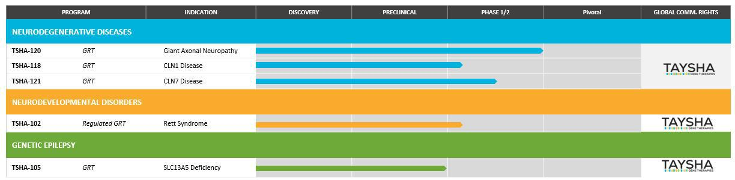

Clinical Programs

TSHA-120 for Giant Axonal Neuropathy (GAN)

In March 2021, we acquired the exclusive worldwide rights to a clinical-stage, intrathecally dosed AAV9 gene therapy program, now known as TSHA-120, for the treatment of giant axonal neuropathy, or GAN, pursuant to a license agreement with Hannah’s Hope Fund for Giant Axonal Neuropathy, Inc., or HHF. Under the terms of the agreement, HHF received an upfront payment of $5.5 million and will be eligible to receive clinical, regulatory and commercial milestones totaling up to $19.3 million, as well as a low, single-digit royalty on net sales upon commercialization of TSHA-120.

GAN is a rare autosomal recessive disease of the central and peripheral nervous systems caused by loss-of-function gigaxonin gene mutations.

There are an estimated 5,000 affected GAN patients in addressable markets.

Symptoms and features of children with GAN usually develop around the age of five years and include an abnormal, wide based, unsteady gait, weakness and some sensory loss. There is often associated dull, tightly curled, coarse hair, giant axons seen on a nerve biopsy, and spinal cord atrophy and white matter abnormality seen on MRI. Symptoms progress and as the children grow older they develop progressive scoliosis and contractures, their weakness progresses to the point where they will need a wheelchair for mobility, respiratory muscle strength diminishes to the point where the child will need a ventilator (usually in the early to mid-teens) and the children often die during their late teens or early twenties, typically due to respiratory failure. There is an early- and late-onset phenotype associated with the disease, with shared physiology. The late-onset phenotype is often categorized as Charcot-Marie-Tooth Type 2, or CMT2, with a lack of tightly curled hair and CNS symptoms with relatively slow progression of disease. This phenotype represents up to 6% of all CMT2 diagnosis. In the late-onset population, patients have poor quality of life but the disease is not life-limiting. In early-onset disease, symptomatic treatments attempt to maximize physical development and minimize the rate of deterioration. Currently, there are no approved disease-modifying treatments available.

20

TSHA-120 is an AAV9 self-complementary viral vector encoding the full length human gigaxonin protein. The construct was invented by Dr. Steven Gray and is the first AAV9 gene therapy candidate to deliver a functional copy of the GAN gene under the control of a JeT promoter that drives ubiquitous expression.
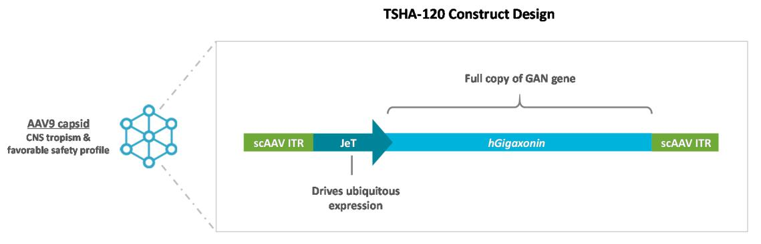

We have received orphan drug designation and rare pediatric disease designation from the U.S. Food and Drug Administration, or the FDA, for TSHA-120 for the treatment of GAN. In April 2022, we received orphan drug designation from the European Commission for TSHA-120 for the treatment of GAN.

There is an ongoing longitudinal prospective natural history study being led by the NIH, that has already identified and followed a number of patients with GAN for over five years with disease progression characterized by a number of clinical assessments. The GAN natural history study was initiated in 2013 and included 45 patients with GAN, aged 3 to 21 years. Imaging data from this study have demonstrated that there are distinctive increased T2 signal abnormalities within the cerebellar white matter surrounding the dentate nucleus of the cerebellum, which represent one of the earliest brain imaging findings in individuals with GAN. These findings precede the more widespread periventricular and deep white matter signal abnormalities associated with advanced disease. In addition, cortical and spinal cord atrophy appeared to correspond to more advanced disease severity and older age. Impaired pulmonary function in patients with GAN also was observed, with forced vital capacity correlating well with several functional outcomes such as the MFM32, a validated 32-item scale for motor function measurement developed for neuromuscular diseases. Nocturnal hypoventilation and sleep apnea progressed over time, with sleep apnea worsening as ambulatory function

21

deteriorated. Total MFM32 score also correlated with ambulatory status, where independently ambulant individuals performed better and had higher MFM32 scores than the non-ambulant group, as shown in the graph below.
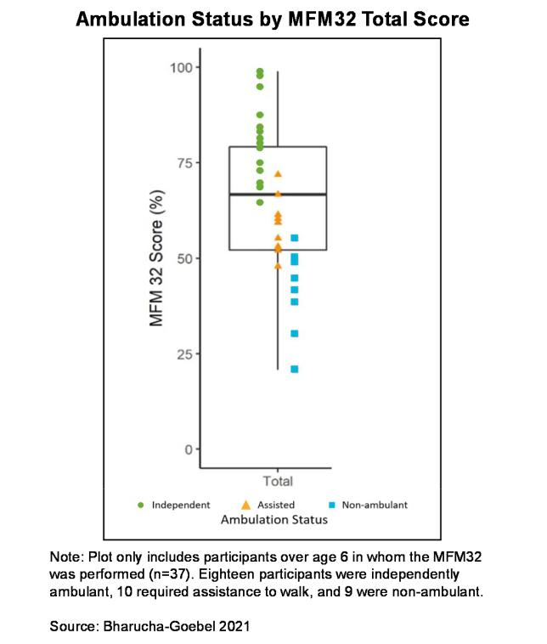

Patients also reported significant autonomic dysfunction based on the COMPASS 31 self-assessment questionnaire. In addition, nerve conduction function demonstrated progressive sensorimotor polyneuropathy with age. As would be expected for a neurodegenerative disease, younger patients have higher baseline MFM32 scores. However, the rate of decline in the MFM32 scores demonstrated consistency across patients of all ages, with most demonstrating an average 8-point decline per year regardless of age and/or baseline MFM32 score, as shown in the natural history plot below.
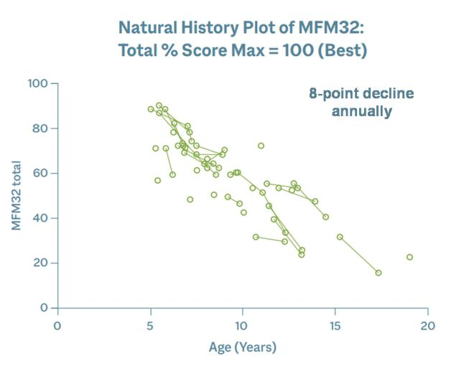

22

A 4-point score change in the MFM32 is considered clinically meaningful, suggesting that patients with GAN lose significant function annually.

To date, we have up to eight years of robust data from this study.

Preclinical Data

TSHA-120 performed well across in vitro and in vivo studies, and demonstrated improved motor function and nerve pathology, and long-term safety across several animal models. Of note, improved dorsal root ganglia, or DRG, pathology was demonstrated in TSHA-120-treated GAN knockout mice. These preclinical results have been published in a number of peer-reviewed journals.

Additional preclinical data from a GAN knockout rodent model that had received AAV9-mediated GAN gene therapy demonstrated that GAN rodents treated at 16 months performed significantly better than 18-month old untreated GAN rodents and equivalently to controls. These rodents were evaluated using a rotarod performance test which is designed to evaluate endurance, balance, grip strength and motor coordination in rodents. The time to fall off the rotarod, known as latency, was also evaluated and the data below demonstrated the clear difference in latency in treated versus untreated GAN rodents.
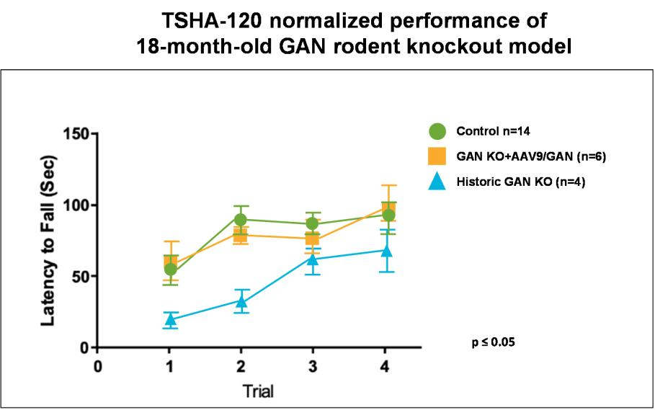

A result is considered statistically significant when the probability of the result occurring by random chance, rather than from the efficacy of the treatment, is sufficiently low. The conventional method for determining the statistical significance of a result is known as the “p-value,” which represents the probability that random chance caused the result (e.g., a p-value = 0.01 means that there is a 1% probability that the difference between the control group and the treatment group is purely due to random chance). Generally, a p-value less than 0.05 is considered statistically significant.

23

With respect to DRG inflammation, a topic of considerable interest within the gene therapy arena, the DRG have a significantly abnormal histological appearance and function as a consequence of underlying disease pathophysiology. Treatment with TSHA-120 resulted in considerable improvements in the pathological appearance of the DRG in the GAN knockout mice. Shown below is tissue from a GAN knockout mouse model with numerous abnormal neuronal inclusions containing aggregates of damaged neurofilament in the DRG as indicated by the yellow arrows. On image C, tissue from the GAN knockout mice treated with an intrathecal (IT) injection of TSHA-120 had a notable improvement in the reduction of these neuronal inclusions in the DRG.
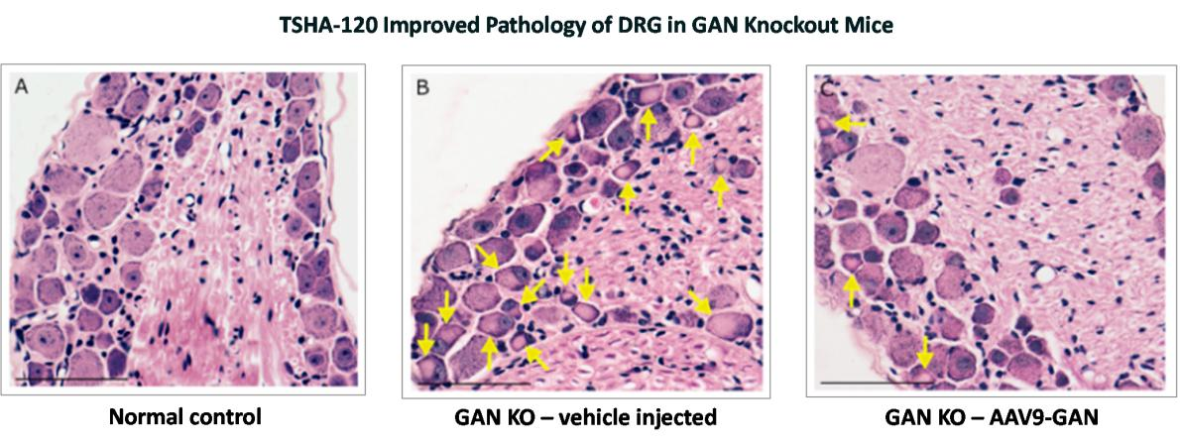

When a quantitative approach to reduce inclusions in the DRG was applied, it was observed that TSHA-120 treated mice experienced a statistically significant reduction in the average number of neuronal inclusions versus the GAN knockout mice that received vehicle as illustrated below.
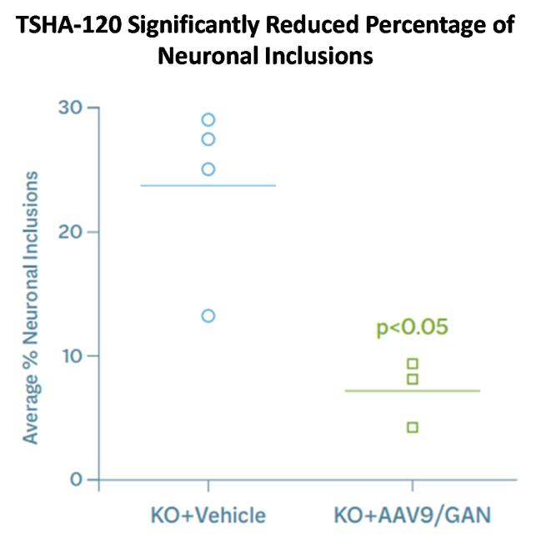

24

Additionally, TSHA-120 demonstrated improved pathology of the sciatic nerve in the GAN knockout mice as shown below.
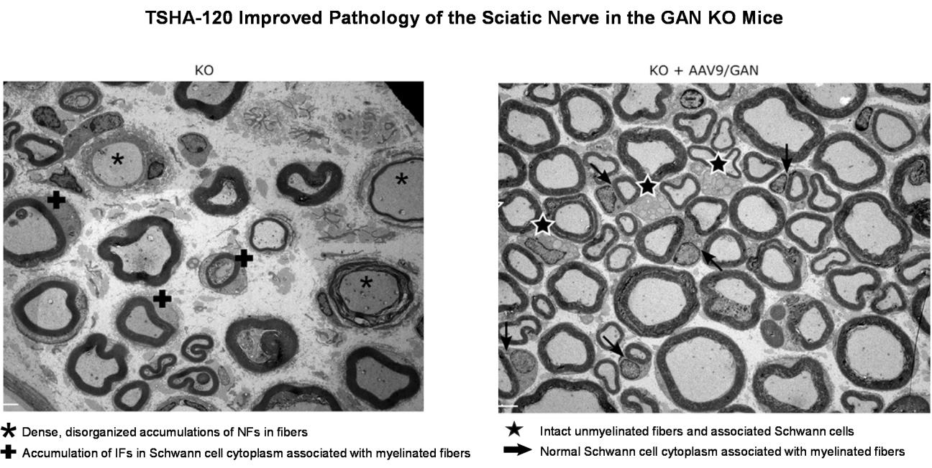

Results of Ongoing Phase 1/2 Clinical Trial

A Phase 1/2 clinical trial of TSHA-120 is being conducted by the NIH under an accepted IND. The ongoing trial is a single-site, open-label, non-randomized dose-escalation trial, in which patients are intrathecally dosed with one of 4 dose levels of TSHA-120 – 3.5E13 total vg, 1.2E14 total vg,
1.8E14 total vg or 3.5E14 total vg. The primary endpoint is to assess safety, with secondary endpoints measuring efficacy using pathologic, physiologic, functional, and clinical markers. To date, 14 patients have been intrathecally dosed and twelve patients have at least three years’ worth of long-term follow up data.

At 1-year post-gene transfer, a clinically meaningful and statistically significant slowing or halting of disease progression was seen with TSHA-120 at the highest dose of 3.5E14 total vg (n=3). The change in the rate of decline in the MFM32 score improved by 5 points in the 3.5E14 total vg cohort compared to an 8-point decline in natural history.
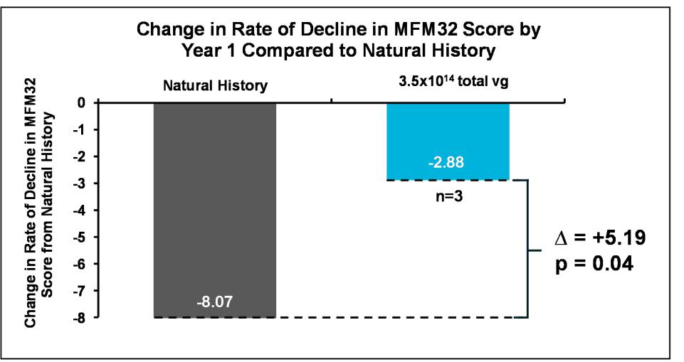

25

Although the change in the MFM32 score was clinically meaningful, we might have expected a greater change in the MFM32 score compared to natural history in the first year but one patient in the high dose cohort was a delayed responder. At the 12-month follow-up visit, the patient had a 7-point decline in the MFM32 total score that was similar to the slope of the natural history curve as shown below. Notably, from Year 1 post gene transfer to Year 2, this patient’s change in the MFM32 score remained unchanged suggesting stabilization of disease at 2 years post-treatment. At that 2-year post treatment timepoint, there was a 9-point improvement in the patient’s MFM32 score compared to the estimated natural history decline of 16 points. The annualized estimate of natural history over time assumes the same rate of decline as in Year 1.
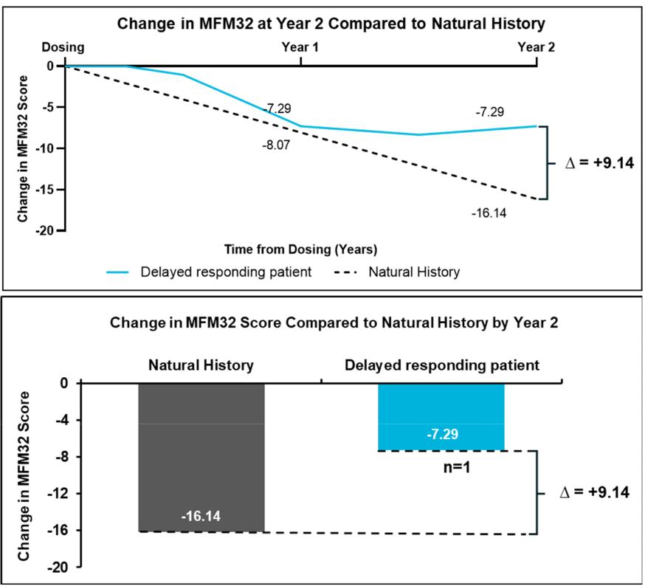

26

An additional analysis was performed to examine the change in the rate of decline in the MFM32 score of all therapeutic doses combined (n=12). As shown below, the change in the rate of decline in the MFM32 score improved by 7 points by Year 1 compared to the natural history decline in the MFM32 score of 8 points. This result was clinically meaningful and statistically significant.
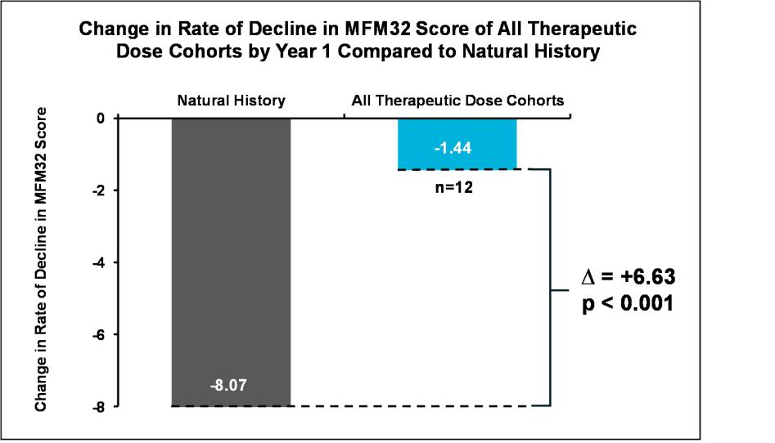

A Bayesian analysis was conducted on the 1.2E14 total vg, 1.8E14 total vg and 3.5E14 total vg dose cohorts at Year 1 to assess the probability of clinically meaningful slowing of disease progression as compared to natural history. This type of statistical analysis enables direct probability statements to be made and is both useful and accepted by regulatory agencies in interventional studies of rare diseases and small patient populations. As shown in the table below, for all therapeutic dose cohorts, there was nearly 100% probability of any slowing of disease and a 96.7% probability of clinically meaningful slowing of 50% or more following treatment with TSHA-120 compared to natural history data.
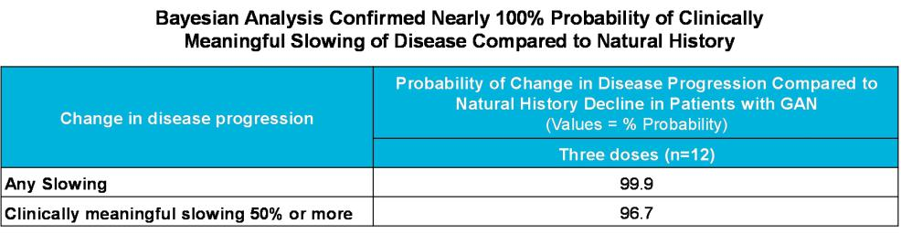

27

There remained consistent improvement in TSHA-120’s effect over time on the mean change from baseline in the MFM32 score for all patients in the therapeutic dose cohorts compared to the estimated natural history decline over the years. By Year 3, as depicted below, there was a 10-point improvement in the mean change from baseline in MFM32 score for all patients in the therapeutic dose cohorts.
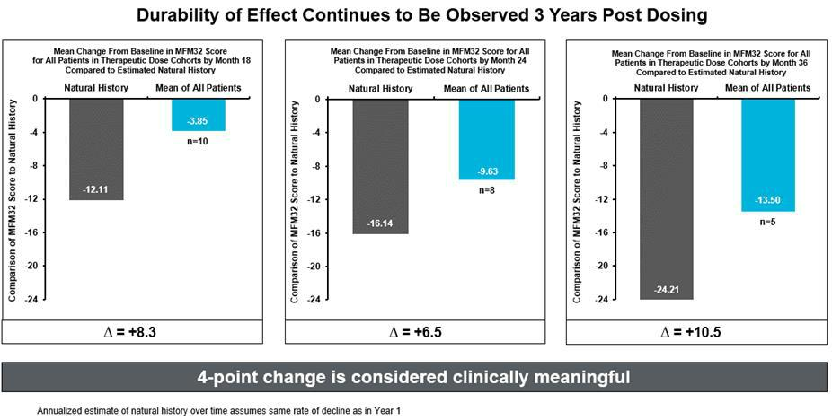

In addition to the compelling three-year data, there was one patient at Year 5 whose MFM32 change from baseline improved by nearly 26-points in the 1.2E14 total vg dose cohort compared to the estimated natural history decline of 40 points by this timepoint.
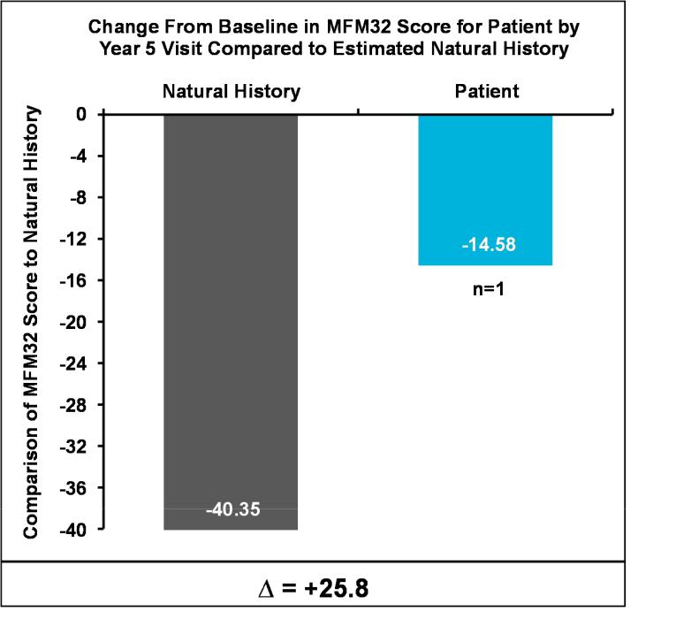

28

Below is an additional analysis of the mean change from baseline in MFM32 score for the therapeutic dose cohorts compared to natural history at patients’ last visit. As shown, TSHA-120 demonstrated increasing improvement in the mean change in MFM32 score from baseline over time.
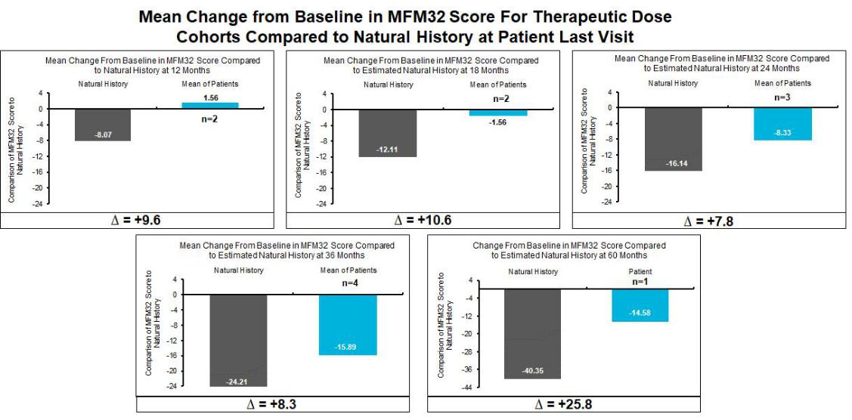

Additional Endpoints

Sensory nerve action potential, or SNAP, was assessed through nerve conduction studies in patients with GAN. Natural history data from the NIH suggest rapid and irreversible decline in sensory function early in life in patients with GAN. SNAPs are within normal limits early in life and rapid reduction in SNAP amplitude occurs around the age of symptom presentation. As demonstrated below, all patients with classic GAN have an abnormally low SNAP by the age of 4, reflective of compromised sensory neuronal function. By age 9, all patients had an irreversibly absent SNAP. The results from these nerve conduction studies reflect the clinical progression of patients with GAN.
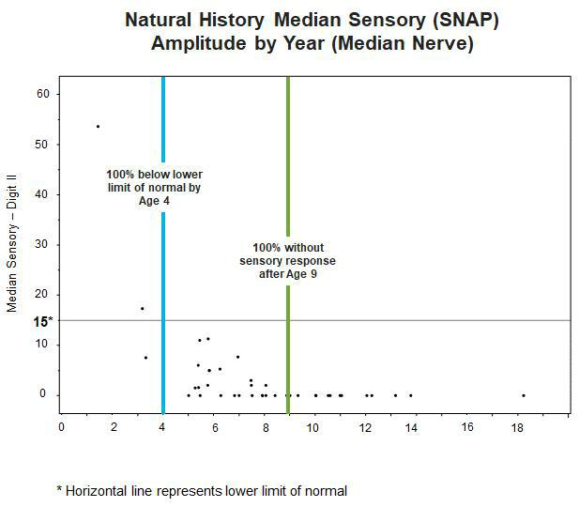

29

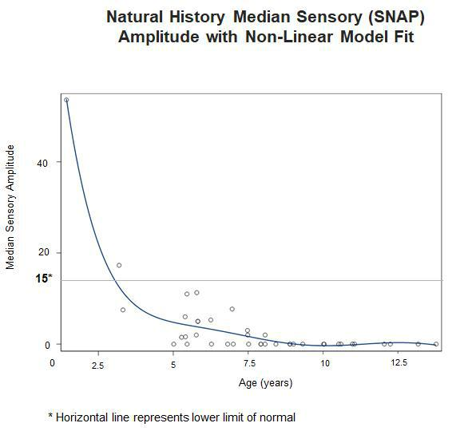

TSHA-120-treated patients demonstrated a durable improvement in SNAP response compared to natural history. Five of the twelve patients treated demonstrated a response. One patient demonstrated near complete recoverability to normal from zero at the time of treatment.
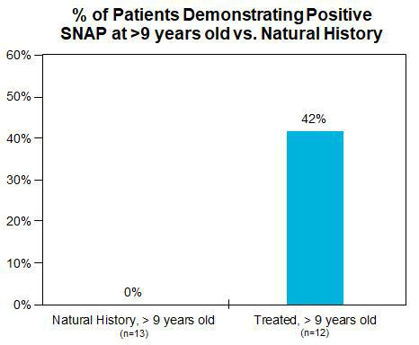

30

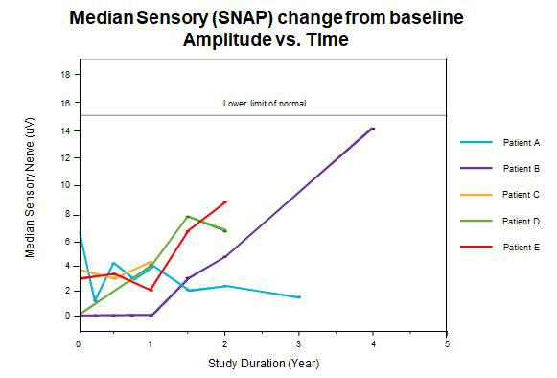

Once SNAP reaches zero, natural history suggests sensory function is presumed non-recoverable. Among patients treated with 1.2E14 total vg or greater of TSHA-120, the three patients with a positive value at baseline maintained a positive SNAP at last study visit with the longest span of 3 years to date and continue to improve.
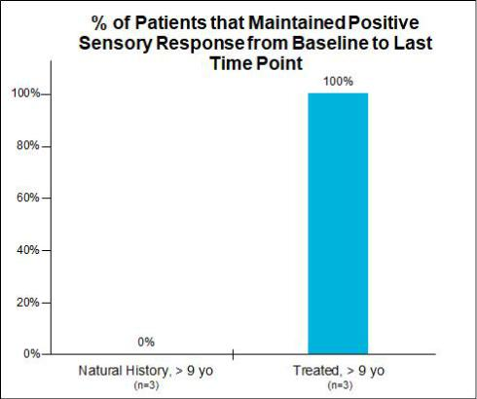

31

Below are individual patient SNAP change from baseline from treated patients who showed a positive response including their run-in natural

history.
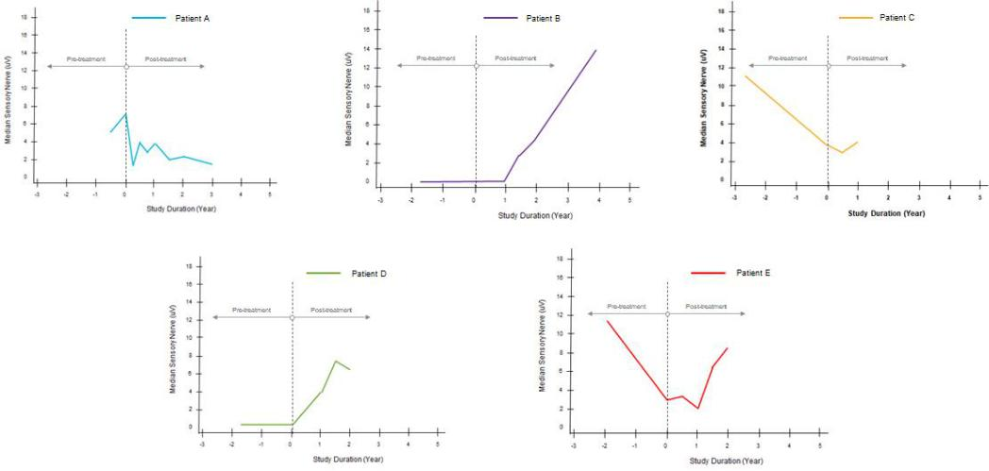

Biopsies of TSHA-120-treated patients confirmed presence of regenerative nerve clusters. Below is pathology data from biopsies of the superficial radial sensory nerve in 11 out of 11 patient samples analyzed. The remaining two samples were unable to be assessed due to biopsy limitations. Peripheral nerve biopsies from the superficial radial sensory nerve were obtained at baseline and at 1 year post gene therapy transfer. Data consistently generated an increase in the number of regenerative clusters observed at Year 1 compared to baseline, indicating active regeneration of nerve fibers following treatment with TSHA-120. Data also indicated improvement in disease pathology, providing evidence that the peripheral nervous system can respond to treatment.
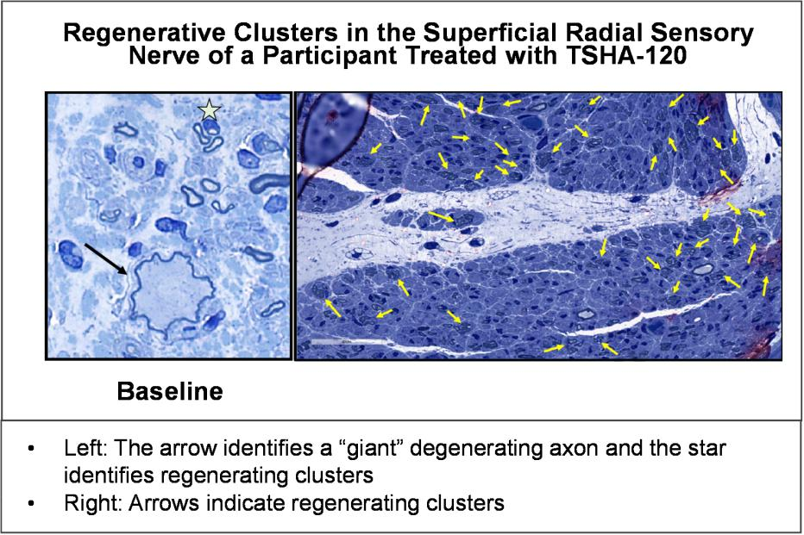

Loss of vision has been frequently cited by patients and caregivers as a symptom they find particularly debilitating and would like to see improvement in following treatment. Patients were analyzed for visual acuity using a standard Logarithm of the Minimum Angle of Resolution, or LogMAR. An increase in LogMAR score represents a decrease in visual acuity. A LogMAR score of 0 means normal vision, approximately 0.3 reflects the need for eyeglasses, and a score value of 1.0 reflects blindness. Based on natural history,

32

individuals with GAN experience a progressive loss in visual function as indicated by an increase in the LogMAR score. Ophthalmologic assessments following treatment with TSHA-120 demonstrated preservation of visual acuity over time compared to the loss of visual acuity observed in natural history. Stabilization of visual acuity was observed following treatment with TSHA-120 as demonstrated below.
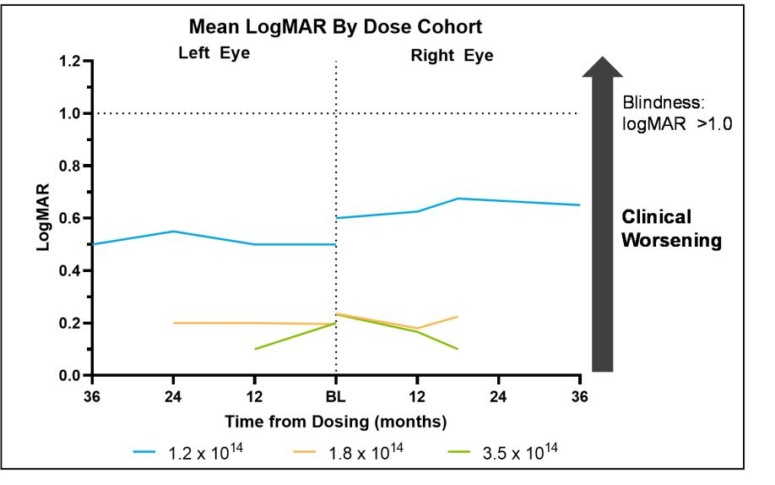

The thickness of the retinal nerve fiber layer or RNFL was also examined as an objective biomarker of visual system involvement and overall nervous system degeneration in GAN. Treatment with TSHA-120 resulted in stabilization of RNFL thickness and prevention of axonal nerve degeneration compared to diffuse thinning of RNFL observed in natural history as measured by optical coherence tomography, or OCT. Analysis by individual dose groups, as seen on the graph below, demonstrated relatively stable RNFL thickness which is in contrast to the natural history of GAN, where RNFL decreases. Overall, these data provide new evidence of TSHA-120’s ability to generate nerve fibers and preserve visual acuity.
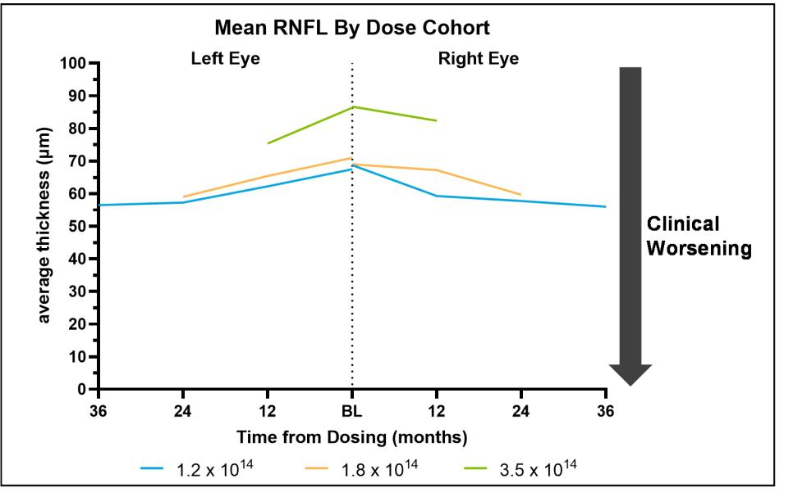

33

Safety and Tolerability

As of January 2022, there were 53 patient-years of clinical data to support TSHA-120’s favorable safety and tolerability profile. TSHA-120 has been well-tolerated at multiple doses with no signs of significant acute or subacute inflammation, no sudden sensory changes and no drug-related or persisting transaminitis. Adverse events related to immunosuppression or study procedures were similar to what has been seen with other gene therapies and transient in nature. There was no increase in incidence of adverse events with increased dose. Importantly, TSHA-120 was safely dosed in the presence of neutralizing antibodies as a result of the combination of route of administration, dosing and immunosuppression regimen.
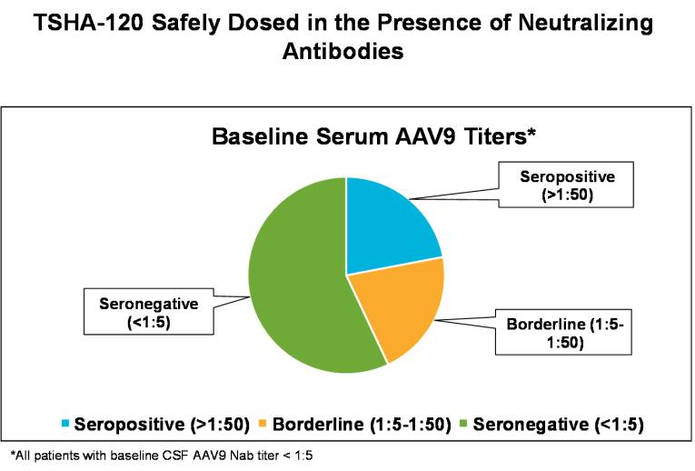

We currently have up to six years of longitudinal data in individual patients with GAN and collectively 53-patient years of clinical safety and efficacy data from our ongoing clinical study. Treatment with TSHA-120 was well-tolerated with no significant safety issues. There was no increase in incidence of adverse events with increased dose, no dose-limiting toxicity, no signs of acute or subacute inflammation, no sudden sensory changes and no drug-related or persistent elevation of transaminases. Adverse events related to immunosuppression or study procedures were similar to what was seen with other gene therapies and transient in nature.

We believe the comprehensive set of evidence generated across disease manifestations, depicted in the table below, support a robust clinical package for TSHA-120 in GAN.
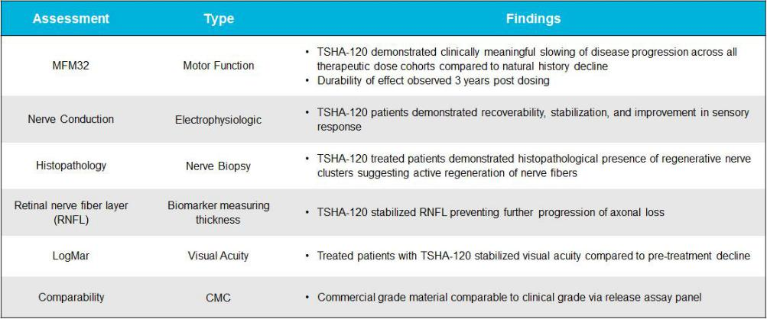

In order to deliver a robust chemistry, manufacturing, and controls, or CMC, data package to support licensure discussions, we have successfully completed six development and GMP lots of TSHA-120 with our contract development and manufacturing organization, or CDMO, partner. We have also completed a comprehensive side-by-side biochemical and biophysical analysis of

34

current and previous clinical lots. Our CDMO utilizes the same Pro10TM manufacturing platform used to produce the original GAN lots, therefore reducing which is intended to reduce comparability risk. Five development lots ranging from 2L to 250L scale and one full-scale 500L GMP lot were analyzed side-by-side with the current TSHA-120 clinical lot using a comprehensive analytical panel that meets current regulatory requirements including assays for critical attributes such as product and process residuals, empty/full ratio, genetic integrity, potency and strength.

The side-by-side analysis demonstrated that the newly produced TSHA-120 lots were generally comparable to the original clinical trial material in impurity profile including host cell contaminants, residual plasmid, empty particle content, aggregate content and genomic integrity. These results supported our biophysical and biochemical comparability of the newly produced lots. Furthermore, we developed product-specific GAN potency methods which have also demonstrated that the previous and current clinical lots were functionally indistinguishable. Validation of our potency release assay is now underway.

We have applied our panel of release assays for side-by-side testing of the original clinical trial material and our commercial grade lots. Shown below are eight of the most critical attributes of TSHA-120.
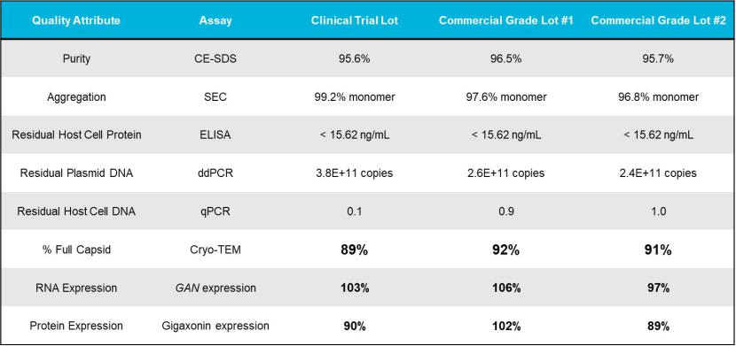

First, all results demonstrated that both the clinical and commercial grade lots were of a high purity and lacked significant levels of host cell or process contaminants such as protein and, DNA or and aggregated species. Vector purity was in excess of 95% for all three lots and host cell protein contamination was below detection. In addition, and aggregation of all lots was very low. Host cell and plasmid DNA contamination are also important attributes to discuss with regulatory agencies since carryover represents a theoretical immunogenicity or oncogenicity risk. Residual plasmid and host cell DNA were similar for all lots, indicating a similar safety profile for both products. Empty capsids are a key attribute for AAV vectors since empty capsids can stimulate immune responses to the vector and reduce potency. All three lots were highly enriched in full particles. Potency of AAV vectors is a key measure that correlates with clinical efficacy. We developed a number of product-specific potency assays to measure the functional activity of our product which is reported relative to a reference standard. These assays recapitulated the biological activity of TSHA-120 starting with transduction of GAN knockout cell lines. Activity is measured by quantitation of transgene RNA or protein expression as two independent and complimentary readouts. We observed good agreement with both readouts and high activity of all three lots against our reference suggesting that the lots are of high and comparable activity.

Overall, these results support that our early clinical and pivotal lots are biochemically and biophysically similar and based on these results we believe they should perform identically in a clinical study.

Recently, regulators have encouraged sponsors to conduct deeper analysis of product contaminants not covered by standard release assays to better assess product safety and comparability. To comply with this guidance, we have added Pac-Bio next generation sequencing to our product characterization panel to better understand the nature of nucleic acid contaminants in our products. This method not only allows us to identify the source of the nucleic acid, but also the fragment size, and sequence variability, which also needs to be considered when assessing AAV safety and efficacy. Our analysis of the clinical trial lot and commercial grade pivotal batches demonstrated that the source and composition of transgene and contaminating host and plasmid

35

DNA are nearly identical and provided further support that for a conclusion that the nature of our product is unchanged between our early clinical and pivotal batches as noted in the below pie charts.
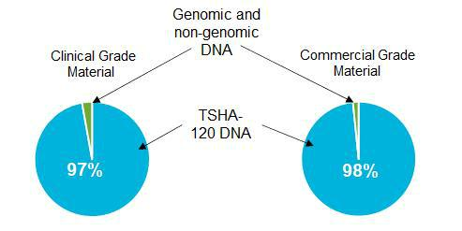

The TSHA-120 pivotal lot, which yielded over 50 patient doses of TSHA-120 at the highest dose cohort of 3.5E14 total vg, is expected to complete quality release testing by end of the third quarter of 2022. This material positions us for future BLA-enabling activities and commercial production. These lots were also placed on stability to provide critical shelf-life data in support of our BLA filing.

In September 2021, we submitted a request for a Scientific Advice meeting for TSHA-120 to the United Kingdom’s Medicines and Healthcare products Regulatory Agency, or MHRA, and were granted a meeting in January 2022. MHRA agreed on our commercial manufacturing and release assay testing strategy including potency assays and we plan to dose a few additional patients with commercial grade material, which will be released in September 2022. Finally, MHRA was supportive of our proposal to perform validation work on MFM32 for GAN as a key clinical endpoint and for us to explore the MFM32 items with patients and families as part of this process. Given the positive comparability data for TSHA-120 that we recently received, additional discussions with Health Authorities to discuss these data and potential registration pathway are planned with regulatory feedback anticipated by year-end 2022.

TSHA-102 for Rett Syndrome

TSHA-102, a neurodevelopmental disorder product candidate, is being developed for the treatment of Rett syndrome, one of the most common genetic causes of severe intellectual disability, characterized by rapid developmental regression and in many cases caused by heterozygous loss of function mutations in MECP2, a gene essential for neuronal and synaptic function in the brain. The estimated prevalence of Rett syndrome is 350,000 patients worldwide and the disease occurs in 1 of every 10,000 female births worldwide. We designed TSHA-102 to prevent gene overexpression-related toxicity by inserting microRNA, or miRNA, target binding sites into the 3’ untranslated region of viral genomes. This overexpression of MECP2 is seen in the clinic in patients with a condition known as MECP2 duplication syndrome, where elevated levels of MECP2 result in a clinical phenotype similar to Rett syndrome both in terms of symptoms and severity. TSHA-102 is constructed from a neuronal specific promoter, MeP426, coupled with the miniMECP2 transgene, a truncated version of MECP2, and miRNA-Responsive Auto-Regulatory Element, or miRARE, our novel miRNA target panel, packaged in self-complementary AAV9. Currently, there are no approved therapies for the treatment of Rett syndrome, which affects more than 350,000 patients worldwide, according to the Rett Syndrome Research Trust.

In May 2021, preclinical data from the ongoing natural history study for TSHA-102 were published online in Brain, a highly esteemed neurological science peer-reviewed journal. The preclinical study was conducted by the UT Southwestern Medical Center laboratory of Sarah Sinnett, Ph.D., and evaluated the safety and efficacy of regulated miniMECP2 gene transfer, TSHA-102 (AAV9/miniMECP2-miRARE), via IT administration in adolescent mice between four and five weeks of age. TSHA-102 was compared to unregulated full length MECP2 (AAV9/MECP2) and unregulated miniMECP2 (AAV9/miniMECP2).

TSHA-102 extended knockout survival by 56% via IT delivery. In contrast, the unregulated miniMECP2 gene transfer failed to significantly extend knockout survival at either dose tested. Additionally, the unregulated full-length MECP2 construct did not demonstrate a significant extension in survival and was associated with an unacceptable toxicity profile in wild type mice.

In addition to survival, behavioral side effects were explored. Mice were subjected to phenotypic scoring and a battery of tests including gait, hindlimb clasping, tremor and others to comprise an aggregate behavioral score. miRARE attenuated

36

miniMECP2-mediated aggravation in wild type aggregate phenotype severity scores. Mice were scored on an aggregate severity scale using an established protocol. AAV9/MECP2- and AAV9/miniMECP2-treated wild type mice had a significantly higher mean (worse) aggregate behavioral severity score versus that observed for saline-treated mice (p <0.05; at 6–30 and 7–27 weeks of age, respectively). TSHA-102-treated wild type mice had a significantly lower (better) mean aggregate severity score versus those of AAV9/MECP2- and AAV9/miniMECP2-treated mice at most timepoints from 11–19 and 9–20 weeks of age, respectively. No significant difference was observed between saline- and TSHA-102-treated wild type mice.

miRARE-mediated genotype-dependent gene regulation was demonstrated by analyzing tissue sections from wild type and knockout mice treated with AAV9 vectors given intrathecally. When knockout mice were injected with a vector expressing the mini-MECP2 transgene with and without the miRARE element, miRARE reduced overall miniMECP2 transgene expression compared to unregulated miniMECP2 in wild type mice as shown below.
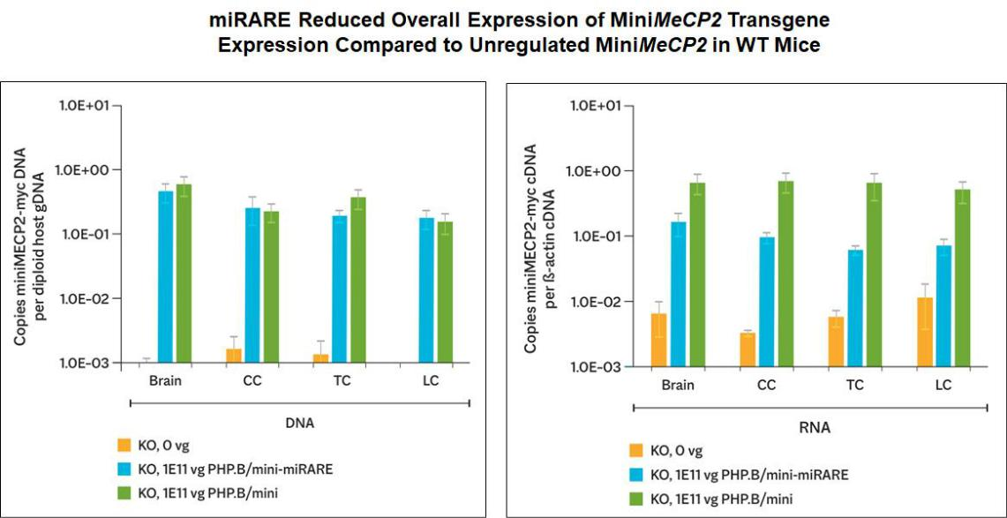

TSHA-102 demonstrated regulated expression in different regions of the brain. As shown in the graph and photos below, in the pons and midbrain, miRARE inhibited mean MECP2 gene expression in a genotype-dependent manner as indicated by significantly fewer myc(+) cells observed in wild type mice compared to knockout mice (p<0.05), thereby demonstrating that TSHA-102 achieved MECP2 expression levels similar to normal physiological parameters.

37

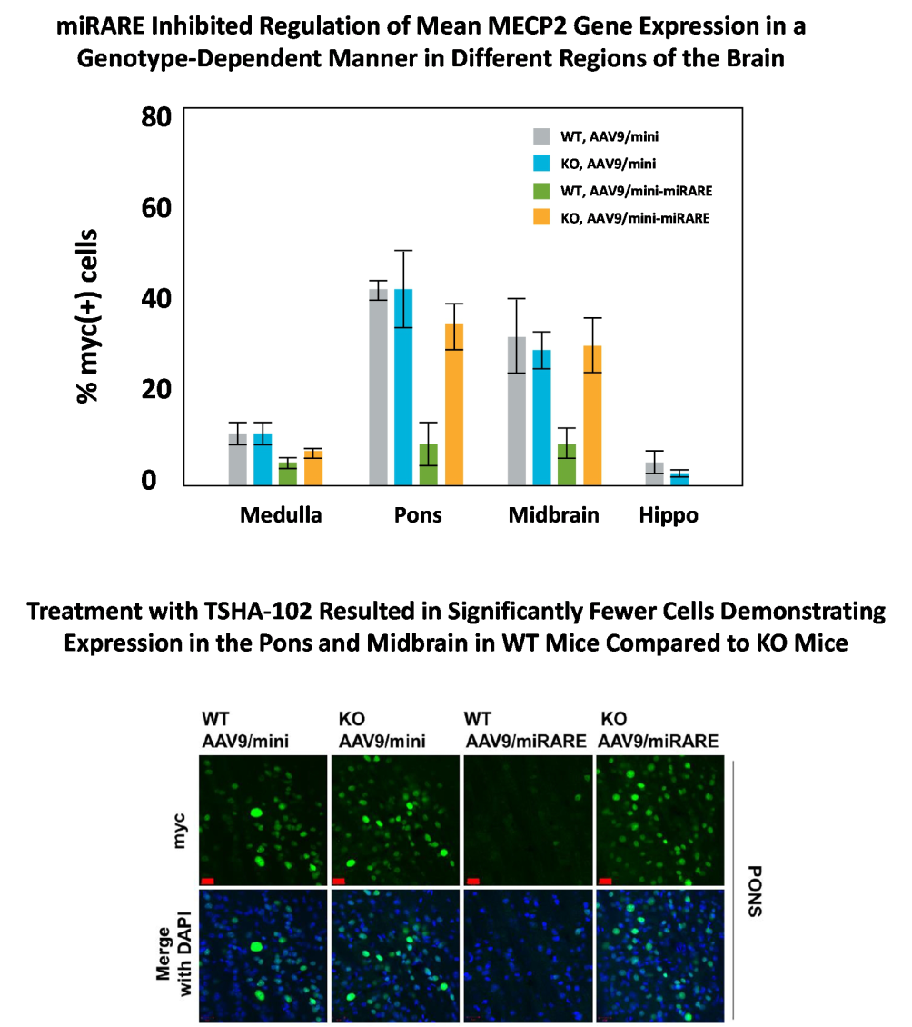

In preclinical animal models, intrathecal myc-tagged TSHA-102 was not associated with early death and did not cause adverse behavioral side effects in wild type mice demonstrating appropriate downregulation of miniMECP2 protein expression as compared to unregulated MECP2 gene therapy constructs. In addition, preclinical data demonstrated that miRARE reduced overall expression of miniMECP2 transgene expression and regulated genotype-dependent myc-tagged miniMECP2 expression across different brain regions on a cell-by-cell basis and improved the safety of TSHA-102 without compromising efficacy in juvenile mice. Pharmacologic activity of TSHA-102 following IT administration was assessed in the MECP2 knockout mouse model of Rett syndrome across three dose levels and three age groups (n=252). A one-time IT injection of TSHA-102 significantly increased survival at all dose levels, with the mid to high doses improving survival across all age groups compared to vehicle-treated controls. Treatment with TSHA-102 significantly improved body weight, motor function and respiratory assessments in MECP2 knockout mice. An additional study in neonatal mice is ongoing, and preliminary data suggest normalization of survival. Finally, an IND/CTA-enabling 6-month Good Laboratory Practice, or GLP, toxicology study (n=24) examined the biodistribution, toxicological effects and mechanism of action of TSHA-102 when intrathecally administered to Non-Human Primates, or NHPs, across three dose levels. Biodistribution, as reflected by DNA copy number, was observed in multiple areas of the brain, sections of spinal cord and the DRG. Importantly, mRNA levels across multiple tissues were low, indicating miRARE regulation is minimizing transgene expression from the construct in the presence of endogenous MECP2 as expected, despite the high levels of DNA that were delivered. No toxicity from

38

transgene overexpression was observed, confirmed by functional and histopathologic evaluations demonstrating no detrimental change in neurobehavioral assessments and no adverse tissue findings on necropsy.

In neonatal knockout Rett mice, treatment with TSHA-102 resulted in near normalization of survival as shown below. A single intracerebroventricular, or ICV, injection of TSHA-102 at a dose of 8.8E10 vg/mouse (Human Equivalent Dose of 2.86E14 vg/participant) within 48 hours after birth in Mecp2-/Y male mice significantly extended the survival of the animals as shown below. All cohorts, including vehicle, were sacrificed at 34 weeks. Preliminary data demonstrated approximately 70% of the treated Mecp2-/Y males survived to 34 weeks of age compared to 9 weeks in the vehicle-treated Mecp2-/Y male.
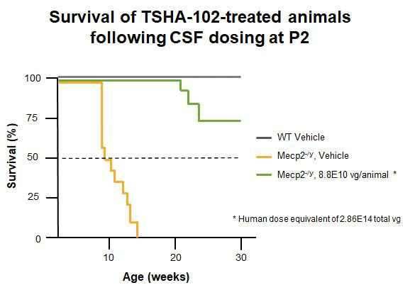

In addition, neonatal knockout Rett mice demonstrated normalization of behavior following treatment with TSHA-102 as assessed by the Bird Score, a composite measure of six different phenotypic abilities. Knockout animals were initially assessed at 4 weeks of age with a mean Bird Score of 4. Over the course of the study, TSHA-102 improved the behaviors (as assessed by the Bird aggregate score) of TSHA-102 treated mice as shown below.

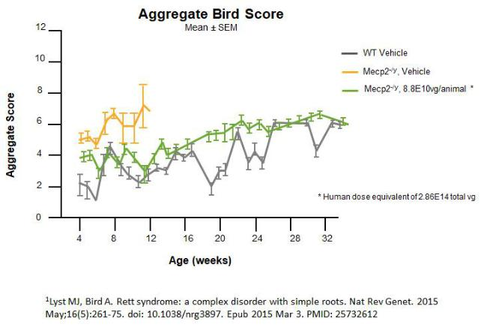.

In summary, we believe the totality of preclinical data generated to date, specifically including the mouse pharmacology study to ascertain minimally effective dose, the two toxicology studies (wild type rat and wild type NHP) and the recent mouse neonatal data, represents the most robust package supporting clinical advancement of TSHA-102 in Rett syndrome as shown below.

39

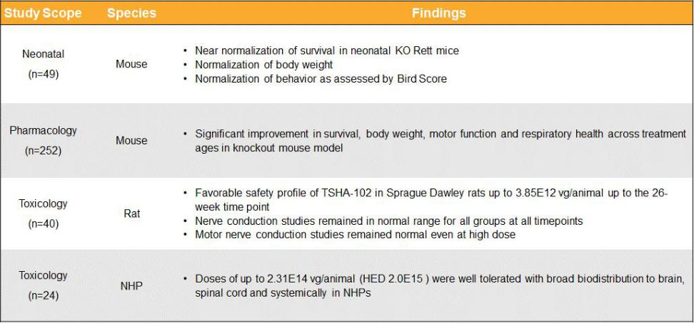

Safety and biodistribution assessments in NHPs were presented in May 2022 at the International Rett Syndrome Foundation (IRSF) meeting along with the caregiver perspective on Rett syndrome in adulthood. At the ASCEND National Summit, there was an oral presentation on “Putting Patients at the Center.” Finally, mouse pharmacology, rat and NHP toxicology data were presented at the 25th Annual Meeting of the American Society of Gene & Cell Therapy (ASGCT).

We submitted a CTA for TSHA-102 in November 2021 and announced initiation of clinical development under a CTA approved by Health Canada in March 2022. We are advancing TSHA-102 in the REVEAL Phase 1/2 clinical trial which is an open-label, dose escalation, randomized, multicenter study that will examine the safety and efficacy of TSHA-102 in adult female patients with Rett syndrome. Up to 18 patients will be enrolled. In the first cohort, a single 5E14 total vg dose of TSHA-102 will be given intrathecally. The second cohort will be given a 1E15 total vg dose of TSHA-102. Key assessments will include Rett-specific and global assessments, quality of life, biomarkers, and neurophysiology and imaging assessments. Sainte-Justine Mother and Child University Hospital Center in Montreal, Quebec, Canada has been selected as the initial clinical trial site under the direction of Dr. Elsa Rossignol, Assistant Professor Neuroscience and Pediatrics, and Principal Investigator. We expect to report preliminary clinical data for TSHA-102 in Rett syndrome by year-end 2022.

We have received orphan drug designation and rare pediatric disease designation from the FDA and orphan drug designation from the European Commission for TSHA-102 for the treatment of Rett syndrome.

TSHA-121 for CLN7 Disease

The first-generation construct for the CLN7 program was developed in the laboratory of Steven Gray, Ph.D., Associate Professor at UT Southwestern Medical Center and our Chief Scientific Advisor with financial support from Mila’s Miracle and Batten Hope, the leading CLN7 patient advocacy groups. We provided a grant to Batten Hope to support patient awareness, disease education and newborn screening initiatives. We recently executed an exclusive option from UT Southwestern to license worldwide rights to a clinical-stage CLN7 program. The CLN7 program is currently in a Phase 1 clinical proof-of-concept trial run by UT Southwestern, and we reported preliminary clinical safety data for the first patient in history to be intrathecally dosed at 1.0E15 total vg with the first-generation construct in December 2021. Development of the CLN7 program will continue in collaboration with existing partners with future clinical development to focus on the first-generation construct.

CLN7 disease is a rare, fatal and rapidly progressive neurodegenerative disease that is a form of Batten disease. CLN7 is caused by autosomal recessive mutations in the MFSD8 gene that results in lysosomal dysfunction. Disease onset occurs around two to five years of age, with death often ensuing in young adolescence. Patients experience gradual nerve cell loss in certain parts of the brain and typically present with seizures, vision loss, speech impairment and mental and motor regression. Currently, there are no approved therapies to treat CLN7 disease, which impacts an estimated 4,000 patients globally. Preclinical data in rodents supported advancement of the first-generation construct into a Phase 1 clinical proof-of-concept study in patients with CLN7 disease. In an in vivo efficacy study, IT administration of the first-generation construct to MFSD8 knockout mice with high or low doses resulted in clear age and dose effects with early intervention and high dose achieving the best therapeutic benefits. IT high dose of the first-generation construct in younger knockout mice resulted in: 1) widespread MFSD8 mRNA expression in all tissues assessed; 2) nearly complete normalization of impaired open field and rotarod performance at 6 and 9 months post injection; 3) more than doubled

40

median life expectancy (16.82 months versus 7.77 months in untreated knockout mice); and 4) maintenance of healthy body weight for a prolonged period of time. Toxicology studies in wild type rodents demonstrated safety and tolerability of IT administration of the first-generation construct.

Clinical safety data presented at WORLDSymposium in February 2022 for the first-generation construct from the ongoing clinical trial following IT administration further demonstrated that the first-generation construct was well-tolerated at multiple doses including 1.0E15 total vg, which is the highest dose administered in humans ever for a gene therapy product. No adverse immune responses were noted, including no evidence of dorsal root ganglion toxicity or brain inflammation across all subjects. Moreover, stabilization in sural nerve conduction supported the absence of dorsal root ganglia inflammation. The ongoing trial includes three patients dosed to date, with two patients treated at the highest dose of 1.0Ex15 total vg. Complete blood counts revealed no signs of bone marrow suppression or clinically significant bone marrow reactivity, and CSF analysis revealed no signs of pleocytosis. A fourth patient was recently dosed at 1.0E15 total vg in March 2022.

TSHA-118 for CLN1 Disease

CLN1 disease (one of the forms of Batten disease), a lysosomal storage disorder, is a progressive, fatal neurodegenerative disease with early childhood onset that has an estimated incidence of approximately 1 in 138,000 live births worldwide. The estimated prevalence of CLN1 disease is 1,000 patients in the United States and European Union. CLN1 disease is caused by loss-of-function mutations in the CLN1 gene that encodes the enzyme palmitoyl-protein thioesterase-1, or PPT1, a small glycoprotein involved in the degradation of certain lipid-modified proteins. Loss of function mutations in the CLN1 gene causes accumulation of these lipid-modified proteins in cells, eventually leading to aggregation, neuronal cellular dysfunction and ultimately neuronal cell death.

In the infantile-onset form of CLN1 disease, clinical symptoms appear between six to 24 months and include rapid deterioration of speech and motor function, refractory epilepsy, ataxia and visual failure. Infantile-onset CLN1 patients are typically poorly responsive by five years of age and remain noncommunicative until their death, which usually occurs by seven years of age. Late-infantile-onset CLN1 disease begins between two to four years of age with initial visual and cognitive decline followed by the development of ataxia and myoclonus, or quick, involuntary muscle jerks. Juvenile-onset CLN1 disease patients present between the ages of five to ten years old, with vision loss as a first symptom followed by cognitive decline, seizures and motor decline. Approximately 60% of the children diagnosed with CLN1 disease in the United States present with early-onset infantile forms, with the remaining 40% experiencing later-onset childhood forms.

All currently available therapeutic approaches for patients with CLN1 disease are targeted towards the treatment of symptoms, and no disease-modifying therapies have been approved. Gene therapy has shown promise in correcting forms of neuronal ceroid lipofuscinoses, or NCL, diseases that involve mutations in soluble enzymes, in part, due to cross-correction of neighboring non-transduced cells.

We believe that the introduction of a functional CLN1 gene using an AAV9 vector delivered intrathecally to the CNS offers the potential of a disease-modifying therapeutic approach for this disease. TSHA-118 is a self-complementary AAV9 viral vector that expresses human codon-optimized CLN1 complementary deoxyribonucleic acid under control of the chicken ß-actin hybrid promoter. We acquired exclusive worldwide rights to certain intellectual property rights and know-how relating to the research, development and manufacture of TSHA-118 (formerly ABO-202) in August 2020 pursuant to a license agreement with Abeona Therapeutics Inc., or Abeona.

There is currently an open IND for the CLN1 program. We submitted a CTA filing for TSHA-118 which was approved by Health Canada in 2021 and have initiated clinical development.

TSHA-118 has been granted orphan drug designation, rare pediatric disease designation and fast track designation from the FDA and orphan drug designation from the European Medicines Agency for the treatment of CLN1 disease.

TSHA-105 for SLC13A5 Deficiency

We are developing TSHA-105 for the treatment of SLC13A5 deficiency, a rare autosomal recessive epileptic encephalopathy characterized by the onset of seizures within the first few days of life. SLC13A5 deficiency is caused by bi-allelic loss-of function mutations in the SLC13A5 gene, which codes for a sodium dependent citrate transporter, or NaCT, that is largely expressed in the brain and liver. To date, all tested mutations result in no or a greatly reduced amount of the citrate in the cells. Diminished NaCT

41

function leads to loss of neuronal uptake of citrate and other metabolites such as succinate that are critical to brain energy metabolism and function. Affected children have impairments in gross motor function and speech production with relative preservation of fine motor skills and receptive speech. Currently, there are no approved therapies for SLC13A5 deficiency, and treatment is largely to address symptoms. The estimated prevalence of SLC13A5 deficiency is 1,900 patients in the United States and European Union.

We are developing TSHA-105 as a gene replacement therapy for SLC13A5 deficiency. TSHA-105 is constructed from a codon-optimized human SLC13A5 gene packaged in a self-complementary AAV9 capsid.

We have received orphan drug designation and rare pediatric disease designation from the FDA and orphan drug designation from the European Commission for TSHA-105 for the treatment of epilepsy caused by caused by SLC13A5 deficiency. We expect to initiate clinical development on TSHA-105 in SLC13A5 deficiency.

License Agreements

Research, Collaboration and License Agreement with The University of Texas Southwestern Medical Center

In November 2019, we entered into a research, collaboration and license agreement, or the UT Southwestern Agreement, with The Board of Regents of the University of Texas System on behalf of UT Southwestern, as amended in April 2020.

In connection with the UT Southwestern Agreement, we obtained an exclusive, worldwide, royalty-free license under certain patent rights of UT Southwestern and a non-exclusive, worldwide, royalty-free license under certain know-how of UT Southwestern, in each case to make, have made, use, sell, offer for sale and import licensed products for use in certain specified indications. Additionally, we obtained a non-exclusive, worldwide, royalty-free license under certain patents and know-how of UT Southwestern for use in all human uses, with a right of first refusal to obtain an exclusive license under certain of such patent rights and an option to negotiate an exclusive license under other of such patent rights. We are required to use commercially reasonable efforts to develop, obtain regulatory approval for, and commercialize at least one licensed product.

In connection with the UT Southwestern Agreement, we issued to UT Southwestern 2,179,000 shares of our common stock. We do not have any future milestone or royalty obligations to UT Southwestern under the UT Southwestern Agreement, other than costs related to the maintenance of patents.

The UT Southwestern Agreement expires on a country-by-country and licensed product-by-licensed product basis upon the expiration of the last valid claim of a licensed patent in such country for such licensed product. After the initial research term, we may terminate the agreement, on an indication-by-indication and licensed product-by-licensed product basis, at any time upon specified written notice to UT Southwestern. Either party may terminate the agreement upon an uncured material breach of the agreement or insolvency of the other party.

License Agreement with Queen’s University

In February 2020, we entered into a license agreement, or the Queen’s University Agreement with Queen’s University. In connection with the Queen’s University Agreement, we obtained an exclusive, perpetual, worldwide, royalty-bearing license, with the right to grant sublicenses, under certain patent rights and know-how of Queen’s University, including certain improvements to the foregoing, to make, have made, use, offer for sale, sell and import licensed products and otherwise exploit such patents and know-how for use in certain specified indications. We also obtained an exclusive right of first negotiation to license certain next generation technology and improvements of Queen’s University that do not constitute an already-licensed improvement to the licensed technology.

In connection with the Queen’s University Agreement, we paid Queen’s University a one-time fee of $3.0 million as an upfront fee and

approximately $0.2 million to reimburse Queen’s University for certain plasmid production costs. We are obligated to pay Queen’s University up to

$10.0 million in the aggregate upon achievement of certain regulatory milestones and up to $10.0 million in the aggregate upon achievement of certain

commercial milestones, a low single digit royalty on net sales of licensed products, subject to certain customary reductions, and a percentage of non-royalty

sublicensing revenue ranging in the low double digits. Royalties are payable on a licensed product-by-licensed product basis and country-by-country basis

until expiration of the last valid claim of a licensed patent covering such licensed product in such country and the expiration of any regulatory exclusivity

for such licensed product in such country. Additionally, we are obligated to pay Queen’s University a low double-digit portion of any

42

amounts received by us in connection with the sale of a priority review voucher related to a licensed product, not to exceed a low eight-figure amount.

In connection with a separate research grant agreement with Queen’s University, we reimbursed Queen’s University for certain manufacturing production costs totaling $3.8 million in fiscal year 2020. No additional milestone payments were made in connection with the Queen’s University Agreement during the six months ended June 30, 2022.

License Agreement with Abeona (CLN1 Disease)

In August 2020, we entered into a license agreement, or the Abeona CLN1 Agreement, with Abeona Therapeutics Inc., or Abeona. In connection with the Abeona CLN1 Agreement, we obtained an exclusive, worldwide, royalty-bearing license, with the right to grant sublicenses under certain patents, know-how and materials originally developed by the University of North Carolina at Chapel Hill and Abeona to research, develop, manufacture, have manufactured, use, and commercialize licensed products for gene therapy for the prevention, treatment, or diagnosis of CLN1 Disease (one of the forms of Batten disease) in humans.

In connection with the license grant, we paid Abeona a one-time upfront license fee of $3.0 million during fiscal year 2020. We are obligated to pay Abeona up to $26.0 million in regulatory-related milestones and up to $30.0 million in sales-related milestones per licensed product and high single-digit royalties on net sales of licensed products. Royalties are payable on a licensed product-by-licensed product and country-by-country basis until the latest of the expiration or revocation or complete rejection of the last licensed patent covering such licensed product in the country where the licensed product is sold, the loss of market exclusivity in such country where the product is sold, or, if no licensed product exists in such country and no market exclusivity exists in such country, ten years from first commercial sale of such licensed product in such country. In addition, concurrent with the Abeona CLN1 Agreement, we entered into a purchase and reimbursement agreement with Abeona, pursuant to which we purchased specified inventory from Abeona and reimbursed Abeona for certain research and development costs previously incurred for total consideration of $4.0 million paid in fiscal year 2020.

In December 2021 the Company’s CTA filing for TSHA-118 for the treatment of CLN1 disease was approved by Health Canada and therefore triggered a regulatory milestone payment in connection with the Abeona CLN1 Agreement, and therefore we recorded $3.0 million within research and development expenses in the consolidated statements of operations for the year ended December 31, 2021. The milestone fee was paid in January 2022 and has been classified as an investing outflow in the condensed consolidated statements of cash flows for the six months ended June 30, 2022. No additional milestone payments were made or triggered during the six months ended June 30, 2022.

The Abeona CLN1 Agreement expires on a country-by-country and licensed product-by-licensed product basis upon the expiration of the last royalty term of a licensed product. Either party may terminate the agreement upon an uncured material breach of the agreement or insolvency of the other party. We may terminate the agreement for convenience upon specified prior written notice to Abeona.

License Agreement with Abeona (Rett Syndrome)

In October 2020, we entered into a license agreement, or the Abeona Rett Agreement, with Abeona pursuant to which we obtained an exclusive, worldwide, royalty-bearing license, with the right to grant sublicenses under certain patents, know-how and materials originally developed by the University of North Carolina at Chapel Hill, the University of Edinburgh and Abeona to research, develop, manufacture, have manufactured, use, and commercialize licensed products for gene therapy and the use of related transgenes for Rett syndrome.

Subject to certain obligations of Abeona, we are required to use commercially reasonable efforts to develop at least one licensed product and commercialize at least one licensed product in the United States.

In connection with the Abeona Rett Agreement, we paid Abeona a one-time upfront license fee of $3.0 million during fiscal year 2020. We are obligated to pay Abeona up to $26.5 million in regulatory-related milestones and up to $30.0 million in sales-related milestones per licensed product and high single-digit royalties on net sales of licensed products. Royalties are payable on a licensed product-by-licensed product and country-by-country basis until the latest of the expiration or revocation or complete rejection of the last licensed patent covering such licensed product in the country where the licensed product is sold, the loss of market exclusivity in such country where the product is sold, or, if no licensed product exists in such country and no market exclusivity exists in such country, ten years from first commercial sale of such licensed product in such country.

43

In March 2022, our CTA filing for TSHA-102 for the treatment of Rett Syndrome was approved by Health Canada and therefore triggered a regulatory milestone payment in connection with the Rett Agreement. We recorded $1.0 million within research and development expenses in the condensed consolidated statements of operations for the six months ended June 30, 2022. This milestone fee was not paid as of June 30, 2022 and has been recorded in accrued expenses and other current liabilities. This milestone fee was paid in July 2022.

The Abeona Rett Agreement expires on a country-by-country and licensed product-by-licensed product basis upon the expiration of the last royalty term of a licensed product. Either party may terminate the agreement upon an uncured material breach of the agreement or insolvency of the other party. We may terminate the agreement for convenience.

Impact of COVID-19 on Our Business

We have been actively monitoring the COVID-19 situation and its impact globally. We believe our financial results for the six months ended June 30, 2022 were not significantly impacted by COVID-19. We believe our hybrid and remote working arrangements have had limited impact on our ability to maintain internal operations during the six months ended June 30, 2022. The extent to which COVID-19 may impact our business and operations will depend on future developments that are highly uncertain and cannot be predicted with confidence, such as the duration of the outbreak, the effectiveness of actions to contain and treat COVID-19, the efficacy, availability and adoption of vaccines and other treatments, both domestically and globally, and the impact of new variants or mutations of the coronavirus, such as the Delta and Omicron variants. Although we have not experienced any material business shutdowns or interruptions due to the COVID-19 pandemic, we cannot predict the scope and severity of any potential business shutdowns or disruptions in the future, including to our planned clinical trials and preclinical studies. Any such shutdowns or other business interruptions could result in material and negative effects to our ability to conduct our business in the manner and on the timelines presently planned, which could have a material adverse impact on our business, results of operation and financial condition. Further, disruption of global financial markets and a recession or market correction, including as a result of the COVID-19 pandemic, the ongoing military conflict between Russia and Ukraine and the related sanctions imposed against Russia, and other global macroeconomic factors such as inflation, could reduce the Company’s ability to access capital, which could in the future negatively affect the Company’s liquidity and could materially affect the Company’s business and the value of its common stock.

Components of Results of Operations

Revenue

To date, we have not recognized any revenue from any sources, including from product sales, and we do not expect to generate any revenue from the sale of products, if approved, in the foreseeable future. If our development efforts for our product candidates are successful and result in regulatory approval, or license agreements with third parties, we may generate revenue in the future from product sales. However, there can be no assurance as to when we will generate such revenue, if at all.

Operating Expenses

Research and Development Expenses

Research and development expenses primarily consist of preclinical development of our product candidates and discovery efforts, including conducting preclinical studies, manufacturing development efforts, preparing for clinical trials and activities related to regulatory filings for our product candidates. Research and development expenses are recognized as incurred and payments made prior to the receipt of goods or services to be used in research and development are capitalized until the goods or services are received. Costs incurred in obtaining technology licenses through asset acquisitions are charged to research and development expense if the licensed technology has not reached technological feasibility and has no alternative future use. Research and development expenses include:

- employee-related expenses, including salaries, bonuses, benefits, stock-based compensation, severance costs and other related costs for those employees involved in research and development efforts;

- license maintenance fees and milestone fees incurred in connection with various license agreements;

- external research and development expenses incurred under agreements with consultants, contract research organizations, or CROs, investigative sites and consultants to conduct our preclinical studies;

- costs related to manufacturing material for our preclinical studies and clinical trials, including fees paid to contract manufacturing organizations, or CMOs;

- laboratory supplies and research materials;

44

- costs related to compliance with regulatory requirements; and

- facilities, depreciation and other allocated expenses, which include direct and allocated expenses for rent, maintenance of facilities, insurance and equipment.

Research and development activities are central to our business model. Product candidates in later stages of clinical development generally have higher development costs than those in earlier stages of clinical development, primarily due to the increased size and duration of later-stage clinical trials. We cannot determine with certainty the timing of initiation, the duration or the completion costs of current or future preclinical studies and clinical trials of our product candidates due to the inherently unpredictable nature of preclinical and clinical development. Clinical and preclinical development timelines, the probability of success and development costs can differ materially from expectations. Due to the strategic reprioritization of programs and reduction in force announced in March 2022, we expect overall lower research and development expenses for the remainder of 2022 compared to 2021. We expect lower expenses for the remainder of 2022 as certain programs have been deprioritized. Our future expenses may vary significantly each period based on factors such as:

- expenses incurred to conduct preclinical studies required to advance our product candidates into clinical development;

- per patient trial costs, including based on the number of doses that patients received;

- the number of patients who enroll in each trial;

- the number of trials required for approval;

- the number of sites included in the trials;

- the countries in which the trials are conducted;

- the length of time required to enroll eligible patients;

- the drop-out or discontinuation rates of patients;

- potential additional safety monitoring requested by regulatory agencies;

- the duration of patient participation in the trials and follow-up;

- the phase of development of the product candidate;

- third-party contractors failing to comply with regulatory requirements or meet their contractual obligations to us in a timely manner, or at all;

- the ability to manufacture of our product candidates;

- regulators or institutional review boards, or IRBs requiring that we or our investigators suspend or terminate clinical development for various reasons, including noncompliance with regulatory requirements or a finding that the participants are being exposed to unacceptable health risks; and

- the efficacy and safety profile of our product candidates.

General and Administrative Expenses

General and administrative expenses consist principally of salaries and related costs for personnel in executive and administrative functions, including stock-based compensation, severance costs, travel expenses and recruiting expenses. Other general and administrative expenses include professional fees for legal, consulting, accounting and audit and tax-related services and insurance costs.

We anticipate that our general and administrative expenses will decrease in the future due to the strategic reprioritization and reduction in force that was announced in March 2022. We also anticipate that our general and administrative expenses as a result of payments for accounting, audit, legal, consulting services, as well as costs associated with maintaining compliance with Nasdaq listing rules and SEC requirements, director and officer liability insurance and other expenses associated with operating as a public company will stay constant for the near future, but may increase over time.

45

Results of Operations

Results of Operations for the Three Months ended June 30, 2022 and 2021

The following table summarizes our results of operations for the three months ended June 30, 2022 and 2021 (in thousands):

 | For the Three Months Ended June 30,
 | 2022 |  |  |  | 2021
Operating expenses:
Research and development | $ | 23,118 |  | $ | 30,643
General and administrative |  | 9,867 |  | $ | 10,129
Total operating expenses |  | 32,985 |  |  | 40,772
Loss from operations |  | (32,985) |  |  | (40,772)
Other income (expense):
Interest income |  | 27 |  |  | 40
Interest expense |  | (912) |  |  | (194)
Other expense |  | (3) |  |  | —
Total other expense, net |  | (888) |  |  | (154)
Net loss | $ | (33,873) |  | $ | (40,926)

Research and Development Expenses

Research and development expenses were $23.1 million for the three months ended June 30, 2022, compared to $30.6 million for the three months ended June 30, 2021. The $7.5 million decrease was primarily attributable to a decrease of $3.8 million in third-party research and development primarily related to GLP toxicology studies, a decrease of $3.2 million in research and development manufacturing, and lower employee compensation expenses of $0.5 million.

General and Administrative Expenses

General and administrative expenses were $9.9 million for the three months ended June 30, 2022, compared to $10.1 million for the three months ended June 30, 2021. The decrease of approximately $0.2 million was primarily attributable to a decrease of $1.1 million in professional fees related to market research, recruiting, accounting, and patient advocacy activities. This was partially offset by $0.9 million of incremental employee compensation expenses.

Other Income (Expense)

Interest Expense

Interest expense was $0.9 million for the three months ended June 30, 2022, compared to $0.2 million for the three months ended June 30, 2021. The increase of approximately $0.7 million was primarily attributable to interest expense incurred under the Term Loan Agreement which we entered into in the third quarter of 2021.

46

Results of Operations for the Six Months ended June 30, 2022 and 2021

The following table summarizes our results of operations for the six months ended June 30, 2022 and 2021 (in thousands):

For the Six Months

Ended June 30,
 | 2022 |  |  |  |  |  | 2021
Operating expenses:
Research and development | $ |  | 60,917 |  | $ |  | 54,497
General and administrative |  |  | 21,336 |  |  |  | 18,365
Total operating expenses |  |  | 82,253 |  |  |  | 72,862
Loss from operations |  |  | (82,253) |  |  |  | (72,862)
Other income (expense):
Interest income |  |  | 41 |  |  |  | 106
Interest expense |  |  | (1,761) |  |  |  | (194)
Other expense |  |  | (11) |  |  |  | —
Total other expense, net |  |  | (1,731) |  |  |  | (88)
Net loss |  | $ | (83,984) |  |  | $ | (72,950)

Research and Development Expenses

Research and development expenses were $60.9 million for the six months ended June 30, 2022, compared to $54.5 million for the six months ended June 30, 2021. The $6.4 million increase was primarily attributable to an increase of $8.9 million in employee compensation, which included $2.2 million of one-time severance and termination costs in connection with the reduction in force announced in March 2022. We also incurred an increase of $2.6 million of clinical study CRO activities and consulting for regulatory and clinical studies. This was partially offset by a year-over-year decrease of $5.1 million in research and development licensing fees and manufacturing expenses.

General and Administrative Expenses

General and administrative expenses were $21.3 million for the six months ended June 30, 2022, compared to $18.4 million for the six months ended June 30, 2021. The increase of approximately $2.9 million was primarily attributable to $3.7 million of incremental employee compensation expenses, which included $0.4 million of one-time severance and termination costs and $1.2 million of non-cash stock-based compensation. This was partially offset by a year-over-year decrease of $0.8 million in professional fees related to insurance, legal, recruiting and patient advocacy activities.

Other Income (Expense)

Interest Expense

Interest expense was $1.8 million for the six months ended June 30, 2022, compared to $0.2 million for the six months ended June 30, 2021. The increase of approximately $1.6 million was primarily attributable to interest expense incurred under the Term Loan Agreement which we entered into in the third quarter of 2021.

Interest Income

Interest income for the six months ended June 30, 2022 and 2021 primarily consisted of interest earned on our savings account.

Liquidity and Capital Resources

Overview

Since our inception, we have not generated any revenue and have incurred significant operating losses. As of June 30, 2022, we had cash and cash equivalents of $66.2 million. From inception through June 30, 2022, we have funded our operations primarily through equity financings, raising an aggregate of $319.0 million in gross proceeds from our initial public offering and private placements of convertible preferred stock as well as sales of common stock pursuant to our Sales Agreement. Specifically, between March and July 2020, we closed on the sale of an aggregate of 10,000,000 shares of Series A convertible preferred stock for gross proceeds of $30.0 million. In July and August 2020, we closed on the sale of an aggregate of 5,647,048 shares of Series B convertible

47

preferred stock for gross proceeds of $96.0 million. In September 2020, we raised gross proceeds of $181.0 million in our initial public offering.

On August 12, 2021, or the Closing Date, we entered into a Loan and Security Agreement, or the Term Loan Agreement, with the lenders party thereto from time to time, or the Lenders and Silicon Valley Bank, as administrative agent and collateral agent for the Lenders, or the Agent. The Term Loan Agreement provides for (i) on the Closing Date, $40.0 million aggregate principal amount of term loans available through December 31, 2021, (ii) from January 1, 2022 until September 30, 2022, an additional $20.0 million term loan facility available at the Company’s option upon having three distinct and active clinical stage programs, determined at the discretion of the Agent, at the time of draw, (iii) from October 1, 2022 until March 31, 2023, an additional $20.0 million term loan facility available at our option upon having three distinct and active clinical stage programs, determined at the discretion of the Agent, at the time of draw and (iv) from April 1, 2023 until December 31, 2023, an additional $20.0 million term loan facility available upon approval by the Agent and the Lenders, or, collectively, the Term Loans. We drew $30.0 million in term loans on the Closing Date and an additional $10.0 million in term loans on December 29, 2021. The loan repayment schedule provides for interest only payments until August 31, 2024, followed by consecutive monthly payments of principal and interest. All unpaid principal and accrued and unpaid interest with respect to each term loan is due and payable in full on August 1, 2026.

On October 5, 2021, we filed a shelf registration statement on Form S-3 with the SEC in relation to the registration of common stock, preferred stock, debt securities, warrants and units or any combination thereof up to a total aggregate offering price of $350.0 million. We also simultaneously entered into a Sales Agreement, or the Sales Agreement, with SVB Leerink LLC and Wells Fargo Securities, LLC, or the Sales Agents, pursuant to which we may issue and sell, from time to time at our discretion, shares of our common stock having an aggregate offering price of up to $150.0 million through the Sales Agents. In March 2022, we amended the Sales Agreement to, among other things, include Goldman Sachs & Co. LLC as an additional Sales Agent. In April 2022, we sold 2,000,000 shares of common stock pursuant to the Sales Agreement and received net proceeds of $11.6 million. No other shares of common stock have been issued and sold pursuant to the Sales Agreement as of June 30, 2022.

Funding Requirements

To date, we have not generated any revenues from the commercial sale of approved drug products, and we do not expect to generate substantial revenue for at least the next few years. If we fail to complete the development of our product candidates in a timely manner or fail to obtain their regulatory approval, our ability to generate future revenue will be compromised. We do not know when, or if, we will generate any revenue from our product candidates, and we do not expect to generate significant revenue unless and until we obtain regulatory approval of, and commercialize, our product candidates. We expect our expenses to decrease in connection with our ongoing activities largely due to the strategic reprioritization of product candidates and the reduction in force announced in March 2022. We will continue the research and development of, initiate clinical trials of and seek marketing approval for specific product candidates, as well as continue the build out of our cGMP manufacturing facility in Durham, North Carolina. In addition, if we obtain approval for any of our product candidates, we then expect to incur significant commercialization expenses related to sales, marketing, manufacturing and distribution. We anticipate that we will need substantial additional funding in connection with our continuing operations. If we are unable to raise capital when needed or on attractive terms, we could be forced to delay, reduce or eliminate our research and development programs or future commercialization efforts.

As of June 30, 2022, our material cash requirements consisted of $49.9 million in total lease payments entered into since inception. Our most significant purchase commitments consist of approximately $6.0 million related to the build-out of our cGMP manufacturing facility and $4.0 million in cancellable purchase obligations to our CROs.

We believe that our existing cash and cash equivalents, along with full access to the term loan facility will enable us to fund our operating expenses and capital requirements into the fourth quarter of 2023. This estimate reflects our strategic prioritization efforts to improve operating efficiency previously announced in March 2022. We will require additional capital to fund the research and development of our product candidates, to fund our manufacturing activities, to fund precommercial activities of our programs and for working capital and general corporate purposes.

48

Because of the numerous risks and uncertainties associated with research, development and commercialization of biological products, we are unable to estimate the exact amount of our operating capital requirements. Our future funding requirements will depend on many factors, including, but not limited to:

- the scope, progress, costs and results of discovery, preclinical development, laboratory testing and clinical trials for TSHA-102, TSHA-105, TSHA-118, TSHA-120, TSHA-121 and any current and future product candidates that we advance;

- our ability to access sufficient additional capital on a timely basis and on favorable terms, including with respect to our term loan facility with Silicon Valley Bank;

- the extent to which we develop, in-license or acquire other product candidates and technologies in our gene therapy product candidate pipeline;

- the costs and timing of process development and manufacturing scale-up activities associated with our product candidates and other programs as we advance them through preclinical and clinical development;

- the number and development requirements of product candidates that we may pursue;

- the costs, timing and outcome of regulatory review of our product candidates;

- our headcount growth and associated costs as we expand our research and development capabilities and establish a commercial infrastructure;

- the costs of establishing and maintaining our own commercial-scale cGMP manufacturing facility;

- the costs and timing of future commercialization activities, including product manufacturing, marketing, sales, and distribution, for any of our product candidates for which we receive marketing approval;

- the costs and timing of preparing, filing and prosecuting patent applications, maintaining and enforcing our intellectual property rights and defending any intellectual property-related claims;

- the revenue, if any, received from commercial sales of our product candidates for which we receive marketing approval; and

- the costs of operating as a public company.

Identifying potential product candidates and conducting preclinical studies and clinical trials is a time-consuming, expensive and uncertain process that takes many years to complete, and we may never generate the necessary data or results required to obtain marketing approval and achieve product sales. In addition, our product candidates, if approved, may not achieve commercial success. Our commercial revenues, if any, will be derived from sales of product candidates that we do not expect to be commercially available in the near term, if at all. Accordingly, we will need to continue to rely on additional financing to achieve our business objectives. Adequate additional financing may not be available to us on acceptable terms, or at all. To the extent that we raise additional capital through the sale of equity or convertible debt securities, the terms of these equity securities or this debt may restrict our ability to operate. The Term Loan Agreement contains negative covenants, including, among other things, restrictions on indebtedness, liens investments, mergers, dispositions, prepayment of other indebtedness and dividends and other distributions. Any future additional debt financing and equity financing, if available, may involve agreements that include covenants limiting and restricting our ability to take specific actions, such as incurring additional debt, making capital expenditures, entering into profit-sharing or other arrangements or declaring dividends. If we raise additional funds through collaborations, strategic alliances or marketing, distribution or licensing arrangements with third parties, we may be required to relinquish valuable rights to our technologies, future revenue streams, research programs or product candidates or to grant licenses on terms that may not be favorable to us.

We are continuing to assess the effect that the COVID-19 pandemic may have on our business and operations. The extent to which COVID-19 may impact our business and operations will depend on future developments that are highly uncertain and cannot be predicted with confidence, such as the duration of the outbreak, the duration and effect of business disruptions and the short-term effects and ultimate effectiveness of the travel restrictions, quarantines, social distancing requirements and business closures in the United States and other countries to contain and treat the disease, the efficacy, availability and adoption of vaccines, both domestically and globally, and the impact of new variants or mutations of the coronavirus. Further, disruption of global financial markets and a recession or market correction, including as a result of the COVID-19 pandemic, the ongoing military conflict between Russia and Ukraine and the related sanctions imposed against Russia, and other global macroeconomic factors such as inflation, could reduce our ability to access capital, which could in the future negatively affect our liquidity and the value of our common stock.

49

Cash Flows

The following table shows a summary of our cash flows for the six months ended June 30, 2022 and 2021 (in thousands):

 | For the Six Months Ended June 30,
 | 2022 |  |  | 2021
Net cash used in operating activities | $ | (74,012) |  | $ | (44,851)
Net cash used in investing activities |  | (19,540) |  |  | (9,032)
Net cash provided by financing activities |  | 10,688 |  |  | —
Net change in cash, cash equivalents and restricted cash | $ | (82,864) |  | $ | (53,883)

Operating Activities

For the six months ended June 30, 2022, our net cash used in operating activities of $74.0 million primarily consisted of a net loss of $84.0 million, primarily attributable to our spending on research and development expenses. The net loss of $84.0 million was partially offset by adjustments for non-cash items, primarily stock-based compensation and depreciation expense of $10.0 million.

For the six months ended June 30, 2021, our net cash used in operating activities of $44.9 million primarily consisted of a net loss of $73.0 million, primarily attributable to our spending on research and development expenses. The net loss of $73.0 million was partially offset by adjustments for non-cash items, primarily the up-front license fee of $5.5 million to HHF related to the acquisition of TSHA-120 and stock-based compensation of $8.1 million. The $73.0 million net loss was also partially offset by a $14.1 million source of cash provided by operating assets and liabilities, primarily resulting from an increase in accounts payable and accrued expenses.

Investing Activities

During the six months ended June 30, 2022, investing activities used $19.5 million of cash primarily attributable to the regulatory milestone payment of $3.0 million paid to Abeona pursuant to the CLN1 Agreement, and $16.3 million in capital expenditures related to our in-house manufacturing facility. During the six months ended June 30, 2021, investing activities used $9.0 million of cash attributable to the upfront license fee payment of $5.5 million to acquire exclusive worldwide rights to TSHA-120, for the treatment of GAN, and $3.5 million in capital expenditures related to our in-house manufacturing facility and office space.

Financing Activities

During the six months ended June 30, 2022, financing activities provided $10.7 million of cash, which is primarily attributable to $11.6 million net proceeds from the sale of 2,000,000 shares of common stock pursuant to the Sales Agreement and $0.3 million of ESPP contributions. The proceeds were partially offset by the payment of shelf registration costs, and other financing transactions. No financing activities took place during the six months ended June 30, 2021.

Off-Balance Sheet Arrangements

We did not have during the periods presented, and we do not currently have, any off-balance sheet arrangements, as defined in the rules and regulations of the SEC.

Critical Accounting Policies and Significant Judgments and Estimates

There were no material changes to our critical accounting policies that are disclosed in our audited consolidated financial statements for the year ended December 31, 2021 filed with the SEC on March 31, 2022.

Recent Accounting Pronouncements

See Note 2 to our unaudited condensed consolidated financial statements located in “Part I – Financial Information, Item 1. Financial Statements” in this Quarterly Report on Form 10-Q for a description of recent accounting pronouncements applicable to our condensed consolidated financial statements.

Emerging Growth Company and Smaller Reporting Company Status

In April 2012, the Jumpstart Our Business Startups Act of 2012, or JOBS Act, was enacted. Section 107 of the JOBS Act provides that an “emerging growth company” can take advantage of the extended transition period provided in Section 7(a)(2)(B) of

50

the Securities Act of 1933, as amended, for complying with new or revised accounting standards. Thus, an emerging growth company can delay the adoption of certain accounting standards until those standards would otherwise apply to private companies. We elected the extended transition period for complying with new or revised accounting standards, which delays the adoption of these accounting standards until they would apply to private companies.

In addition, as an emerging growth company, we may take advantage of specified reduced disclosure and other requirements that are otherwise applicable generally to public companies. These provisions include:

- an exception from compliance with the auditor attestation requirements of Section 404 of the Sarbanes-Oxley Act of 2002, as amended;

- reduced disclosure about our executive compensation arrangements in our periodic reports, proxy statements and registration statements;

- exemptions from the requirements of holding non-binding advisory votes on executive compensation or golden parachute arrangements; and

- an exemption from compliance with the requirements of the Public Company Accounting Oversight Board regarding the communication of critical audit matters in the auditor’s report on financial statements.

We may take advantage of these provisions until we no longer qualify as an emerging growth company. We will cease to qualify as an emerging growth company on the date that is the earliest of: (i) December 31, 2025, (ii) the last day of the fiscal year in which we have more than $1.07 billion in total annual gross revenues, (iii) the date on which we are deemed to be a “large accelerated filer” under the rules of the SEC, which means the market value of our common stock that is held by non-affiliates exceeds $700 million as of the prior June 30th, or (iv) the date on which we have issued more than $1.0 billion of non-convertible debt over the prior three-year period. We may choose to take advantage of some but not all of these reduced reporting burdens. We have taken advantage of certain reduced reporting requirements in this Quarterly Report on Form 10-Q and our other filings with the SEC. Accordingly, the information contained herein may be different than you might obtain from other public companies in which you hold equity interests.

We are also a “smaller reporting company,” meaning that the market value of our shares held by non-affiliates is less than $700 million and our annual revenue was less than $100 million during the most recently completed fiscal year. We may continue to be a smaller reporting company if either

- the market value of our shares held by non-affiliates is less than $250 million or (ii) our annual revenue was less than $100 million during the most recently completed fiscal year and the market value of our shares held by non-affiliates is less than $700 million. If we are a smaller reporting company at the time we cease to be an emerging growth company, we may continue to rely on exemptions from certain disclosure requirements that are available to smaller reporting companies. Specifically, as a smaller reporting company, we may choose to present only the two most recent fiscal years of audited financial statements in our Annual Report on Form 10-K and, similar to emerging growth companies, smaller reporting companies have reduced disclosure obligations regarding executive compensation.

Item 3. Quantitative and Qualitative Disclosures About Market Risk.

We are a smaller reporting company as defined by Rule 12b-2 of the Exchange Act and are not required to provide the information required under this Item.

Item 4. Controls and Procedures.

Evaluation of Disclosure Controls and Procedures

Our management, with the participation of our Chief Executive Officer and Chief Financial Officer, has evaluated the effectiveness of our disclosure controls and procedures (as defined in Rules 13a-15(e) and 15d-15(e) under the Exchange Act ), as of the end of the period covered by this Form 10-Q. Based on such evaluation, our Chief Executive Officer and Chief Financial Officer have concluded that as of June 30, 2022, our disclosure controls and procedures were effective to provide reasonable assurance that the information required to be disclosed by us in this Form 10-Q was (a) reported within the time periods specified by SEC rules and regulations, and (b) communicated to our management, including our Chief Executive Officer and Chief Financial Officer, to allow timely decisions regarding any required disclosure.

51

Changes in Internal Control Over Financial Reporting

There were no changes in our internal control over financial reporting identified in management’s evaluation pursuant to Rules 13a-15(d) or 15d-15(d) of the Exchange Act during the period covered by this Quarterly Report on Form 10-Q that materially affected, or are reasonably likely to materially affect, our internal control over financial reporting.

Inherent Limitations on Effectiveness of Internal Controls

In designing and evaluating the disclosure controls and procedures, management recognizes that any controls and procedures, no matter how well designed and operated, can provide only reasonable, not absolute, assurance of achieving the desired control objectives. In addition, the design of disclosure controls and procedures must reflect the fact that there are resource constraints and that management is required to apply judgment in evaluating the benefits of possible controls and procedures relative to their costs. Our management, including our Chief Executive Officer and Chief Financial Officer, believes that our disclosure controls and procedures and internal control over financial reporting are designed to provide reasonable assurance of achieving their objectives and are effective at the reasonable assurance level. However, our management does not expect that our disclosure controls and procedures or our internal control over financial reporting will prevent all errors and all fraud.

52

PART II—OTHER INFORMATION

Item 1. Legal Proceedings.

We are not subject to any material legal proceedings. From time to time, we may be involved in various claims and legal proceedings relating to claims arising out of our operations. We are not currently a party to any legal proceedings that, in the opinion of our management, are likely to have a material adverse effect on our business. Regardless of outcome, litigation can have an adverse impact on us because of defense and settlement costs, diversion of management resources and other factors.

Item 1A. Risk Factors.

Our business is subject to risks and events that, if they occur, could adversely affect our financial condition and results of operations and the trading price of our securities. In addition to the other information set forth in this quarterly report on Form 10-Q, you should carefully consider the factors described in Part I, Item 1A. “Risk Factors” of our Annual Report on Form 10-K for the fiscal year ended December 31, 2021, filed with the Securities and Exchange Commission on March 31, 2022. Other than as described below, there have been no material changes to the risk factors described in that report.

Risks Related to our Financial Position and Capital Needs

We have incurred significant losses since our inception. We expect to incur losses over the next several years and may never achieve or maintain profitability. These factors raise substantial doubt regarding our ability to continue as a going concern.

Since our inception, we have incurred significant net losses, and we expect to continue to incur significant expenses and operating losses for the foreseeable future. Our net losses were $174.5 million and $60.0 million for the years ended December 31, 2021 and 2020, respectively. As of December 31, 2021, we had an accumulated deficit of $235.6 million. We have financed our operations with $359.0 million in gross proceeds from equity financings, including from our initial public offering, the sale of common stock pursuant to our Sales Agreement and private placements of convertible preferred stock, and from our loan agreement with Silicon Valley Bank. We have no products approved for commercialization and have never generated any revenue from product sales.

All of our product candidates are still in the clinical or preclinical development stage. We expect to continue to incur significant expenses and operating losses over the next several years. We expect that it could be several years, if ever, before we have a commercialized product. Our net losses may fluctuate significantly from quarter to quarter and year to year. We anticipate that our expenses will increase substantially as we:

- continue to advance the preclinical and clinical development of our product candidates and preclinical and discovery programs;

- conduct our ongoing clinical trials of TSHA-102, TSHA-118, TSHA-120 and TSHA-121, as well as initiate and complete additional clinical trials of TSHA-105 and any other current and future product candidates that we advance;
- seek regulatory approval for any product candidates that successfully complete clinical trials;

- continue to develop our gene therapy product candidate pipeline and next-generation platforms;

- scale up our clinical and regulatory capabilities;

- manufacture current good manufacturing practice, or cGMP, material for clinical trials or potential commercial sales;

- establish and validate a commercial-scale cGMP manufacturing facility;

- establish a commercialization infrastructure and scale up internal and external manufacturing and distribution capabilities to commercialize any product candidates for which we may obtain regulatory approval;
- adapt our regulatory compliance efforts to incorporate requirements applicable to marketed products;

- maintain, expand and protect our intellectual property portfolio;

- hire additional clinical, manufacturing quality control, regulatory, manufacturing and scientific and administrative personnel;

- add operational, financial and management information systems and personnel, including personnel to support our product development and planned future commercialization efforts; and
- incur additional legal, accounting and other expenses in operating as a public company.

To date, we have not generated any revenue. To become and remain profitable, we must succeed in developing and eventually commercializing product candidates that generate significant revenue. This will require us to be successful in a range of challenging activities, including completing preclinical testing and clinical trials of our product candidates, obtaining regulatory approval, and manufacturing, marketing and selling any product candidates for which we may obtain regulatory approval, as well as discovering and developing additional product candidates. We are only in the preliminary stages of most of these activities and all of our product candidates are in clinical or preclinical development. We may never succeed in these activities and, even if we do, may never generate any revenue or revenue that is significant enough to achieve profitability.

53

Even if we achieve profitability, we may not be able to sustain or increase profitability on a quarterly or annual basis. Our failure to become and remain profitable would depress the value of our company and could impair our ability to raise capital, expand our business, maintain our development efforts, obtain product approvals, diversify our offerings or continue our operations. A decline in the value of our company could also cause you to lose all or part of your investment.

These and other factors raise substantial doubt regarding our ability to continue as a going concern, which may create negative reactions to the price of our common stock. If we are unable to continue as a going concern, we may have to liquidate our assets and may receive less than the value at which those assets are carried on our financial statements, and it is likely that investors will lose all or a part of their investment. Further, the perception that we may be unable to continue as a going concern may impede our ability to pursue strategic opportunities or operate our business due to concerns regarding our ability to discharge our contractual obligations. In addition, if there remains substantial doubt about our ability to continue as a going concern, investors or other financing sources may be unwilling to provide additional funding to us on commercially reasonable terms, or at all.

Unfavorable global economic conditions could adversely affect our business, financial condition or results of operations.

Our results of operations could be adversely affected by general conditions in the global economy and in the global financial markets. For example, the COVID-19 pandemic has caused extreme volatility and disruptions in the capital and credit markets. In addition, Russia’s invasion of Ukraine may lead to a prolonged, adverse impact on global economic, social and market conditions. A severe or prolonged economic downturn could result in a variety of risks to our business, including weakened demand for our product candidates and our ability to raise additional capital when needed on acceptable terms, if at all. A weak or declining economy could also strain our suppliers, possibly resulting in supply disruption, or cause delays in payments for our services by third-party payors or our collaborators. For example, while we do not have any current operations in Ukraine or Russia, we do not know the extent to which Russia’s invasion of Ukraine could impact any of our current suppliers and their ability to provide us with supplies and services. Any of the foregoing could harm our business and we cannot anticipate all of the ways in which the current economic climate and financial market conditions could adversely impact our business, financial condition, results of operations and prospects.

Item 2. Unregistered Sales of Equity Securities and Use of Proceeds.

(a) Recent Sales of Unregistered Equity Securities

None.

(b) Use of Proceeds

On September 23, 2020, our Registration Statement on Form S-1, as amended (File No. 333-248559), was declared effective in connection with our initial public offering, pursuant to which we sold an aggregate of 9,050,000 shares of our common stock for aggregate net proceeds of $165.9 million.

There has been no material change in the planned use of proceeds from our initial public offering as described in our prospectus filed pursuant to Rule 424(b)(4) under the Securities Act with the SEC on September 25, 2020.

(c) Issuer Purchases of Equity Securities

None.

Item 3. Defaults Upon Senior Securities.

Not applicable.

Item 4. Mine Safety Disclosures.

Not applicable.

Item 5. Other Information.

None.

54

Item 6. Exhibits.

 | The exhibits listed on the Exhibit Index are either filed or furnished with this report or incorporated herein by reference.
Exhibit
Number |  |  |  |  |  |  |  | Description
3.1 |  |  | Amended and Restated Certificate of Incorporation (incorporated by reference to Exhibit 3.1 to the Company’s Current Report on Form 8-K
 |  |  | (File No. 001-39536), filed with the Securities and Exchange Commission on September 29, 2020).
3.2 |  |  | Amended and Restated Bylaws (incorporated by reference to Exhibit 3.4 to the Company’s Current Report on Form 8-K (File No. 001-39536),
 |  |  | filed with the Securities and Exchange Commission on September 29, 2020).
10.1 |  |  | Amendment No. 1 to Sales Agreement, dated March 30, 2022, by and among the Company, Goldman Sachs & Co. LLC, SVB Securities LLC
 |  |  | and Wells Fargo Securities, LLC (incorporated by reference to Exhibit 10.19 to the Company’s Annual Report on Form 10-K (File No. 001-
 |  |  | 39536), filed with the Securities and Exchange Commission on June 30, 2022).
31.1* |  |  | Certification of Principal Executive Officer Pursuant to Rules 13a-14(a) and 15d-14(a) under the Securities Exchange Act of 1934, as Adopted
 |  |  | Pursuant to Section 302 of the Sarbanes-Oxley Act of 2002.
31.2* |  |  | Certification of Principal Financial Officer Pursuant to Rules 13a-14(a) and 15d-14(a) under the Securities Exchange Act of 1934, as Adopted
 |  |  | Pursuant to Section 302 of the Sarbanes-Oxley Act of 2002.
32.1# |  |  | Certification of Principal Executive Officer Pursuant to 18 U.S.C. Section 1350, as Adopted Pursuant to Section 906 of the Sarbanes-Oxley
 |  |  | Act of 2002.
32.2# |  |  | Certification of Principal Financial Officer Pursuant to 18 U.S.C. Section 1350, as Adopted Pursuant to Section 906 of the Sarbanes-Oxley Act
 |  |  | of 2002.
101.INS |  |  | XBRL Instance Document - the instance document does not appear in the Interactive Data File because its XBRL tags are embedded within
 |  |  | the Inline XBRL document
101.SCH |  |  | Inline XBRL Taxonomy Extension Schema Document
101.CAL |  |  | Inline XBRL Taxonomy Extension Calculation Linkbase Document
101.DEF |  |  | Inline XBRL Taxonomy Extension Definition Linkbase Document
101.LAB |  |  | Inline XBRL Taxonomy Extension Label Linkbase Document
101.PRE |  |  | Inline XBRL Taxonomy Extension Presentation Linkbase Document
  - Cover Page Interactive Data File (formatted as inline XBRL and contained in Exhibit 101).

*Filed herewith.

- These certifications are being furnished solely to accompany this quarterly report pursuant to 18 U.S.C. Section 1350, and are not being filed for purposes of Section 18 of the Securities Exchange Act of 1934, as amended, and are not to be incorporated by reference into any filing of the registrant, whether made before or after the date hereof, regardless of any general incorporation language in such filing.

55

SIGNATURES

Pursuant to the requirements of the Securities Exchange Act of 1934, the registrant has duly caused this report to be signed on its behalf by the undersigned thereunto duly authorized.

 | Taysha Gene Therapies, Inc.
Date: August 11, 2022 | By: | /s/ RA Session II
 |  | RA Session II
 |  | President and Chief Executive Officer
 |  | (Principal Executive Officer)
Date: August 11, 2022 | By: | /s/ Kamran Alam
 |  | Kamran Alam
 |  | Chief Financial Officer
(Principal Financial and Accounting Officer)

56

Exhibit 31.1

CERTIFICATION PURSUANT TO

RULES 13a-14(a) AND 15d-14(a) UNDER THE SECURITIES EXCHANGE ACT OF 1934,

AS ADOPTED PURSUANT TO SECTION 302 OF THE SARBANES-OXLEY ACT OF 2002

I, RA Session II, certify that:

- I have reviewed this Quarterly Report on Form 10-Q of Taysha Gene Therapies, Inc.;

- Based on my knowledge, this report does not contain any untrue statement of a material fact or omit to state a material fact necessary to make the statements made, in light of the circumstances under which such statements were made, not misleading with respect to the period covered by this report;

- Based on my knowledge, the financial statements, and other financial information included in this report, fairly present in all material respects the financial condition, results of operations and cash flows of the registrant as of, and for, the periods presented in this report;

- The registrant's other certifying officer(s) and I are responsible for establishing and maintaining disclosure controls and procedures (as defined in Exchange Act Rules 13a-15(e) and 15d-15(e)) and internal control over financial reporting (as defined in exchange act rules 13a-15(f) and 15d-15(f)) for the registrant and have:

  - Designed such disclosure controls and procedures, or caused such disclosure controls and procedures to be designed under our supervision, to ensure that material information relating to the registrant, including its consolidated subsidiaries, is made known to us by others within those entities, particularly during the period in which this report is being prepared;

  - Designed such internal control over financial reporting, or caused such internal control over financial reporting to be designed under our supervision, to provide reasonable assurance regarding the reliability of financial reporting and the preparation of financial statements for external purposes in accordance with generally accepted accounting principles;

  - Evaluated the effectiveness of the registrant's disclosure controls and procedures and presented in this report our conclusions about the effectiveness of the disclosure controls and procedures, as of the end of the period covered by this report based on such evaluation; and

  - Disclosed in this report any change in the registrant's internal control over financial reporting that occurred during the registrant's most recent fiscal quarter (the registrant's fourth fiscal quarter in the case of an annual report) that has materially affected, or is reasonably likely to materially affect, the registrant's internal control over financial reporting; and

- The registrant's other certifying officer(s) and I have disclosed, based on our most recent evaluation of internal control over financial reporting, to the registrant's auditors and the audit committee of the registrant's board of directors (or persons performing the equivalent functions):

  - All significant deficiencies and material weaknesses in the design or operation of internal control over financial reporting which are reasonably likely to adversely affect the registrant's ability to record, process, summarize and report financial information; and

  - Any fraud, whether or not material, that involves management or other employees who have a significant role in the registrant's internal control over financial reporting.

Date: August 11, 2022 By: /s/ RA Session II

RA Session II

President and Chief Executive Officer

(Principal Executive Officer)

Exhibit 31.2

CERTIFICATION PURSUANT TO

RULES 13a-14(a) AND 15d-14(a) UNDER THE SECURITIES EXCHANGE ACT OF 1934,

AS ADOPTED PURSUANT TO SECTION 302 OF THE SARBANES-OXLEY ACT OF 2002

I, Kamran Alam, certify that:

- I have reviewed this Quarterly Report on Form 10-Q of Taysha Gene Therapies, Inc.;

- Based on my knowledge, this report does not contain any untrue statement of a material fact or omit to state a material fact necessary to make the statements made, in light of the circumstances under which such statements were made, not misleading with respect to the period covered by this report;

- Based on my knowledge, the financial statements, and other financial information included in this report, fairly present in all material respects the financial condition, results of operations and cash flows of the registrant as of, and for, the periods presented in this report;

- The registrant's other certifying officer(s) and I are responsible for establishing and maintaining disclosure controls and procedures (as defined in Exchange Act Rules 13a-15(e) and 15d-15(e)) and internal control over financial reporting (as defined in exchange act rules 13a-15(f) and 15d-15(f)) for the registrant and have:

  - Designed such disclosure controls and procedures, or caused such disclosure controls and procedures to be designed under our supervision, to ensure that material information relating to the registrant, including its consolidated subsidiaries, is made known to us by others within those entities, particularly during the period in which this report is being prepared;

  - Designed such internal control over financial reporting, or caused such internal control over financial reporting to be designed under our supervision, to provide reasonable assurance regarding the reliability of financial reporting and the preparation of financial statements for external purposes in accordance with generally accepted accounting principles;

  - Evaluated the effectiveness of the registrant's disclosure controls and procedures and presented in this report our conclusions about the effectiveness of the disclosure controls and procedures, as of the end of the period covered by this report based on such evaluation; and

  - Disclosed in this report any change in the registrant's internal control over financial reporting that occurred during the registrant's most recent fiscal quarter (the registrant's fourth fiscal quarter in the case of an annual report) that has materially affected, or is reasonably likely to materially affect, the registrant's internal control over financial reporting; and

- The registrant's other certifying officer(s) and I have disclosed, based on our most recent evaluation of internal control over financial reporting, to the registrant's auditors and the audit committee of the registrant's board of directors (or persons performing the equivalent functions):

  - All significant deficiencies and material weaknesses in the design or operation of internal control over financial reporting which are reasonably likely to adversely affect the registrant's ability to record, process, summarize and report financial information; and

  - Any fraud, whether or not material, that involves management or other employees who have a significant role in the registrant's internal control over financial reporting.

Date: August 11, 2022 By: /s/ Kamran Alam

Kamran Alam

Chief Financial Officer

(Principal Financial Officer and Principal Accounting Officer)

Exhibit 32.1

CERTIFICATION PURSUANT TO

18 U.S.C. SECTION 1350, AS ADOPTED PURSUANT TO

SECTION 906 OF THE SARBANES-OXLEY ACT OF 2002

Pursuant to the requirement set forth in Rule 13a-14(b) of the Securities Exchange Act of 1934, as amended (the “Exchange Act”) and Section 1350 of Chapter 63 of Title 18 of the United States Code (18 U.S.C. §1350), RA Session II, Chief Executive Officer of Taysha Gene Therapies, Inc. (the “Company”) hereby certifies that, to the best of his knowledge:

- The Company’s Quarterly Report on Form 10-Q for the period ended June 30, 2022, to which this Certification is attached as Exhibit 32.1 (the “Periodic Report”) fully complies with the requirements of Section 13(a) or Section 15(d) of the Exchange Act; and

- The information contained in the Periodic Report fairly presents, in all material respects, the financial condition and results of operations of the Company.

Date: August 11, 2022 By: /s/ RA Session II

RA Session II

President and Chief Executive Officer

(Principal Executive Officer)

Exhibit 32.2

CERTIFICATION PURSUANT TO

18 U.S.C. SECTION 1350, AS ADOPTED PURSUANT TO

SECTION 906 OF THE SARBANES-OXLEY ACT OF 2002

Pursuant to the requirement set forth in Rule 13a-14(b) of the Securities Exchange Act of 1934, as amended (the “Exchange Act”) and Section 1350 of Chapter 63 of Title 18 of the United States Code (18 U.S.C. §1350), Kamran Alam, Chief Financial Officer of Taysha Gene Therapies, Inc. (the “Company”) hereby certifies that, to the best of his knowledge:

- The Company’s Quarterly Report on Form 10-Q for the period ended June 30, 2022, to which this Certification is attached as Exhibit 32.1 (the “Periodic Report”) fully complies with the requirements of Section 13(a) or Section 15(d) of the Exchange Act; and

- The information contained in the Periodic Report fairly presents, in all material respects, the financial condition and results of operations of the Company.

Date: August 11, 2022 By: /s/ Kamran Alam

Kamran Alam

Chief Financial Officer

(Principal Financial Officer and Principal Accounting Officer)

