UNITED STATES

SECURITIES AND EXCHANGE COMMISSION
WASHINGTON, DC 20549

FORM 10-Q

(Mark One)

- QUARTERLY REPORT PURSUANT TO SECTION 13 OR 15(d) OF THE SECURITIES EXCHANGE ACT OF 1934 For the quarterly period ended March 31, 2021

- TRANSITION REPORT PURSUANT TO SECTION 13 OR 15(d) OF THE SECURITIES EXCHANGE ACT OF 1934 For the transition period from ___________ to ___________

Commission File Number: 001-39536

Taysha Gene Therapies, Inc.

(Exact Name of Registrant as Specified in its Charter)

Delaware | 84-3199512
( State or other jurisdiction of | (I.R.S. Employer
incorporation or organization) | Identification No.)
3000 Pegasus Park Drive Ste 1430
Dallas, Texas | 75247
(Address of principal executive offices) | (Zip Code)

Registrant’s telephone number, including area code: (214) 612-0000

Securities registered pursuant to Section 12(b) of the Act:

Title of each class |  | Trading |  | Name of each exchange on which registered
 |  | Symbol(s) |  | Name of each exchange on which registered
Common stock, par value $0.00001 per share |  | TSHA |  | The Nasdaq Stock Market LLC

Indicate by check mark whether the registrant (1) has filed all reports required to be filed by Section 13 or 15(d) of the Securities Exchange Act of 1934 during the preceding 12 months (or for such shorter period that the registrant was required to file such reports), and (2) has been subject to such filing requirements for the past 90 days.

Yes ☒ No ☐

Indicate by check mark whether the registrant has submitted electronically every Interactive Data File required to be submitted pursuant to Rule 405 of Regulation S-T (§232.405 of this chapter) during the preceding 12 months (or for such shorter period that the registrant was required to submit such files). Yes ☒ No ☐

Indicate by check mark whether the registrant is a large accelerated filer, an accelerated filer, a non-accelerated filer, smaller reporting company, or an emerging growth company. See the definitions of “large accelerated filer,” “accelerated filer,” “smaller reporting company,” and “emerging growth company” in Rule 12b-2 of the Exchange Act.

Large accelerated filer | ☐ | Accelerated filer | ☐
Non-accelerated filer | ☒ | Smaller reporting company | ☒
Emerging growth company | ☒

If an emerging growth company, indicate by check mark if the registrant has elected not to use the extended transition period for complying with any new or revised financial accounting standards provided pursuant to Section 13(a) of the Exchange Act. ☐

Indicate by check mark whether the registrant is a shell company (as defined in Rule 12b-2 of the Exchange Act). Yes ☐ No ☒ As of May 11, 2021, the registrant had 37,917,473 shares of common stock, $0.00001 par value per share, outstanding.

Table of Contents

PART I. |  | FINANCIAL INFORMATION |  |  |  |  |  |  |  |  |  |  |  |  |  |  |  |  |  | Page
Item 1. |  | Condensed Consolidated Financial Statements (Unaudited) |  |  |  |  |  |  |  |  |  |  |  |  |  |  |  |  |  | 1
 |  | Balance Sheets |  |  |  |  |  |  |  |  |  |  |  |  |  |  |  |  |  | 1
 |  | Statements of Operations |  |  |  |  |  |  |  |  |  |  |  |  |  |  |  |  |  | 2
 |  | Statements of Convertible Preferred Stock and Stockholders’ Equity (Deficit) |  |  |  |  |  |  |  |  |  |  |  |  |  |  |  |  |  | 3
 |  | Statements of Cash Flows |  |  |  |  |  |  |  |  |  |  |  |  |  |  |  |  |  | 5
 |  | Notes to Financial Statements |  |  |  |  |  |  |  |  |  |  |  |  |  |  |  |  |  | 6
Item 2. |  | Management’s Discussion and Analysis of Financial Condition and Results of Operations |  |  |  |  |  |  |  |  |  |  |  |  |  |  |  |  |  | 18
Item 3. |  | Quantitative and Qualitative Disclosures About Market Risk |  |  |  |  |  |  |  |  |  |  |  |  |  |  |  |  |  | 47
Item 4. |  | Controls and Procedures |  |  |  |  |  |  |  |  |  |  |  |  |  |  |  |  |  | 47
PART II.
 |  | OTHER INFORMATION
Item 1. |  | Legal Proceedings |  |  |  |  |  |  |  |  |  |  |  |  |  |  |  |  |  | 49
Item 1A. |  | Risk Factors |  |  |  |  |  |  |  |  |  |  |  |  |  |  |  |  |  | 49
Item 2. |  | Unregistered Sales of Equity Securities and Use of Proceeds |  |  |  |  |  |  |  |  |  |  |  |  |  |  |  |  |  | 49
Item 3. |  | Defaults Upon Senior Securities |  |  |  |  |  |  |  |  |  |  |  |  |  |  |  |  |  | 49
Item 4. |  | Mine Safety Disclosures |  |  |  |  |  |  |  |  |  |  |  |  |  |  |  |  |  | 49
Item 5. |  | Other Information |  |  |  |  |  |  |  |  |  |  |  |  |  |  |  |  |  | 49
Item 6. |  | Exhibits |  |  |  |  |  |  |  |  |  |  |  |  |  |  |  |  |  | 50
Signatures |  |  |  |  |  |  |  |  |  |  |  |  |  |  |  |  |  |  |  | 51

i

PART I—FINANCIAL INFORMATION

Item 1. Financial Statements.

Taysha Gene Therapies, Inc.

Condensed Consolidated Balance Sheets

(in thousands, except share and per share data)

(Unaudited)

 |  | March 31, |  |  | December 31,
 |  | 2021 |  |  | 2020
ASSETS
Current assets:
Cash and cash equivalents | $ | 228,684 |  | $ | 251,253
Prepaid expenses and other current assets |  | 10,817 |  |  | 6,626
Deferred offering costs |  | 128 |  |  | —
Total current assets |  | 239,629 |  |  | 257,879
Deferred lease asset |  | 703 |  |  | 715
Property, plant and equipment, net |  | 2,497 |  |  | 287
Total assets | $ | 242,829 |  | $ | 258,881
LIABILITIES AND STOCKHOLDERS' EQUITY
Current liabilities
Accounts payable | $ | 4,083 |  | $ | 1,994
Accrued expenses and other current liabilities |  | 14,875 |  |  | 5,135
Total current liabilities |  | 18,958 |  |  | 7,129
Other non-current liabilities |  | 999 |  |  | 450
Total liabilities |  | 19,957 |  |  | 7,579
Commitments and contingencies - Note 10
Stockholders' equity
Preferred stock, $0.00001 par value per share; 10,000,000 shares authorized and no shares issued and
outstanding as of March 31, 2021 and December 31, 2020 |  | — |  |  | —
Common stock, $0.00001 par value per share; 200,000,000 shares authorized and 37,761,435 issued and
outstanding as of March 31, 2021 and December 31, 2020 |  | — |  |  | —
Additional paid-in capital |  | 316,022 |  |  | 312,428
Accumulated deficit |  | (93,150) |  |  | (61,126)
Total stockholders’ equity |  | 222,872 |  |  | 251,302
Total liabilities and stockholders' equity | $ | 242,829 |  | $ | 258,881

The accompanying notes are an integral part of these unaudited condensed consolidated financial statements.

1

Taysha Gene Therapies, Inc.

Condensed Consolidated Statements of Operations

(in thousands, except share and per share data)

(Unaudited)

 |  | For the Three Months |  |  | For the Three Months
 | Ended March 31, 2021 |  |  | Ended March 31, 2020
Operating expenses:
Research and development | $ | 23,854 |  | $ | 5,514
General and administrative |  | 8,236 |  |  | 70
Total operating expenses |  | 32,090 |  |  | 5,584
Loss from operations |  | (32,090) |  |  | (5,584)
Other income (expense):
Change in fair value of preferred stock tranche liability |  | — |  |  | 180
Interest income |  | 66 |  |  | —
Interest expense |  | — |  |  | (27)
Total other income, net |  | 66 |  |  | 153
Net loss | $ | (32,024) |  | $ | (5,431)
Net loss per common share, basic and diluted | $ | (0.87) |  | $ | (0.50)
Weighted average common shares outstanding, basic and diluted |  | 36,992,377 |  |  | 10,894,999

The accompanying notes are an integral part of these unaudited condensed consolidated financial statements.

2

Taysha Gene Therapies, Inc.

Condensed Consolidated Statements of Convertible Preferred Stock and Stockholders’ Equity (Deficit)

(in thousands, except share data)

(Unaudited)

For the Three Months Ended March 31, 2021

 |  |  |  |  |  |  |  | Additional |  |  |  |  |  | Total
 | Common Stock |  |  |  |  |  |  | Paid-in |  |  | Accumulated |  |  | Stockholders'
 | Shares |  | Amount |  |  |  |  | Capital |  |  | Deficit |  |  | Equity
Balance as of December 31, 2020 | 37,761,435 |  | $ | — |  |  | $ | 312,428 |  | $ | (61,126) |  | $ | 251,302
Stock-based compensation | — |  |  | — |  |  |  | 3,594 |  |  | — |  |  | 3,594
Net loss | — |  |  | — |  |  |  | — |  |  | (32,024) |  |  | (32,024)
Balance as of March 31, 2021 | 37,761,435 |  | $ | — |  |  | $ | 316,022 |  | $ | (93,150) |  | $ | 222,872

The accompanying notes are an integral part of these unaudited condensed consolidated financial statements.

3

Taysha Gene Therapies, Inc.

Condensed Consolidated Statements of Convertible Preferred Stock and Stockholders’ Equity (Deficit)

(in thousands, except share data)

(Unaudited)

For the Three Months Ended March 31, 2020

 | Series A |  |  |  |  |  |  |  |  |  |  |  | Additional |  |  |  |  | Stockholders'
 | Convertible |  |  |  |  |  |  |  |  |  |  |  | Paid-in |  | Accumulated |  |  |  | Equity
 | Preferred Stock |  |  |  |  |  | Common Stock |  |  |  |  |  | Capital |  |  | Deficit |  |  | (Deficit)
 | Shares |  |  | Amount |  |  | Shares |  |  | Amount
Balance as of December 31, 2019 | — |  |  | — |  |  | 10,894,999 |  |  | — |  |  | 980 |  |  | (1,115) |  |  | (135)
Issuance of Series A convertible preferred stock,
net of offering costs of $430 and issuance of
preferred stock tranche liability of $1,050 | 6,000,000 |  |  | 16,520 |  |  | — |  |  | — |  |  | — |  |  | — |  |  | —
Net loss | — |  |  | — |  |  | — |  |  | — |  |  | — |  |  | (5,431) |  |  | (5,431)
Balance as of March 31, 2020 | 6,000,000 |  | $ | 16,520 |  |  | 10,894,999 |  | $ | — |  | $ | 980 |  | $ | (6,546) |  | $ | (5,566)

The accompanying notes are an integral part of these unaudited condensed consolidated financial statements.

4

Taysha Gene Therapies, Inc.

Condensed Consolidated Statements of Cash Flows

(in thousands)

(Unaudited)

 |  | For the Three Months |  |  | For the Three Months
 | Ended March 31, 2021 |  |  | Ended March 31, 2020
Cash flows from operating activities
Net loss | $ | (32,024) |  | $ | (5,431)
Adjustments to reconcile net loss to net cash used in operating activities:
Depreciation expense |  | 32 |  |  | —
Change in fair value of preferred stock tranche liability |  | — |  |  | (180)
Research and development license expense |  | 5,500 |  |  | 3,000
Stock-based compensation |  | 3,594 |  |  | —
Changes in operating assets and liabilities:
Prepaid expenses and other assets |  | (4,184) |  |  | —
Accounts payable |  | 1,872 |  |  | —
Accrued expenses and other liabilities |  | 3,183 |  |  | 907
Due to related party |  | (8) |  |  | 5
Net cash used in operating activities |  | (22,035) |  |  | (1,699)
Cash flows from investing activities
Purchase of property, plant and equipment |  | (534) |  |  | —
Net cash used in investing activities |  | (534) |  |  | —
Cash flows from financing activities
Proceeds from issuances of Series A convertible preferred stock |  | — |  |  | 18,000
Proceeds from note payable to related party |  | — |  |  | 1,673
Repayment of note payable to related party |  | — |  |  | (1,646)
Net cash provided by financing activities |  | — |  |  | 18,027
Net (decrease) increase in cash and cash equivalents |  | (22,569) |  |  | 16,328
Cash at the beginning of the period |  | 251,253 |  |  | —
Cash at the end of the period | $ | 228,684 |  | $ | 16,328
Supplemental disclosure of noncash investing and financing activities:
Purchase of research and development license not yet paid | $ | 5,500 |  | $ | 3,000
Property, plant and equipment in accounts payable and accrued expenses | $ | 1,101 |  | $ | —
Acquisition of property, plant and equipment funded by landlord | $ | 607 |  | $ | —
Deferred offering costs not yet paid | $ | 128 |  | $ | —
Allocation of preferred stock tranche liability | $ | — |  | $ | 1,050
Series A issuance costs not yet paid | $ | — |  | $ | 430

The accompanying notes are an integral part of these unaudited condensed consolidated financial statements.

5

Note 1—Organization and Description of Business Operations

Taysha Gene Therapies, Inc. (the “Company” or “Taysha”) was originally formed under the laws of the State of Texas on September 20, 2019 (“Inception”). Taysha converted to a Delaware corporation on February 13, 2020, which had no impact to the Company’s par value or issued and authorized capital structure.

Taysha is a patient-centric gene therapy company focused on developing and commercializing AAV-based gene therapies for the treatment of monogenic diseases of the central nervous system in both rare and large patient populations.

Stock Split

On September 16, 2020, the Company effected a 1.0895-for-one stock split of its authorized, issued and outstanding shares of common stock and a proportional adjustment to the existing conversion ratios for each series of the Company’s convertible preferred stock as discussed in Note 5. Accordingly, all share and per share amounts for the periods presented in the accompanying condensed consolidated financial statements and notes thereto have been adjusted retroactively, where applicable, to reflect this stock split and adjustment of the convertible preferred stock conversion ratios. On September 16, 2020, the Company also increased the number of shares of common stock authorized for issuance under the 2020 Equity Incentive Plan (the “Existing Plan”) to 3,845,294.

Initial Public Offering

On September 23, 2020, the Company’s registration statement on Form S-1 (File No. 333-248559) related to the initial public offering (“IPO”) of its common stock became effective and on September 28, 2020, the IPO closed. Pursuant to the IPO, the Company issued and sold 9,050,000 shares of common stock at a public offering price of $20.00 per share, which included 1,180,434 shares of common stock issued upon the exercise in full of the underwriters’ option to purchase additional shares. The Company received net proceeds of $165.9 million after deducting underwriting discounts and commissions and other offering costs of $2.5 million. The shares began trading on the Nasdaq Global Select Market on September 24, 2020.

On September 28, 2020, in connection with the closing of the IPO, 10,000,000 shares of Series A and 5,647,048 shares of Series B convertible preferred stock automatically converted into an aggregate of 17,047,378 shares of common stock with a conversion ratio of 1.0895 shares of common stock for each share of Series A and Series B convertible preferred stock.

As a result of the IPO, including the underwriters’ exercise in full of their option to purchase additional shares, and the conversions of the Series A and B convertible preferred stock, the Company’s total number of outstanding shares increased by 26,097,378 immediately following the closing of the IPO.

Upon the effectiveness of the Company’s registration statement related to the IPO, the Company’s 2020 Stock Incentive Plan (the “New Plan”) and 2020 Employee Stock Purchase Plan became effective. At that time, all shares reserved for issuance under the Existing Plan ceased to be available for issuance under such plan and became available for issuance under the New Plan.

Liquidity and Capital Resources

The Company has incurred operating losses since inception and expects to continue to incur significant operating losses for the foreseeable future and may never become profitable. As of March 31, 2021, the Company had an accumulated deficit of $93.2 million.

Prior to the closing of the Company’s IPO, between March and July 2020, the Company closed on the sale of an aggregate of 10,000,000 shares of Series A convertible preferred stock for gross proceeds of $30.0 million. Between July and August 2020, the Company closed on the sale of an aggregate of 5,647,048 shares of Series B convertible preferred stock for gross proceeds of $96.0 million.

Future capital requirements will depend on many factors, including the timing and extent of spending on research and development and the market acceptance of the Company’s products. The Company will need to obtain additional financing in order to complete clinical studies and launch and commercialize any product candidates for which it receives regulatory approval. There can be no assurance that such financing will be available or will be on terms acceptable to the Company. As of March 31, 2021, the Company had cash of $228.7 million which the Company believes will be sufficient to fund its planned operations for a period of at least twelve months from the date of issuance of these condensed consolidated financial statements.

6

In December 2019, the novel coronavirus (“COVID-19”) emerged and has subsequently spread worldwide. The World Health Organization has declared COVID-19 a global pandemic, resulting in federal, state and local governments and private entities implementing various restrictions, including travel restrictions, restrictions on public gatherings, stay at home orders, and advisories and quarantining people who may have been exposed to the virus. The Company has been actively monitoring COVID-19 and its impact globally. Management believes the financial results for the three months ended March 31, 2021 were not significantly impacted by COVID-19. In addition, management believes the remote working arrangements and travel restrictions imposed by various governmental jurisdictions have had limited impact on the Company’s ability to maintain internal operations during the three months ended March 31, 2021. The full extent to which the COVID-19 pandemic will directly or indirectly impact the Company’s business, results of operations and financial condition will depend on future developments that are highly uncertain, including as a result of new information that may emerge concerning COVID-19 and the actions taken to contain it or treat COVID-19.

Note 2—Summary of Significant Accounting Policies

Basis of Presentation

The unaudited condensed consolidated financial statements have been prepared in conformity with accounting principles generally accepted in the United States ("GAAP") as determined by the Financial Accounting Standards Board (“FASB”) Accounting Standards Codification (“ASC”) for interim financial information and the instructions to Form 10-Q and Article 10 of Regulation S-X and are consistent in all material respects with those included in the Company’s Annual Report on Form 10-K for the year ended December 31, 2020, filed with the Securities and Exchange Commission ("SEC") on March 3, 2021 (the “2020 Annual Report”). In the opinion of management, the unaudited condensed consolidated financial statements reflect all adjustments, which include only normal recurring adjustments necessary for the fair statement of the balances and results for the periods presented. The consolidated balance sheet as of December 31, 2020 is derived from audited financial statements, however, it does not include all of the information and footnotes required by GAAP for complete financial statements. These unaudited condensed consolidated financial statements should be read in conjunction with the consolidated financial statements and related notes in the Company’s 2020 Annual Report.

Principles of Consolidation

The accompanying interim condensed consolidated financial statements include the accounts of Taysha and its inactive wholly owned U.S.

subsidiaries that were incorporated during 2020. All intercompany transactions and balances have been eliminated in consolidation.

Use of Estimates

The preparation of financial statements in conformity with GAAP requires management to make estimates and assumptions that affect the reported amounts of assets and liabilities and disclosure of contingent assets and liabilities at the date of the financial statements and the reported amounts of expenses during the reporting period. The most significant estimates and assumptions in the Company’s financial statements relate to the determination of the fair value of the common stock prior to the IPO (as an input into stock-based compensation), estimating preclinical manufacturing accruals and accrued or prepaid research and development expenses, and the valuation of the preferred stock tranche liability. These estimates and assumptions are based on current facts, historical experience and various other factors believed to be reasonable under the circumstances, the results of which form the basis for making judgments about the carrying values of assets and liabilities and the recording of expenses that are not readily apparent from other sources. Actual results may differ materially from these estimates. To the extent there are material differences between the estimates and actual results, the Company’s future results of operations will be affected. In response to the ongoing and rapidly evolving COVID-19 pandemic, management considered the impact of the estimated economic implications on the Company’s critical and significant accounting estimates, including assessment of impairment of long-lived assets.

Significant Accounting Policies

There have been no changes in the Company’s significant accounting policies as disclosed in Note 2 to the audited consolidated financial statements included in the 2020 Annual Report.

Recently Issued Accounting Pronouncements

In February 2016, the FASB issued ASU No. 2016-02, Leases (Topic 842), as amended, with guidance regarding the accounting for and disclosure of leases. This update requires lessees to recognize the liabilities related to all leases, including operating leases, with a term greater than 12 months on the balance sheets. This update also requires lessees and lessors to disclose

7

key information about their leasing transactions. This guidance will become effective for the Company for annual reporting periods beginning after December 15, 2021 and interim periods within fiscal years beginning after December 15, 2022. The new standard requires the use of one of the following two approaches, either (1) retrospectively to each prior reporting period presented in the financial statements with the cumulative effect recognized at the beginning of the earliest comparative period presented, or (2) retrospectively at the beginning of the period of adoption through a cumulative-effect adjustment. The Company has not yet concluded which approach will be utilized to adopt the new standard and is currently evaluating the impact of this standard on its consolidated financial statements.

Note 3—Balance Sheet Components

Prepaid expenses and other current assets consisted of the following (in thousands):
 |  | March 31, |  |  | December 31,
 |  | 2021 |  |  | 2020
Prepaid research and development | $ | 6,281 |  | $ | 2,462
Prepaid insurance |  | 1,654 |  |  | 2,480
Prepaid bonus |  | 1,115 |  |  | 409
Prepaid clinical trial |  | 928 |  |  | 944
Other |  | 839 |  |  | 331
Total prepaid expenses and other current assets | $ | 10,817 |  | $ | 6,626
Property, plant and equipment consisted of the following (in thousands):

 |  | March 31, |  |  | December 31,
 |  | 2021 |  |  | 2020
Computer equipment | $ | 242 |  | $ | 95
Laboratory equipment |  | 407 |  |  | —
Construction in progress |  | 1,889 |  |  | 201
 |  | 2,538 |  |  | 296
Accumulated depreciation |  | (41) |  |  | (9)
Property, plant and equipment, net | $ | 2,497 |  | $ | 287

Depreciation expense was $32,000 for the three months ended March 31, 2021. There was no depreciation expense for the three months ended March 31, 2020.

Accrued expenses and other current liabilities consisted of the following (in thousands):
 |  | March 31, |  |  | December 31,
 |  | 2021 |  |  | 2020
Accrued research and development | $ | 5,672 |  | $ | 2,106
Accrued license fees |  | 5,500 |  |  | —
Accrued compensation |  | 1,427 |  |  | 1,766
Accrued professional and consulting fees |  | 1,119 |  |  | 999
Accrued construction in progress |  | 1,029 |  |  | 173
Other |  | 128 |  |  | 91
Total accrued expenses and other current liabilities | $ | 14,875 |  | $ | 5,135

Note 4—Research, Collaboration and License Agreements

UT Southwestern Agreement

On November 19, 2019, the Company entered into a research, collaboration and license agreement (“UT Southwestern Agreement”) with the Board of Regents of the University of Texas System on behalf of The University of Texas Southwestern

8

Medical Center (“UT Southwestern”). Under the UT Southwestern Agreement, UT Southwestern is primarily responsible for preclinical development activities with respect to licensed products for use in certain specified indications (up to investigational new drug application-enabling studies), and the Company is responsible for all subsequent clinical development and commercialization activities with respect to the licensed products. UT Southwestern will conduct such preclinical activities for a two-year period under mutually agreed upon sponsored research agreements that were entered into beginning in April 2020. During the initial research phase, the Company has the right to expand the scope of specified indications under the UT Southwestern Agreement.

In connection with the UT Southwestern Agreement, the Company obtained an exclusive, worldwide, royalty-free license under certain patent rights of UT Southwestern and a non-exclusive, worldwide, royalty-free license under certain know-how of UT Southwestern, in each case to make, have made, use, sell, offer for sale and import licensed products for use in certain specified indications. Additionally, the Company obtained a non-exclusive, worldwide, royalty-free license under certain patents and know-how of UT Southwestern for use in all human uses, with a right of first refusal to obtain an exclusive license under certain of such patent rights and an option to negotiate an exclusive license under other of such patent rights. The Company is required to use commercially reasonable efforts to develop, obtain regulatory approval for, and commercialize at least one licensed product.

On April 2, 2020, the Company amended the UT Southwestern Agreement to include the addition of another licensed product and certain indications, and a right of first refusal to the Company over certain patient dosing patents. No additional consideration was transferred in connection with this amendment.

The UT Southwestern Agreement expires on a country-by-country and licensed product-by-licensed product basis upon the expiration of the last valid claim of a licensed patent in such country for such licensed product. After the initial research term, the Company may terminate the agreement, on an indication-by-indication and licensed product-by-licensed product basis, at any time upon specified written notice to UT Southwestern. Either party may terminate the agreement upon an uncured material breach of the agreement or insolvency of the other party.

In November 2019, as partial consideration for the license rights granted under the UT Southwestern Agreement, the Company issued 2,179,000 shares of its common stock, or 20% of its then outstanding fully-diluted common stock, to UT Southwestern. As additional consideration, UT Southwestern was entitled to receive additional shares if their holdings fell below 10% on a fully-diluted basis before or as a result of the completion of a qualified financing. In March 2020, following the initial closing of the Series A convertible preferred stock agreement, which met the definition of such qualified financing, the anti-dilution feature expired and no additional shares were issued. The Company does not have any future milestone or royalty obligations to UT Southwestern under the UT Southwestern Agreement other than costs related to maintenance of patents.

Queen’s Agreement

In late December 2019, the Company entered into a research grant agreement (“RGA”) with Queen’s University at Kingston (“Queen’s”), for certain research and development activities related to the generation of AAV9 vector. The Company committed to fund $3.8 million under the RGA with Queen’s. The Company issued Queen’s a promise-to-pay note whereby any amounts paid directly by Queen’s for the manufacture of the vector for use in the funded research activities, to the extent such amounts had not already been funded by the Company to Queen’s, would become a loan obligation for the Company (the “Note”), subject to an interest rate of 6%. Any amounts outstanding under the Note were required to be repaid, along with any accrued interest, by or before June 30, 2020. In the event of default, any amount outstanding was deemed immediately payable by RA Session II, the Company’s President and Chief Executive Officer, as a personal guarantor (see Note 8). For the period from Inception through December 31, 2019, the Company did not incur any expenses associated with the Queen’s RGA, and no amounts were due or outstanding under the Note as of December 31, 2019. For the year ended December 31, 2020, the Company paid all expenses associated with the Queen’s RGA, thus no amounts were due or outstanding under the Note as of December 31, 2020, and the promise-to-pay has therefore expired.

On February 21, 2020, the Company entered into a license agreement with Queen’s (the “Queen’s Agreement”) to obtain the exclusive perpetual, royalty-bearing license, with the right to sublicense through multiple tiers, under certain patent rights and know-how of Queen’s, including certain improvements to such patent rights and know-how, to develop products in any field which use one or more valid claims of the patents licensed under the Queen’s Agreement (the “Licensed Patents”), or the technology, information and intellectual property related to the patents licensed under the Queen’s Agreement (together with the Licensed Patents, the “Licensed Products”), and to make, have made, use, sell, offer for sale, import and export Licensed Products and otherwise exploit such patents and know-how for use in certain specified indications. In exchange for the rights granted to the Company, the Company made a cash payment of $3.0 million in April 2020 which is recorded in research and development expenses in the condensed consolidated statements of operations for the three months ended March 31, 2020. The Company is obligated to make aggregate cash payments of up to $10.0 million upon the completion of a combination of regulatory milestones and up to $10.0 million upon the completion of a combination of commercial milestones. In further consideration of the rights granted, beginning with the Company’s first commercial sale of the Licensed Products, the Company will also pay an annual earned royalty in the low single digits on net

9

sales of Licensed Products, subject to certain customary reductions, and a percentage of non-royalty sublicensing revenue ranging in the low double digits. Royalties are payable, on a Licensed Products-by-Licensed Products and a country-by-country basis, until expiration of the last valid claim of a Licensed Patent covering such Licensed Products in such country and the expiration of any regulatory exclusivity for such Licensed Products in such country.

Abeona CLN1 Agreements

In August 2020, the Company entered into license and inventory purchase agreements with Abeona Therapeutics Inc. (“Abeona”) for worldwide exclusive rights to certain intellectual property rights and know-how relating to the research, development and manufacture of ABO-202, an AAV-based gene therapy for CLN1 disease (also known as infantile Batten disease). Under the terms of the agreements, the Company made initial cash payments to Abeona of $3.0 million for the license fee and $4.0 million for purchase of clinical materials and reimbursement for previously incurred development costs in October 2020. In exchange for the license rights, the Company recorded an aggregate of $7.0 million within research and development expenses in the consolidated statements of operations for the year ended December 31, 2020 since the acquired license or acquired inventory do not have an alternative future use. The Company is obligated to make up to $26.0 million in regulatory-related milestones and up to $30.0 million in sales-related milestones per licensed CLN1 product. The Company will also pay an annual earned royalty in the high single digits on net sales of any licensed CLN1 products. The license agreement expires on a country-by-country and licensed product-by-licensed product basis upon the expiration of the last royalty term of a licensed product. Either party may terminate the agreement upon an uncured material breach of the agreement or insolvency of the other party. The Company may terminate the license agreement for convenience upon specified prior written notice to Abeona.

No additional milestone payments were made in connection with this agreement during the three months ended March 31, 2021.

Abeona Rett Agreement

On October 29, 2020, the Company entered into a license agreement (the “Abeona Rett Agreement”) with Abeona pursuant to which the Company obtained an exclusive, worldwide, royalty-bearing license, with the right to grant sublicenses under certain patents, know-how and materials originally developed by the University of North Carolina at Chapel Hill, the University of Edinburgh and Abeona to research, develop, manufacture, have manufactured, use, and commercialize licensed products for gene therapy and the use of related transgenes for Rett syndrome.

Subject to certain obligations of Abeona, the Company is required to use commercially reasonable efforts to develop at least one licensed product and commercialize at least one licensed product in the United States.

In connection with the Abeona Rett Agreement, the Company paid Abeona a one-time upfront license fee of $3.0 million which is recorded in research and development expenses in the consolidated statements of operations for the year ended December 31, 2020 since the acquired license does not have an alternative future use. The Company is obligated to pay Abeona up to $26.5 million in regulatory-related milestones and up to $30.0 million in sales-related milestones per licensed Rett product and high single-digit royalties on net sales of licensed Rett products. Royalties are payable on a licensed product-by-licensed product and country-by-country basis until the latest of the expiration or revocation or complete rejection of the last licensed patent covering such licensed product in the country where the licensed product is sold, the loss of market exclusivity in such country where the product is sold, or, if no licensed product exists in such country and no market exclusivity exists in such country, ten years from first commercial sale of such licensed product in such country.

The Abeona Rett Agreement expires on a country-by-country and licensed product-by-licensed product basis upon the expiration of the last royalty term of a licensed product. Either party may terminate the agreement upon an uncured material breach of the agreement or insolvency of the other party. The Company may terminate the agreement for convenience upon specified prior written notice to Abeona.

No additional milestone payments were made in connection with the Abeona Rett Agreement during the three months ended March 31, 2021.

Acquisition of Worldwide Rights for TSHA-120 for the treatment of GAN

In March 2021, the Company acquired the exclusive worldwide rights to a clinical-stage AAV9 gene therapy program, now known as TSHA-120, for the treatment of Giant Axonal Neuropathy (“GAN”). TSHA-120 is an intrathecally dosed AAV9 gene therapy currently being evaluated in a clinical trial for the treatment of GAN. The trial is being conducted by the National Institutes of Health in close collaboration with a leading patient advocacy group focused on finding treatments and cures for GAN. TSHA-120 has received rare pediatric disease and orphan drug designations from the U.S. Food and Drug Administration for the treatment of GAN.

10

The worldwide rights was acquired through a license agreement, effective March 29, 2021, between Hannah’s Hope Fund for Giant Axonal Neuropathy, Inc. (“HHF”).

Under the terms of the agreement, in exchange for granting the Company the exclusive worldwide rights to TSHA-120, HHF will receive an upfront payment of $5.5 million and will be eligible to receive clinical, regulatory and commercial milestones totaling up to $19.3 million, as well as a low, single-digit royalty on net sales upon commercialization of the product.

In exchange for the license rights, the Company recorded an aggregate of $5.5 million within research and development expenses in the condensed consolidated statements of operations since the acquired license does not have an alternative future use. This license fee was not paid as of March 31, 2021 and has been recorded in accrued expenses and other current liabilities.

Note 5—Stockholders’ Equity (Deficit), Convertible Preferred Stock and Tranche Liability

Authorized Shares

The Company amended its certificate of incorporation on March 4, 2020, July 2, 2020 and again on July 28, 2020 such that the total number of shares of common stock authorized to be issued was increased to 32,685,000, and the total number of shares of preferred stock authorized to be issued was increased to 15,647,052, of which 10,000,000 preferred shares were designated Series A convertible preferred stock and 5,647,052 were designated Series B convertible preferred stock. On September 28, 2020, the Company amended its certificate of incorporation such that the total number of shares of common stock authorized to be issued was increased to 200,000,000, and the total number of shares of new preferred stock authorized to be issued was 10,000,000. As of March 31, 2021 and December 31, 2020, no shares of preferred stock were issued or outstanding.

IPO

On September 28, 2020, the Company issued an aggregate of 7,869,566 shares of common stock in the IPO, and on September 29, 2020, the Company issued an aggregate of 1,180,434 shares of common stock upon the underwriters’ exercise in full of their option to purchase additional shares, each at the public offering price of $20.00 per share less underwriting discounts and commissions. In connection with the IPO, the Company received gross proceeds of $181.0 million, which was offset by issuance costs, including underwriters’ discounts and commissions, of approximately $15.1 million.

Series A and B convertible preferred stock

On March 4, 2020, the Company entered into a purchase agreement (the “Series A Purchase Agreement”) providing for a private placement of up to 10,000,000 shares of Series A convertible preferred stock at an original issuance price of $3.00 per share, subject to separate closings, including: (1) 6,000,000 shares at the initial closing on March 4, 2020, and (2) 2,000,000 shares at each of two subsequent closings triggered by the achievement of specific clinical milestones. The Series A Purchase Agreement obligated the Company to issue and sell and the Series A investors to purchase up to a total of 4,000,000 additional shares of Series A convertible preferred stock (the “Milestone Shares”) at the same price per share upon the achievement of certain defined clinical milestones (the “tranche liability”). The determination as to whether the milestone events had been met was subject to certification by the Board of Directors. Each Series A investor had the right, but not the obligation, to purchase all or any portion of the Milestone Shares at any time in its sole option and in its sole and absolute discretion, whether or not the Company had achieved the applicable clinical milestone.

On June 30, 2020, several affiliated Series A investors elected to exercise in full their options to purchase 200,000 shares, representing all of their remaining pro-rata portion of the Milestone Shares, prior to the Company’s achievement of the clinical milestones for gross proceeds of $0.6 million. The remainder of the Series A investors exercised in full their options to purchase 3,800,000 shares, representing all of their remaining pro-rata portion of the Milestone Shares, prior to the Company’s achievement of the clinical milestones, for gross proceeds of $11.4 million between July 1, 2020 and July 2, 2020. As part of this issuance, the Company issued and sold 3,266,667 shares to PBM TGT Holdings, LLC and 400,000 shares to Nolan Capital, LLC, which stockholders are controlled by certain members of the Company’s board of directors.

On July 2, 2020, the Company entered into a purchase agreement (the “Series B Purchase Agreement”), as later amended on July 28, 2020, providing for a private placement of up to 5,647,052 shares of Series B convertible preferred stock. The Company sold

11

5,647,048 shares of Series B convertible preferred stock at a price of $17.00 per share in multiple closings in July and August 2020 for gross proceeds of $96.0 million. The majority of investors that participated in the Series B Purchase Agreement were new investors.

As described above, in connection with the closing of the IPO, all shares of Series A and Series B convertible preferred stock were automatically converted into an aggregate of 17,047,378 shares of common stock with a conversion ratio, which was adjusted for the stock split, of 1.0895 shares of common stock for each share of Series A and Series B convertible preferred stock then outstanding.

Series A convertible preferred stock tranche liability

The Company concluded that the tranche liability met the definition of a freestanding financial instrument, as it was legally detachable and separately exercisable from the initial closing of the Series A convertible preferred stock. The estimated fair value of the tranche liability was determined using a Monte Carlo simulation at the initial issuance date. As of March 4, 2020, the simulations occurred based on the implied aggregate equity value of the Company derived from the Series A convertible preferred stock offering price of $3.00 per share, along with, in part, the following subjective assumptions: risk-free rate of 0.59%, an expected volatility of 80%, the expected term to a liquidity event of 1 year, and a 60% probability of achieving the clinical milestones and timing thereof. Subsequently, the estimated fair value of the tranche liability was determined using a backsolve approach at June 30, 2020, immediately prior to the issuance of the Milestone Shares, which was calculated based on the aggregate equity value of the Company derived from the Series B convertible preferred stock offering price of $17.00 per share. The subsequent remeasurement also considered, in part, a risk-free rate of 0.17%, an expected volatility of 80%, and the expected term to a liquidity event of 0.5 years.

Based on the analysis, the Company recorded a preferred stock tranche liability of $1.1 million at the issue date to account for the obligation to issue the Milestone Shares at a predetermined fixed price at a future settlement date. The Company remeasured the tranche liability at March 31, 2020, resulting in a gain of $0.2 million that was recorded in other income, net in the condensed consolidated statements of operations. The tranche liability was again later remeasured to fair value and reclassified to convertible preferred stock when the remaining Milestone Shares were sold to the investors.

Note 6—Stock-Based Compensation

On July 1, 2020, the Company’s board of directors approved the Existing Plan which permits the granting of incentive stock options, non-statutory stock options, stock appreciation rights, RSAs, RSUs and other stock-based awards to employees, directors, officers and consultants. On July 1, 2020, 3,529,412 shares of common stock were authorized for issuance under the Existing Plan. On September 16, 2020, the Company increased the number of shares of common stock authorized for issuance under the Existing Plan to 3,845,294.

On September 16, 2020, the Company’s stockholders approved the New Plan, which became effective upon the execution of the underwriting agreement in connection with the IPO. The number of shares available for future issuance under the New Plan is the sum of (1) 3,390,168 new shares of common stock, (2) 209,841 remaining shares of common stock reserved under the Existing Plan that became available for issuance upon the effectiveness of the New Plan and (3) the number of shares of common stock subject to outstanding awards under the Existing Plan when the New Plan became effective that thereafter expire or are forfeited, canceled, withheld to satisfy tax withholding or to purchase or exercise an award, repurchased by the Company or are otherwise terminated. At December 31, 2020, there were 2,941,509 shares available for future grant under the New Plan. The number of shares of common stock reserved for issuance under the New Plan will automatically increase on January 1 of each year, for a period of ten years, from January 1, 2021 continuing through January 1, 2030, by 5% of the total number of shares of common stock outstanding on December 31 of the preceding calendar year, or a lesser number of shares as may be determined by the Company’s board of directors. On January 1, 2021 the board of directors increased the number of common stock reserved for issuance under the New Plan by 1,434,934 shares.

Furthermore, on September 16, 2020, the Company’s stockholders approved the Employee Stock Purchase Plan (“ESPP”), which became effective upon the execution of the underwriting agreement in connection with the IPO. The maximum number of shares of common stock that may be issued under the ESPP will not exceed 362,000 shares of common stock, plus the number of shares of common stock that are automatically added on January 1st of each year for a period of up to ten years, commencing on the first January 1 following the IPO Date and ending on (and including) January 1, 2030, in an amount equal to the lesser of (i) one percent (1.0%) of the total number of shares of capital stock outstanding on December 31st of the preceding calendar year, and (ii) 724,000 shares of common stock. No shares have been added to the ESPP as of January 1, 2021 and no issuances have been made under the ESPP as of March 31, 2021.

12

Stock Options

On July 1, 2020, options to purchase 2,896,782 shares of common stock under the Existing Plan were awarded to certain employees and consultants of the Company with an exercise price per share of $0.80, which were expected to vest over a four-year period, all of which were subsequently cancelled (the “Cancelled Options”). The grant date fair value of the Cancelled Options was $13.8 million at the original grant date. In exchange, the Company awarded 2,518,932 RSUs on September 2, 2020, which are expected to vest over a four-year term. The Company accounted for the changes in award terms as a modification in accordance with ASC 718 Compensation – Stock Compensation. The modification was accounted for as an exchange of the original award for a new award with total compensation cost equal to the grant-date fair value of the original award plus any incremental value measured on the modification date. The Company determined that there was no incremental value as the fair value of the original award immediately before the modification was greater than the fair value of the new award immediately after the modification. Accordingly, the Company continues to recognize the remaining compensation cost of the Cancelled Options over the vesting period of the RSUs.

For the three months ended March 31, 2021, 1,621,900 shares of common stock under the New Plan were awarded with a weighted-average grant date fair value per share of $18.75. The stock options vest over four years and have a ten-year contractual term.

The following weighted-average assumptions were used to estimate the fair value of stock options that were granted during the three months ended March 31, 2021:

Risk-free interest rate |  |  |  |  |  |  |  |  |  | 0.64%
Expected dividend yield |  |  |  |  |  |  |  |  |  | —
Expected term in years |  |  |  |  |  |  |  |  |  | 6.1
Expected volatility |  |  |  |  |  |  |  |  |  | 75%
The following table summarizes stock option activity, during the three months ended March 31, 2021:
 |  |  |  |  |  | Weighted
 |  |  |  | Weighted |  | Average |  |  |  | Aggregate
 |  |  |  | Average |  | Remaining |  |  |  | Intrinsic
 | Stock |  |  | Exercise |  | Contractual |  |  |  | Value
 | Options |  |  | Price |  | Life (in years) |  |  |  | (in thousands)
Outstanding at December 31, 2020 | 674,842 |  |  | 20.68 |  | 9.8 |  |  | $ | 3,953
Options granted | 1,621,900 |  |  | 28.81
Options cancelled or forfeited | (10,600) |  |  | 26.87
Outstanding at March 31, 2021 | 2,286,142 |  | $ | 26.42 |  | 9.8 |  |  | $ | 213
Vested and expected to vest at March 31, 2021 | 2,286,142 |  | $ | 26.42 |  | 9.8 |  |  | $ | 213
Options exercisable at March 31, 2021 | 27,552 |  | $ | 20.44 |  | 9.5 |  |  | $ | 6

The aggregate intrinsic value in the above table is calculated as the difference between the fair value of the Company’s common stock as of March 31, 2021 and the exercise price of the stock options. As of March 31, 2021, the total unrecognized compensation related to unvested stock option awards granted was $37.0 million, which the Company expects to recognize over a weighted-average period of approximately 3.7 years.

13

Restricted Stock Units

On September 2, 2020, the Company issued 331,121 RSUs to an employee under the Existing Plan; 25% of the shares of common stock underlying the RSUs vest at each anniversary over a four-year period. The RSUs are subject to a service-based vesting condition. The RSUs were also subject to a liquidity-based performance vesting condition that was met upon the closing of the IPO. The Company at any time may accelerate the vesting of the RSUs. Such shares are not accounted for as outstanding until they vest. As of March 31, 2021, the total unrecognized compensation related to unvested RSUs granted, including the remaining compensation cost associated with the RSUs granted on September 2, 2020 in exchange for the Cancelled Options, was $15.4 million which is expected to be amortized on a straight-line basis over the weighted-average remaining vesting period of approximately 1.7 years. The Company’s RSU activity for the three months ended March 31, 2021 was as follows:

 |  |  |  | Weighted
 |  |  |  | Average
 |  |  |  | Grant Date
 | Number |  |  | Fair Value
 | of Shares |  |  | per Share
Nonvested at January 1, 2021 | 2,850,053 |  | $ | 6.37
Restricted units granted | — |  |  | —
Vested | — |  |  | —
Nonvested at March 31, 2021 | 2,850,053 |  | $ | 6.37

Restricted Stock Awards

RA Session II, the Company’s President and Chief Executive Officer, was awarded 769,058 RSAs under the Existing Plan on July 1, 2020, which are expected to vest over a three-year term, subject to continuous employment. As of March 31, 2021, the total unrecognized compensation related to unvested RSAs granted was $3.0 million which is expected to be amortized on a straight-line basis over the weighted-average remaining vesting period of approximately 2.0 years. The fair value of these RSAs at the grant date of July 1, 2020 was $5.28 per share.

The Company’s RSA activity for the three months ended March 31, 2021 was as follows:

 |  |  |  | Weighted
 |  |  |  | Average
 |  |  |  | Grant Date
 | Number |  |  | Fair Value
 | of Shares |  |  | per Share
Nonvested at December 31, 2020 | 769,058 |  | $ | 5.28
Restricted stock granted | — |  |  | —
Vested | — |  |  | —
Nonvested at March 31, 2021 | 769,058 |  | $ | 5.28

The following table summarizes the total stock-based compensation expense for the stock options, RSAs and RSUs recorded in the condensed consolidated statements of operations for the three months ended March 31, 2021 (in thousands):

 |  | For the Three Months
 |  | Ended March 31, 2021
Research and development expense | $ | 1,579
General and administrative expense |  | 2,015
Total | $ | 3,594

Note 7—Net Loss Per Common Share

Basic net loss per common share is computed by dividing net loss attributable to common stockholders by the weighted-average number of shares of common stock outstanding for the period. Since the Company had a net loss in all periods presented, basic and diluted net loss per common share are the same.

14

The following table represents the calculation of basic and diluted net loss per common share (in thousands, except share and per share data):

 |  |  | For the Three Months
 |  |  | Ended March 31,
 |  |  | 2021 |  |  | 2020
Net loss |  | $ | (32,024) |  | $ | (5,431)
Weighted-average shares of common stock outstanding used to compute net loss per
common share, basic and diluted |  |  | 36,992,377 |  |  | 10,894,999
Net loss per common share, basic and diluted |  | $ | (0.87) |  | $ | (0.50)

The following common stock equivalents outstanding as of March 31, 2021 and 2020 were excluded from the computation of diluted net loss per share attributable to common stockholders for the periods presented because including them would have been anti‑dilutive:

 | March 31, 2021 |  | March 31, 2020
Unvested RSUs | 2,850,053 |  | —
Unvested RSAs | 769,058 |  | —
Stock options | 2,286,142 |  | —
Series A convertible preferred stock | — |  | 6,000,000
Total | 5,905,253 |  | 6,000,000

Note 8—Related Party Transactions

RA Session II, President and Chief Executive Officer and a member of the Company’s board of directors, was a guarantor under the Guaranty and Security Agreement between himself, Queen’s and the Company, and in the event of the Company’s failure to fund its obligations under the RGA with Queen’s, had personally guaranteed payments due by the Company to Queen’s. In addition, the Company entered into two secured promissory notes with Mr. Session in January 2020 for an aggregate of $1.67 million, with 10% interest. The Company secured the notes with a first priority security interest in certain assets of the Company. During March 2020, the Company repaid $1.65 million of the notes, and the remaining balance was repaid in July 2020.

In March 2020, the Company entered into a services agreement with PBM Capital Group, LLC (“PBM”), an affiliate of PBM TGT Holdings, LLC whereby PBM provides accounting and other administrative and management services related to payroll administration, human resources, bookkeeping, preparation of financial statements and tax returns, accounts payable and receivable, and other similar functions for a fee of $2,500 per month. Paul B. Manning, a member of the Company’s board of directors and a holder of more than 5% of the Company’s capital stock, is the Chief Executive Officer of PBM Capital Group, LLC and has sole voting and investment power with respect to the shares held by PBM TGT Holdings, LLC. In September 2020, PBM TGT Holdings, LLC distributed all of the shares of Series A convertible preferred stock it previously held to its beneficial owners, including Mr. Manning and entities controlled by Mr. Manning, for no additional consideration in accordance with the terms of its operating agreement. As of March 31, 2021, and December 31, 2020, the Company had recorded an immaterial amount due to PBM in the consolidated balance sheets.

Note 9—Income Taxes

Deferred tax assets and liabilities are determined based on the difference between the financial statement and tax bases of assets and liabilities using enacted tax rates in effect for the year in which the differences are expected to reverse. Valuation allowances are provided if based upon the weight of available evidence, it is more likely than not that some or all of the deferred tax assets will not be realized. The Company has evaluated the positive and negative evidence bearing upon the realizability of its deferred tax assets. There is no provision for income taxes because the Company has incurred operating losses and capitalized certain items for income tax purposes since its inception and maintains a full valuation allowance against its net deferred tax assets. The

15

reported amount of income tax expense for the period differs from the amount that would result from applying the federal statutory tax rate to net loss before taxes primarily because of the change in valuation allowance.

As of March 31, 2021, there were no material changes to either the nature or the amounts of the uncertain tax positions previously determined for the year ended December 31, 2020.

Note 10—Commitments and Contingencies

Litigation

The Company is not a party to any material legal proceedings and is not aware of any pending or threatened claims. From time to time, the Company may be subject to various legal proceedings and claims that arise in the ordinary course of its business activities.

Commitments

In the normal course of business, the Company enters into contracts that contain a variety of indemnifications with its employees, licensors, suppliers and service providers. The Company’s maximum exposure under these arrangements is unknown at March 31, 2021. The Company does not anticipate recognizing any significant losses relating to these arrangements.

Durham Lease

On December 17, 2020, the Company entered into a lease agreement (the “Durham Lease”) with Patriot Park Partners II, LLC, a Delaware limited liability company (the “Durham Landlord”), pursuant to which the Company agreed to lease approximately 187,500 square feet of a manufacturing facility located at 5 National Way, Durham, North Carolina (the “Facility”). The Durham Lease commenced on April 1, 2021 and is expected to have a term of approximately fifteen years and six months. The Company has two options to extend the term of the Durham Lease, each for a period of an additional five years.

The Company was not required to provide a security deposit in connection with its entry into the Durham Lease. The Company will be responsible for constructing interior improvements within the Facility. The Durham Landlord has the right to terminate the Durham Lease upon specified events of default, including the Company’s failure to pay rent in a timely manner and upon the occurrence of certain events of insolvency with respect to the Company.

The Company may terminate the Durham Lease if construction of the base building shell of the Facility is not complete by May 16, 2021. The Company incurred initial direct costs to enter into the Durham Lease of approximately $0.8 million. The costs have been recorded on the consolidated balance sheets as a deferred lease asset and will be amortized into earnings over the term of the Durham Lease.

Dallas Lease

On January 11, 2021, the Company entered into a lease agreement (the “Dallas Lease”) with Pegasus Park, LLC, a Delaware limited liability company (the “Dallas Landlord”), pursuant to which the Company will lease approximately 15,000 square feet of office space at 3000 Pegasus Park Drive, Dallas, Texas 75247 (the “Office Space”).

The Lease commences on the date on which certain improvements to the Office Space have been made and the Office Space is tendered to the Company for possession, which the Company and the Dallas Landlord presently anticipate to be delivered on or about May 15, 2021, and will have a term of approximately ten years. The Company has an option to extend the term of the Lease for one additional period of five years. The Company’s obligation for the payment of base rent for the Office Space will initially be approximately $32,500 per month and will increase annually, up to an estimated monthly base rent of $50,000 during the term of the Lease. The Company is obligated to pay operating costs and utilities applicable to the Office Space. The Company was required to provide a security deposit of $32,500 in connection with its entry into the Lease. Total future minimum lease payments under the Dallas Lease over the initial 10 year term are approximately $4.9 million. The Company will be responsible for costs of constructing interior improvements within the Office Space that exceed a construction allowance provided by the Dallas Landlord not to exceed $40.00 per rentable square foot.

The Company has a right of first refusal with respect to certain additional adjacent office space before the Dallas Landlord accepts any offer for such space.

16

The Landlord has the right to terminate the Lease, or the Company’s right to possess the Office Space without terminating the Lease, upon specified events of default, including the Company’s failure to pay rent in a timely manner and upon the occurrence of certain events of insolvency with respect to the Company. The Company may terminate the Lease if the Office Space is not delivered will all improvements to be made by the Landlord pursuant to the Lease substantially completed by May 31, 2021.

As of March 31, 2021, the Company recognized approximately $0.6 million of lease construction incentive based on the construction allowance provided. The construction incentive has been recorded on the consolidated balance sheets as a deferred lease incentive obligation and will be amortized into earnings as a deduction of rent expense over the term of the Dallas Lease.

17

Item 2. Management’s Discussion and Analysis of Financial Condition and Results of Operations.

The following discussion and analysis of our financial condition and results of operations should be read in conjunction with our unaudited condensed consolidated financial statements and related notes included in this Quarterly Report on Form 10-Q and the audited financial statements and notes thereto as of and for the year ended December 31, 2020 and the related Management’s Discussion and Analysis of Financial Condition and Results of Operations, included in our Annual Report on Form 10-K for the year ended December 31, 2020, or Annual Report, filed with the Securities and Exchange Commission, or the SEC, on March 3, 2021. Unless the context requires otherwise, references in this Quarterly Report on Form 10-Q to “we,” “us,” and “our” refer to Taysha Gene Therapies, Inc. together with its consolidated subsidiaries.

Forward-Looking Statements

The information in this discussion contains forward-looking statements and information within the meaning of Section 27A of the Securities Act of 1933, as amended, or the Securities Act, and Section 21E of the Securities Exchange Act of 1934, as amended, or the Exchange Act, which are subject to the “safe harbor” created by those sections. These forward-looking statements include, but are not limited to, statements concerning our strategy, future operations, future financial position, future revenues, projected costs, prospects and plans and objectives of management. The words “anticipates,” “believes,” “estimates,” “expects,” “intends,” “may,” “plans,” “projects,” “will,” “would” and similar expressions are intended to identify forward-looking statements, although not all forward-looking statements contain these identifying words. We may not actually achieve the plans, intentions, or expectations disclosed in our forward-looking statements and you should not place undue reliance on our forward-looking statements. Actual results or events could differ materially from the plans, intentions and expectations disclosed in the forward-looking statements that we make. These forward-looking statements involve risks and uncertainties that could cause our actual results to differ materially from those in the forward-looking statements, including, without limitation, the risks set forth in Part II, Item 1A, “Risk Factors” in our Annual Report. The forward-looking statements are applicable only as of the date on which they are made, and we do not assume any obligation to update any forward-looking statements.

Note Regarding Trademarks

All brand names or trademarks appearing in this report are the property of their respective holders. Unless the context requires otherwise, references in this report to the “Company,” “we,” “us,” and “our” refer to Taysha Gene Therapies, Inc.

Overview

We are a patient-centric gene therapy company focused on developing and commercializing AAV-based gene therapies for the treatment of monogenic diseases of the central nervous system, or CNS, in both rare and large patient populations. We were founded in partnership with The University of Texas Southwestern Medical Center, or UT Southwestern, to develop and commercialize transformative gene therapy treatments. Together with UT Southwestern, we are advancing a deep and sustainable product portfolio of 26 gene therapy product candidates, with exclusive options to acquire four additional development programs at no cost. By combining our management team’s proven experience in gene therapy drug development and commercialization with UT Southwestern’s world-class gene therapy research capabilities, we believe we have created a powerful engine to develop transformative therapies to dramatically improve patients’ lives. We recently acquired exclusive worldwide rights to a clinical-stage, intrathecally dosed AAV9 gene therapy program, now known as TSHA-120, for the treatment of giant axonal neuropathy, or GAN. A Phase 1/2 clinical trial of TSHA-120 is being conducted by the National Institutes of Health under an accepted investigational new drug application, or IND, and we expect to provide a regulatory and clinical update by the end of 2021. A Phase 1/2 clinical trial of TSHA-101 was initiated by Queen’s University at Kingston, or Queen’s University, under an accepted Clinical Trial Application, or CTA, in Canada, and Queen’s University expects to report preliminary safety and biomarker data in the second half of 2021 and preliminary clinical data by the end of 2021. We plan to submit an IND for TSHA-101 for the treatment of GM2 gangliosidosis to the U.S. Food and Drug Administration, or FDA, and initiate a Phase 1/2 clinical trial in the United States, each in the second half of 2021. In addition, we plan to submit INDs / CTAs for each of TSHA-102 in Rett syndrome and TSHA-104 in SURF1-associated Leigh syndrome in the second half of 2021 and one of the following programs in 2021: TSHA-103 in SLC6A1 haploinsufficiency, TSHA-105 in SLC13A5 deficiency, TSHA-111-LAFORIN and TSHA-111-MALIN for two different forms of Lafora disease, TSHA-112 in APBD and TSHA-119 in GM2 AB variant. We are also developing TSHA-118 for the treatment of CLN1 disease (one of the forms of Batten disease) and intend to initiate a Phase 1/2 clinical trial of TSHA-118 in the second half of 2021 under a currently open IND. In addition to our product pipeline candidates, we are building a platform of next-generation technologies to optimize key components of our AAV-based gene therapies, including redosing, transgene regulation and capsid development.

We have a limited operating history. Since our inception, our operations have focused on organizing and staffing our company, business planning, raising capital and entering into collaboration agreements for conducting preclinical research and development activities for our product candidates. All of our lead product candidates are still in the clinical or preclinical development stage. We do not have any product candidates approved for sale and have not generated any revenue from product sales. We have

18

funded our operations through the sale of equity, raising an aggregate of $307.0 million of gross proceeds from our initial public offering and private placements of our convertible preferred stock.

Since our inception, we have incurred significant operating losses. Our net losses were $32.0 million for the three months ended March 31, 2021 and $5.4 million for the three months ended March 31, 2020. As of March 31, 2021, we had an accumulated deficit of $93.2 million. We expect to continue to incur significant expenses and operating losses for the foreseeable future. We anticipate that our expenses will increase significantly in connection with our ongoing activities, as we:

- continue to advance the preclinical and clinical development of our product candidates and preclinical and discovery programs;

- conduct our ongoing clinical trial of TSHA-101 and TSHA-120, as well as initiate and complete additional clinical trials of TSHA-101, TSHA-118, TSHA-102, TSHA-104 and any other current and future product candidates that we advance;

- seek regulatory approval for any product candidates that successfully complete clinical trials;

- continue to develop our gene therapy product candidate pipeline and next-generation platforms;

- scale up our clinical and regulatory capabilities;

- manufacture current Good Manufacturing Practice, or cGMP material for clinical trials or potential commercial sales;

- establish and validate a commercial-scale cGMP manufacturing facility;

- establish a commercialization infrastructure and scale up internal and external manufacturing and distribution capabilities to commercialize any product candidates for which we may obtain regulatory approval;

- adapt our regulatory compliance efforts to incorporate requirements applicable to marketed products;

- maintain, expand and protect our intellectual property portfolio;

- hire additional clinical, manufacturing quality control, regulatory, manufacturing and scientific and administrative personnel;

- add operational, financial and management information systems and personnel, including personnel to support our product development and planned future commercialization efforts; and

- incur additional legal, accounting and other expenses in operating as a public company.

19

Our Pipeline

We are advancing a deep and sustainable product portfolio of 26 gene therapy product candidates for monogenic diseases of the CNS in both rare and large patient populations, with exclusive options to acquire four additional development programs at no cost. Our portfolio of gene therapy candidates targets broad neurological indications across three distinct therapeutic categories: neurodegenerative diseases, neurodevelopmental disorders and genetic epilepsies. Our current pipeline, including the stage of development of each of our product candidates, is represented in the table below.
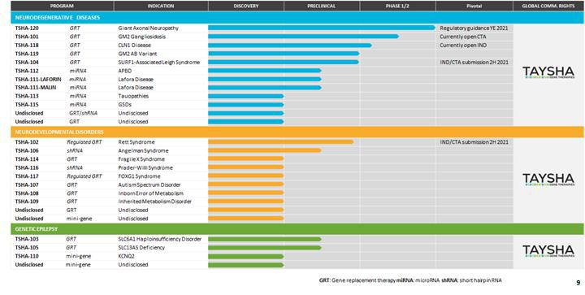

Recent Developments

In March 2021, we acquired the exclusive worldwide rights to a clinical-stage AAV9 gene therapy program, now known as TSHA-120, for the treatment of GAN, pursuant to a license agreement with Hannah’s Hope Fund for Giant Axonal Neuropathy, Inc., or HHF. Under the terms of the agreement, HHF will receive an upfront payment of $5.5 million and will be eligible to receive clinical, regulatory and commercial milestones totaling up to $19.3 million, as well as a low, single-digit royalty on net sales upon commercialization of TSHA-120.

TSHA-120 for Giant Axonal Neuropathy

We recently acquired exclusive worldwide rights to a clinical-stage, intrathecally dosed AAV9 gene therapy program, now known as TSHA-120, for the treatment of giant axonal neuropathy, or GAN. GAN is a rare autosomal recessive disease of the central and peripheral nervous systems caused by loss-of-function gigaxonin gene mutations. The estimated prevalence of GAN is 2,400 patients in the Unites States and European Union.

Symptoms and features of children with GAN usually develop around the age of five years and include an abnormal, wide based, unsteady gait, weakness and some sensory loss. There is often associated dull, tightly curled, coarse hair, giant axons seen on a nerve biopsy, and spinal cord atrophy and white matter abnormality seen on MRI. Symptoms progress and as the children grow older they develop progressive scoliosis and contractures, their weakness progresses to the point where they will need a wheelchair for mobility, respiratory muscle strength diminishes to the point where the child will need a ventilator (usually in the early to mid teens) and the children often die during their late teens or early twenties, typically due to respiratory failure. There is an early- and late-onset phenotype associated with the disease, with shared physiology. The late-onset phenotype is often categorized as Charcot-Marie-Tooth Type 2, or CMT2, with a lack of tightly curled hair and CNS symptoms with relatively slow progression of disease. This phenotype represents up to 6% of all CMT2 diagnosis. In the late-onset population, patients have poor quality of life but the disease is not life-

20

limiting. In early-onset disease, symptomatic treatments attempt to maximize physical development and minimize the rate of deterioration. Currently, there are no approved disease-modifying treatments available.

TSHA-120 is an AAV9 self-complementary viral vector encoding the full length human gigaxonin protein. The construct was invented by Dr. Steven Gray and is the first AAV9 gene therapy candidate to deliver a functional copy of the GAN gene under the control of a JeT promoter that drives ubiquitous expression.
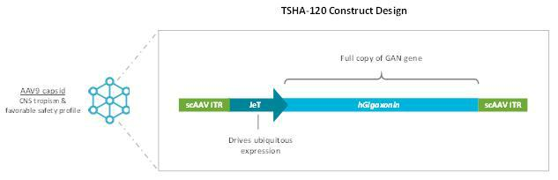

We have received orphan drug designation and rare pediatric disease designation from the FDA for TSHA-120 for the treatment of GAN.

There is an ongoing natural history study being led by the NIH, that has already identified and followed a number of patients with GAN for over five years with disease progression characterized by a number of clinical assessments. The GAN natural history study was initiated in 2013 and included 45 GAN patients, aged 3 to 21 years. As would be expected for a neurodegenerative disease, younger patients have higher baseline scores. However, the rate of decline in the MFM32 scores demonstrated consistency across patients of all ages, with most demonstrating an average 8-point decline per year regardless of age and/or baseline MFM32 score, as shown in the natural history plot below.
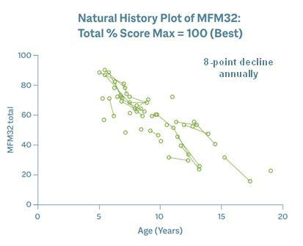

A 4-point score change in the MFM32 is considered clinically meaningful, suggesting that GAN patients lose significant function annually.

21

Preclinical Data

TSHA-120 performed well across in vitro and in vivo studies, and demonstrated improved motor function and nerve pathology, and long-term safety across several animal models. Of note, improved dorsal root ganglia, or DRG, pathology was demonstrated in TSHA-120-treated GAN knockout mice. These preclinical results have been published in a number of peer-reviewed journals.

Additional preclinical data from a GAN knockout rodent model that had received AAV9-mediated GAN gene therapy demonstrated that GAN rodents treated at 16 months performed significantly better than 18-month old untreated GAN rodents and equivalently to controls. These rodents were evaluated using a rotarod performance test which is designed to evaluate endurance, balance, grip strength and motor coordination in rodents. The time to fall off the rotarod, known as latency, was also evaluated and the data below demonstrate the clear difference in latency in treated versus untreated GAN rodents.
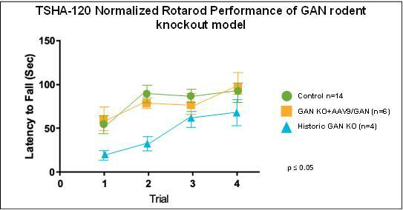

A result is considered to be statistically significant when the probability of the result occurring by random chance, rather than from the efficacy of the treatment, is sufficiently low. The conventional method for determining the statistical significance of a result is known as the “p-value,” which represents the probability that random chance caused the result (e.g., a p-value = 0.01 means that there is a 1% probability that the difference between the control group and the treatment group is purely due to random chance). Generally, a p-value less than 0.05 is considered statistically significant.

With respect to dorsal root ganglia, or DRG, inflammation that has been a topic of considerable interest within the gene therapy circles, in GAN and in the majority of diseases in our neurodegenerative franchise, the DRG have a significantly abnormal histological appearance and function as a consequence of underlying disease pathophysiology. Treatment with TSHA-120 resulted in considerable improvements in the pathological appearance of the DRG in the GAN knockout mice. Shown below is tissue from a GAN knockout mouse model with numerous abnormal neuronal inclusions containing aggregates of damaged neurofilament in the

22

DRG as indicated by the yellow arrows. On image C, the tissue from the GAN knockout mice treated with an intrathecal injection of TSHA-120 had a notable improvement in the reduction of these neuronal inclusions in the DRG.
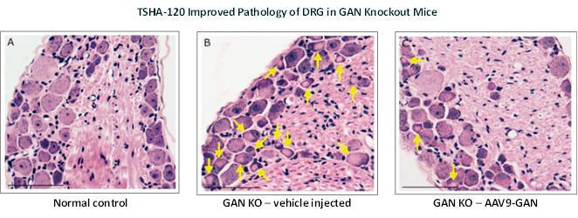

When a quantitative approach to the reduction in inclusions in the DRG was applied, it was observed that TSHA-120 treated mice experienced a statistically significant reduction in the average number of neuronal inclusions versus the GAN knockout mice that received vehicle as illustrated below.
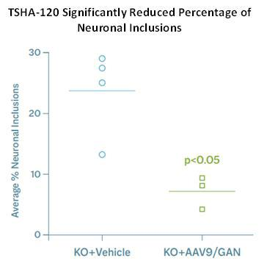

Results of Ongoing Phase 1/2 Clinical Trial

A Phase 1/2 clinical trial of TSHA-120 is being conducted by the NIH under an accepted IND. The ongoing trial is a single-site, open-label, non-randomized dose-escalation trial, in which patients are intrathecally dosed with one of 4 dose levels of TSHA-120 – 3.5x1013 total vg, 1.2x1014 total vg,
1.8x1014 total vg or 3.5x1014 total vg. The primary endpoint is to assess safety, with secondary endpoints measuring efficacy using pathologic, physiologic, functional, and clinical markers. To date, 14 patients have been intrathecally dosed and six patients have at least three years’ worth of long-term follow up data. The 1.8x1014 total vg dose and

23

1.2x1014 total vg cohorts demonstrated dose-related and meaningful slowing of disease progression in the first year post dosing, as illustrated below. The

1.8x1014 total vg dose effected a statistically significant 8-point improvement versus the historical control over the course of a year and the 1.2x1014 total vg dose effected a statistically significant 6-point improvement over the course of a year.
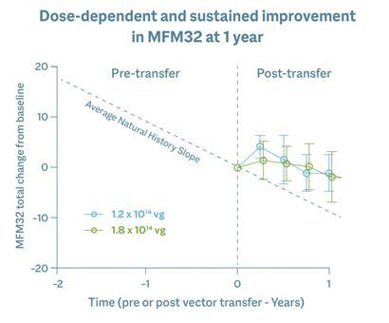

Six patients in the trial have been followed for more than three years. Patients dosed with 1.8x1014 total vg and 1.2x1014 total vg have shown sustained dose-dependent improvements in MFM32 scores for more than three years, as illustrated below.
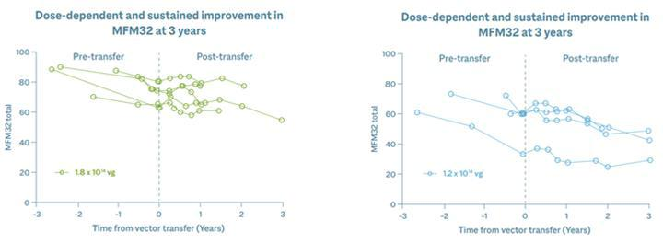

24

To date, TSHA-120 has been well-tolerated at multiple doses with no signs of significant acute or subacute inflammation, no sudden sensory changes and no drug-related or persistent elevation of transaminases. We expect to report additional data from this trial later this year, including results from the highest dose cohort of 3.5x1014 total vg.

Bayesian Analysis of TSHA-120

To gain further insight into the impact of TSHA-120 treatment on GAN disease progression and to add more robustness to the data, an additional analysis utilizing Bayesian statistical methodology was performed. Bayesian analysis is a useful method that enables direct probability statements about any unknown quantity of interest to be made, in this case, a statement around the probability of a clinically meaningful improvement in MFM32. Bayesian analysis also enables immediate incorporation into the analysis of data gathered as the trial progresses. It is a particularly appropriate approach for a clinical trial in a rare disease and is a way of statistically increasing the power of a clinical trial in a small patient population when used to incorporate auxiliary information such as historical data, or data that are being accumulated as the trial progresses. Importantly, it has been accepted by regulatory agencies in such cases. Below are the results of the Bayesian analysis of patient data from cohorts treated at 1.8x1014 total vg and 1.2x1014 total vg. As seen in the table, the analysis confirmed both the natural history data of an 8-point decline in the MFM32 total percent score per year, and importantly, that patients treated with 1.8x1014 total vg experienced an arrest of disease progression that was statistically significant. The Bayesian analysis confirms the positive findings that were seen with the frequentist approach.
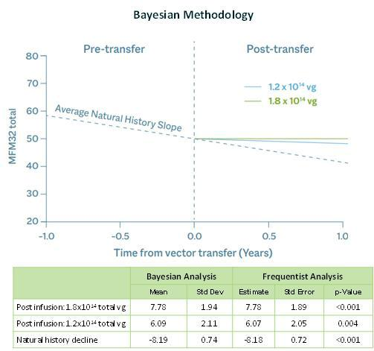

As shown below, the Bayesian efficacy analysis confirmed that TSHA-120 halted patients’ pre-treatment rate of decline when compared to individual historical data. As shown on these graphs, the 1.8x1014 total vg dose halted patient pre-treatment rate of decline with an average annual slope improvement of 7.78 points while the 1.2x1014 total vg dose resulted in a clinically meaningful

25

slowing of disease progression with an average annual slope improvement of 6.09 points. These results are consistent with a dose response relationship.
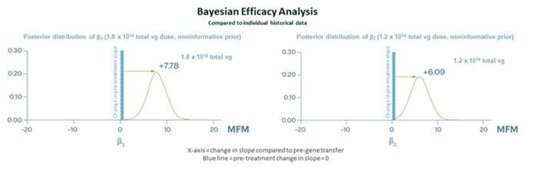

Further analyses confirmed that there was a nearly 100% probability of clinically meaningful slowing of disease progression. As shown below, the 1.8x1014 total vg dose confirmed a virtually 100% probability of clinically meaningful slowing of disease

26

compared to natural history decline of GAN patients while the 1.2x1014 total vg dose confirmed an approximately 85% probability of clinically meaningful slowing of disease and a virtually 100% probability of any slowing of disease.
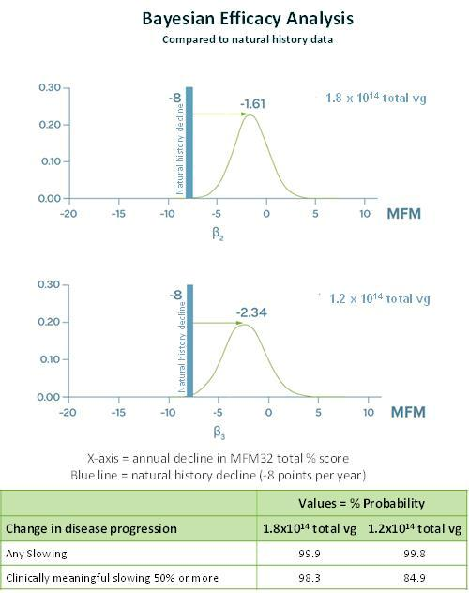

We intend to engage with the FDA, European Medicines Agency, Medicines and Healthcare products Regulatory Agency in the United Kingdom and the Pharmaceuticals and Medical Devices Agency in Japan to discuss the regulatory pathway for TSHA-120 and will provide an update by year-end.

Preclinical Program Updates

Vagus Nerve Redosing

Proof-of-concept research in the preclinical setting has supported that direct injection into the vagus nerve of TSHA-120 following an intrathecal administration of TSHA-120 may ameliorate autonomic nervous system dysfunction. At either four or sixteen weeks after wild-type rats were injected intrathecally with TSHA-120, they received a second dose via direct injection of the AAV9 vector into the vagus nerve. Four weeks after the second injection, tissues were assessed for expression of our re-dosed virus by

27

staining for the green fluorescent protein, GFP, carried by the second AAV9 vector. Examination of the injected vagus nerve and associated nodose ganglia showed a robust expression of GFP (as represented by the brown staining below), indicating that in rats, AAV9 can be re-dosed through a direct nerve injection following intrathecal delivery.
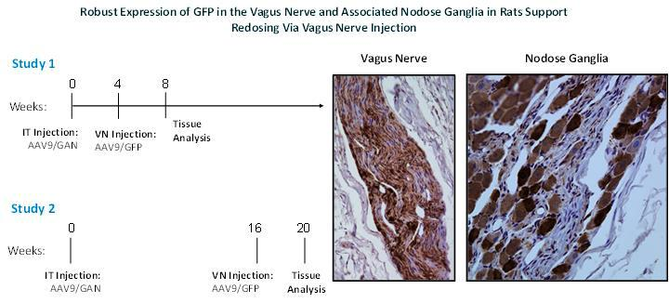

Consistent with single-dosing studies, re-dosed animals showed expression in the medulla vagus nerve nuclei. As shown below, GFP expression was seen in the nucleus ambiguous, which controls motor functions critical for vocalization, swallowing and

28

peristalsis and in the Pre-Botzinger complex, which contains respiratory rhythm generating neurons – all of which are autonomic functions compromised in GAN and many other neurological diseases.
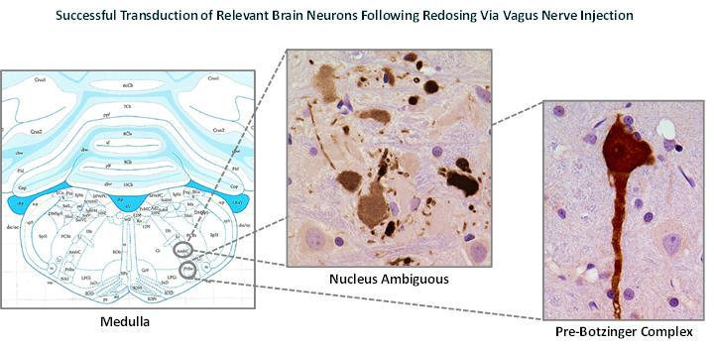

As illustrated below, further support of how vagus nerve injection permits AAV9 redosing was demonstrated in the brain of a naïve animal shown on the left compared to an intrathecally AAV9-immunized rat on the right. Efficient GFP transduction was observed in vagal nerve fibers and in brain neurons. In the area postrema, which has a reduced blood-barrier and is a target for vagal afferent fiber trafficking, there was reduced GFP expression in pre-immunized animals, at four and sixteen weeks, as compared to naïve animals. This suggests that pre-existing neutralization antibodies may dampen the overall transduction of vagal nerve delivered

29

AAV9, but efficient transduction of autonomic relevant neurons can still be achieved. These results support that the vagus nerve space is immune privileged enough to allow for redosing.
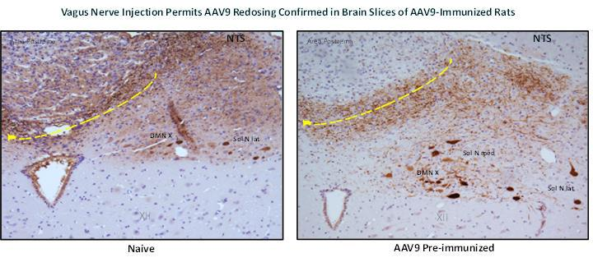

TSHA-102 for Rett Syndrome

TSHA-102, a neurodevelopmental disorder product candidate, is being developed for the treatment of Rett syndrome, one of the most common genetic causes of severe intellectual disability, characterized by rapid developmental regression and in many cases caused by heterozygous loss of function mutations in MECP2, a gene essential for neuronal and synaptic function in the brain. We designed TSHA-102 to prevent gene overexpression-related toxicity by inserting microRNA, or miRNA target binding sites into the 3’ untranslated region of viral genomes. This overexpression of MECP2 is seen in the clinic in patients with a condition known as MECP2 duplication syndrome, where elevated levels of MECP2 result in a clinical phenotype similar to Rett syndrome both in terms of symptoms and severity. TSHA-102 is constructed from a neuronal specific promoter, MeP426, coupled with the miniMECP2 transgene, a truncated version of MECP2, and miRNA-Responsive Auto-Regulatory Element, or miRARE, our novel miRNA target panel, packaged in self-complementary AAV9.

Recently, preclinical data from the ongoing natural history study for TSHA-102 were published online in Brain, a highly esteemed neurological science peer-reviewed journal. The preclinical study was conducted by the UT Southwestern Medical Center (UT Southwestern) laboratory of Sarah Sinnett, Ph.D., and evaluated the safety and efficacy of regulated miniMECP2 gene transfer, TSHA-102 (AAV9/miniMECP2-miRARE), via intrathecal (IT) administration in adolescent mice between four and five weeks of age. TSHA-102 was compared to unregulated full length MECP2 (AAV9/MECP2) and unregulated miniMECP2 (AAV9/miniMECP2).

TSHA-102 extended knockout survival by 56% via IT delivery. In contrast, the unregulated miniMECP2 gene transfer failed to significantly extend knockout survival at either dose tested. Additionally, the unregulated full-length MECP2 construct did not demonstrate a significant extension in survival and was associated with an unacceptable toxicity profile in wild type mice.

In addition to survival, behavioral side effects were explored. Mice were subjected to phenotypic scoring and a battery of tests including gait, hindlimb clasping, tremor and others to comprise an aggregate behavioral score. miRARE attenuated miniMECP2-mediated aggravation in wild type aggregate phenotype severity scores. Mice were scored on an aggregate severity scale using an established protocol. AAV9/MECP2- and AAV9/miniMECP2-treated wild type mice had a significantly higher mean (worse) aggregate behavioral severity score versus that observed for saline-treated mice (p <0.05; at 6–30 and 7–27 weeks of age, respectively). TSHA-102-treated wild type mice had a significantly lower (better) mean aggregate severity score versus those of AAV9/MECP2- and AAV9/miniMECP2-treated mice at most timepoints from 11–19 and 9–20 weeks of age, respectively. No significant difference was observed between saline- and TSHA-102-treated wild type mice.

miRARE-mediated genotype-dependent gene regulation was demonstrated by analyzing tissue sections from wild type and knockout mice treated with AAV9 vectors given intrathecally. TSHA-102 demonstrated regulated expression in different regions of

30

the brain. As shown in the graph and photos below, in the pons and midbrain, miRARE inhibited mean MECP2 gene expression in a genotype-dependent manner as indicated by significantly fewer myc(+) cells observed in wild type mice compared to knockout mice (p<0.05), thereby demonstrating that TSHA-102 achieved MECP2 expression levels similar to normal physiological parameters.
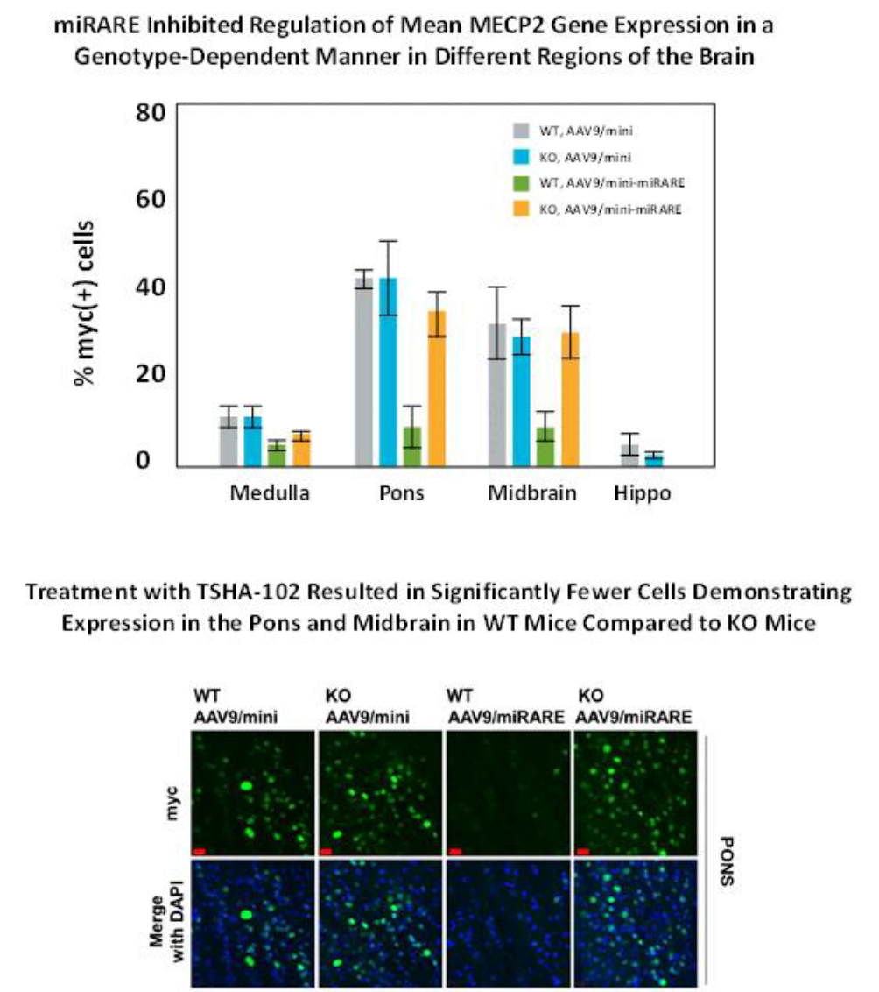

We plan to submit an IND / CTA for TSHA-102 in the second half of 2021 and initiate a clinical trial by the end of 2021.

TSHA-104 for SURF1-Associated Leigh Syndrome

We are developing TSHA-104, a neurodegenerative product candidate, for the treatment of SURF1-associated Leigh syndrome. The SURF1 gene encodes the SURF1 protein, which plays a critical role in mitochondrial translation and is involved in the assembly of the cytochrome c oxidase complex. Mutations in SURF1 lead to SURF1-associated Leigh syndrome, a recessively inherited mitochondrial disease, and are the most frequent cause of Leigh syndrome, a rapidly progressive neurological condition characterized by the degeneration of the CNS. To date over 100 SURF1 mutations, including non-sense, frame shift and missense variants have been described in literature. The incidence of SURF1-associated Leigh syndrome is estimated to be approximately 1 in 100,000 live births. The estimated prevalence of SURF1 deficiency is 300 to 400 patients in the United States and European Union.

31

SURF1-associated Leigh syndrome can lead to difficulty swallowing in infancy, with subsequent failure to thrive. Severely diseased muscle tone leading to respiratory failure, movement disorders and balance abnormalities are common. According to the literature, only a few patients have been reported to survive beyond 10 years of age. In the majority of SURF1-deficient patients, serum lactate is elevated, and elevated levels of serum lactate have been reported in the CSF as well, indicative of mitochondrial dysfunction. We are pursuing a gene replacement strategy with the goal of restoring mitochondrial function in patients with SURF1-associated Leigh syndrome caused by loss-of-function mutations.

We are constructing TSHA-104 from a codon-optimized version of the human SURF1 gene packaged within a self-complementary AAV9 viral vector under the control of a CBh promoter. We plan to submit an IND / CTA for TSHA-104 in the second half of 2021 and initiate a Phase 1/2 clinical trial by the end of 2021.

We have received orphan drug designation and rare pediatric disease designation from the FDA for TSHA-104 for the treatment of SURF1-associated Leigh Syndrome.

Preclinical Studies

Data from preclinical studies suggest that functional gene replacement strategy could restore mitochondrial functions in SURF1-associated Leigh syndrome caused by SURF1 loss-of-function mutations, which we believe supports continued development of TSHA-104. In these studies, TSHA-104 was administered at two dose levels via intrathecal lumbar puncture to a knock-out mouse model of SURF1-associated Leigh syndrome. Intrathecal treatment with TSHA-104 was observed to be well tolerated. TSHA-104 also induced SURF1 expression in the brain and partially rescued COX activity in a tissue specific manner as shown below.
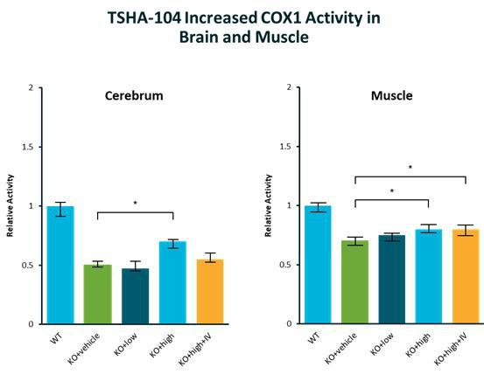

32

As shown below, TSHA-104 restored elevation of blood lactate on exhaustive exercise in the SURF1 knock-out mice.
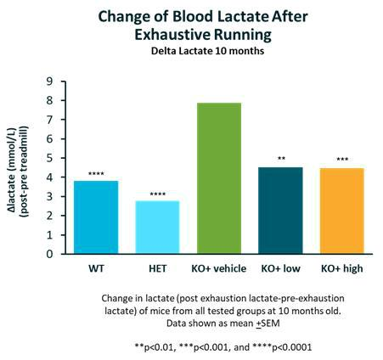

TSHA-113 for Tauopathies

We are developing TSHA-113 for the treatment of tauopathies. Tau accumulation predicts neurodegeneration in Alzheimer’s disease, and the propagation of tau aggregates is thought to mediate the progression of several neurodegenerative diseases, including progressive supranuclear palsy, corticobasal degeneration, behavioral variant frontotemporal degeneration, chronic traumatic encephalopathy, frontotemporal dementia and parkinsonism linked to chromosome 17.

As a result, multiple strategies are currently being tested to reduce tau and ameliorate the effects of these diseases. Preclinical studies testing tau anti-sense oligonucleotides, or ASOs, in the PS19 tauopathy mouse model prevented neuronal loss and showed a reversal of pathological tau deposition and seeding. This treatment in being tested in clinical trials. While promising, ASOs only reduced tau protein levels by approximately 50% in mice, and they required repeated, life-long intrathecal administration to reach this maximum effect.

We are developing TSHA-113 to utilize AAV-mediated gene silencing to deliver life-long reduction of tau protein levels in neurons following administration of a single dose. We are developing tau-specific miRNA shuttles that have been designed to target mRNA for all six isoforms of tau found in the human brain and/or mouse brain. Our preliminary data in cells has shown that our tau miRNA selectively reduced some human and mouse tau expression in vitro and we have packaged our miRNA shuttles in AAV9 capsids for further evaluation in mouse models of human tauopathies.

33

Preclinical Studies

In transgenic mouse models carrying human tau, TSHA-113 significantly reduced tau mRNA and protein levels, as shown in the three figures

below.
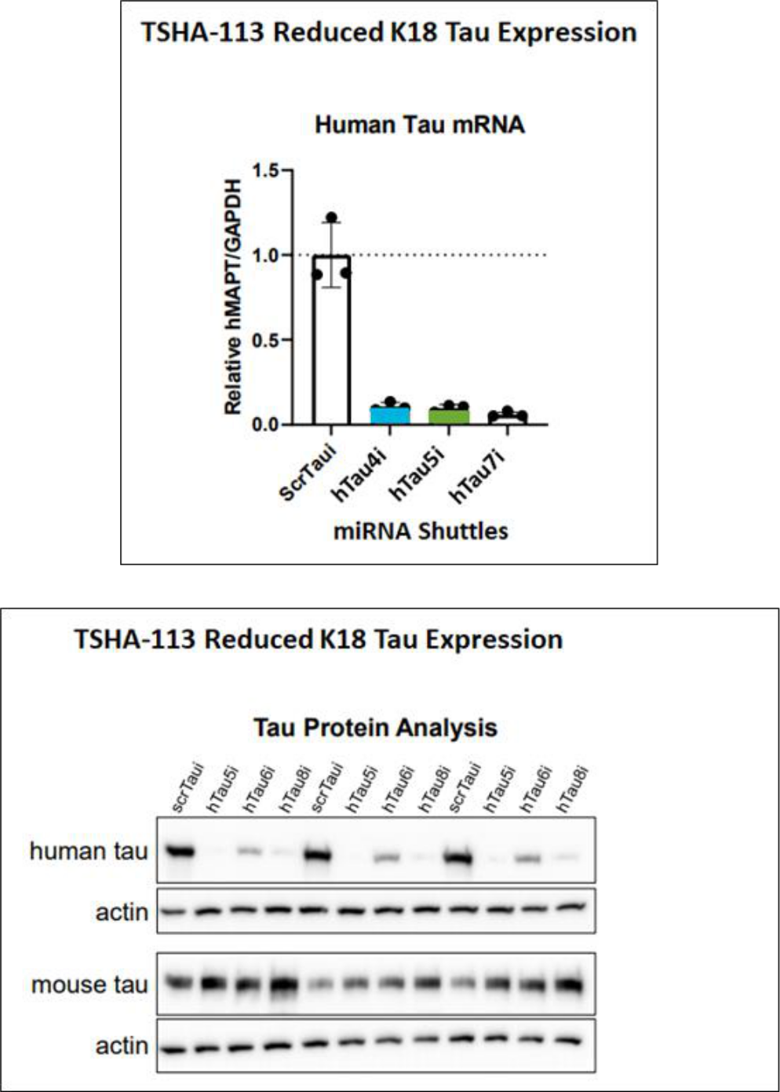

34

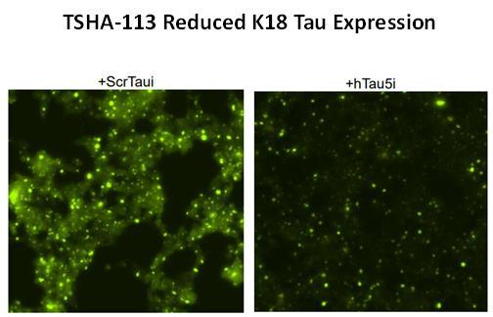

Mice dosed with TSHA-113 demonstrated widespread function and GFP expression in neurons and glia, as illustrated below.
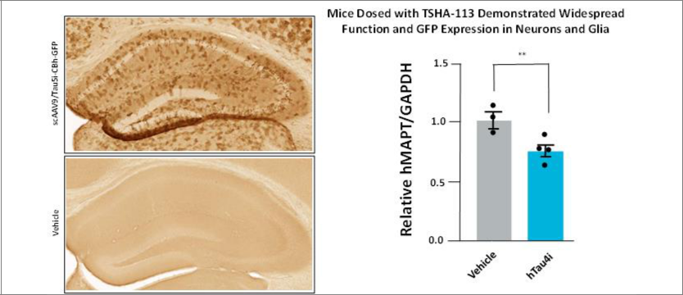

Together with previous in vitro findings, we believe that these data further validate selective reduction of tau mRNA and protein levels and warrant further preclinical development.

TSHA-105 for SLC13A5 Deficiency

We are developing TSHA-105 for the treatment of SLC13A5 deficiency, a rare autosomal recessive epileptic encephalopathy characterized by the onset of seizures within the first few days of life. The estimated prevalence of SLC13A5 deficiency is 1,900 patients in the United States and European Union. Affected children have impairments in gross motor function and speech production with relative preservation of fine motor skills and receptive speech. SLC13A5 deficiency is caused by bi-allelic loss-of function

35

mutations in the SLC13A5 gene, which codes for a sodium dependent citrate transporter, or NaCT, that is largely expressed in the brain and liver. To date, all tested mutations result in no or a greatly reduced amount of the citrate in the cells.

Diminished NaCT function leads to loss of neuronal uptake of citrate and other metabolites such as succinate that are critical to brain energy metabolism and function. Currently, there are no approved therapies for SLC13A5 deficiency, and treatment is largely to address symptoms.

We are developing TSHA-105 as a gene replacement therapy for SLC13A5 deficiency. TSHA-105 is constructed from a codon-optimized human SLC13A5 gene packaged in a self-complementary AAV9 capsid.

We have received orphan drug designation and rare pediatric disease designation from the FDA for TSHA-105 for the treatment of epilepsy caused by caused by SLC13A5 deficiency.

Preclinical Studies

In preliminary safety studies conducted in wildtype mice, vehicle or TSHA-105 was administered via CSF delivery. Weight and survival in the control and treatment group were the same and no overt toxicities were observed for up to one-year post-treatment.

Studies to evaluate TSHA-105 were conducted using SLC13A5 knockout mice. In comparison to age-matched, wildtype controls, SLC13A5 knockout mice exhibit altered citrate metabolism along with abnormal electroencephalogram, or EEG, activity and increased seizure susceptibility. At 3 months of age, SLC13A5 knockout mice were treated with TSHA-105 via CSF delivery. Administration of TSHA-105 resulted in a significant, sustainable decrease of plasma citrate levels up to 3-months post-injection, as shown below.
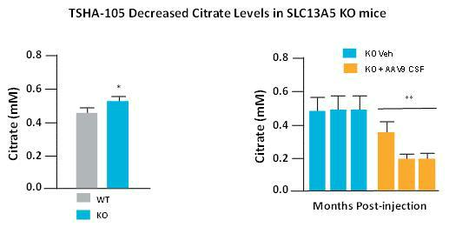

36

In addition, in ongoing EEG studies, TSHA-105 normalized EEG activity and decreased the number of seizures in knockout mice in comparison vehicle-treated controls as shown below.
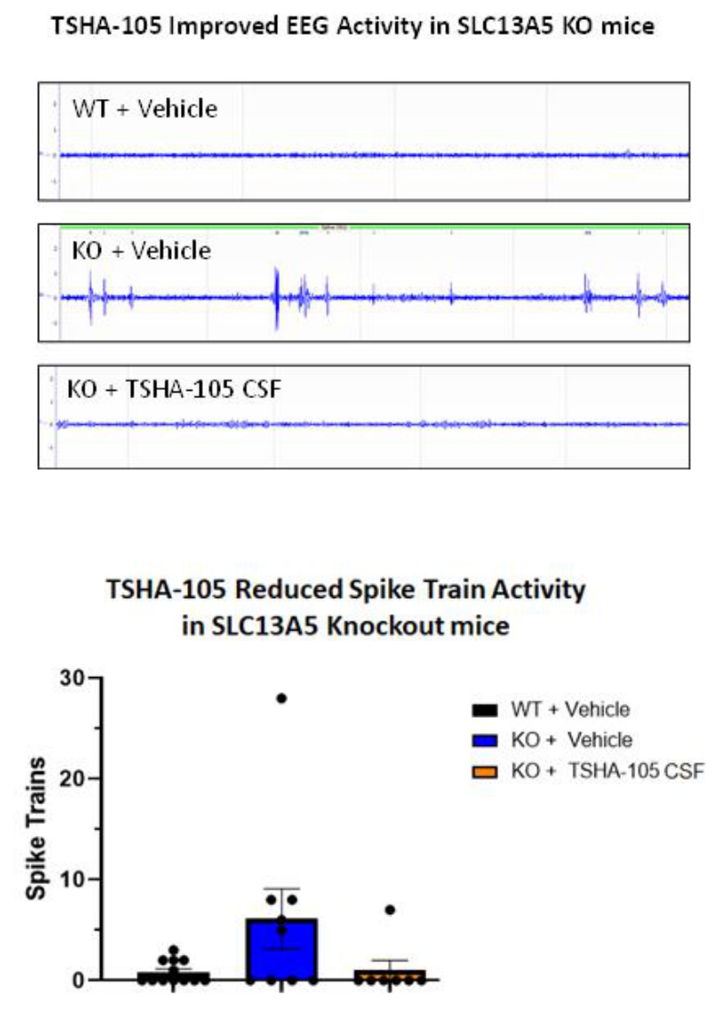

37

TSHA-105 also reduced seizure susceptibility in SLC13A5 knockout mice as shown below.
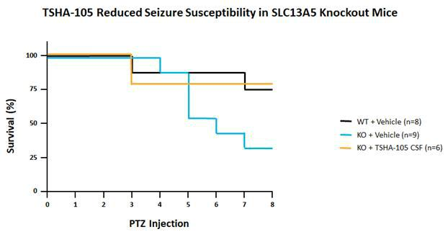

TSHA-103 for SLC6A1 Haploinsufficiency Disorder

SLC6A1 haploinsufficiency disorder is caused by loss-of-function mutations in the SLC6A1 gene. Loss of-function mutations in

the SLC6A1 gene have been identified as one of the most common monogenic causes of epilepsy with myoclonic atonic seizures, or brief and abrupt seizures followed by loss of muscle strength, as well as autism spectrum disorder and intellectual disability.

Patients diagnosed with SLC6A1 haploinsufficiency disorder typically present with developmental delay, varying degrees of intellectual disability, seizures and abnormal EEG characterized by generalized spike-wave discharges. Most patients are refractory to pharmacological seizure control although a portion of patients become seizure free during the course of disease progression. Importantly, seizure control is not associated with improved cognitive outcomes, which highlights the complexity of the disease as well as the need for novel therapies directed at its underlying pathology.

Approximately 81% of patients with SLC6A1 haploinsufficiency disorder have epilepsy, with typical absence seizures, which are abrupt and followed by lack of awareness, being the predominant form observed. In addition, 91% of individuals exhibit developmental delays, with more than 80% characterized as mild or moderate intellectual disability. Ataxia, or tremors, is present in approximately 29% of individuals, while autism or autistic features are observed in approximately 24% of individuals diagnosed with SLC6A1 haploinsufficiency disorder.

The SLC6A1 gene encodes the gamma-aminobutyric acid, or GABA, transporter 1, or GAT1. GAT1 is a voltage-dependent transporter responsible for the reuptake of GABA, a non-protein amino acid that is well characterized for its role as a major inhibitory neurotransmitter within the mammalian CNS. GAT1 plays a critical role in the reuptake of GABA from neuronal synapses and extracellular spaces and as a result, a critical role in balancing neuronal excitations. When GABA transport is disrupted, brain development is negatively impacted resulting in deficits in attention and cognition as well as seizures.

The exact incidence and prevalence of SLC6A1 haploinsufficiency disorder is unknown but we believe the estimated prevalence is 17,000 patients in the United States and European Union. According to recently published data, the incidence of SLC6A1 haploinsufficiency disorder is approximately 1 in 36,000 live births. We believe that SLC6A1 haploinsufficiency disorder is underdiagnosed as the underlying biology was only recently elucidated and the gene had not been part of commercially available genetic epilepsy screening panels. Clinician education and expanded use of genetic screening panels that include SLC6A1 will likely lead to increased identification of individuals with these mutations.

38

Our Solution: TSHA-103

We are developing TSHA-103, a genetic epilepsy product candidate, for the treatment of SLC6A1 haploinsufficiency disorder. TSHA-103 is a gene replacement therapy constructed from a codon-optimized version of the human SLC6A1 gene packaged within a self-complementary AAV9 viral vector. We are currently conducting preclinical studies of TSHA-103.

We have received orphan drug designation and rare pediatric disease designation from the FDA for TSHA-103 for the treatment of epilepsy caused by SLC6A1 haploinsufficiency disorder.

Preclinical Studies

We are currently conducting preclinical studies of TSHA-103. In the SLC6A1 knockout mouse model, TSHA-103 improved nesting and EEG, activity, as shown below.
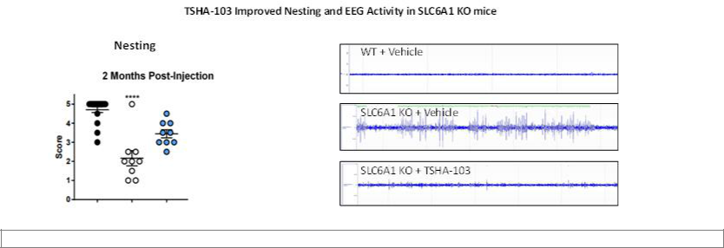

In SLC6A1 knockout and heterozygous mouse models, TSHA-103 reduced spike train activity, which is a recording of abnormal neuronal activity associated with seizures, as shown below.
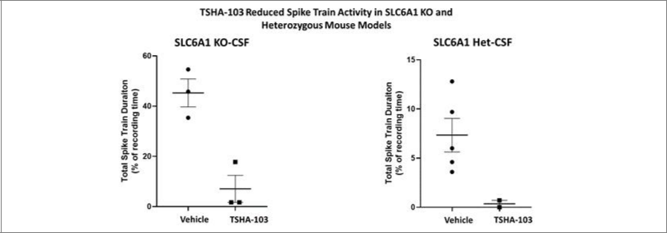

39

License Agreements

Research, Collaboration and License Agreement with The University of Texas Southwestern Medical Center

In November 2019, we entered into a research, collaboration and license agreement, or the UT Southwestern Agreement with The Board of Regents of the University of Texas System on behalf of UT Southwestern, as amended in April 2020.

In connection with the UT Southwestern Agreement, we obtained an exclusive, worldwide, royalty-free license under certain patent rights of UT Southwestern and a non-exclusive, worldwide, royalty-free license under certain know-how of UT Southwestern, in each case to make, have made, use, sell, offer for sale and import licensed products for use in certain specified indications. Additionally, we obtained a non-exclusive, worldwide, royalty-free license under certain patents and know-how of UT Southwestern for use in all human uses, with a right of first refusal to obtain an exclusive license under certain of such patent rights and an option to negotiate an exclusive license under other of such patent rights. We are required to use commercially reasonable efforts to develop, obtain regulatory approval for, and commercialize at least one licensed product.

In connection with the entry into the UT Southwestern Agreement, we issued to UT Southwestern 2,179,000 shares of our common stock. We do not have any future milestone or royalty obligations to UT Southwestern under the UT Southwestern Agreement, other than costs related to the maintenance of patents.

License Agreement with Queen’s University

In February 2020, we entered into a license agreement, or the Queen’s University Agreement with Queen’s University. In connection with the Queen’s University Agreement, we obtained an exclusive, perpetual, worldwide, royalty-bearing license, with the right to grant sublicenses, under certain patent rights and know-how of Queen’s University, including certain improvements to the foregoing, to make, have made, use, offer for sale, sell and import licensed products and otherwise exploit such patents and know-how for use in certain specified indications. We also obtained an exclusive right of first negotiation to license certain next generation technology and improvements of Queen’s University that do not constitute an already-licensed improvement to the licensed technology.

In connection with the Queen’s University Agreement, we paid Queen’s University a one-time fee of $3.0 million as an upfront fee and

approximately $0.2 million to reimburse Queen’s University for certain plasmid production costs. We are obligated to pay Queen’s University up to

$10.0 million in the aggregate upon achievement of certain regulatory milestones and up to $10.0 million in the aggregate upon achievement of certain

commercial milestones, a low single digit royalty on net sales of licensed products, subject to certain customary reductions, and a percentage of non-royalty

sublicensing revenue ranging in the low double digits. Royalties are payable on a licensed product-by-licensed product basis and country-by-country basis

until expiration of the last valid claim of a licensed patent covering such licensed product in such country and the expiration of any regulatory exclusivity

for such licensed product in such country. Additionally, we are obligated to pay Queen’s University a low double-digit portion of any amounts received by

us in connection with the sale of a priority review voucher related to a licensed product, not to exceed a low eight-figure amount.

In connection with a separate research grant agreement with Queen’s University, we reimbursed Queen’s University for certain manufacturing production costs totaling $3.8 million in fiscal year 2020.

License Agreement with Abeona (CLN1 Disease)

In August 2020, we entered into a license agreement, or the Abeona CLN1 Agreement, with Abeona Therapeutics Inc., or Abeona. In connection with the Abeona CLN1 Agreement, we obtained an exclusive, worldwide, royalty-bearing license, with the right to grant sublicenses under certain patents, know-how and materials originally developed by the University of North Carolina at Chapel Hill and Abeona to research, develop, manufacture, have manufactured, use, and commercialize licensed products for gene therapy for the prevention, treatment, or diagnosis of CLN1 Disease (one of the forms of Batten disease) in humans.

In connection with the license grant, we paid Abeona a one-time upfront license fee of $3.0 million during fiscal year 2020. We are obligated to pay Abeona up to $26.0 million in regulatory-related milestones and up to $30.0 million in sales-related milestones per licensed product and high single-digit royalties on net sales of licensed products. Royalties are payable on a licensed product-by-licensed product and country-by-country basis until the latest of the expiration or revocation or complete rejection of the last licensed patent covering such licensed product in the country where the licensed product is sold, the loss of market exclusivity in such country where the product is sold, or, if no licensed product exists in such country and no market exclusivity exists in such

40

country, ten years from first commercial sale of such licensed product in such country. In addition, concurrent with the Abeona CLN1 Agreement we entered into a purchase and reimbursement agreement with Abeona, pursuant to which we purchased specified inventory from Abeona and reimbursed Abeona for certain research and development costs previously incurred for total consideration of $4.0 million paid in fiscal year 2020.

The Abeona CLN1 Agreement expires on a country-by-country and licensed product-by-licensed product basis upon the expiration of the last royalty term of a licensed product. Either party may terminate the agreement upon an uncured material breach of the agreement or insolvency of the other party. We may terminate the agreement for convenience upon specified prior written notice to Abeona.

License Agreement with Abeona (Rett Syndrome)

In October 2020, we entered into a license agreement, or the Abeona Rett Agreement with Abeona pursuant to which we obtained an exclusive, worldwide, royalty-bearing license, with the right to grant sublicenses under certain patents, know-how and materials originally developed by the University of North Carolina at Chapel Hill, the University of Edinburgh and Abeona to research, develop, manufacture, have manufactured, use, and commercialize licensed products for gene therapy and the use of related transgenes for Rett syndrome.

Subject to certain obligations of Abeona, we are required to use commercially reasonable efforts to develop at least one licensed product and commercialize at least one licensed product in the United States.

In connection with the Abeona Rett Agreement, we paid Abeona a one-time upfront license fee of $3.0 million during fiscal year 2020. We are obligated to pay Abeona up to $26.5 million in regulatory-related milestones and up to $30.0 million in sales-related milestones per licensed product and high single-digit royalties on net sales of licensed products. Royalties are payable on a licensed product-by-licensed product and country-by-country basis until the latest of the expiration or revocation or complete rejection of the last licensed patent covering such licensed product in the country where the licensed product is sold, the loss of market exclusivity in such country where the product is sold, or, if no licensed product exists in such country and no market exclusivity exists in such country, ten years from first commercial sale of such licensed product in such country.

The Abeona Rett Agreement expires on a country-by-country and licensed product-by-licensed product basis upon the expiration of the last royalty term of a licensed product. Either party may terminate the agreement upon an uncured material breach of the agreement or insolvency of the other party. We may terminate the agreement for convenience.

Impact of COVID-19 on Our Business

We have been actively monitoring the COVID-19 situation and its impact globally. Our financial results for the quarter ended March 31, 2021 were not impacted by COVID-19. We believe the remote working arrangements and travel restrictions imposed by various governmental jurisdictions have had limited impact on our ability to maintain internal operations during the quarter ended March 31, 2021. The extent to which COVID-19 may impact our business and operations will depend on future developments that are highly uncertain and cannot be predicted with confidence, such as the duration of the outbreak, the effectiveness of actions to contain and treat COVID-19 and the efficacy, availability and adoption of vaccines, both domestically and globally. Although we have not experienced any material business shutdowns or interruptions due to the COVID-19 pandemic, we cannot predict the scope and severity of any potential business shutdowns or disruptions in the future, including to our planned clinical trials and preclinical studies. Any such shutdowns or other business interruptions could result in material and negative effects to our ability to conduct our business in the manner and on the timelines presently planned, which could have a material adverse impact on our business, results of operation and financial condition.

Components of Results of Operations

Revenue

To date, we have not recognized any revenue from any sources, including from product sales, and we do not expect to generate any revenue from the sale of products, if approved, in the foreseeable future. If our development efforts for our product candidates are successful and result in regulatory approval, or license agreements with third parties, we may generate revenue in the future from product sales. However, there can be no assurance as to when we will generate such revenue, if at all.

41

Operating Expenses

Research and Development Expenses

Research and development expenses primarily consist of preclinical development of our product candidates and discovery efforts, including conducting preclinical studies, manufacturing development efforts, preparing for clinical trials and activities related to regulatory filings for our product candidates. Research and development expenses are recognized as incurred and payments made prior to the receipt of goods or services to be used in research and development are capitalized until the goods or services are received. Costs incurred in obtaining technology licenses through asset acquisitions are charged to research and development expense if the licensed technology has not reached technological feasibility and has no alternative future use. Research and development expenses include or could include:

- employee-related expenses, including salaries, bonuses, benefits, stock-based compensation, other related costs for those employees involved in research and development efforts;

- external research and development expenses incurred under agreements with consultants, contract research organizations, or CROs, investigative sites and consultants to conduct our preclinical studies;

- costs related to manufacturing material for our preclinical studies and clinical trials, including fees paid to contract manufacturing organizations, or CMOs;

- laboratory supplies and research materials;

- costs related to compliance with regulatory requirements; and

- facilities, depreciation and other allocated expenses, which include direct and allocated expenses for rent, maintenance of facilities, insurance and equipment.

Research and development activities are central to our business model. Product candidates in later stages of clinical development generally have higher development costs than those in earlier stages of clinical development, primarily due to the increased size and duration of later-stage clinical trials. We plan to substantially increase our research and development expenses for the foreseeable future as we continue the development of our product candidates and manufacturing processes and conduct discovery and research activities for our preclinical programs. We cannot determine with certainty the timing of initiation, the duration or the completion costs of current or future preclinical studies and clinical trials of our product candidates due to the inherently unpredictable nature of preclinical and clinical development. Clinical and preclinical development timelines, the probability of success and development costs can differ materially from expectations. We anticipate that we will make determinations as to which product candidates to pursue and how much funding to direct to each product candidate on an ongoing basis in response to the results of ongoing and future preclinical studies and clinical trials, regulatory developments and our ongoing assessments as to each product candidate’s commercial potential. We will need to raise substantial additional capital in the future. Our clinical development costs are expected to increase significantly as we commence clinical trials. Our future expenses may vary significantly each period based on factors such as:

- expenses incurred to conduct preclinical studies required to advance our product candidates into clinical development;

- per patient trial costs, including based on the number of doses that patients received;

- the number of patients who enroll in each trial;

- the number of trials required for approval;

- the number of sites included in the trials;

- the countries in which the trials are conducted;

- the length of time required to enroll eligible patients;

- the drop-out or discontinuation rates of patients;

- potential additional safety monitoring requested by regulatory agencies;

- the duration of patient participation in the trials and follow-up;

- the phase of development of the product candidate;

- third-party contractors failing to comply with regulatory requirements or meet their contractual obligations to us in a timely manner, or at all;

42

- the ability to manufacture of our product candidates;

- regulators or institutional review boards, or IRBs requiring that we or our investigators suspend or terminate clinical development for various reasons, including noncompliance with regulatory requirements or a finding that the participants are being exposed to unacceptable health risks; and

- the efficacy and safety profile of our product candidates.

General and Administrative Expenses

General and administrative expenses consist or will consist principally of salaries and related costs for personnel in executive and administrative functions, including stock-based compensation, travel expenses and recruiting expenses. Other general and administrative expenses include professional fees for legal, consulting, accounting and audit and tax-related services and insurance costs.

We anticipate that our general and administrative expenses will increase in the future as we increase our headcount to support our expanded infrastructure, as well as the initiation and continuation of our preclinical studies and clinical trials for our product candidates. We also anticipate that our general and administrative expenses will increase as a result of payments for accounting, audit, legal, consulting services, as well as costs associated with maintaining compliance with Nasdaq listing rules and SEC requirements, director and officer liability insurance, investor and public relations activities and other expenses associated with operating as a public company. We anticipate the additional costs for these services will increase our general and administrative expenses by between $6.0 million and $7.0 million on an annual basis, including the cost of director and officer liability insurance.

Results of Operations

Results of Operations for the Three Months Ended March 31, 2021 and for the Three Months Ended March 31, 2020

The following table summarizes our results of operations for the three months ended March 31, 2021 and the three months ended March 31,

2020 (in thousands):

 |  | For the Three Months |  |  | For the Three Months
 | Ended March 31, 2021 |  |  | Ended March 31, 2020
Operating expenses:
Research and development | $ | 23,854 |  | $ | 5,514
General and administrative |  | 8,236 |  |  | 70
Total operating expenses |  | 32,090 |  |  | 5,584
Loss from operations |  | (32,090) |  |  | (5,584)
Other income (expense):
Change in fair value of preferred stock tranche liability |  | — |  |  | 180
Interest income |  | 66 |  |  | —
Interest expense |  | — |  |  | (27)
Total other income, net |  | 66 |  |  | 153
Net loss | $ | (32,024) |  | $ | (5,431)

Research and Development Expenses

Research and development expenses were $23.9 million for the three months ended March 31, 2021, compared to $5.5 million for the three months ended March 31, 2020. The $18.4 million increase was primarily attributable to an increase of $3.1 million of expenses incurred in research and development manufacturing and other raw material purchases, which included cGMP batches produced by Catalent and UT Southwestern. Additionally, we incurred a year-over-year increase of $3.1 million in research and development licensing fees driven by the acquisition of exclusive worldwide rights to TSHA-120, for the treatment of GAN. We incurred an increase in employee compensation and expenses of $5.2 million, which included $1.6 million of non-cash stock-based compensation. We also incurred an increase of $2.4 million in sponsored research agreement expenses for our various product candidates. Additionally, we incurred an increase of $2.7 million for research and development consulting fees including technical operations support and translational sciences, $0.9 million for regulatory and clinical consulting, and other research and development of $1.0 million.

43

General and Administrative Expenses

General and administrative expenses were $8.2 million for the three months ended March 31, 2021, compared to less than $0.1 million for the three months ended March 31, 2020. The increase of approximately $8.1 million was primarily attributable to $4.2 million of incremental compensation expense, which included $2.0 million of non-cash stock-based compensation, $1.5 million of additional consulting and professional fees, including patient advocacy consulting fees and personnel recruiting expenses. We also incurred an increase of $0.9 million of professional fees, which included $0.7 million in legal expenses related to general corporate matters, $0.8 million related to insurance expenses, $0.3 million of marketing expenses, and other general and administrative expenses of $0.5 million.

Other Income (Expense)

Change in Fair Value of Preferred Stock Tranche Liability

We determined that our obligation to issue, and the investors’ right to purchase, additional shares of Series A convertible preferred stock pursuant to the milestone closings represented a freestanding financial instrument, or the tranche liability. The tranche liability was initially recorded at fair value. We concluded that the tranche liability met the definition of a freestanding financial instrument, as it was legally detachable and separately exercisable from the initial closing of the Series A convertible preferred stock.

On March 31, 2020 the tranche liability was remeasured and a non-cash gain of $0.2 million was recorded in other income, net.

Liquidity and Capital Resources

Overview

Since our inception, we have not generated any revenue and have incurred significant operating losses. As of March 31, 2021, we had cash and cash equivalents of $228.7 million. We have funded our operations through equity financings, raising an aggregate of $307.0 million in gross proceeds from our initial public offering and private placements of convertible preferred stock. Specifically, between March and July 2020, we closed on the sale of an aggregate of 10,000,000 shares of Series A convertible preferred stock for gross proceeds of $30.0 million. In July and August 2020, we closed on the sale of an aggregate of 5,647,048 shares of Series B convertible preferred stock for gross proceeds of $96.0 million. In September 2020, we raised gross proceeds of $181.0 million in our initial public offering.

Funding Requirements

To date, we have not generated any revenues from the commercial sale of approved drug products, and we do not expect to generate substantial revenue for at least the next few years. If we fail to complete the development of our product candidates in a timely manner or fail to obtain their regulatory approval, our ability to generate future revenue will be compromised. We do not know when, or if, we will generate any revenue from our product candidates, and we do not expect to generate significant revenue unless and until we obtain regulatory approval of, and commercialize, our product candidates. We expect our expenses to increase in connection with our ongoing activities, particularly as we continue the research and development of, initiate clinical trials of and seek marketing approval for our product candidates, as well as build out of our cGMP manufacturing facility in Durham, North Carolina. In addition, if we obtain approval for any of our product candidates, we expect to incur significant commercialization expenses related to sales, marketing, manufacturing and distribution. Furthermore, we expect to incur additional costs associated with operating as a public company. We anticipate that we will need substantial additional funding in connection with our continuing operations. If we are unable to raise capital when needed or on attractive terms, we could be forced to delay, reduce or eliminate our research and development programs or future commercialization efforts.

We believe that our existing cash and cash equivalents will enable us to fund our operating expenses and capital requirements into 2023. We intend to devote our existing cash and cash equivalents to the clinical and preclinical development of our product candidates. We have based this estimate on assumptions that may prove to be imprecise, and we could utilize our available capital resources sooner than we expect.

44

Because of the numerous risks and uncertainties associated with research, development and commercialization of biological products, we are unable to estimate the exact amount of our operating capital requirements. Our future funding requirements will depend on many factors, including, but not limited to:

- the scope, progress, costs and results of discovery, preclinical development, laboratory testing and clinical trials for TSHA-101, TSHA-118, TSHA-102, TSHA-104, and TSHA-120 and any current and future product candidates that we advance;

- the extent to which we develop, in-license or acquire other product candidates and technologies in our gene therapy product candidate pipeline;

- the costs and timing of process development and manufacturing scale-up activities associated with our product candidates and other programs as we advance them through preclinical and clinical development;

- the number and development requirements of product candidates that we may pursue;

- the costs, timing and outcome of regulatory review of our product candidates;

- our headcount growth and associated costs as we expand our research and development capabilities and establish a commercial infrastructure;

- the costs of establishing and maintaining our own commercial-scale cGMP manufacturing facility;

- the costs and timing of future commercialization activities, including product manufacturing, marketing, sales, and distribution, for any of our product candidates for which we receive marketing approval;

- the costs and timing of preparing, filing and prosecuting patent applications, maintaining and enforcing our intellectual property rights and defending any intellectual property-related claims;

- the revenue, if any, received from commercial sales of our product candidates for which we receive marketing approval; and

- the costs of operating as a public company.

Identifying potential product candidates and conducting preclinical studies and clinical trials is a time-consuming, expensive and uncertain process that takes many years to complete, and we may never generate the necessary data or results required to obtain marketing approval and achieve product sales. In addition, our product candidates, if approved, may not achieve commercial success. Our commercial revenues, if any, will be derived from sales of product candidates that we do not expect to be commercially available in the near term, if at all. Accordingly, we will need to continue to rely on additional financing to achieve our business objectives. Adequate additional financing may not be available to us on acceptable terms, or at all. To the extent that we raise additional capital through the sale of equity or convertible debt securities, the terms of these equity securities or this debt may restrict our ability to operate. Any future debt financing and equity financing, if available, may involve agreements that include covenants limiting and restricting our ability to take specific actions, such as incurring additional debt, making capital expenditures, entering into profit-sharing or other arrangements or declaring dividends. If we raise additional funds through collaborations, strategic alliances or marketing, distribution or licensing arrangements with third parties, we may be required to relinquish valuable rights to our technologies, future revenue streams, research programs or product candidates or to grant licenses on terms that may not be favorable to us.

We are continuing to assess the effect that the COVID-19 pandemic may have on our business and operations. The extent to which COVID-19 may impact our business and operations will depend on future developments that are highly uncertain and cannot be predicted with confidence, such as the duration of the outbreak, the duration and effect of business disruptions and the short-term effects and ultimate effectiveness of the travel restrictions, quarantines, social distancing requirements and business closures in the United States and other countries to contain and treat the disease and the efficacy, availability and adoption of vaccines, both domestically and globally. While the potential economic impact brought by, and the duration of, COVID-19 may be difficult to assess or predict, a continued and growing pandemic could result in significant disruption of global financial markets, reducing our ability to

45

access capital, which could in the future negatively affect our liquidity. In addition, a recession or market correction resulting from the spread of COVID-19 could materially affect our business and the value of our common stock.

Cash Flows

The following table shows a summary of our cash flows for the three months ended March 30, 2021 and 2020 (in thousands):

 |  | For the Three Months |  |  | For the Three Months
 | Ended March 31, 2021 |  |  | Ended March 31, 2020
Net cash used in operating activities | $ | (22,035) |  | $ | (1,699)
Net cash used in investing activities |  | (534) |  |  | —
Net cash provided by financing activities |  | — |  |  | 18,027
Net change in cash and cash equivalents | $ | (22,569) |  | $ | 16,328

Operating Activities

For the three months ended March 31, 2021, our net cash used in operating activities of $22.0 million primarily consisted of a net loss of $32.0 million, primarily attributable to our spending on research and development expenses. The net loss of $32.0 million was partially offset by adjustments for non-cash items, primarily the up-front license fee of $5.5 million to HHF related to the acquisition of TSHA-120 and stock-based compensation of $3.6 million.

For the three months ended March 31, 2020, our net cash used in operating activities of $1.7 million primarily consisted of a net loss of $5.4 million, primarily attributable to spending on research and development expenses. The net loss of $5.4 million was partially offset by the upfront fee to acquire the license rights pursuant to the Queen’s University Agreement for $3.0 million.

Investing Activities

During the three months ended March 31, 2021, investing activities used $0.5 million of cash attributable to capital expenditures related to computer and lab equipment. No investing activities took place in the three months ended March 31, 2020.

Financing Activities

During the three months ended March 31, 2020, financing activities provided $18.0 million attributable to the net proceeds from the sale of our Series A convertible preferred stock. No financing activities took place during the three months ended March 31, 2021.

Off-Balance Sheet Arrangements

We did not have during the periods presented, and we do not currently have, any off-balance sheet arrangements, as defined in the rules and regulations of the SEC.

Critical Accounting Policies and Significant Judgments and Estimates

There were no material changes to our critical accounting policies that are disclosed in our audited consolidated financial statements for the year ended December 31, 2020 filed with the SEC on March 3, 2021.

Recent Accounting Pronouncements

See Note 2 to our unaudited condensed consolidated financial statements located in “Part I – Financial Information, Item 1. Financial Statements” in this Quarterly Report on Form 10-Q for a description of recent accounting pronouncements applicable to our consolidated financial statements.

Emerging Growth Company and Smaller Reporting Company Status

In April 2012, the Jumpstart Our Business Startups Act of 2012, or JOBS Act, was enacted. Section 107 of the JOBS Act provides that an “emerging growth company” can take advantage of the extended transition period provided in Section 7(a)(2)(B) of the Securities Act of 1933, as amended, for complying with new or revised accounting standards. Thus, an emerging growth company

46

can delay the adoption of certain accounting standards until those standards would otherwise apply to private companies. We elected the extended transition period for complying with new or revised accounting standards, which delays the adoption of these accounting standards until they would apply to private companies.

In addition, as an emerging growth company, we may take advantage of specified reduced disclosure and other requirements that are otherwise applicable generally to public companies. These provisions include:

- an exception from compliance with the auditor attestation requirements of Section 404 of the Sarbanes-Oxley Act of 2002, as amended;

- reduced disclosure about our executive compensation arrangements in our periodic reports, proxy statements and registration statements;

- exemptions from the requirements of holding non-binding advisory votes on executive compensation or golden parachute arrangements; and

- an exemption from compliance with the requirements of the Public Company Accounting Oversight Board regarding the communication of critical audit matters in the auditor’s report on financial statements.

We may take advantage of these provisions until we no longer qualify as an emerging growth company. We will cease to qualify as an emerging growth company on the date that is the earliest of: (i) December 31, 2025, (ii) the last day of the fiscal year in which we have more than $1.07 billion in total annual gross revenues, (iii) the date on which we are deemed to be a “large accelerated filer” under the rules of the SEC, which means the market value of our common stock that is held by non-affiliates exceeds $700 million as of the prior June 30th, or (iv) the date on which we have issued more than $1.0 billion of non-convertible debt over the prior three-year period. We may choose to take advantage of some but not all of these reduced reporting burdens. We have taken advantage of certain reduced reporting requirements in this Quarterly Report on Form 10-Q and our other filings with the SEC. Accordingly, the information contained herein may be different than you might obtain from other public companies in which you hold equity interests.

We are also a “smaller reporting company,” meaning that the market value of our shares held by non-affiliates is less than $700 million and our annual revenue was less than $100 million during the most recently completed fiscal year. We may continue to be a smaller reporting company if either
- the market value of our shares held by non-affiliates is less than $250 million or (ii) our annual revenue was less than $100 million during the most recently completed fiscal year and the market value of our shares held by non-affiliates is less than $700 million. If we are a smaller reporting company at the time we cease to be an emerging growth company, we may continue to rely on exemptions from certain disclosure requirements that are available to smaller reporting companies. Specifically, as a smaller reporting company, we may choose to present only the two most recent fiscal years of audited financial statements in our Annual Report on Form 10-K and, similar to emerging growth companies, smaller reporting companies have reduced disclosure obligations regarding executive compensation.

Item 3. Quantitative and Qualitative Disclosures About Market Risk.

We are a smaller reporting company as defined by Rule 12b-2 of the Exchange Act and are not required to provide the information required under this Item.

Item 4. Controls and Procedures.

Evaluation of Disclosure Controls and Procedures

Our management, with the participation of our Chief Executive Officer and Chief Financial Officer, has evaluated the effectiveness of our disclosure controls and procedures (as defined in Rules 13a-15(e) and 15d-15(e) under the Exchange Act ), as of the end of the period covered by this Form 10-Q. Based on such evaluation, our Chief Executive Officer and Chief Financial Officer have concluded that as of March 31, 2021, our disclosure controls and procedures were effective to provide reasonable assurance that the information required to be disclosed by us in this Form 10-Q was (a) reported within the time periods specified by SEC rules and regulations, and (b) communicated to our management, including our Chief Executive Officer and Chief Financial Officer, to allow timely decisions regarding any required disclosure.

47

Changes in Internal Control Over Financial Reporting

There were no changes in our internal control over financial reporting identified in management’s evaluation pursuant to Rules 13a-15(d) or 15d-15(d) of the Exchange Act during the period covered by this Quarterly Report on Form 10-Q that materially affected, or are reasonably likely to materially affect, our internal control over financial reporting.

Inherent Limitations on Effectiveness of Internal Controls

In designing and evaluating the disclosure controls and procedures, management recognizes that any controls and procedures, no matter how well designed and operated, can provide only reasonable, not absolute, assurance of achieving the desired control objectives. In addition, the design of disclosure controls and procedures must reflect the fact that there are resource constraints and that management is required to apply judgment in evaluating the benefits of possible controls and procedures relative to their costs. Our management, including our Chief Executive Officer and Chief Financial Officer, believes that our disclosure controls and procedures and internal control over financial reporting are designed to provide reasonable assurance of achieving their objectives and are effective at the reasonable assurance level. However, our management does not expect that our disclosure controls and procedures or our internal control over financial reporting will prevent all errors and all fraud.

48

PART II—OTHER INFORMATION

Item 1. Legal Proceedings.

We are not subject to any material legal proceedings. From time to time, we may be involved in various claims and legal proceedings relating to claims arising out of our operations. We are not currently a party to any legal proceedings that, in the opinion of our management, are likely to have a material adverse effect on our business. Regardless of outcome, litigation can have an adverse impact on us because of defense and settlement costs, diversion of management resources and other factors.

Item 1A. Risk Factors.

Our business is subject to risks and events that, if they occur, could adversely affect our financial condition and results of operations and the trading price of our securities. In addition to the other information set forth in this quarterly report on Form 10-Q, you should carefully consider the factors described in Part I, Item 1A. “Risk Factors” of our Annual Report on Form 10-K for the fiscal year ended December 31, 2020, filed with the Securities and Exchange Commission on March 3, 2021. There have been no material changes to the risk factors described in that report.

Item 2. Unregistered Sales of Equity Securities and Use of Proceeds.

(a) Recent Sales of Unregistered Equity Securities

None.

(b) Use of Proceeds

On September 23, 2020, our Registration Statement on Form S-1, as amended (File No. 333-248559), was declared effective in connection with our initial public offering, pursuant to which we sold an aggregate of 9,050,000 shares of our common stock, including the full exercise of the underwriters’ option to purchase additional shares, at a price to the public of $20.00 per share. Goldman Sachs & Co. LLC, Morgan Stanley & Co. LLC and Jefferies LLC acted as joint book-running managers and Chardan Capital Markets, LLC acted as lead manager for the offering.

The initial public offering closed on September 28, 2020 with respect to 7,869,566 shares of common stock. On September 29, 2020, the offering

closed with respect to an additional 1,180,434 shares purchased by the underwriters pursuant to the underwriters’ option to purchase additional shares. The

aggregate net proceeds from our initial public offering, after underwriting discounts and commissions, and other offering expenses of $2.5 million, were

$165.9 million. In connection with our initial public offering, no payments were made by us to directors, officers or persons owning ten percent or more of

our common stock or to their associates or to our affiliates. There has been no material change in the planned use of proceeds from our initial public

offering as described in our prospectus filed pursuant to Rule 424(b)(4) under the Securities Act with the SEC on September 25, 2020.

(c) Issuer Purchases of Equity Securities

None.

Item 3. Defaults Upon Senior Securities.

Not applicable.

Item 4. Mine Safety Disclosures.

Not applicable.

Item 5. Other Information.

Not applicable.

49

Item 6. Exhibits.

 | The exhibits listed on the Exhibit Index are either filed or furnished with this report or incorporated herein by reference.
Exhibit
Number |  |  |  |  |  |  |  | Description
3.1 |  |  | Amended and Restated Certificate of Incorporation (incorporated by reference to Exhibit 3.1 to the Company’s Current Report on Form 8-K
 |  |  | (File No. 001-39536), filed with the Securities and Exchange Commission on September 29, 2020).
3.2 |  |  | Amended and Restated Bylaws (incorporated by reference to Exhibit 3.2 to the Company’s Current Report on Form 8-K (File No. 001-39536),
 |  |  | filed with the Securities and Exchange Commission on September 29, 2020).
31.1* |  |  | Certification of Principal Executive Officer Pursuant to Rules 13a-14(a) and 15d-14(a) under the Securities Exchange Act of 1934, as Adopted
 |  |  | Pursuant to Section 302 of the Sarbanes-Oxley Act of 2002.
31.2* |  |  | Certification of Principal Financial Officer Pursuant to Rules 13a-14(a) and 15d-14(a) under the Securities Exchange Act of 1934, as Adopted
 |  |  | Pursuant to Section 302 of the Sarbanes-Oxley Act of 2002.
32.1*# |  |  | Certification of Principal Executive Officer Pursuant to 18 U.S.C. Section 1350, as Adopted Pursuant to Section 906 of the Sarbanes-Oxley
 |  |  | Act of 2002.
32.2*# |  |  | Certification of Principal Financial Officer Pursuant to 18 U.S.C. Section 1350, as Adopted Pursuant to Section 906 of the Sarbanes-Oxley Act
 |  |  | of 2002.
101.INS |  |  | XBRL Instance Document
101.SCH |  |  | XBRL Taxonomy Extension Schema Document
101.CAL |  |  | XBRL Taxonomy Extension Calculation Linkbase Document
101.DEF |  |  | XBRL Taxonomy Extension Definition Linkbase Document
101.LAB |  |  | XBRL Taxonomy Extension Label Linkbase Document
101.PRE |  |  | XBRL Taxonomy Extension Presentation Linkbase Document

- Filed herewith.

- These certifications are being furnished solely to accompany this quarterly report pursuant to 18 U.S.C. Section 1350, and are not being filed for purposes of Section 18 of the Securities Exchange Act of 1934, as amended, and are not to be incorporated by reference into any filing of the registrant, whether made before or after the date hereof, regardless of any general incorporation language in such filing.

50

SIGNATURES

Pursuant to the requirements of the Securities Exchange Act of 1934, the registrant has duly caused this report to be signed on its behalf by the undersigned thereunto duly authorized.

 | Company Name
Date: May 11, 2021 | By: |  | /s/ RA Session II
 |  |  | RA Session II
 |  |  | President and Chief Executive Officer
 |  |  | (Principal Executive Officer)
Date: May 11, 2021 | By: |  | /s/ Kamran Alam
 |  |  | Kamran Alam
 |  |  | Chief Financial Officer
 |  |  | (Principal Financial and Accounting Officer)
 | 51

Exhibit 31.1

CERTIFICATION PURSUANT TO

RULES 13a-14(a) AND 15d-14(a) UNDER THE SECURITIES EXCHANGE ACT OF 1934,

AS ADOPTED PURSUANT TO SECTION 302 OF THE SARBANES-OXLEY ACT OF 2002

I, RA Session II, certify that:

- I have reviewed this Quarterly Report on Form 10-Q of Taysha Gene Therapies, Inc.;

- Based on my knowledge, this report does not contain any untrue statement of a material fact or omit to state a material fact necessary to make the statements made, in light of the circumstances under which such statements were made, not misleading with respect to the period covered by this report;

- Based on my knowledge, the financial statements, and other financial information included in this report, fairly present in all material respects the financial condition, results of operations and cash flows of the registrant as of, and for, the periods presented in this report;

- The registrant's other certifying officer(s) and I are responsible for establishing and maintaining disclosure controls and procedures (as defined in Exchange Act Rules 13a-15(e) and 15d-15(e)) for the registrant and have:

  - Designed such disclosure controls and procedures, or caused such disclosure controls and procedures to be designed under our supervision, to ensure that material information relating to the registrant, including its consolidated subsidiaries, is made known to us by others within those entities, particularly during the period in which this report is being prepared;

  - Evaluated the effectiveness of the registrant's disclosure controls and procedures and presented in this report our conclusions about the effectiveness of the disclosure controls and procedures, as of the end of the period covered by this report based on such evaluation; and

  - Disclosed in this report any change in the registrant's internal control over financial reporting that occurred during the registrant's most recent fiscal quarter (the registrant's fourth fiscal quarter in the case of an annual report) that has materially affected, or is reasonably likely to materially affect, the registrant's internal control over financial reporting; and

- The registrant's other certifying officer(s) and I have disclosed, based on our most recent evaluation of internal control over financial reporting, to the registrant's auditors and the audit committee of the registrant's board of directors (or persons performing the equivalent functions):

  - All significant deficiencies and material weaknesses in the design or operation of internal control over financial reporting which are reasonably likely to adversely affect the registrant's ability to record, process, summarize and report financial information; and

  - Any fraud, whether or not material, that involves management or other employees who have a significant role in the registrant's internal control over financial reporting.

Date: May 11, 2021 By: /s/ RA Session II

RA Session II

President and Chief Executive Officer

(Principal Executive Officer)

Exhibit 31.2

CERTIFICATION PURSUANT TO

RULES 13a-14(a) AND 15d-14(a) UNDER THE SECURITIES EXCHANGE ACT OF 1934,

AS ADOPTED PURSUANT TO SECTION 302 OF THE SARBANES-OXLEY ACT OF 2002

I, Kamran Alam, certify that:

- I have reviewed this Quarterly Report on Form 10-Q of Taysha Gene Therapies, Inc.;

- Based on my knowledge, this report does not contain any untrue statement of a material fact or omit to state a material fact necessary to make the statements made, in light of the circumstances under which such statements were made, not misleading with respect to the period covered by this report;

- Based on my knowledge, the financial statements, and other financial information included in this report, fairly present in all material respects the financial condition, results of operations and cash flows of the registrant as of, and for, the periods presented in this report;

- The registrant's other certifying officer(s) and I are responsible for establishing and maintaining disclosure controls and procedures (as defined in Exchange Act Rules 13a-15(e) and 15d-15(e)) for the registrant and have:

  - Designed such disclosure controls and procedures, or caused such disclosure controls and procedures to be designed under our supervision, to ensure that material information relating to the registrant, including its consolidated subsidiaries, is made known to us by others within those entities, particularly during the period in which this report is being prepared;

  - Evaluated the effectiveness of the registrant's disclosure controls and procedures and presented in this report our conclusions about the effectiveness of the disclosure controls and procedures, as of the end of the period covered by this report based on such evaluation; and

  - Disclosed in this report any change in the registrant's internal control over financial reporting that occurred during the registrant's most recent fiscal quarter (the registrant's fourth fiscal quarter in the case of an annual report) that has materially affected, or is reasonably likely to materially affect, the registrant's internal control over financial reporting; and

- The registrant's other certifying officer(s) and I have disclosed, based on our most recent evaluation of internal control over financial reporting, to the registrant's auditors and the audit committee of the registrant's board of directors (or persons performing the equivalent functions):

  - All significant deficiencies and material weaknesses in the design or operation of internal control over financial reporting which are reasonably likely to adversely affect the registrant's ability to record, process, summarize and report financial information; and

  - Any fraud, whether or not material, that involves management or other employees who have a significant role in the registrant's internal control over financial reporting.

Date: May 11, 2021 By: /s/ Kamran Alam

Kamran Alam

Chief Financial Officer

(Principal Financial Officer and Principal Accounting Officer)

Exhibit 32.1

CERTIFICATION PURSUANT TO

18 U.S.C. SECTION 1350, AS ADOPTED PURSUANT TO

SECTION 906 OF THE SARBANES-OXLEY ACT OF 2002

In connection with the Quarterly Report of Taysha Gene Therapies, Inc. (the “Company”) on Form 10-Q for the period ending March 31, 2021 as filed with the Securities and Exchange Commission on the date hereof (the “Report”), I certify, pursuant to 18 U.S.C. § 1350, as adopted pursuant to § 906 of the Sarbanes-Oxley Act of 2002, that:

- The Report fully complies with the requirements of section 13(a) or 15(d) of the Securities Exchange Act of 1934; and

- The information contained in the Report fairly presents, in all material respects, the financial condition and result of operations of the Company.

Date: May 11, 2021 By: /s/ RA Session II

RA Session II

President and Chief Executive Officer

(Principal Executive Officer)

Exhibit 32.2

CERTIFICATION PURSUANT TO

18 U.S.C. SECTION 1350, AS ADOPTED PURSUANT TO

SECTION 906 OF THE SARBANES-OXLEY ACT OF 2002

In connection with the Quarterly Report of Taysha Gene Therapies, Inc. (the “Company”) on Form 10-Q for the period ending March 31, 2021 as filed with the Securities and Exchange Commission on the date hereof (the “Report”), I certify, pursuant to 18 U.S.C. § 1350, as adopted pursuant to § 906 of the Sarbanes-Oxley Act of 2002, that:

- The Report fully complies with the requirements of section 13(a) or 15(d) of the Securities Exchange Act of 1934; and

- The information contained in the Report fairly presents, in all material respects, the financial condition and result of operations of the Company.

Date: May 11, 2021 By: /s/ Kamran Alam

Kamran Alam

Chief Financial Officer

(Principal Financial Officer and Principal Accounting Officer)

